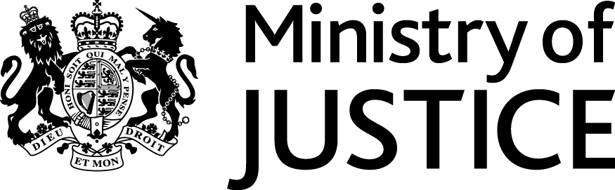
 | Our Reference: 548-16 FOI 108006 |  | November 2016

Freedom of Information Request

You asked for the following information from the Ministry of Justice (MoJ):

“The average length of time it takes (in days) for sexual offenders in sex offence cases including rape, to appear in Crown Court on the first day of their trial, from the time they are arrested.

Please can this information be broken down by region into Carlisle, Eden, Allerdale, Copeland, South Lakeland and Barrow in Furness

Can you provide this data for the time period starting from 2013 to present.

    - Crown Court information regarding the requested regions is only held for the overall Cumbria region at LCJB level, with Carlisle Combined Court Centre being the only Crown Court. Would information at this level suffice for your request?

Regarding the above matter- Could you supply the information in relation to Carlisle Crown Court and Preston Crown Court (I am now informed that this court sits in Barrow intermittently)”

Your request has been handled under the Freedom of Information Act 2000 (FOIA).
I can confirm that the department holds the information that you have asked for, and I am able to provide this to you.

Statistics on the mean average duration of sexual offences cases, from date of arrest to date of first listing in the magistrates’ courts, and from date of arrest to date of main hearing in the Crown Court, can be found in the attached table. The statistics cover cases completing in Carlisle and Preston Combined Court Centres for each year from 2013 to 2015.

Please note that the figures previously provided, under FOI number 107558, showed only the mean average duration from date of arrest to date of first listing in the magistrates’ courts. Statistics have been provided on this basis for consistency, covering both Court Centres, along with further statistics on the basis of duration from date of arrest to date of main hearing in the Crown Court.

