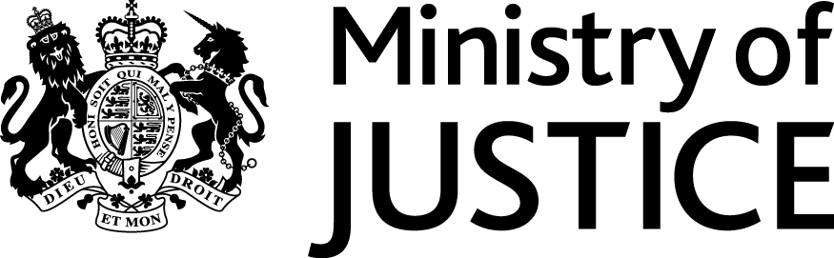
 | Our Reference: FOI/107912 |  | January 2017

Freedom of Information Request

You asked for the following information.

Could you please break down Table 4 (the police force area table) in this release by age (i.e. 10 to 17 and 18+) for the years 2009 to 2016?”

Your request has been handled under the Freedom of Information Act 2000 (FOIA). Please accept my apologies for the delay in this response.

I can confirm that the MoJ holds the data that you have requested. Please see the attached file.

The table in the accompanying file presents the number of knife possession offences in Table 4 of the Knife Possession Sentencing publication, broken down by the age group of the offender. Please note that the number of offences committed by offenders in each age group may not sum to the relevant totals given in the publication as the separate figures exclude a small number of offences where the offender’s age group is unknown.

If a request is made for information and the total figure amounts to five people or fewer, the MoJ must consider whether this could lead to the identification of individuals and whether disclosure of this information would be in breach of our statutory obligations under the Data Protection Act 1998 (DPA). We believe that the release of the some of this information would risk identification of the individuals concerned, and therefore be unlawful under the DPA. For this reason, MoJ has chosen not to provide an exact figure in cases where the true number falls between one and five. However, it should not be assumed that the actual figure represented falls at any particular point within this scale; 'five or fewer' is used as a replacement value from which it would be difficult to isolate or extract any individual data.
We are not obliged, under section 40(2) of the FOIA, to provide information if releasing would contravene any of the provisions in the DPA. In this instance we believe that the release of low figures would allow identification and would be unlawful and therefore contravene the first data protection principle.

The terms of this exemption in the FOIA mean that we do not have to consider whether or not it would be in the public interest for you to have the information.

You can find out more about section 40(2) by reading the extract from the FOIA and some guidance points we consider when applying the exemption, attached at the end of this letter.

The figures provided have been drawn from an extract of the Police National Computer (PNC) data held by the Department. The PNC holds details of all convictions and cautions given for recordable offences and include a number of offences where it is not possible for offenders to be given a custodial sentence. As with any large scale recording system the PNC is subject to possible errors with data entry and processing so data provided may be subject to revision.

EXPLANATION OF FOIA - SECTION 40(2) – INFORMATION RELATING TO THIRD PARTIES

We have provided below additional information about Section 40(2) of the Freedom of Information Act. We have included some extracts from the legislation, as well as some of the guidance we use when applying it. We hope you find this information useful.

The legislation

Section 1: Right of Access to information held by public authorities
(1) Any person making a request for information to a public authority is entitled—
(a) to be informed in writing by the public authority whether it holds information of the description specified in the request, and
(b) if that is the case, to have that information communicated to him.

Section 40: Personal Information.
(1) Any information to which a request for information relates is exempt information if it constitutes personal data of which the applicant is the data subject.
(2) Any information to which a request for information relates is also exempt information if—
(a) it constitutes personal data which do not fall within subsection (1), and
(b) either the first or the second condition below is satisfied.
(3) The first condition is—
(a) in a case where the information falls within any of paragraphs (a) to (d) of the definition of “data” in section 1(1) of the Data Protection Act 1998, that the disclosure of the information to a member of the public otherwise than under this Act would contravene—
(i) any of the data protection principles, or
(ii) section 10 of that Act (right to prevent processing likely to cause damage or distress), and
(b) in any other case, that the disclosure of the information to a member of the public otherwise than under this Act would contravene any of the data protection principles if the exemptions in section 33A(1) of the Data Protection Act 1998 (which relate to manual data held by public authorities) were disregarded.

Guidance
Section 40 of the Freedom of Information Act applies to:
- requests for the personal data of the applicant him or herself
- requests for the personal data of someone else (a third party)

Personal data of a third party: Personal data of a third party is exempt under section 40(2) if its disclosure to a member of the public would contravene one or more of the data protection principles and a request must be refused.
The Data Protection Principles:
The data protection principles are a statutory code for the processing of personal data. They are set out in Part I of Schedule 1 to the Data Protection Act.
Three data protection principles require personal data to be:
- fairly and lawfully processed
- processed for specified and lawful purposes
- adequate, relevant and not excessive
- accurate, and kept up to date
- not kept longer than necessary
- processed in accordance with individuals' rights under the Data Protection Act
- kept secure
- not transferred to non-EEA (European Economic Area) countries without adequate protection
The principle most likely to be relevant to the disclosure of information under the Freedom of Information Act is the first principle. This requires personal information to be:
- processed ‘fairly’
- processed ‘lawfully’
- not processed at all unless one of the ‘conditions’ for fair processing is met
Processing in this context includes disclosure.
In most cases, personal data will be exempt if disclosure would be ‘unfair’. Disclosure of personal data relating to a third party will often breach the fair processing principle if there was a legitimate expectation by a third party that this information would remain confidential.

