ANNEX 1
APPLICATION FORM

Candidate cities are invited to be concise and sharp in their answers to the questions below both at pre-selection and final selection stages. Furthermore great care should be given to ensure maximum readability of the applications.

Introduction – General considerations

- Why does your city wish to take part in the competition for the title of European Capital of Culture?

- Does your city plan to involve its surrounding area? Explain this choice.

- Explain briefly the overall cultural profile of your city.

- Explain the concept of the programme which would be launched if the city is designated as European Capital of Culture.

- Contribution to the long-term strategy

- Describe the cultural strategy that is in place in your city at the time of the application, as well as the city's plans to strengthen the capacity of the cultural and creative sectors, including through the development of long term links between these sectors and the economic and social sectors in your city. What are the plans for sustaining the cultural activities beyond the year of the title?

- How is the European Capital of Culture action included in this strategy?

- If your city is awarded the title of European Capital of Culture, what do you think would be the long-term cultural, social and economic impact on the city (including in terms of urban development)?

- Describe your plans for monitoring and evaluating the impact of the title on your city and for disseminating the results of the evaluation. In particular, the following questions could be considered:

- Who will carry out the evaluation?
- Will concrete objectives and milestones between the designation and the year of the title be included in your evaluation plan?
- What baseline studies or surveys - if any - will you intend to use?
- What sort of information will you track and monitor?
- How will you define "success"?
- Over what time frame and how regularly will the evaluation be carried out?

To get guidance for answering this question, please read the Guidelines established by the European Commission for the cities' own evaluations at the following web address: http://ec.europa.eu/programmes/creative-europe/actions/documents/ecoc/city-own-guide_en.pdf

- European dimension

- Elaborate on the scope and quality of the activities:
- Promoting the cultural diversity of Europe, intercultural dialogue and greater mutual understanding between European citizens;
- Highlighting the common aspects of European cultures, heritage and history, as well as European integration and current European themes;
- Featuring European artists, cooperation with operators and cities in different countries, and transnational partnerships.
Name some European and international artists, operators and cities with which cooperation is envisaged and specify the type of exchanges in question. Name the transnational partnerships your city has already established or plans to establish.

- Can you explain your strategy to attract the interest of a broad European and international public?

- To what extent do you plan to develop links between your cultural programme and the cultural programme of other cities holding the European Capital of Culture title?

- Cultural and artistic content

- What is the artistic vision and strategy for the cultural programme of the year?

- Describe the structure of the cultural programme, including the range and diversity of the activities/main events that will mark the year.
For each one, please supply the following information: date and place / project partners / financing.
(Date and place / project partners / financing are optional at pre-selection stage)

- How will the events and activities that will constitute the cultural programme for the year be chosen?
(This question is optional at pre-selection stage)

- How will the cultural programme combine local cultural heritage and traditional art forms with new, innovative and experimental cultural expressions?

- How has the city involved, or how does it plan to involve, local artists and cultural organisations in the conception and implementation of the cultural programme?
Please give some concrete examples and name some local artists and cultural organisations with which cooperation is envisaged and specify the type of exchanges in question.

- Capacity to deliver
- Please confirm and supply evidence that you have broad and strong political support and a sustainable commitment from the relevant local, regional and national public authorities.

- Please confirm and evidence that your city has or will have adequate and viable infrastructure to host the title. To do that, please answer the following questions:

- Explain briefly how the European Capital of Culture will make use of and develop the city's cultural infrastructure.

- What are the city's assets in terms of accessibility (regional, national and international transport)?

- What is the city's absorption capacity in terms of tourists' accommodation?

- In terms of cultural, urban and tourism infrastructure what are the projects (including renovation projects) that your city plan to carry out in connection with the "European Capital of Culture" action between now and the year of the title? What is the planned timetable for this work?
(This last question is optional at pre-selection stage)

- Outreach

- Explain how the local population and your civil society have been involved in the preparation of the application and will participate in the implementation of the year?

- How will the title create in your city new and sustainable opportunities for a wide range of citizens to attend or participate in cultural activities, in particular young people, volunteers, the marginalised and disadvantaged, including minorities? Please also elaborate on the accessibility of these activities to persons with disabilities and the elderly. Specify the relevant parts of the programme planned for these various groups.
(This question is optional at pre-selection stage)

- Explain your overall strategy for audience development, and in particular the link with education and the participation of schools.

- Management

- Finance

- City budget for culture:

  - What has been the annual budget for culture in the city over the last 5 years (excluding expenditure for the present European Capital of Culture application)? (Please fill in the table below).

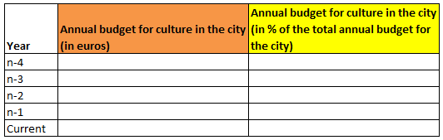

  - In case the city is planning to use funds from its annual budget for culture to finance the European Capital of Culture project, please indicate this amount starting from the year of submission of the bid until the European Capital of Culture year.

  - Which amount of the overall annual budget does the city intend to spend for culture after the European Capital of Culture year (in euros and in % of the overall annual budget)?

- Operating budget for the title year

- Income to cover operating expenditure:

  - Please explain the overall operating budget (i.e. funds that are specifically set aside to cover operational expenditure). The budget shall cover the preparation phase, the year of the title, the evaluation and provisions for the legacy activities. Please also fill in the table below.

Total income to cover operating expenditure | From the public sector | From the public sector | From the private sector | From the private sector
(in euro) | (in euro) | (in %) | (in euro) | (in %)

Income from the public sector:

  - What is the breakdown of the income to be received from the public sector to cover operating expenditure? Please fill in the table below:
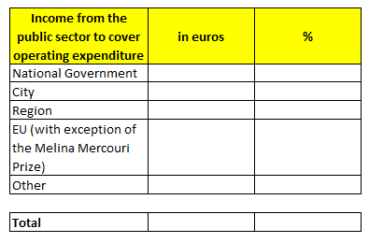

  - Have the public finance authorities (City, Region, State) already voted on or made financial commitments to cover operating expenditure? If not, when will they do so?

  - What is your fund raising strategy to seek financial support from Union programmes/funds to cover operating expenditure?

  - According to what timetable should the income to cover operating expenditure be received by the city and/or the body responsible for preparing and implementing the ECoC project if the city receives the title of European Capital of Culture? Please fill in the table below (this question is optional at pre-selection stage):

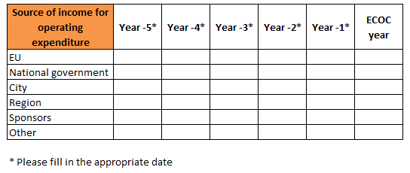

Income from the private sector:

  - What is the fund-raising strategy to seek support from private sponsors? What is the plan for involving sponsors in the event?

  - Operating expenditure:

  - Please provide a breakdown of the operating expenditure, by filling in the table below.
Breakdown of operating expenditure

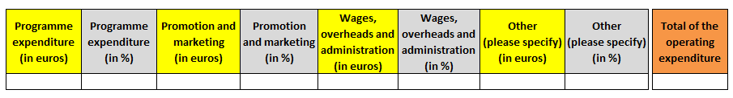

  - Planned timetable for spending operating expenditure (this question is optional at pre-selection stage)

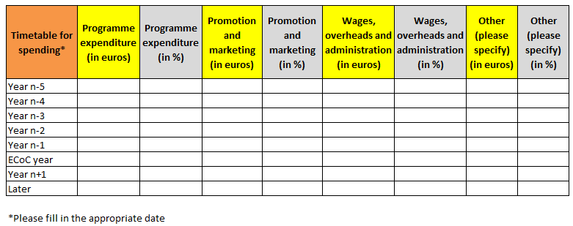

- Budget for capital expenditure :

  - What is the breakdown of the income to be received from the public sector to cover capital expenditure in connection with the title year? Please fill in the table below:

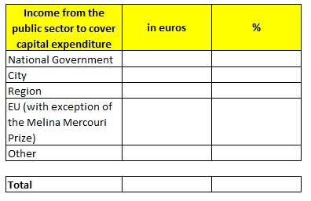

  - Have the public finance authorities (city, region, State) already voted on or made financial commitments to cover capital expenditure? If not, when will they do so?

  - What is your fund raising strategy to seek financial support from Union programmes/funds to cover capital expenditure?

  - According to what timetable should the income to cover capital expenditure be received by the city and/or the body responsible for preparing and implementing the ECoC project if the city receives the title of European Capital of Culture? (please fill in the table below. This table is optional at pre-selection stage)

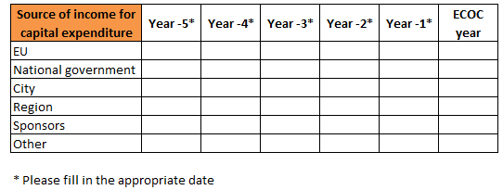

  - If appropriate, please insert a table here that specifies which amounts will be spent for new cultural infrastructure to be used in the framework of the title year.

- Organisational structure

- What kind of governance and delivery structure is envisaged for the implementation of the European Capital of Culture year?

- How will this structure be organised at management level? Please make clear who will be the person(s) having the final responsibility for global leadership of the project?

- How will you ensure that this structure has the staff with the appropriate skills and experience to plan, manage and deliver the cultural programme for the year of the title?

These two questions above could be answered by enclosing in particular diagrams, the statutes of the organisation, its staff numbers and the curricula vitae of those primarily responsible.

- How will you make sure that there is an appropriate cooperation between the local authorities and this structure including the artistic team?

- According to which criteria and under which arrangements have the general director and the artistic director been chosen – or will be chosen? What are – or will be – their respective profiles? When will they take up the appointment? What will be their respective fields of action?

- Contingency planning

- Have you carried out/planned a risk assessment exercise?

- What are the main strengths and weaknesses of your project?

- How are you planning to overcome weakness, including through the use of risk mitigation and planning tools, contingency planning, etc.

- Marketing and communication

- Could your artistic programme be summed up by a slogan?

- What is the city's intended marketing and communication strategy for the European Capital of Culture year?

(in particular with regard to the media strategy and the mobilisation of large audiences. At the final selection stage, consideration must be given in particular to the partnerships planned or established with the written press and the audiovisual sector with a view to ensuring media coverage of the event and of the plans relating to this strategy).

- How will you mobilise your own citizens as communicators of the year to the outside world?

- How does the city plan to highlight that the European Capital of Culture is an action of the European Union?

Additional information

- In a few lines explain what makes your application so special compared to others?

- Add any further comments which you deem necessary in relation with your application.

ANNEX 2
DECLARATION OF HONOUR BY THE APPLICANT CITY

The undersigned [insert name of the signatory of this form]:

representing the following legal person:
full official name:
official legal form:
full official address:
VAT registration number:
- certify that the applicant city is not in one of the following situations which would exclude it from receiving Union prizes:
- is bankrupt or being wound up, is having its affairs administered by the courts, has entered into an arrangement with creditors, has suspended business activities, is the subject of proceedings concerning those matters, or is in any analogous situation arising from a similar procedure provided for in national legislation or regulations;
- has been convicted of an offence concerning professional conduct by a judgment of a competent authority of a Member State which has the force of res judicata;
- has been guilty of grave professional misconduct proven by any means which the Commission can justify including by decisions of the European Investment Bank and international organisations;
- is not in compliance with all its obligations relating to the payment of social security contributions and the payment of taxes in accordance with the legal provisions of the country in which it is established, with those of the country of the authorising officer responsible and those of the country where the action is to be implemented;
- has been the subject of a judgement which has the force of res judicata for fraud, corruption, involvement in a criminal organisation, money laundering or any other illegal activity, where such activity is detrimental to the Union's financial interests;
- is subject to an administrative penalty for being guilty of misrepresenting the information required as a condition of participation in a procurement procedure or another grant award procedure or failing to supply this information, or having been declared to be in serious breach of its obligations under contracts or agreements covered by the Union's budget.
- declare that the applicant city:
- has no conflict of interests in connection with the prize; a conflict of interests could arise in particular as a result of economic interests, political or national affinity, family, emotional life or any other shared interest;
- will inform the Commission, without delay, of any situation considered a conflict of interests or which could give rise to a conflict of interests;
- has not granted and will not grant, has not sought and will not seek, has not attempted and will not attempt to obtain, and has not accepted and will not accept any advantage, financial or in kind, to or from any party whatsoever, where such advantage constitutes an illegal practice or involves corruption, either directly or indirectly, inasmuch as it is an incentive or reward relating to the award of the prize;
- provided accurate, sincere and complete information within the context of this prize award procedure.
- I declare that the applicant city is fully eligible in accordance with the criteria set out in the specific call for submission of applications.
- I acknowledge that according to Article 131 of the Financial Regulation of 25 October 2012 on the financial rules applicable to the general budget of the Union (Official Journal L 298 of 26.10.2012, p. 1) and Article 145 of its Rules of Application (Official Journal L 362, 31.12.2012, p.1) applicants found guilty of misrepresentation may be subject to administrative and financial penalties under certain conditions.
If selected to be awarded a prize, the applicant city accepts the conditions as laid down in the call for submission of applications.

Last name, first name:

Title or position in the city:
Signature [and official stamp] of the applicant:
Date:

Your reply to the call for submission of applications will involve the recording and processing of personal data (such as your name, address and CV), which will be processed pursuant to Regulation (EC) No 45/2001 on the protection of individuals with regard to the processing of personal data by the Community institutions and bodies and on the free movement of such data. Unless indicated otherwise, your replies to the questions in this form and any personal data requested are required to assess your application in accordance with the specifications of the call for submission of applications and will be processed solely for that purpose by the Department for Culture, Media and Sport. Details concerning the processing of your personal data are available on the privacy statement at the page: http://ec.europa.eu/dataprotectionofficer/privacystatement_publicprocurement_en.pdf.

Your personal data may be registered in the Early Warning System (EWS) only or both in the EWS and Central Exclusion Database (CED) by the Accounting Officer of the Commission, should you be in one of the situations mentioned in:
- the Commission Decision 2008/969 of 16.12.2008 on the Early Warning System (for more information see the Privacy Statement on http://ec.europa.eu/budget/contracts_grants/info_contracts/legal_entities/legal_entities_en.cfm), or

- the Commission Regulation 2008/1302 of 17.12.2008 on the Central Exclusion Database (for more information see the Privacy Statement on
http://ec.europa.eu/budget/explained/management/protecting/protect_en.cfm#BDCE )

