Howsham Fish Passage Consultation Response document
Report – ENVIMNE000903
Final version December 2016

We are the Environment Agency. We protect and improve the environment.
Acting to reduce the impacts of a changing climate on people and wildlife is at the heart of everything we do.
We reduce the risks to people, properties and businesses from flooding and coastal erosion.
We protect and improve the quality of water, making sure there is enough for people, businesses, agriculture and the environment. Our work helps to ensure people can enjoy the water environment through angling and navigation.
We look after land quality, promote sustainable land management and help protect and enhance wildlife habitats. And we work closely with businesses to help them comply with environmental regulations.
We can’t do this alone. We work with government, local councils, businesses, civil society groups and communities to make our environment a better place for people and wildlife.

Published by:
Environment Agency  Horizon House, Deanery Road,  Bristol BS1 5AH  Email: enquiries@environment-agency.gov.uk  www.gov.uk/environment-agency  © Environment Agency 2014  All rights reserved. This document may be reproduced with prior permission of the Environment Agency. | Further copies of this report are available  from our publications catalogue: www.gov.uk/government/publications  or our National Customer Contact Centre:  T: 03708 506506  Email: enquiries@environment-agency.gov.uk.

Contents
Purpose of this document 4
Introduction 5
About the consultation 5
How we ran the consultation 7
Overview of responses received 7
Summary of comments 8
Responses to questions raised during consultation 9
Benefits of fish passage 9
Changes to flows downstream of the weir 9
Access to the site for construction 9
Number and size of fish passes 9
Type of fish pass 10
Fish passage for other species 10
Movement of fish 10
Predators 11
Other factors affecting fish in the Derwent 11
Maintenance of fish passes 11
Funding 11
Timing 12
Eddies for canoe slalom 12
Gate to control flow through canoe chute 12
Next Steps 13
Annex 1 - List of respondents 14
Annex 2 - Meetings/events held 14

Purpose of this document
This report provides a summary of the consultation on our plans to provide a fish passage over the northern end of Howsham Weir.
We have;
- Explained why and how we ran the consultation;
- Outlined the responses we received; and
- Explained how we are considering the responses to inform our decisions.

Introduction
Background
To improve the environmental quality of the River Derwent, we are looking at what changes are needed at our weirs and other structures on the river. As part of this project, we are aiming to improve fish passage at Howsham Weir.
The River Derwent from Ryemouth to Barmby-on-the-Marsh, where it joins the River Ouse, is designated as nationally and internationally important, reflecting the special characteristics of this unique lowland river. However, its condition is classed as unfavourable due to diffuse pollution from agricultural run-off, siltation, historic flood defences and structures in the channel, such as weirs constructed for navigation and mills.
We are working together with Natural England to address problems at five weirs we own. Howsham Weir is one of the structures identified for improvement. It is an obstacle to migrating fish, eel and lamprey. Improving fish passage at Howsham Weir will have a number of benefits including:
- improving fish populations, especially eel and lamprey, by allowing them to move freely between the river and coastal waters to access breeding, nursery or feeding grounds
- helping species naturally re-colonise the river upstream after floods, droughts or pollution
- contributing to meeting legal fish passage obligations and environmental targets.
This stretch of river and the weir are popular with canoeists and anglers. Installing fish passage may affect these activities. The length of the weir makes it difficult to find a solution to accommodate all the existing uses of the river.
We used this consultation to seek views and opinions to help us decide on the best solution.

About the consultation
We asked for views on our plans for fish passage across Howsham Weir by asking 4 questions.
General plans for fish passage across Howsham Weir
1. Please tell us if there is any other information we need to take into account in planning to install fish passage.
Options for fish passage across the northern end of the weir
2a. Have we identified all the advantages of each option?
2b. Have we identified all the disadvantages of each option?
2c. Please tell us if you have any ideas or suggestions for how the disadvantages could be managed or reduced.
2d. Is there any other information we should consider when choosing an option?
3. Please tell us if you have any further comments on our options.
4. After the consultation we would like to work with representatives from key interest groups (for example local residents, canoeists, anglers, other recreational users, environmental interests, the Council, landowners and the catchment partnership) to develop the plans further before we make a decision. We are looking for representatives who:
• know the site well
• can communicate with others who are interested in Howsham for a similar purpose
• will put forward the information and the range of different views of their group in a balanced way.

If you feel you can represent your interest group on an engagement panel after the end of the consultation, please email or write to us before 20 July with your name, email address and contact telephone number.

Answers which consultees gave to these questions are summarised below. They are grouped by topic and our responses are shown alongside.

How we ran the consultation
Before the consultation opened we sent a briefing note to 32 groups and individuals who we knew had an interest in the project. We advertised the consultation on local noticeboards and social media. The briefing note explained what the consultation was about and when it would take place, and invited people to attend a drop in event in July and to join an engagement panel.
The consultation ran for 10 weeks from 30 June to 8 September, and was published online at https://www.gov.uk/government/consultations/howsham-weir-fish-passage-consultation. Consultees were invited to submit their comments via email or through the post.
We held a drop in event on 18 July at Welburn Village Hall for anyone to come along to find out more information about the consultation and ask any questions. Copies of the consultation document were also available to take away. 16 people attended the event.
We set up an engagement panel which included people who responded to the request we made during the consultation for people to get involved. Two meetings have been held on 11 October and 23 November, and along with the consultation responses we are considering the views and information provided by the panel to help us reach a decision.
An independent facilitator managed the engagement panel which included representatives from landowners, residents, Natural England, anglers, local canoeists and kayakers, British Canoeing, fisheries science, the River Derwent Catchment Partnership and the Environment Agency.

Overview of responses received

23 consultation responses were received:
- 12 were from canoeists
- 3 from individuals
- 2 from public sector
- 4 from anglers/angling clubs
- 1 from business
- 1 general recreational interest

Summary of comments

A majority of respondents stressed the importance of the site for the use of canoes, kayaks and Canadian canoes, and the frequency of use, particularly for training young people who go on to compete nationally and internationally.
There were requests for clarification about how fish populations will benefit from the proposed work, and what effect other obstacles or pollution have. The need for two fish passes on the weir was questioned, especially in view of the possible impact on canoeing. There was support for our proposal to provide fish passage at the weir, and it was pointed out that there is a lot of work going on further up the catchment to improve fish passage. Most respondents were keen in principle to see environmental improvements, including fish passage, and some stated that as much as possible should be done to improve fish populations.
Some respondents said that the potential effect of the proposals on substrates such as gravels and silt downstream of the weir should be looked at. This was particularly a concern in view of the designated features of the Special Area of Conservation. We have taken advice and concluded there will be no significant effect.
Most respondents put forward constructive suggestions of ways to combine fish and canoe passage at this site. We were asked if any work could be done passage of other fish species, but obstacles are not a limiting factor for smaller species.
Through the consultation and other activities it became clear that the option of splitting the canoe chute lengthways to accommodate canoe and fish passage would not be possible. On the other hand, we received suggestions about putting a gate on the canoe chute to close it when not in use. Although we said in the consultation that we thought this was not be feasible, these comments have led us to look at this option further.

Responses to questions raised during consultation

Benefits of fish passage
Question: What benefit will there be to fish populations from this project?
Answer: This project is part of a programme to improve fish passage on five weirs in the lower Derwent. The benefits will come from work on all the weirs together, because fish need to pass a number of obstacles to get to the habitat they need for spawning. The programme will connect habitat and particularly improve the condition of lamprey, which are a protected species of the river, eels and migratory salmonids. These species will be able to reach spawning grounds in the upper reaches.
Changes to flows downstream of the weir
Question: Installing fish passage will mean levelling off the weir crest. Less water is likely to come directly over the weir, and most of the water will go through fish/canoe passes. What will the different flows downstream do to sediment, rocks, spawning areas and plant growth downstream of the weir? Is there a risk to stability of the north bank?
Answer: Our expert hydrogeomorphologist has looked at the proposals, information about the site, and comments from Natural England. Their advice and that of our project team and consultants was that movement of sand, silt, gravel, rocks etc. will mostly happen in high flows. As our proposals will not substantially change how high flows cross the weir, we do not expect any significant impact. The clean gravels near the existing turbine will not become silted, as there will be more water flowing down this end of the weir due to the new turbine and the new fish pass at the south end. None of the works proposed thus far will increase the volume or velocity of water in the vicinity of the north bank.
To summarise, our assessment has concluded that there will not be a significant impact.
Access to the site for construction
Question: Can the site be accessed by heavier plant, for example back filling the lock channel or installing a temporary bridge?
Answer: We have been unsuccessful in contacting the owner of the lock channel for some time. To access the south bank (at the mill) the size of machinery we can use is limited by the size of the swing bridge and space around the mill. It may be possible to move machinery up the river by pontoon - this would be limited by the size of pontoon that will fit along the river. Accessing the north bank would be difficult because it is steep, so to get any plant down to the river is likely to require digging out a very substantial track way to produce a low enough slope. If we need to get concrete wagons to the north bank a haul road would be required.
To summarise: the larger the machinery required, the more likelihood there is of the works becoming prohibitively costly, disruptive to the site, or not feasible.
Number and size of fish passes
Question: The consultation document explained that more than one fish pass is needed, and that if there was a pass next to the canoe chute it would need a larger or equal flow to that coming through the chute. One response suggested that at some other sites there is only one fish pass even though there are several pools. Another said that less flow is needed through a fish pass than through an adjacent hydropower turbine. Why are these approaches not suitable here?
Answer: Fish are attracted to fast-flowing water. Hydropower turbines reduce the energy of water passing through, which means that a fish pass next to a turbine doesn't need to have a high flow to attract fish away from the turbine. However, the canoe chute produces a fast jet of water, so a fish pass next to the chute would need to take a lot of flow to attract fish. We follow our fish pass manual to inform the design of fish passes. Fish naturally follow the outside of a bend in a river, which at Howsham would lead them towards the north end of the weir. Migratory salmonids do not feed while migrating, so need to conserve energy by finding a route up the river without difficulty.
To summarise: the flow needed through a fish pass depends on the situation. We are following our fish pass manual as closely as we can to design new fish passes.
Type of fish pass
Question: Instead of Larinier fish passes, have we considered a meander type fish pass, rock ramp, or a vertical slot pass which is better for lamprey? Can the lock channel be used?
Answer: A meander type fish pass would have to be located on the north bank (there is no space at the mill side). There is limited space here and a very steep bank, which means it would not be possible to build a long enough pass meandering from the upstream of the weir to downstream.
A rock ramp needs a shallow slope to operate. It would need to be three times the length of a Larinier style pass and very wide, possibly extending as far across as the canoe chute - it would need large machinery and careful construction to ensure that fish can pass through it.
A vertical slot pass also needs a shallow slope. It would need to be about three times the length of the Larinier and not suitable in this setting. It is an extremely expensive option. Although a vertical slot pass is generally ideal for lamprey, we consider that lamprey can pass Howsham Weir at some flows, so due to space and cost lamprey tiles are more appropriate.
We do not own the lock channel and have not been able to hold any discussion with the owner. The lock channel would not be suitable for fish passage as most fish will follow the main river flow, swimming past the lock outflow and being attracted towards the weir where the turbines and canoe chute are.
To summarise: We have considered many types of pass and put forward Larinier style with eel and lamprey tiles on the weir as the most suitable for this difficult location. This is due to the limit on size of machinery and space - some of the other passes put forward require a much gentler slope and therefore much more space.
Fish passage for other species
Question: Can we include fish passage for other fish species, including smaller fish such as bullhead and others.
Answer: Larinier fish passes are suitable for numerous species and sizes. The pass proposed next to the turbines will work help coarse fish populations above and below the weir to mix, but will not work in all conditions. The status of other fish species in these reaches is already good, so the new fish pass will bring an added benefit. Fish passage is not usually a limiting factor on small fish species. They have a lesser need to migrate long distances, but may be helped to some extent by the passes we are proposing. The main population of bullheads in the Derwent is much further upstream.
To summarise: Providing passage for small species of fish at Howsham will not bring significant benefits.
Movement of fish
Question: The consultation explains that migratory salmonids will be attracted to both ends of the weir.
Is it possible to encourage these fish towards the southern end? Will the installation of a new turbine and fish passes change this?
Answer: We have explored this and concluded that it is not possible to encourage fish to a particular end of the weir. We have considered the new turbine and fish passes in our assessment of how fish will move.
To summarise: We need to work with the fact that the fish will move to both ends of the weir, although this makes Howsham a difficult site to install fish passage on.
Predators
Question: How has the effect of the otter population on fish been considered? Have otters been introduced here?
Answer: Captive bred otters were released in counties other than Yorkshire up to about 16 years ago. In a separate programme, between 1990 and 1996, some injured or orphaned otters were rehabilitated and re-released in Yorkshire. Descendants of these form only a tiny proportion of the otter population in England. Most wild otters are the result of the natural recovery of the species after the banning of toxic pesticides.
The Environment Agency, Natural England and the Wildlife Trusts concentrate on encouraging natural recovery by improving river habitat. Otters are designated in the Derwent as part of the Special Area of Conservation. We would not be trying to improve fish populations if it was likely that the benefit to numbers would be removed by predation.
To summarise: Otter introductions are not significant in this area. Otters are a protected species and natural predator to fish, but passage will still benefit fish populations.
Other factors affecting fish in the Derwent
Question: What is being done about diffuse pollution in the catchment?
Answer: The Catchment Sensitive Farming officer for the Environment Agency and Natural England provided workshops and advice. The Environment Agency has tackled industrial diffuse pollution, for example at Full Sutton industrial estate. There is a planned project on the Rye, which is a major source of diffuse pollution in the catchment, and further work is has been proposed for the Upper Derwent. Barriers are expected to be the main factor still restricting fish movement up the Derwent catchment.
To summarise: Diffuse pollution may affect fish movement up the Derwent, but we are working to address these problems, and barriers are a greater constraint on fish populations.
Maintenance of fish passes
Question: Will weeds/algae grow on the fish pass - does it need to be covered? How often does a fish pass need to be maintained and how will this be done, particularly on the north end at the canoe chute?
Answer: We would not wish to cover the fish pass as this may cause more debris to collect and require more maintenance.
We inspect fish passes regularly during the migration season, with the frequency depending on their type and specific location - in some cases this may be every week but often much less frequent inspection is needed. Small debris would typically wash away during spate flows. For larger blockages we or our contractors would access a fish pass in mid channel by boat. Larinier fish passes are designed to be relatively easy to maintain. If we were to split the canoe chute into a fish pass and canoe chute, then this would be somewhat more difficult to maintain as the channels would be narrower. An arrangement with a gate which opens during slalom sessions would be more difficult to maintain because debris can get caught on the gate, and because it has moving parts which may need repair.
To summarise: The options entail different maintenance difficulties. We want to find a solution which works with minimum maintenance.
Funding
Question: Anglers fund work by the EA through rod licences. What funding will be provided by canoeists.
Answer: We will seek funding from appropriate sources internally or externally depending on the solution chosen and what benefits it brings. The consultation set out our duties to provide fish passage. We also have a duty to promote recreation when exercising our responsibilities.
Timing
Question: Would it be possible to build a fish pass next to the turbine, monitor its success and then afterwards consider the need for one at the north end of the weir.
Answer: We are unable to install just one fish pass without limiting options for another. This would be a positive step towards improving fish passage, but the size of the fish pass at the turbine will determine how much water remains for any future work at the north end of the weir.
Monitoring the effectiveness of a fish pass at the south end would not provide useful data because there is little spawning area between Howsham Weir and Kirkham upstream. We will ultimately assess the success of all our work to improve fish passage across our weirs on the lower Derwent by looking at how populations in the catchment upstream change. When following our fish pass manual to design a fish pass, using tried and tested methods, we can be confident of how effective it will be.
To summarise: If we put in one fish pass now next to the turbines, this would not necessarily prevent us from installing a second in the future, but it would limit the options for the north end.
Eddies for canoe slalom
Question: Can there be a gap between a new fish pass and the canoe chute, which could improve canoeing?
Answer: We will keep this in consideration, although it will be difficult to predict how successful it would be. Risks we will have to look at include safety and the effect on how fish are attracted to the pass.
Gate to control flow through canoe chute
Question: Can flow through the canoe chute be stopped by a gate except during slalom sessions or events, so that there is enough for fish passage most of the time?
Answer: We did not initially think this was feasible but have been looking at the option again. We would have to overcome the following problems:
- informal use of the canoe chute: we need to consider what the effect would be on anyone wanting to use the chute outside of formal slalom sessions
- cost: we estimate that this would amount to at least double the cost of putting in a Larinier pass next to the turbines.
- maintenance: a gate would need maintenance (including removing debris and mechanical maintenance). We appreciate that canoeists have volunteered to carry out light maintenance. We would need to be sure that all maintenance can be carried out safely.
- fish passes: we need to make sure these work correctly so that they are effective
- responsibility: specific people would need to be responsible for operating a gate
To summarise: If we were to take this option forward there would be a number of risks which mean it is not certain to be successful.

Next Steps
The project board for the Doing more for the Derwent programme, which includes the Howsham fish pass project, will review the information and views from the consultation and other engagement activities along with advice from our experts.
Once the project board has decided on the best solution, we will contact people who have responded to the consultation or been involved in either of our engagement panel meetings to let them know what we plan to do, and give reasons for the decision.

Annex 1 - List of respondents
Natural England
North Yorkshire Moors National Park Authority
Mannpower Consulting Ltd
Lower Wharfe Canoe Club
Members of the Public - 19

Annex 2 - Meetings/events held
18 July - Howsham Fish pass drop in
11 October - Engagement Panel meeting
23 November - Engagement Panel meeting

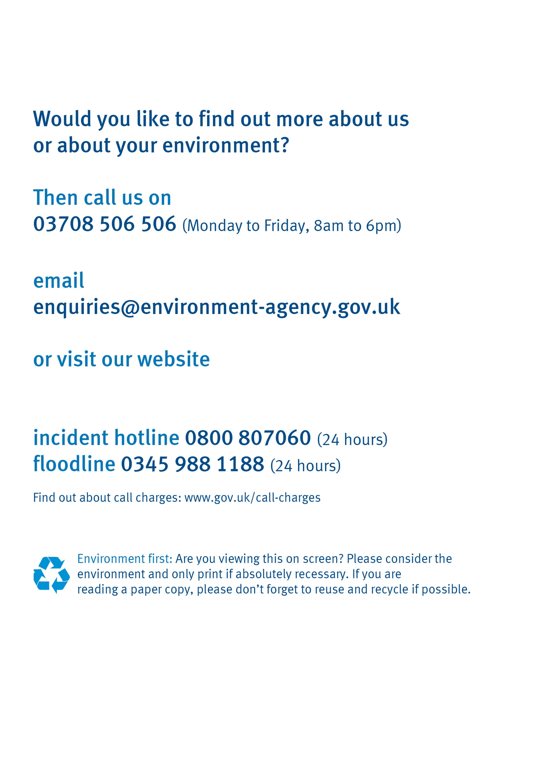

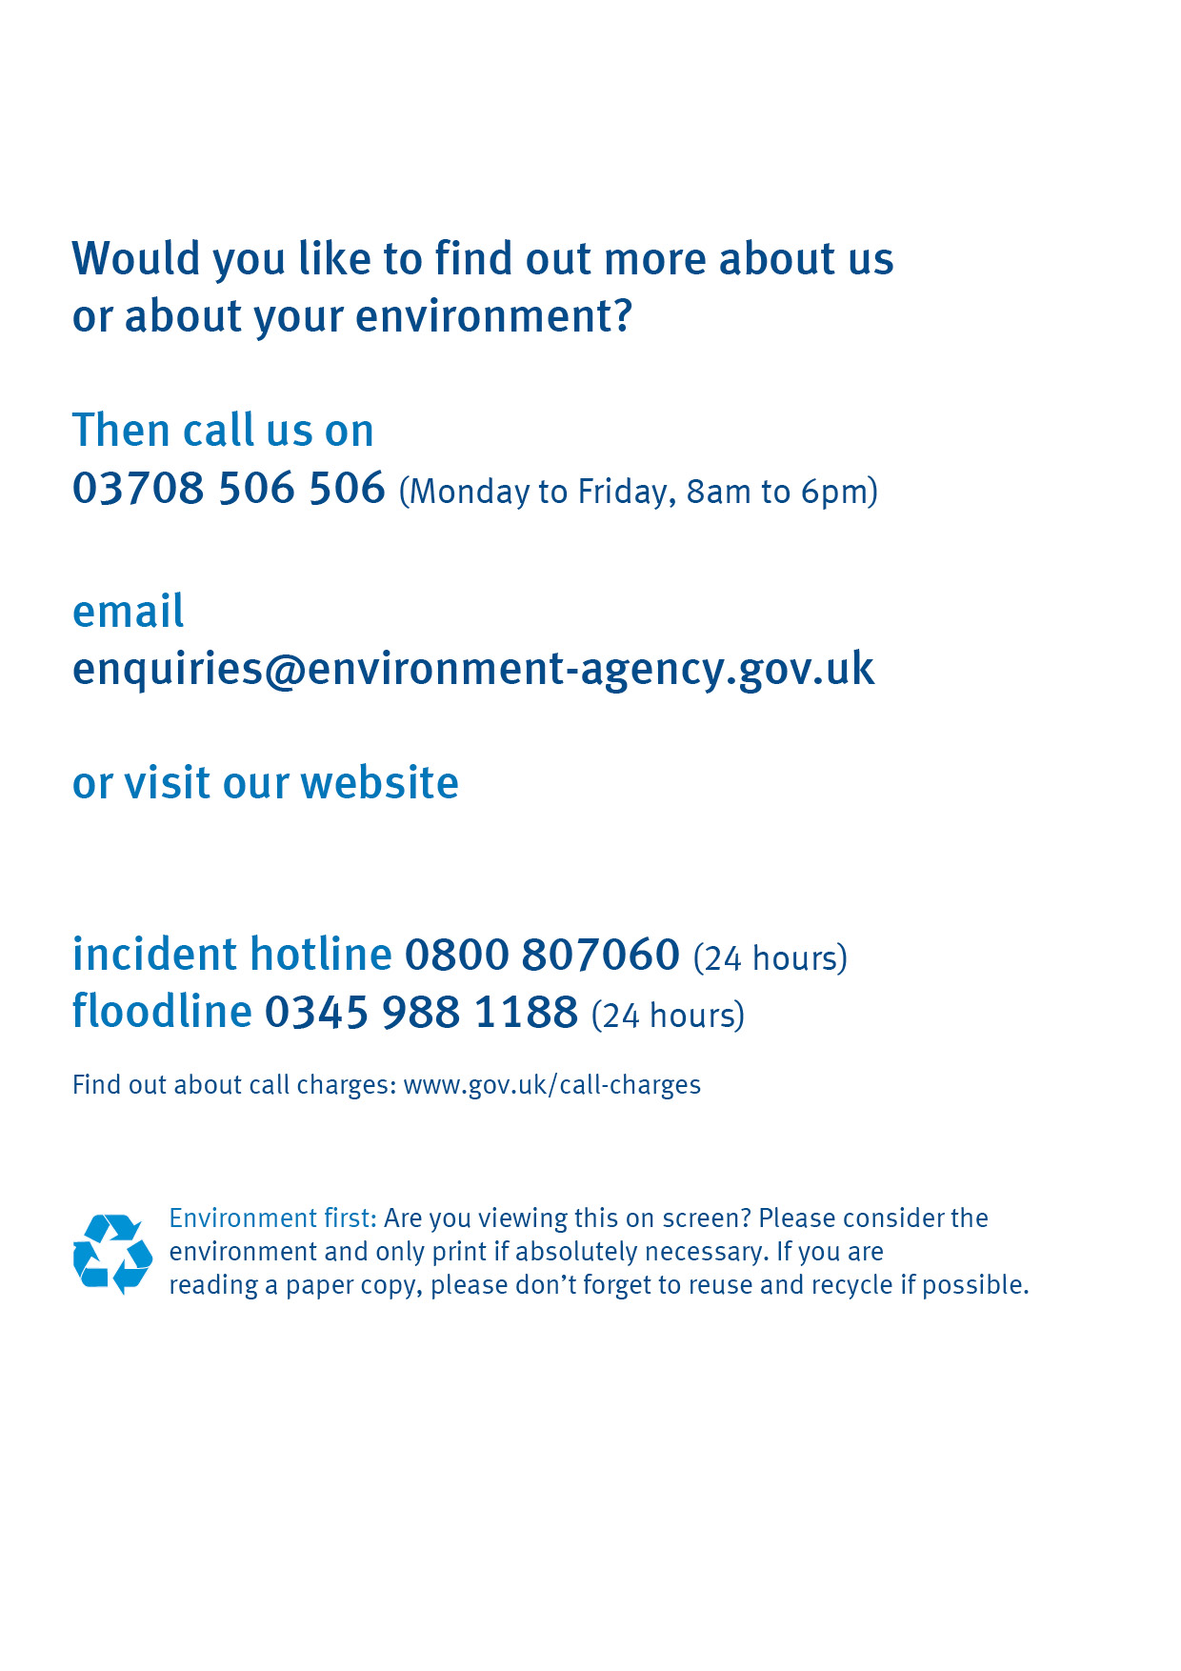
Lit code details to be inserted here
www.gov.uk/environment-agency

