This document was archived 2016 because it is no longer current.

Using the physical environment as a tool for teaching: Netherfield Primary School

URN: 134930
Region: East Midlands
Remit: Schools

Provider background
Netherfield Primary School is located in the outskirts of Nottingham. It was judged to be outstanding in 2013.

Brief description
This Ofsted good practice example shows how a primary school makes highly effective use of resources and space to provide children with outstanding learning experiences. A range of teaching approaches, both formal and informal, sit side by side in a highly planned curriculum where both the indoor and outdoor environment are used creatively. A research-based approach was taken when setting up the environments, and a large staff team works together to seek ever better ways of ensuring that children get off to a good start. At this school, the headteacher is clear that ‘the environment is the best teaching tool we have’.
This is part of a set of eight good practice examples showcasing good practice in early years to support the report: ‘Teaching and play in the early years – a balancing act?’.

The good practice in detail

Making use of the indoor space
The indoor environment is highly structured. It consists of one large room (the unit) with several smaller, ‘groups rooms’ radiating from it. These rooms can be closed with moveable dividers. As the early years leader explains, the environment is “designed with the child in mind, ensuring ease of access and independence. It starts with the furniture, where clear zoning enables children to see exactly what resources are available. These zones are located strategically so that children can select resources from one zone that will help with their play in another. For example, ‘small world’ is adjacent to the ‘big blocks’ because children frequently play with these resources together.”

How the indoor space is organised
- The zones, called ‘Learning Labs’ by staff and children alike, are where activities are permananently located. In each lab, resources are laid out very clearly at child-friendly height and with shadow stickers for easy replacement. Consequently, children become familiar with the location of common resources quickly and use them independently.
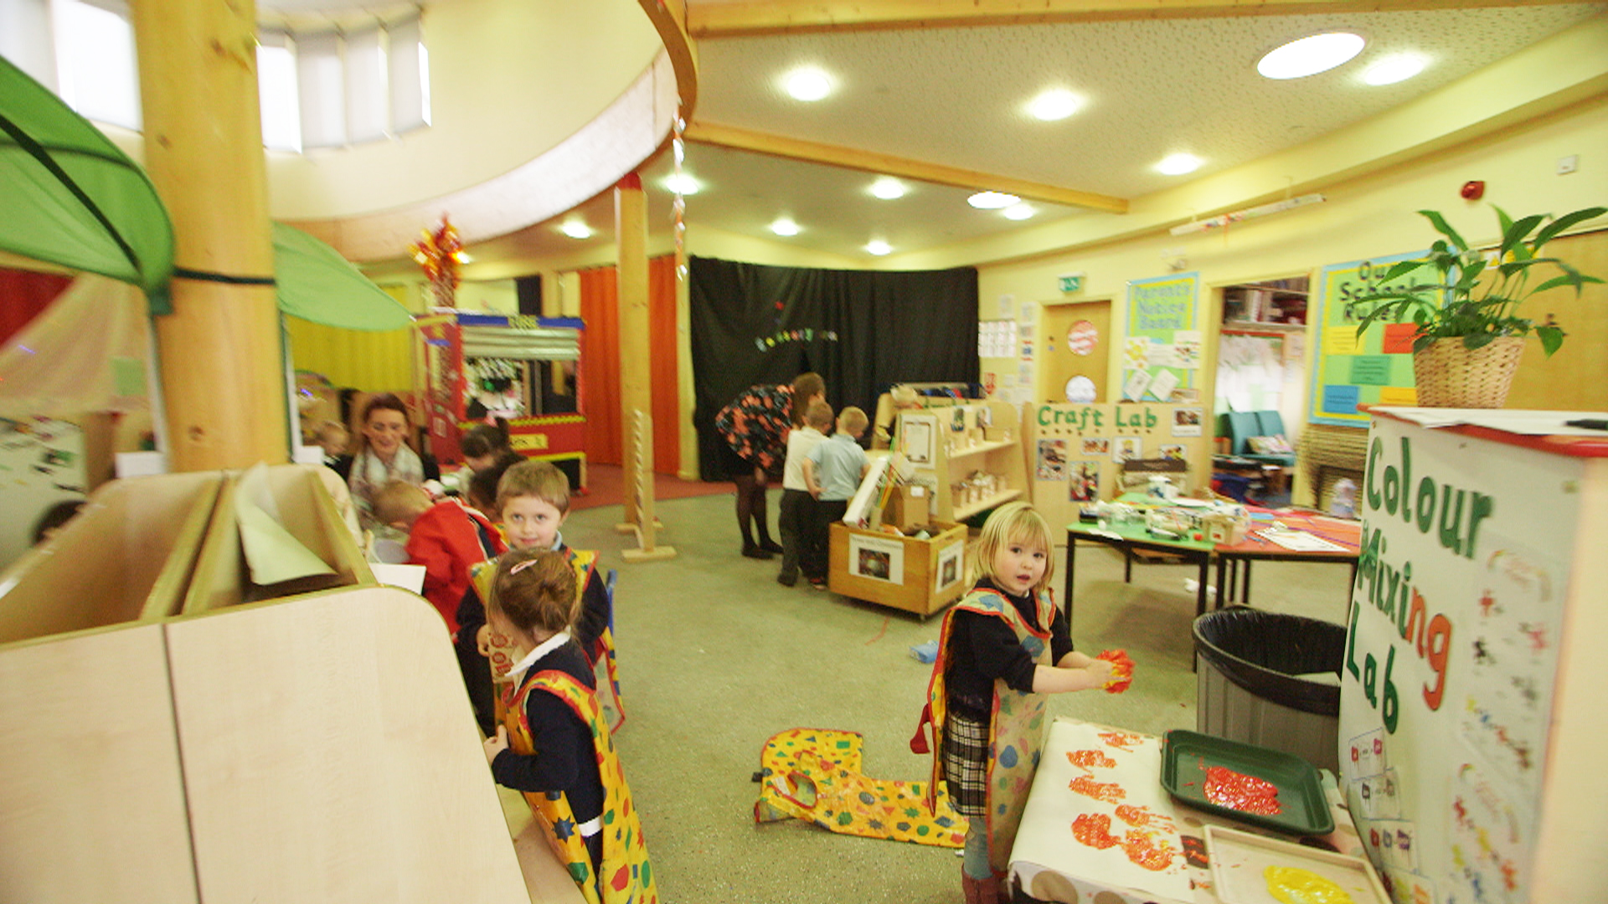
- The group rooms have flexible dividers that close easily to create areas for small groups to learn more formally or without the distractions of other children and activities. The dividers are substantial enough to reduce sound and create spaces where children can focus and concentrate. In these rooms, children are taught the basic skills of reading (daily phonics), writing and mathematics. The school also prioritises a daily massage session for every child, encouraging respect, appropriate contact and consideration for others. This is regarded as a formal element of the curriculum. At the end of the formal learning, often consisting of a short teaching input, children are encouraged to use these skills independently in the learning labs.
- Labelling is consistent with the school’s phonic programme: all zones and resources are labelled so that common digraphs (ck, ng) are highlighted in a different colour. This means that children’s formal learning can be reinforced when they are in the main learning room.

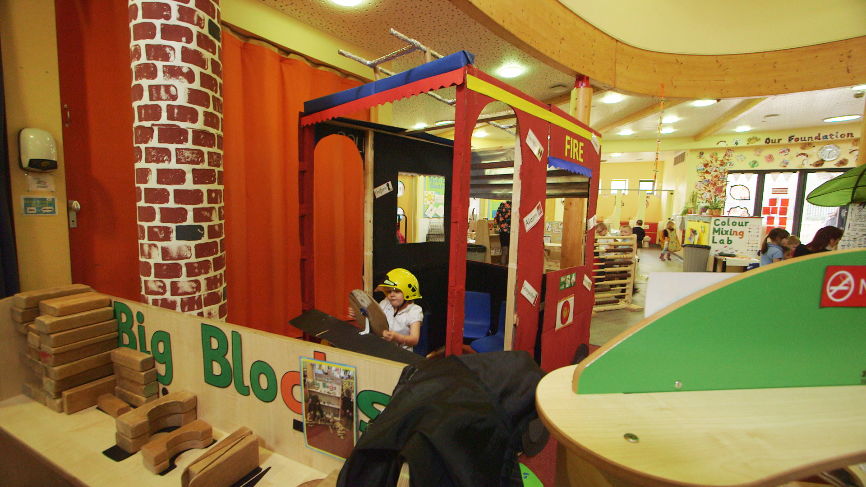

- In addition to the permanent learning labs, there are zones that change in response to the children’s interests and their current learning. For example, at the time of the visit, a large fire engine sat in the centre of the unit because all children were to visit a fire station in the near future. The engine, made from cardboard by the staff, had a range of resources, costumes and writing materials to encourage children to explore, learn new skills and, critically, be ready to ask questions when they made their visit.

The great outdoors
Despite being located in an urban setting, with limited space and only a small playing field, Netherfield Primary School makes the absolute most of its outdoor resources. The early years leader describes the outdoor environment as ‘mirroring the indoor environment as much as possible so that children have access to all of the same kinds of activities and learning opportunities outside as they would inside’. This strategy responds to the school acknowledging that some children prefer to learn outside and would miss out if the areas were dissimilar. However, the early years leader also believes that, ‘the outdoor activities have to be challenging and open-ended to encourage and promote problem solving, creativity and critical thinking.’ The children’s interests are also reflected in the outdoor area.
- A shed, bearing the sign ‘Our School’, was built after staff observed that children were enjoying role-play as teachers and learners. The children were involved in the painting of the signs, the design of the shed and the selection of resources. This is a popular place, where children write, count and develop their imaginations.
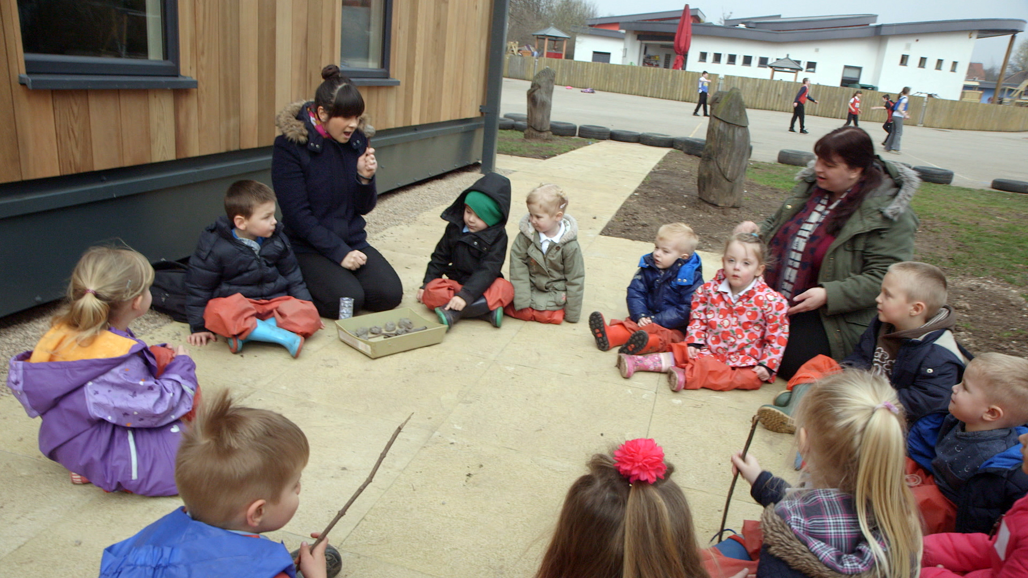
- Beyond the outdoor area, but within the school site, is a small piece of grassed land with a few trees and bushes. This is used as the early years ‘forest school’, where children play and learn, exploring the natural environment and solve problems that are set according to their particular needs. Some children were, for example, seeking out natural materials that were ‘rough, spiky, smooth, hard, soft, shiny’ because staff had realised, through assessments, that these children needed to develop their vocabulary.
- The school’s farm, an established feature of its grounds, is very popular with children. This small section of the site houses chickens, rabbits and goats. Children throughout the school take turns looking after the animals, feeding them and cleaning their cages. This supports children’s personal, social and emotional development as well as adding to their understanding of the world around them.

Into the community
A cornerstone of Netherfield’s strategy is its involvement with the local community. This starts when families first bring their children to the school. Home visits and regular transition events before children start in the nursery help staff to get to know the children.
But this is only half the story: opportunities to get to know families, their circumstances and their needs are regarded just as highly. Netherfield prides itself on how readily parents and other family members get involved. In a community where aspiration and achievement have been stubbornly low, the school is making a difference because it actively involves adults. For example:
- many adults have taken courses delivered in the familiar and secure setting of the primary school to get back into employment or further training
- families with a history of challenge come together for a shared weekly meal, which they take turns in preparing and serving
- families and their children, who often experience isolation in an otherwise busy community, enjoy high quality time both together and with others
- staff who attend such events follow up with help and support, including home visits and further activities that require continued, active participation.
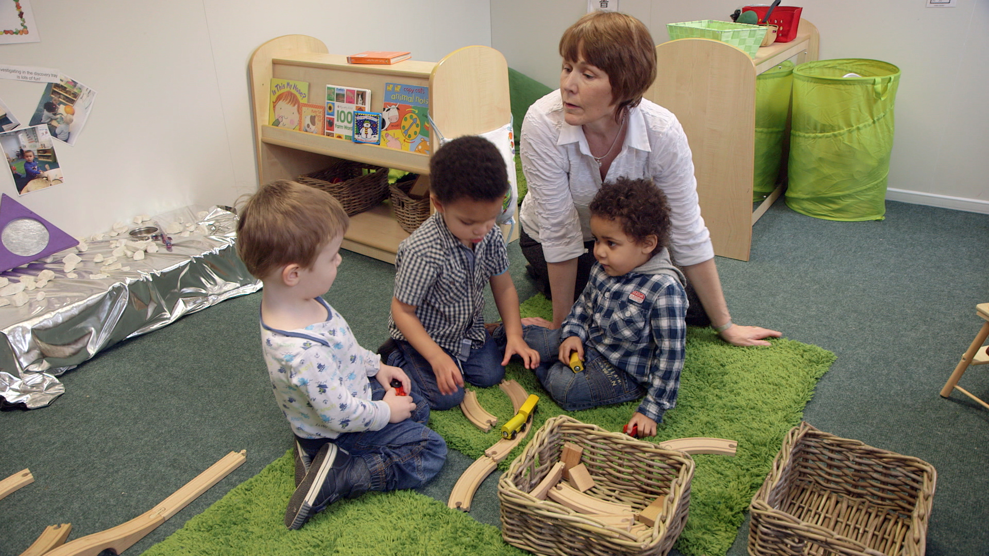

Parents and families in the community told the headteacher that they needed and wanted better care for two-year-olds. As a result, new provision – funded and provided by the school and located onsite – began operating in 2015.
Leaders are clear: this isn’t formal education. It is, however, an opportunity for the school to support families whose children will most benefit from high quality care. The unit for two-year-olds is staffed by two teaching assistants. The planning is overseen by a teacher whose aim it is to ensure that these children, the most vulnerable that the school serves, enter the nursery on an equal footing with the others. This means that children who have very poor levels of verbal communication are exposed to a rich and varied vocabulary. They have a diverse range of experiences and meet other children. ‘Progress is clear’, says the headteacher; ‘the language is coming, slowly but surely, and interactions that were almost exclusively non-verbal are now word-based.’
In summary, the learning environment is central to the team’s planning. It is the focal point of all that happens in the Early Years Foundation Stage. It is where the learning happens and is, rightly, centre stage.
The good practice case studies that Ofsted publishes highlight specific examples of practice that providers of education, learning and children’s services have used to achieve successful outcomes.
For education, the case studies do not recommend a single particular approach to teaching and learning. Ofsted has no preferred lesson structure or teaching style. We showcase and share a wide range of approaches that providers have found work well for them in achieving good outcomes for children, young people and learners.
Are you thinking of putting these ideas into practice; or already doing something similar that could help other providers; or just interested? We'd welcome your views and ideas. Complete our survey here.
Click here to see other good practice examples.
If you would like a copy of this document in a different format, such as large print or Braille, please telephone 0300 123 1231, or email enquiries@ofsted.gov.uk.

