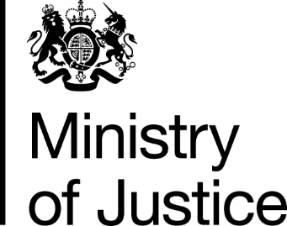

 | Our Reference: 107959 |  | November 2016

Freedom of Information Request

You asked for the following information from the Ministry of Justice (MoJ):

From the data provided regarding AGFS and LGFS closed cases for the years 2013-14 to 2015-16 please provide the number and total cost of those cases where the cost exceeded £1m.
From the data provided regarding Crime Crown court VHCC cases for the years 2013-14 and 2015-16 please provide the number and total cost of cases where the cost exceeded £1m.

Your request has been handled under the Freedom of Information Act 2000 (FOIA).

I can confirm that the department holds information that you have asked for, and I am pleased to provide this to you.

LGFS & AGFS
Closed cases (where total cost is over £1m)
 | Volume | LGFS | AGFS | Total costs
2013-2014 | 14 | £13,184,800 | £8,119,518 | £21,304,318
2014-2015 | 11 | £11,364,152 | £3,878,403 | £15,242,555
2015-2016 | 23 | £26,657,860 | £14,210,272 | £40,868,132
VHCC
Closed cases (where total cost is over £1m)
 | Volume | Total costs
2013-2014 | 32 | £88,026,898
2014-2015 | 11 | £56,743,488
2015-2016 | 3 | £18,109,847

Please note: the above costs include VAT and disbursements,
These are based on closed case volumes based on HMCTS case numbers, so multiple defendants are included within some cases and may have been dealt with at different times.
The Government has taken action to reduce legal aid expenditure. It has fallen by over 20% since 2010.
Anyone facing a Crown Court trial is eligible for legal aid, subject to a strict means test, but may be required to pay significant contributions - up to the entire cost of their defence.
The Government has cut the fees paid to lawyers in criminal legal aid cases, such as these, to ensure legal aid represents better value for the taxpayer.

You can also find more information by reading the full text of the Act (available at http://www.legislation.gov.uk/ukpga/2000/36/contents).

