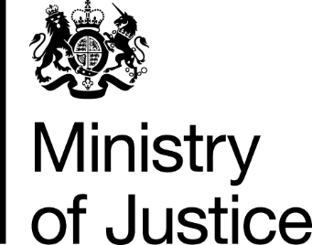
 | Our Reference: 455-16 FOI 107002 |  | September 2016

Freedom of Information Request

You asked for the following information from the Ministry of Justice (MoJ):

In recent years you have supplied me with data on rape prosecutions and conditions via a Freedom of Information request. Is it possible to initiate a new FOI request for the 2015 calendar year data on rape prosecutions and convictions by police force area?

Your request has been handled under the Freedom of Information Act 2000 (FOIA), and we apologise for the delay in response, which is due to administrative errors.

I can confirm that the Ministry of Justice holds the information that you have asked for and I am pleased to provide this to you.

The number of persons proceeded against at magistrates' courts and found guilty at all courts (along with conviction ratio) for rape offences, by police force area and plea, in England and Wales, in 2015, can be viewed in the table.

You can find out more about information held for the purposes of the Act by reading some guidance points we consider when processing a request for information, attached at the end of this letter.

You can also find more information by reading the full text of the Act, available at http://www.legislation.gov.uk/ukpga/2000/36/contents.

