UK standards for microbiology investigations

Conjunctivitis

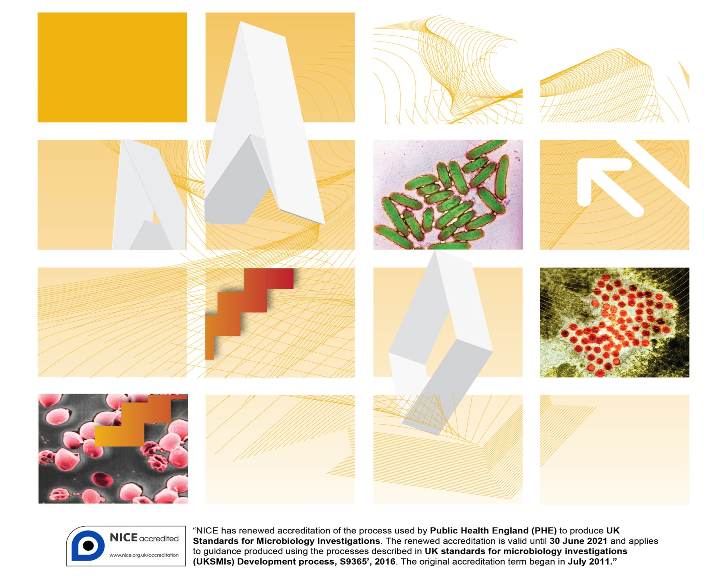

Acknowledgments

UK Standards for Microbiology Investigations (UK SMIs) are developed under the auspices of Public Health England (PHE) working in partnership with the National Health Service (NHS), Public Health Wales and with the professional organisations whose logos are displayed below and listed on the website <https://www.gov.uk/uk-standards-for-microbiology-investigations-smi-quality-and-consistency-in-clinical-laboratories>. SMIs are developed, reviewed and revised by various working groups which are overseen by a steering committee (see <https://www.gov.uk/government/groups/standards-for-microbiology-investigations-steering-committee>).

The contributions of many individuals in clinical, specialist and reference laboratories who have provided information and comments during the development of this document are acknowledged. We are grateful to the medical editors for editing the medical content.

For further information please contact us at:

Standards Unit

Microbiology Services

Public Health England

61 Colindale Avenue

London NW9 5EQ

E-mail: [standards@phe.gov.uk](mailto:standards@phe.gov.uk)

Website: <https://www.gov.uk/uk-standards-for-microbiology-investigations-smi-quality-and-consistency-in-clinical-laboratories>

PHE publication gateway number: 2016401

UK Standards for Microbiology Investigations are produced in association with:



Logos correct at time of publishing.

Contents

Acknowledgments 2

Contents 4

Amendment table 5

UK SMI: scope and purpose 6

User manual template - background 9

Introduction and scope 10

Overview of services offered 10

Locating and contacting the laboratory 10

Consent, collection and transport of specimens 11

Test repertoire 12

Reporting results 13

Interpreting laboratory results 13

Quality assurance and governance 14

Appendix 1: National user manual conjunctivitis 15

References 17



Amendment table

Each SMI method has an individual record of amendments. The current amendments are listed on this page. The amendment history is available from [standards@phe.gov.uk](mailto:standards@phe.gov.uk).

New or revised documents should be controlled within the laboratory in accordance with the local quality management system.

|  |  |
| --- | --- |
| Amendment number/date | New amendment number/dd.mm.yy <tab+enter> |
| Issue number discarded | xx |
| Insert issue number | #.# <tab+enter> |
| Anticipated next review date* |  |
| **Section(s) involved** | **Amendment** |
|  |  |

*Reviews can be extended up to five years subject to resources available.

UK SMI[1]#: scope and purpose

Users of SMIs

Primarily, UK SMIs are intended as a general resource for practising professionals operating in the field of laboratory medicine and infection specialties in the UK. UK SMIs also provide clinicians with information about the available test repertoire and the standard of laboratory services they should expect for the investigation of infection in their patients, as well as providing information that aids the electronic ordering of appropriate tests. The documents also provide commissioners of healthcare services with the appropriateness and standard of microbiology investigations they should be seeking as part of the clinical and public health care package for their population.

Background to SMIs

SMIs comprise a collection of recommended algorithms and procedures covering all stages of the investigative process in microbiology from the pre-analytical (clinical syndrome) stage to the analytical (laboratory testing) and post analytical (result interpretation and reporting) stages. Syndromic algorithms are supported by more detailed documents containing advice on the investigation of specific diseases and infections. Guidance notes cover the clinical background, differential diagnosis, and appropriate investigation of particular clinical conditions. Quality guidance notes describe laboratory processes which underpin quality, for example assay validation.

Standardisation of the diagnostic process through the application of SMIs helps to assure the equivalence of investigation strategies in different laboratories across the UK and is essential for public health surveillance, research and development activities.

Equal partnership working

UK SMIs are developed in equal partnership with PHE, NHS, Royal College of Pathologists and professional societies. The list of participating societies may be found at <https://www.gov.uk/uk-standards-for-microbiology-investigations-smi-quality-and-consistency-in-clinical-laboratories>. Inclusion of a logo in an SMI indicates participation of the society in equal partnership and support for the objectives and process of preparing UK SMIs. Nominees of professional societies are members of the Steering Committee and working groups which develop UK SMIs. The views of nominees cannot be rigorously representative of the members of their nominating organisations nor the corporate views of their organisations. Nominees act as a conduit for two way reporting and dialogue. Representative views are sought through the consultation process. UK SMIs are developed, reviewed and updated through a wide consultation process.

Quality assurance

NICE has accredited the process used by the UK SMI working groups to produce SMIs. The accreditation is applicable to all guidance produced since October 2009. The process for the development of UK SMIs is certified to ISO 9001:2008. UK SMIs represent a good standard of practice to which all clinical and public health microbiology laboratories in the UK are expected to work. SMIs are NICE accredited and represent neither minimum standards of practice nor the highest level of complex laboratory investigation possible. In using SMIs, laboratories should take account of local requirements and undertake additional investigations where appropriate. SMIs help laboratories to meet accreditation requirements by promoting high quality practices which are auditable. SMIs also provide a reference point for method development. The performance of SMIs depends on competent staff and appropriate quality reagents and equipment. Laboratories should ensure that all commercial and in-house tests have been validated and shown to be fit for purpose. Laboratories should participate in external quality assessment schemes and undertake relevant internal quality control procedures.

Patient and public involvement

The SMI working groups are committed to patient and public involvement in the development of SMIs. By involving the public, health professionals, scientists and voluntary organisations the resulting SMI will be robust and meet the needs of the user. An opportunity is given to members of the public to contribute to consultations through our open access website.

Information governance and equality

PHE is a Caldicott compliant organisation. It seeks to take every possible precaution to prevent unauthorised disclosure of patient details and to ensure that patient-related records are kept under secure conditions. The development of SMIs is subject to PHE Equality objectives <https://www.gov.uk/government/organisations/public-health-england/about/equality-and-diversity>.

The SMI working groups are committed to achieving the equality objectives by effective consultation with members of the public, partners, stakeholders and specialist interest groups.

Legal statement

While every care has been taken in the preparation of SMIs, PHE and the partner organisations, shall, to the greatest extent possible under any applicable law, exclude liability for all losses, costs, claims, damages or expenses arising out of or connected with the use of an SMI or any information contained therein. If alterations are made by an end user to an SMI for local use, it must be made clear where in the document the alterations have been made and by whom such alterations have been made and also acknowledged that PHE and the partner organisations shall bear no liability for such alterations. For the further avoidance of doubt, as SMIs have been developed for application within the UK, any application outside the UK shall be at the user’s risk.

The evidence base and microbial taxonomy for the SMI is as complete as possible at the date of issue. Any omissions and new material will be considered at the next review. These standards can only be superseded by revisions of the standard, legislative action, or by NICE accredited guidance.

SMIs are Crown copyright which should be acknowledged where appropriate.

Suggested citation for this document

Public Health England. (YYYY <tab+enter>). National user manual template conjunctivitis. UK Standards for Microbiology Investigations. U # <tab+enter> Issue #.# <tab+enter>. <https://www.gov.uk/uk-standards-for-microbiology-investigations-smi-quality-and-consistency-in-clinical-laboratories>

User manual template - background

The user manual template has been developed by an SMI joint working group of microbiologists. The document aims to help microbiology service providers produce a comprehensive user manual meeting the current ISO standards. The ISO standards should be used in conjunction with this template1. Duplications within the document are intended to emphasise key points. The document should be considered a template, with suggested headings providing the basis on which individual labs or services can develop their own user manual.

The suggested ordering and content of this user manual can be changed but we recommend all suggested content remains included, for example, it may be possible to encompass many elements in a single hyperlinked table of services and tests offered.

The microbiology service provider’s user manual is intended as a general resource for practising healthcare professionals.

It is recommended that user manuals are made available to general practitioners through their local Clinical Commissioning Group (CCG). Although not intended for public and patient groups, they may find the user manual a useful source of information.

The use of plain English is recommended.

Introduction and scope

Conjunctivitis is the inflammation of the conjunctiva. There are two main types of

conjunctivitis – allergic and infective.

Allergic conjunctivitis occurs when the immune system of the body attacks something that is not an infectious agent, such as pollen or make-up, causing inflammation.

Infective conjunctivitis is caused by several different types of viruses, bacteria, or fungi infecting the eye. Symptoms of conjunctivitis include hyperaemic red conjunctiva and a profuse mucopurulent discharge. Conjunctivitis is sometimes called pink eye. Features such as the clinical appearance of the eye, the age of the patient, and the exposure history should be taken into account in assessing the likely cause of this condition.

In most scenarios there is no requirement to test, however conjunctivitis can be a feature of systemic illness (notably measles)2,3.

Overview of services offered

You should include:

* detail of basic services (diagnostic testing, clinical advice, infection control, infectious diseases, outbreak management, antibiotic stewardship, etc)
* listing of specialist areas, for example, regional or national reference facilities and provision of immunoglobulins and vaccines

Locating and contacting the laboratory

You should include:

* location maps for both outside and inside the hospital (or links to the relevant source)
* specimen reception opening times and out of hours contact instructions
* instructions on making enquiries for results and requests for additional tests on existing samples
* availability of clinical advice on ordering of examinations and interpretation of examination results
* details of any out-of-hours service or shift system at the laboratory. Outline which services will always be provided and which will only be provided after consultation
* contact details for key members of staff including availability times, email addresses of key members of staff, how to obtain results and clinical advice for out of hours service
* whether the public has access to the laboratory or not and where phlebotomy (and paediatric phlebotomy) services are located
* clear advice to patients on how to obtain results; explain whether patients should or should not call the laboratory directly for results – indicating consideration of data security and clinical risk

Consent, collection and transport of specimens

You may wish to include generic advice on collecting and transporting specimens such as:

* instructions for preparation for sample collection (for example, for caregivers, phlebotomists, sample collectors and patients)
* instructions on how to determine the identity of the patient from whom a sample is collected. Follow local policy on patient identification
* verifying and recording that pre-examination requirements, for example, medication status (time of last dose or cessation) or predetermined sample collection times (or time intervals) are fulfilled
* procedures for the safe collection and handling of primary samples, including appropriate health and safety advice on labelling and transporting high risk samples, such as those containing radioactive isotopes. Information for users? on whether certain samples should be regarded as high risk should be clear. Universal precautions should be recommended
* instructions for sample collectors, including instructions for patient-collected samples, for example: type and amount of the primary sample(s) to be collected; descriptions of the primary sample containers (pictures may be helpful) and any necessary additives; special timing of collection, where needed; how and where to provide clinical information relevant to or affecting sample collection, test performance or result interpretation (for example, drug dosages and timings); information on how to order supplies of the relevant containers, forms, labels etc. This may be displayed in table format or images/pictures and may be linked or cross referenced to patient information sheets
* information on the appropriate amount of specimens required for multiple requests (this may be automatically calculated by electronic test order software)
* instructions for labelling of primary samples in a manner that provides an unequivocal link with the patients from whom they are collected
* the identity of the person collecting the primary sample, the collection date and, when needed, the collection time. True collection times should be mentioned and documented accordingly
* instructions for the safe disposal of materials used in the collection
* instructions for proper storage conditions and maximum times for storage before collected samples are delivered to the laboratory and in a manner that ensures the integrity of the sample and safety for the carrier, general public and receiving laboratory, in compliance with established requirements. You should refer to the applicable ISO standard
* instructions for transportation of samples, including any special handling needs (such as high risk samples, radioactive isotopes, samples on dry ice). You may wish to describe specific or defined details of the transport times as well as cut off times for receipt at individual laboratories, if applicable
* laboratory’s criteria for accepting and rejecting samples

Also, if applicable, this section may provide information directly for patients, such as: any specific requirements for patient consent (for example, consent to disclose clinical information and family history to relevant healthcare professionals); a link to the relevant organisation’s consent policy; an explanation of any clinical procedure to be performed with links to patient information sheets; receipt of sample implies consent to test and that any information provided may be transmitted onwards for further referral work in line with the Caldicott and Control of Infectious Diseases guidelines; the principle that additional tests not directly requested may be performed by the laboratory if such tests aid interpretation of the initial test result (also known as reflex testing).

Test repertoire

|  |  |  |  |  |
| --- | --- | --- | --- | --- |
| **Conjunctivitis** |  |  |  |  |
|  |  | **First line investigation** | **Second line** | **Notes** |
| Neonate (under 28 days old) |  | *C.trachomatis* - Chlamydia eye swab for NAAT (see laboratory specific testing kit instructions) |  | *Can put CKS info in here*; Viral infection rare, however, suspected neonatal HSV should trigger urgent paediatric referral.  *N.gonorrhoeae* NAAT is also available in most laboratories undertaking *C. trachomatis* NAAT.  If *C. trachomatis* or *N. gonorrhoeae* detected, mother and her sexual contacts should be offered testing. |
|  |  | Bacterial eye swab – *N .gonorrhoeae, S. pneumoniae, S. pyogenes, S. aureus* |  | Bacterial eye swab local laboratory information on swab types/ medium |
| Not neonate- uncomplicated suspected infective conjunctivitis |  | Bacterial eye swab –*N. gonorrhoeae, S. pneumoniae, S. pyogenes, S. aureus,M. catarrhalis, H. influenzae* etc | Chlamydia eye swab –  *C. trachomatis* | Rare –  *P. aeruginosa, C. diphtheriae, C. albicans*  *Consider BASHH guidelines on NAAT for non-genital samples; mention genital or urine testing if sexual transmission suspected* |
|  |  | Viral eye swab -adenovirus/HSV | Viral eye swab, lesion swab – VZV, enterovirus; lesion | Haemorrhagic conjunctivitis -enterovirus 70, 71 and coxsackievirus A24, B2  Adenovirus 8,19 – associated with keratoconjunctivitis including outbreaks  Notify laboratory if an outbreak is suspected. |
| Conjunctivitis as a feature of systemic illness |  | Depends on illness- see sections on rash……..*In some of these, eye swab will detect pathogen, some not* |  |  |
|  |  |  |  |  |
| Amoebic conjunctivitis |  | *Acanthamoeba –* culture/detection. |  | Rare- suspected mainly in contact lens wearers |
| Specific conditions |  | Molluscum contagiosum - EM/PCR of vesicle material |  | Call laboratory? |
|  |  | Papillomavirus 6,11 – Swab/ biopsy for NAAT |  | Call laboratory |

You should include the following:

* examinations offered by the laboratory. Include logical listings or tables of tests and turnaround times), primary sample volumes, specific specimen containers, special precautions, and procedures for medico-legal samples
* details of relevant clinical algorithms, with links to local or national policies
* lists of referred tests, including the names, addresses and accreditation status of laboratories to which work is routinely referred
* a table to state the duration of storage for samples that may need re-testing, with information on disease incubation periods, testing interval and time limits for requesting additional tests

You may also wish to include information on the costs of tests.

Reporting results

You should include the following:

* provide instructions for making result enquiries
* advice to review electronic reporting systems before phoning for results
* explanation of different report status categories (interim, final, amended)

Interpreting laboratory results

You should include relevant information on:

* biological reference intervals or clinical decision values (document their basis)
* a list of factors known to significantly affect the performance of the examination (uncertainty of measurement) or the interpretation of the results
* performance characteristics – sensitivity/specificity of the tests

You may wish to include:

* pitfalls of serology, PCR, culture etc. As well as having such things embedded within individual tests, consider a brief explanation of passively acquired antibody, cross reactivities for IgM assays and the effects of sample quality

Quality assurance and governance

You should include details of:

* the quality assurance and governance structure for the laboratory
* the complaints procedure
* the laboratory’s policy on protection of personal information; and the fax and email policy
* ensure that the manual is consistent with ISO15189 guidance (reference the ISO guidance in this section)1
* a statement on the accreditation status, link to the accreditation body, and list of which (if any) tests are excluded from the accredited scope of practice (accreditation status of test repertoire)
* how to obtain validation/verification data
* compliance with Human Tissue Act

Appendix 1: National user manual conjunctivitis



Footnotes

* 1. Also refer to [B 2 Investigations of Eye Swabs and Canalicular Pus](http://www.hpa.org.uk/smi/pdf/bacteriology), [B 28 – Investigation of Genital Tract and Associated Specimens](http://www.hpa.org.uk/smi/pdf/bacteriology), [V 21 – Isolation of Viruses Associated with Infections of the Eye: Keratoconjunctivitis](http://www.hpa.org.uk/smi/pdf/virology), [V 37 – Chlamydia Infection – Testing by Nucleic Acid Amplification Test (NAATS)](http://www.hpa.org.uk/smi/pdf/virology)
  2. Only carried out if shingles is indicated in the clinical details

References

1. European committee on Standardization. Medical laboratories - Requirements for quality and competence (ISO 15189:2012). British Standards Institution. 1-50. 2012.

2. Royal College of General Practitioners. Management of infective conjunctivitis in primary care. 1-5. 2014.

3. The Royal College of Opthalmologists. Commissioning better eye care. 1-17. 2013.

1. # Microbiology is used as a generic term to include the two GMC-recognised specialties of Medical Microbiology (which includes Bacteriology, Mycology and Parasitology) and Medical Virology.