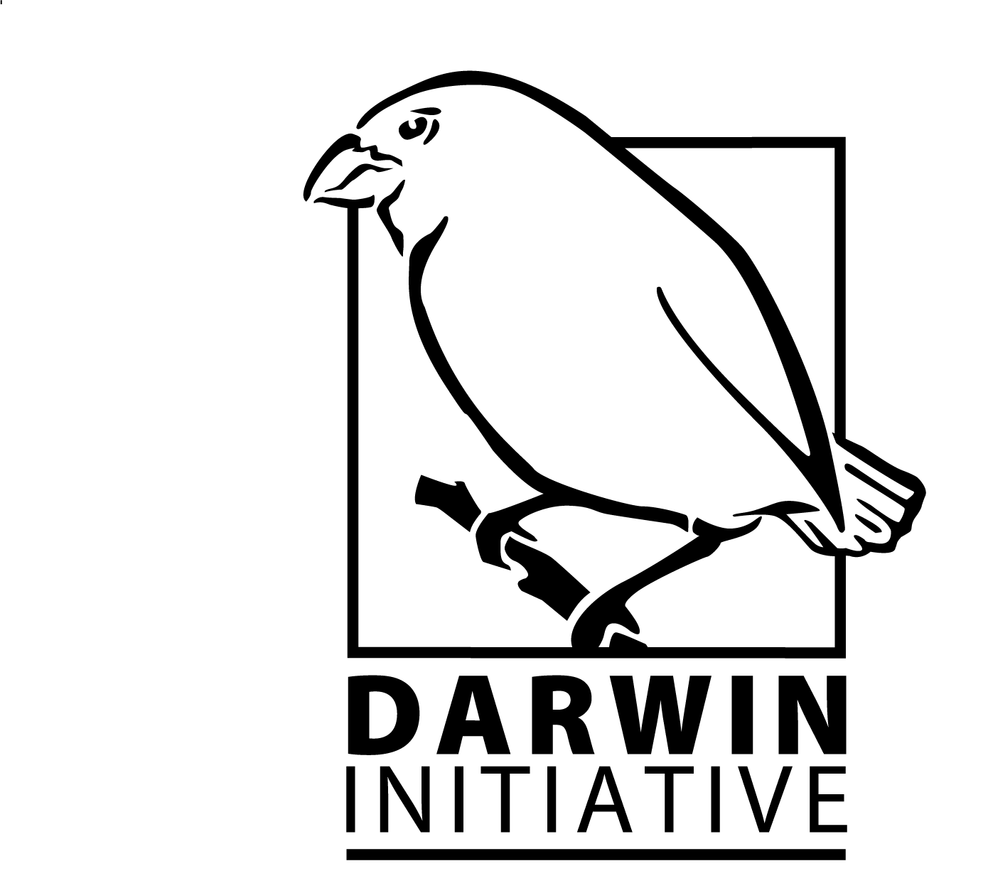

Submit by Wednesday 10 August 2016

DARWIN INITIATIVE APPLICATION FOR GRANT For Round 23: STAGE 1
Please read the Guidance before completing this form.
Information to be extracted to the database is highlighted blue. Blank cells may render your application ineligible
Office use only | Date logged: | Init: | Consultant ID:

Name of Project Leader and main contact |  | Applicant Organisation Name:
(notification of results will be by email to this person)

Address: |  | Address:
City: |  | City:
Postcode: |  | Postcode:
Country: |  | Country:
Email: |  | Email:
Phone: |  | Phone:

Project title (not exceeding 10 words):

Project Description (not exceeding 50 words):

Host country/ies:  Country 1:  Country 2: |  |  |  | Other collaborating country/ies:  Country 1:  Country 2:
Start date: |  | End date: |  |  |  | Duration (in years):
Darwin funding request  (Apr – Mar) | 2017/18  £ |  | 2018/19  £ |  | 2019/20  £ | 2020/2021  £ | Total  £
Indicative matched funding as % of full project cost:
What matched funding arrangements are proposed? If none, please explain why.

Have you ever applied for Scoping funding for this project? | Yes/No
Year of Scoping application and reference if known
Was your application successful? If yes, attach your report | Yes/No
Is this a resubmission of a previously unsuccessful application? | Yes/No
Year and stage of application
Application number if known

List the partner organisations and briefly outline their involvement in the project to date: (Max 150 words)

No. of people to be employed on the project from LDCs/lower/lower middle income country/ies (more than 10% of their time):
No. of people to be employed by the project in developed countries (more than 10% of their time on the project):

1. Problem the project is trying to address
Please describe the problem your project is trying to address in terms of biodiversity and its relationship with poverty. For example, what are the drivers of loss of biodiversity that the project will attempt to address? Why are they relevant, for whom? How did you identify these problems?
If your project is working on an area of biodiversity or biodiversity-development linkages that has had limited attention (both in the Darwin Initiative portfolio and in conservation in general) please give details.
(max 300 words)

2. Outcome statement
Please insert the outcome statement here copied directly from your logframe
(Max 30 words)

3. Biodiversity conventions
Your project must support the objectives of one or more of the agreements listed below. Please indicate which agreement(s) will be supported and describe which objectives your project will address and how. Note: projects supporting more than one will not achieve a higher score.
Convention on Biological Diversity (CBD) | Yes/No
Nagoya Protocol on Access and Benefit Sharing (ABS) | Yes/No
International Treaty on Plant Genetic Resources for Food and Agriculture (ITPGRFA) | Yes/No
Convention on International Trade in Endangered Species (CITES) | Yes/No
Global Goals for Sustainable Development | Yes/No
(Max 300 words)

4. Methodology
Describe the methods and approach you will use to achieve your intended outcomes and impact. Provide information on how you will undertake the work (materials and methods) and how you will manage the work (roles and responsibilities, project management tools etc.).
(Max 500 words)

5. Change Expected
Detail the expected changes this work will deliver. You should identify what will change and who will benefit a) in the short-term and b) in the long-term.
(Max 300 words)

6. LOGICAL FRAMEWORK
Darwin projects will be asked to report against their progress towards their expected outputs and outcomes if funded. This section sets out the expected outputs and outcomes of your project. Further detail is provided in Annexes E and F of the guidance which you are encouraged to refer to. The use of the logical framework is sometimes described in terms of the Logical Framework Approach, which is about applying clear, logical thought when seeking to tackle the complex and ever-changing challenges of poverty and need. In other words, it is about sensible planning.

For Stage 1 we require a broad understanding of what you expect to achieve and how you will measure that. At Stage 2 you will be expected to provide much more detail and complete a logframe down to activity level.
Project summary | Measurable Indicators | Means of verification | Important Assumptions
Impact:
(Max 30 words)
Outcome:  (Max 30 words) | 0.1  0.2  etc. | 0.1  0.2  etc.
Outputs:  1. | 1.1  1.2  etc. | 1.1  1.2  etc.
2.

3.
4.

I certify that, to the best of my knowledge and belief, the statements made in this application are true and the information provided is correct and that I have the authority to submit an application on behalf of my organisation.

Name (block capitals):

Position in organisation:

Signed:

Dated:

If this section is incomplete the entire application will be rejected. You must provide a real (not typed) signature. You may include a pdf of the signature page for security reasons if you wish. Please write PDF in the signature section above if you do so.
Stage 1 Application - Checklist for submission

Check
Have you read the Guidance?
Have you read and can you meet the current Terms and Conditions for this fund?
Have you provided actual start and end dates for your project?
Have you provided your budget based on UK government financial years ie 1 April – 31 March? NB: we do not require the budget spreadsheet at this stage.
Have you checked you are within the word limits?
Has your application been signed?
If you received a relevant Scoping Award, have you included the report with this application?
Have you checked the Darwin website immediately prior to submission to ensure there are no late updates?
Do not include letters of support or CVs with this application.

Once you have answered Yes to the questions above, please submit the application in Word format, not later than 2359 GMT on Wednesday 10 August 2016 to
Darwin-Applications@ltsi.co.uk using the title of the project (or first few words) as the subject of your email. You do not need to send a hard copy.

DATA PROTECTION ACT 1998: Applicants must agree to any disclosure or exchange of information supplied on the application form (including the content of a declaration or undertaking) which the Department considers necessary for the administration, evaluation, monitoring and publicising of the Darwin Initiative. Application form data will also be held by contractors dealing with Darwin Initiative monitoring and evaluation. It is the responsibility of applicants to ensure that personal data can be supplied to the Department for the uses described in this paragraph. A completed application form will be taken as an agreement by the applicant and the grant/award recipient also to the following:- putting certain details (ie name, contact details and location of project work) on the Darwin Initiative and Defra websites (details relating to financial awards will not be put on the websites if requested in writing by the grant/award recipient); using personal data for the Darwin Initiative postal circulation list; and sending data to Foreign and Commonwealth Office posts outside the United Kingdom, including posts outside the European Economic Area. Confidential information relating to the project or its results and any personal data may be released on request, including under the Environmental Information Regulations, the code of Practice on Access to Government Information and the Freedom of Information Act 2000

