This document was archived in June 2016 because it is no longer current.

Supporting the ‘hard to reach’: Kensington Children’s Centre

URN: 21650
Local authority: Liverpool
Date published: 8 January 2013
Reference: 130003
Brief description

Kensington Children’s Centre provides an impressive range of services and activities which encourages high rates of participation from the local community and reaches those most in need of intervention and support. Parents and carers attend with their children because the centre actively seeks their views and provides services that are carefully matched to their interests and needs.
Overview – the centre’s message

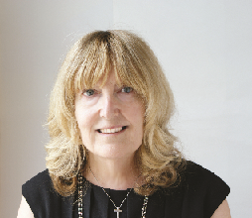
‘We have a number of strategies to assess people’s starting points when they engage with the centre. At the same time we make best use of local intelligence about the needs of the area from the data sets that are available to us. These help to inform our programme.

Activities are grouped to maximise participation. For example, establishing a creative arts group alongside parenting courses so that parents and carers can develop confidence and personal skills in a different environment from the focused parenting programme, and having opportunities to grow in their own right as an adult.
We also track and record parents’ and carers’ progress which complement the processes used with children as part of the Early Years Foundation Stage framework. The learning gained from this helps us to know what is working and what we have to change.’
Lyn Carey, Centre Manager
The good practice in detail

‘What can we do for you?’
Local authority representative Hazel Patterson describes the centre’s ability and willingness to respond to parents’ and carers’ wishes, opinions and interests as one of the primary reasons that attendance rates are so high.
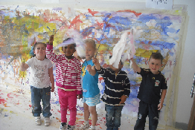
The centre has developed its own accredited learning resources as well as providing an extensive range of parenting programmes and easy access to a wide range of adult learning courses. Some 97% of all families living in the local area with children under five years old have registered with the centre. Last year the centre doubled the local authority’s target for attendance over the year with an active registration of 77%. In the most deprived lower super output area this proportion was higher, with over 96% of families taking part in the centre’s activities and support programmes.
The range of parenting programmes on offer allows parents and carers to progress from one course to the next to sustain and build on their learning. In addition to the ‘Incredible Years’ 14-week course, the centre offers a six-week ‘Your child and you’ parenting course, an advanced ‘Incredible Years’ course and a baby and toddler parenting programme. Referrals through the Common Assessment Framework and case conferences can select the most effective programme based on the family’s particular needs. A measure of the centre’s success in matching services to needs is that increasingly courts are referring directly to the parenting programmes and the centre has also seen an increase in self-referral from families.
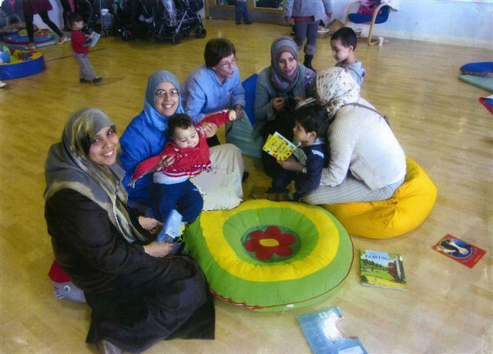
A range of courses for those who speak English as a second or other language (ESOL), provided in conjunction with Adult Learning Services and Liverpool Community College, helps to develop parents’ and carers’ English skills from beginners’ sessions upwards. Around three quarters of families in the area are from minority ethnic heritages and are learning to speak English as an additional language. In any single week there are 14 different ESOL classes take place at the centre, with parenting programmes delivered by tutors who are fluent in a range of languages.
The centre’s support for families from minority ethnic backgrounds has developed to include a wide range of services and activities from helping families to access local health and education settings to encouraging parents and carers to support their children’s learning and development.
A range of learning opportunities
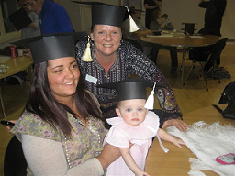
Kensington Children’s Centre has gained approval to deliver National Open College Network (NOCN) validated courses and qualifications as well as accredited City and Guilds courses in a range of subjects including health and social care; foundation for learning and life; child development; and preparation for work. As a result the centre can offer a wide range of opportunities for parents and carers to learn in small groups in an informal setting close to their homes. One parent explained, ‘I have attended so many courses here and they have all offered opportunities for me to learn new skills and knowledge.’ Another reason for the high levels of attendance is that while parents and carers are studying, their children are enjoying high-quality crèche provision in the same building. The result is that parents and carers, many with few previous academic qualifications, have obtained over 70 accreditations and qualifications in the last year alone.
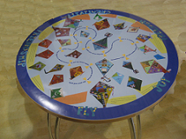
Creative art sessions have developed and broadened in response to parents’ and carers’ wishes over the years. A regular arts and crafts session has evolved into a weekly therapeutic ‘Arts and Minds’ course. Art sessions are beneficial in developing parents’ and carers’ overall well-being and raise their self-confidence. One parent described how the course ‘keeps my mind occupied and gives me hope’. The sessions have helped to break down the barriers between members of the local community and new arrivals into the area by providing an insight into the reasons that families have moved into the city. The centre’s internal café tables are adorned with displays of artwork produced at the centre. On one table, colourful and detailed images of kites include moving written accounts of relocation. These convey a number of personal stories that describe the circumstances of trauma, famine and persecution experienced by different families in their place of birth, which ultimately led to their arrival in Liverpool.
In partnership with the Tate Gallery in Liverpool, children and families recently attended workshops at the gallery and are working towards producing an exhibition of art work next year.
Other creative initiatives include a link with Liverpool Philharmonic Orchestra, which has provided children and families with opportunities to listen to a range of classical instruments. ‘Tuning into children’ is a 10-week programme where children experiment with the instruments, develop musical and creative skills and learn nursery rhymes to the accompaniment of classical instruments.
Careful planning with explicit learning descriptors and course content, matched to the Adult Literacy core curriculum content, underpins many of the centre’s programmes. Much of the adult provision is mapped to an accreditation framework through Open Awards which allows the centre to work to a learning outcomes model. To capture wider aspects of progression, they use Learning Journeys to record individual progress.
The centre’s background

Kensington Children’s Centre opened in 2004 and moved to its present site in 2005. The centre is situated in an area with high levels of deprivation. Of the eight super output areas that fall in the centre’s catchment, three quarters are classified in the lowest 5% and four in the lowest 2% nationally.
A diverse range of minority ethnic groups live in the local area and over three quarters of these do not use English as their first language. A fifth of minority ethnic families are of Chinese origin and a fifth of African origin.
Are you thinking of putting these ideas into practice; or already doing something similar that could help other providers; or just interested? We'd welcome your views and ideas. Get in touch here.
To view other good practice examples, go to: www.ofsted.gov.uk/resources/goodpractice

