This document was archived in June 2016 because it is no longer current.

Improving employability skills: The Bassetlaw Training Agency Limited

URN: 54810
Area: Nottinghamshire
Date published: 30 May 2013
Reference: 130163
Brief description

Work experience and the development of employability skills are often seen as weaker areas for learners on Foundation learning programmes. This example explains how Bassetlaw Training Agency (BTA) has taken robust action to ensure that all learners are encouraged to develop these skills from the very first day of their programme. The curriculum successfully prepares learners for progression into workplace learning by offering individual programmes and qualifications to support employability skills.

Overview – the provider’s message


‘In the past we focussed too much on providing care and support for our learners. But the change of programme from Entry to Employment to Foundation learning provided the impetus to bolster the work experience element of the programme. We decided to build on the success of work experience placements in relation to each learner’s personal and professional progression.
We already had strong links with employers from diverse sectors such as retail, charity shops, hairdressing, care for the elderly and child care, catering, landscape gardening, business administration and engineering. We use our database of around 500 placements to provide work experience that suits the needs of the learners, is easily accessible and is based on their interests, hobbies and abilities.
We trust our learners and expect them to achieve high standards. Most do not let us down and rise to the challenge.’
Sylvia Lilley, Managing Director
The good practice in detail

Foundation learning programme
Foundation learning at BTA is a flexible programme with mandatory work placements for all learners regardless of their background, barriers or job-readiness. Learners enrol at any time of the year. Soon after the referral and the initial assessment, an individual learning plan is developed. Learners are quickly matched to a placement that meets their vocational aspirations. They can start the placement from the beginning of the programme and work for as little as half a day to up to three days per week.

Personal and social skills development is the core of the programme. Learners develop employability skills alongside their academic qualifications. The most vulnerable learners are offered several short-term placements to build their confidence. For example, a learner with very poor reading skills attended seven placements starting at a charity retail shop before she acquired full-time employment with a national clothing store. She is now a valued member of staff and acts as a role model and mentor to other learners.
Our philosophy is that the development of confidence and employability skills is a fundamental starting point for all learners. Jan Hughes, Foundation Learning Coordinator
Detailed initial assessment is used well to establish accurate starting points. Learners are carefully matched with the employers who offer work that matches their vocational interests. Most have the choice of a range of placements to support the development of their confidence and skills. Placements are arranged within the first couple of weeks of the induction programme. Clear targets are set in their individual learning plans to develop soft skills related to employability and learning objectives in their work place. Employers are well prepared to support learners and play an integral part in the learning and development of individuals. Their responsibilities and the learners’ expectations are clearly outlined in a detailed placement providers’ handbook. BTA works with the employers to set individual targets for learners at reviews, which take place on a fortnightly or monthly basis.
All learners are placed with an employer as soon as possible after initial assessment and enrolment on the Foundation learning programme. Learners can explain with conviction their journey from low academic achievement, difficult personal circumstances and disruptive schooling to positive progression to higher levels of learning and employment. They are well respected in the work place and employers comment favourably on the preparation that had taken place to support the placement.
How learners benefit
Learners benefit enormously from the work experience element of their programme. Some of the benefits after six months’ work experience are:
- a clear structure – the learners forward plan and develop a structure to their lives, focussing on subjects such as what to wear, time management and travel planning
- improved work skills – such as using a till, organising a display, organising activities for nursery children and following instructions
- better motivation – learners understand that they are relied upon to attend and that others value their participation at work
- self-reflection – they learn how they would do things differently next time and how the job could be carried out more effectively
- improved communication skills – the programme builds learners’ language in different situations such as with work colleagues, customers, workplace supervisors, children and their parents and carers
- appropriate behaviour – learners become more mature in their approach and their behaviour as a valued member of the team
- improved social skills – they form more mature relationships with others
- greater confidence and self-belief – learners believe that they are capable of achieving and that others value them, which leads to raised levels of confidence and self-esteem.

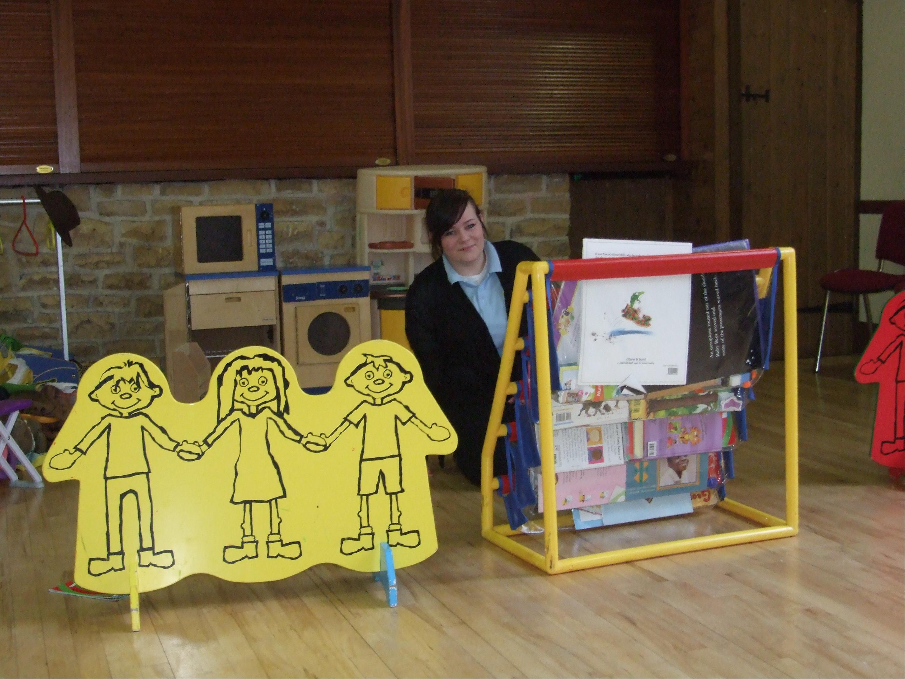
Case study: Alice

Case study: Oliver

Alice joined BTA on the Foundation Learning Programme. She did not like school and was persistently absent. Alice was placed into a private day nursery for two months and then she moved on to a nursery nearer her home. She achieved an NVQ Level 1 in childcare and is currently working towards her Level 2 qualification. She hopes to join an apprenticeship and complete her Level 3.

Oliver was diagnosed with ODD (disability to learn) and suffers from epileptic fits and Autistic Spectrum Disorder. He was excluded from school a number of times. At BTA, Oliver’s behaviour improved dramatically and he attended the majority of classes. He achieved his English Entry Level 2 Functional Skills and is currently working on his maths Entry Level 3 functional skills.

Provider background

The Bassetlaw Training Agency Ltd is based in Worksop. The company also owns and operates a childcare establishment in the area. The immediate area is one of the most deprived in the country with high youth unemployment and low levels of qualifications among the population.
Related good practice case studies

Community Training Services Limited
Economic Solutions Limited (Skills Solutions)
Roots and Shoots Limited
Are you thinking of putting these ideas into practice; or already doing something similar that could help other providers; or just interested? We'd welcome your views and ideas. Get in touch here.
To view other good practice examples, go to: www.ofsted.gov.uk/resources/goodpractice

