UK Standards for Microbiology Investigations

Investigation of Viral Encephalitis

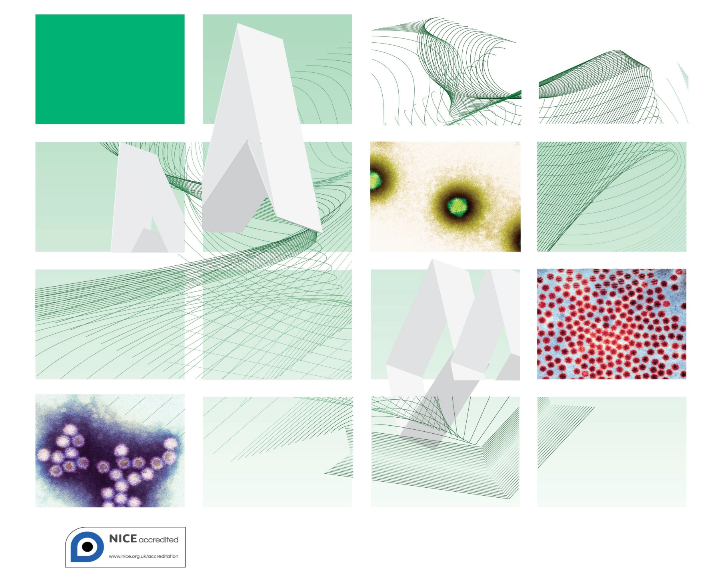

Acknowledgments
UK Standards for Microbiology Investigations (SMIs) are developed under the auspices of Public Health England (PHE) working in partnership with the National Health Service (NHS), Public Health Wales and with the professional organisations whose logos are displayed below and listed on the website https://www.gov.uk/uk-standards-for-microbiology-investigations-smi-quality-and-consistency-in-clinical-laboratories. SMIs are developed, reviewed and revised by various working groups which are overseen by a steering committee (see https://www.gov.uk/government/groups/standards-for-microbiology-investigations-steering-committee).
The contributions of many individuals in clinical, specialist and reference laboratories who have provided information and comments during the development of this document are acknowledged. We are grateful to the Medical Editors for editing the medical content.
For further information please contact us at:
Standards Unit
Microbiology Services
Public Health England
61 Colindale Avenue
London NW9 5EQ
E-mail: standards@phe.gov.uk
Website: https://www.gov.uk/uk-standards-for-microbiology-investigations-smi-quality-and-consistency-in-clinical-laboratories
UK Standards for Microbiology Investigations are produced in association with:
Logos correct at time of publishing.
Contents
Acknowledgments 2
Amendment Table 5
UK Standards for Microbiology Investigations: Scope and Purpose 6
Scope 9
Investigation of Viral Encephalitis 10
Notification to PHE or Equivalent in the Devolved Administrations 12
References 13

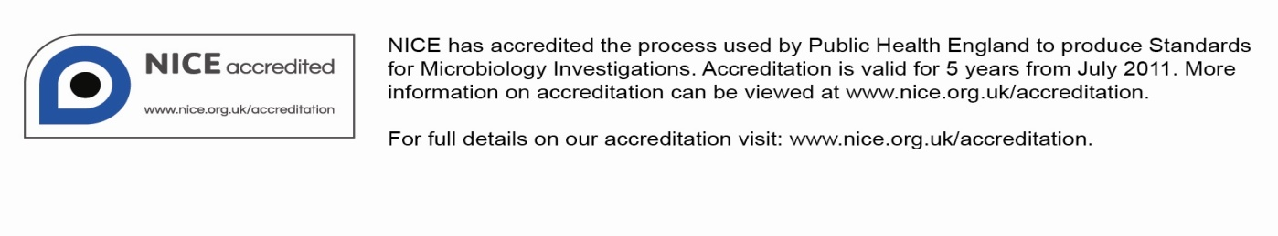
Amendment Table
Each SMI method has an individual record of amendments. The current amendments are listed on this page. The amendment history is available from standards@phe.gov.uk.
New or revised documents should be controlled within the laboratory in accordance with the local quality management system.
Amendment No/Date. | 4/dd.mm.yy <tab+enter>
Issue no. discarded. | 2.3
Insert Issue no. | #.# <tab+enter>
Section(s) involved | Amendment

Amendment No/Date. | 3/16.04.14
Issue no. discarded. | 2.2
Insert Issue no. | 2.3
Section(s) involved | Amendment
Whole document. | Document has been transferred to a new template to reflect the Health Protection Agency’s transition to Public Health England.  Front page has been redesigned.  Status page has been renamed as Scope and Purpose and updated as appropriate.  Professional body logos have been reviewed and updated.  Standard safety and notification references have been reviewed and updated.  Scientific content remains unchanged.

UK Standards for Microbiology Investigations#: Scope and Purpose
Users of SMIs
- SMIs are primarily intended as a general resource for practising professionals operating in the field of laboratory medicine and infection specialties in the UK.
- SMIs provide clinicians with information about the available test repertoire and the standard of laboratory services they should expect for the investigation of infection in their patients, as well as providing information that aids the electronic ordering of appropriate tests.
- SMIs provide commissioners of healthcare services with the appropriateness and standard of microbiology investigations they should be seeking as part of the clinical and public health care package for their population.
Background to SMIs
SMIs comprise a collection of recommended algorithms and procedures covering all stages of the investigative process in microbiology from the pre-analytical (clinical syndrome) stage to the analytical (laboratory testing) and post analytical (result interpretation and reporting) stages.
Syndromic algorithms are supported by more detailed documents containing advice on the investigation of specific diseases and infections. Guidance notes cover the clinical background, differential diagnosis, and appropriate investigation of particular clinical conditions. Quality guidance notes describe laboratory processes which underpin quality, for example assay validation.
Standardisation of the diagnostic process through the application of SMIs helps to assure the equivalence of investigation strategies in different laboratories across the UK and is essential for public health surveillance, research and development activities.
Equal Partnership Working
SMIs are developed in equal partnership with PHE, NHS, Royal College of Pathologists and professional societies.
The list of participating societies may be found at https://www.gov.uk/uk-standards-for-microbiology-investigations-smi-quality-and-consistency-in-clinical-laboratories. Inclusion of a logo in an SMI indicates participation of the society in equal partnership and support for the objectives and process of preparing SMIs. Nominees of professional societies are members of the Steering Committee and Working Groups which develop SMIs. The views of nominees cannot be rigorously representative of the members of their nominating organisations nor the corporate views of their organisations. Nominees act as a conduit for two way reporting and dialogue. Representative views are sought through the consultation process.
SMIs are developed, reviewed and updated through a wide consultation process.
Quality Assurance
NICE has accredited the process used by the SMI Working Groups to produce SMIs. The accreditation is applicable to all guidance produced since October 2009. The process for the development of SMIs is certified to ISO 9001:2008.
SMIs represent a good standard of practice to which all clinical and public health microbiology laboratories in the UK are expected to work. SMIs are NICE accredited and represent neither minimum standards of practice nor the highest level of complex laboratory investigation possible. In using SMIs, laboratories should take account of local requirements and undertake additional investigations where appropriate. SMIs help laboratories to meet accreditation requirements by promoting high quality practices which are auditable. SMIs also provide a reference point for method development.
The performance of SMIs depends on competent staff and appropriate quality reagents and equipment. Laboratories should ensure that all commercial and in-house tests have been validated and shown to be fit for purpose. Laboratories should participate in external quality assessment schemes and undertake relevant internal quality control procedures.
Patient and Public Involvement
The SMI Working Groups are committed to patient and public involvement in the development of SMIs. By involving the public, health professionals, scientists and voluntary organisations the resulting SMI will be robust and meet the needs of the user. An opportunity is given to members of the public to contribute to consultations through our open access website.
Information Governance and Equality
PHE is a Caldicott compliant organisation. It seeks to take every possible precaution to prevent unauthorised disclosure of patient details and to ensure that patient-related records are kept under secure conditions.
The development of SMIs are subject to PHE Equality objectives https://www.gov.uk/government/organisations/public-health-england/about/equality-and-diversity. The SMI Working Groups are committed to achieving the equality objectives by effective consultation with members of the public, partners, stakeholders and specialist interest groups.
Legal Statement
Whilst every care has been taken in the preparation of SMIs, PHE and any supporting organisation, shall, to the greatest extent possible under any applicable law, exclude liability for all losses, costs, claims, damages or expenses arising out of or connected with the use of an SMI or any information contained therein. If alterations are made to an SMI, it must be made clear where and by whom such changes have been made.
The evidence base and microbial taxonomy for the SMI is as complete as possible at the time of issue. Any omissions and new material will be considered at the next review. These standards can only be superseded by revisions of the standard, legislative action, or by NICE accredited guidance.
SMIs are Crown copyright which should be acknowledged where appropriate.
Suggested Citation for this Document
Public Health England. (YYYY <tab+enter>). Investigation of Viral Encephalitis. UK Standards for Microbiology Investigations. V 43 Issue #.# <tab+enter>. https://www.gov.uk/uk-standards-for-microbiology-investigations-smi-quality-and-consistency-in-clinical-laboratories

Scope
Type of specimen
CSF, blood, serum
Scope
Refer to S 5 – Meningoencephalitis and G 4 – Investigation of Viral Encephalitis and Meningitis for further information. This algorithm assumes that, when clinically indicated, appropriate investigations will also be carried out by culture, antigen detection, and PCR to exclude bacterial pathogens such as meningococcus, pneumococcus, listeria etc. Fungal pathogens such as Cryptococcus spp and Aspergillus spp, and parasite infections such as toxoplasmosis, prion diseases and autoimmune diseases may also need to be considered.
Definitions
N/A

Investigation of Viral Encephalitis¹⁻⁹

Footnotes
- Additional results on specimens other than CSF may support an aetiological diagnosis without being diagnostic eg enterovirus PCR in blood, throat swab, faeces, HIV PCR positivity in blood in HIV seroconversion illness, low avidity HHV-6 IgG and positive HHV-6 IgM in serum in a young child, Mycoplasma pneumoniae PCR on respiratory samples and M.pneumoniae antibody testing (particle agglutination, or IgG and IgM on serum). In the neonate EDTA-anticoagulated blood should be tested in suspected herpes simplex infection and CMV infection (where saliva swab and/or urine should also be tested by CMV PCR).
- Refer to G 4 – Investigation of Viral Encephalitis and Meningitis for appropriate diagnostic methods other than CSF PCR and intrathecal antibody production. For example rabies diagnosis might employ serum antibody testing, and PCR or immunofluorescent antibody staining of skin biopsy or PCR on sequential saliva samples in addition to the above, while some arbovirus infections are usually diagnosed by serum antibody testing in the first instance.
- Consider autoimmune antibody testing on serum including N-methyl D-asparate receptor (NMDAR) and Voltage Gated Potassium Channels (VGPC) antibody; magnetic resonance (MR) scan will support possible acute disseminated encephalomyelitis diagnosis.
- A blood sample taken at the same time as the CSF can be helpful when interpreting the NAAT test results of CSF contaminated with blood.
- Clotted blood can be used for enterovirus and parechovirus PCR.
- Throat swabs and faeces are additional, appropriate, sample types for diagnosis of enteroviruses. Detection of virus in these samples is suggestive, but not diagnostic, of an enterovirus being the cause of the CNS infection. Positive enterovirus samples from individuals with neurological illness must be referred to a national reference laboratory for polio surveillance purposes.
- HIV testing is recommended for all adults with meningoencephalitis. Consult guidelines for advice on testing children. In all cases a risk assessment and consideration of other features should be made⁷.
- Prevalence suggests testing under the age of 3 in the immunocompetent. Testing outside of this age is not recommended. This test is not freely available in all laboratories and this may cause delay in the results^{8,9}.
- Immunocompromised patients can present with a wider range of pathogens, in this context Parechovirus should be considered in all age groups.
- Consider rabies in areas designated by WHO as ‘rabies-free’, including UK, if contact with a bat.
- If neurological arbovirus infection is suspected, contact the Imported Fever Service (on 0844 7788990) or Rare and Imported Pathogens Laboratory (on 01980 612348) for advice. Diagnosis is usually made on serum in the first instance. Paired CSF and serum samples are required for the detection of specific intrathecal antibody production.
- Report positive findings to relevant Public Health and surveillance authorities eg SCIEH, Microbiology Services.
Notification to PHE^{10,11} or Equivalent in the Devolved Administrations¹²⁻¹⁵
The Health Protection (Notification) regulations 2010 require diagnostic laboratories to notify Public Health England (PHE) when they identify the causative agents that are listed in Schedule 2 of the Regulations. Notifications must be provided in writing, on paper or electronically, within seven days. Urgent cases should be notified orally and as soon as possible, recommended within 24 hours. These should be followed up by written notification within seven days.
For the purposes of the Notification Regulations, the recipient of laboratory notifications is the local PHE Health Protection Team. If a case has already been notified by a registered medical practitioner, the diagnostic laboratory is still required to notify the case if they identify any evidence of an infection caused by a notifiable causative agent.
Notification under the Health Protection (Notification) Regulations 2010 does not replace voluntary reporting to PHE. The vast majority of NHS laboratories voluntarily report a wide range of laboratory diagnoses of causative agents to PHE and many PHE Health Protection Teams have agreements with local laboratories for urgent reporting of some infections. This should continue.
Note: The Health Protection Legislation Guidance (2010) includes reporting of Human Immunodeficiency Virus (HIV) & Sexually Transmitted Infections (STIs), Healthcare Associated Infections (HCAIs) and Creutzfeldt–Jakob disease (CJD) under ‘Notification Duties of Registered Medical Practitioners’: it is not noted under ‘Notification Duties of Diagnostic Laboratories’.
https://www.gov.uk/government/organisations/public-health-england/about/our-governance#health-protection-regulations-2010
Other arrangements exist in Scotland^{12,13}, Wales¹⁴ and Northern Ireland¹⁵.

References

1. Granerod J, Cunningham R, Zuckerman M, Mutton K, Davies NW, Walsh AL, et al. Causality in acute encephalitis: defining aetiologies. Epidemiol Infect 2010;138:783-800.
2. Granerod J, Ambrose HE, Davies NW, Clewley JP, Walsh AL, Morgan D, et al. Causes of encephalitis and differences in their clinical presentations in England: a multicentre, population-based prospective study. Lancet Infect Dis 2010;10:835-44.
3. Solomon T, Michael BD, Smith PE, Sanderson F, Davies NW, Hart IJ, et al. Management of suspected viral encephalitis in adults - Association of British Neurologists and British Infection Association National Guidelines. J Infect 2012;64:347-73.
4. Solomon T, Hart IJ, Beeching NJ. Viral encephalitis: a clinician's guide. Pract Neurol 2007;7:288-305.
5. Steiner I, Budka H, Chaudhuri A, Koskiniemi M, Sainio K, Salonen O, et al. Viral encephalitis: a review of diagnostic methods and guidelines for management. Eur J Neurol 2005;12:331-43.
6. Kneen R, Michael BD, Menson E, Mehta B, Easton A, Hemingway C, et al. Management of suspected viral encephalitis in children - Association of British Neurologists and British Paediatric Allergy Immunology and Infection Group National Guidelines. J Infect 2011;64:449-77.
7. British HIV Association. UK National Guidelines on HIV Testing. 2008.
8. Harvala H, McLeish N, Kondracka J, McIntyre CL, McWilliam Leitch EC, Templeton K, et al. Comparison of human parechovirus and enterovirus detection frequencies in cerebrospinal fluid samples collected over a 5-year period in edinburgh: HPeV type 3 identified as the most common picornavirus type. J Med Virol 2011;83:889-96.
9. Wolthers KC, Benschop KS, Schinkel J, Molenkamp R, Bergevoet RM, Spijkerman IJ, et al. Human parechoviruses as an important viral cause of sepsislike illness and meningitis in young children. Clin Infect Dis 2008;47:358-63.
10. Public Health England. Laboratory Reporting to Public Health England: A Guide for Diagnostic Laboratories. 2013. p. 1-37.
11. Department of Health. Health Protection Legislation (England) Guidance. 2010. p. 1-112.
12. Scottish Government. Public Health (Scotland) Act. 2008 (as amended).
13. Scottish Government. Public Health etc. (Scotland) Act 2008. Implementation of Part 2: Notifiable Diseases, Organisms and Health Risk States. 2009.
14. The Welsh Assembly Government. Health Protection Legislation (Wales) Guidance. 2010.
15. Home Office. Public Health Act (Northern Ireland) 1967 Chapter 36. 1967 (as amended).

#Microbiology is used as a generic term to include the two GMC-recognised specialties of Medical Microbiology (which includes Bacteriology, Mycology and Parasitology) and Medical Virology.

