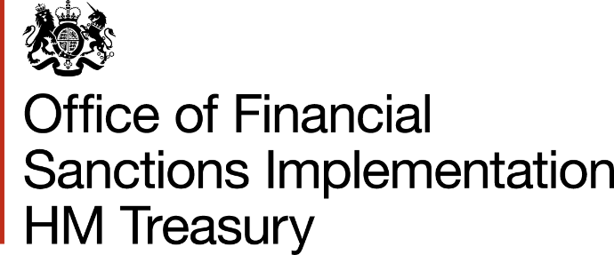

Prior Authorisation of transfers of funds under Article 5c of Council Regulation (EC) 329/2007 (“the Regulation”) concerning restrictive measures against the Democratic People’s Republic of Korea (North Korea).
This form should be used to seek prior authorisation from the Office of Financial Sanctions Implementation (OFSI) regarding otherwise prohibited transfers of funds to or from North Korea. Further guidance on Article 5c of the Regulation can be found here.
Please email completed forms to ofsi@hmtreasury.gsi.gov.uk with “DPRK AUTHORISATION” in the subject line.

Date of proposed transfer
Name, address and contact details of submitter
Submitters role in the transaction
Sender of funds
e.g. Name, address
Remitting bank/institution, location, and account details (where appropriate)
Beneficiary of funds
e.g. Name, address
Beneficiary’s bank location, and account details (where appropriate)
Payment route
i.e. details of other intermediaries – names, addresses, account details
Amount of transfer (specify currency)
Purpose of transfer
Method of Payment
i.e. bank transfer, cash, cheques, money orders etc. (If you are using an agent, please specify Agent/Institution name in ‘payment route’ section above)
Payment Schedule
If you are making multiple smaller payments, please specify amounts and time frame here
Additional Information
Please provide any additional information you feel may assist OFSI in assessing your request for authorisation

