UK Standards for Microbiology Investigations

HIV screening and confirmation

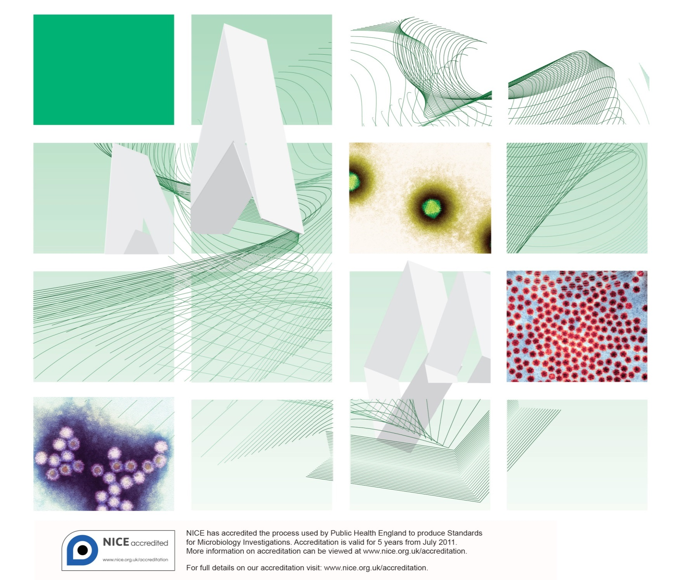

Acknowledgments
UK Standards for Microbiology Investigations (SMIs) are developed under the auspices of Public Health England (PHE) working in partnership with the National Health Service (NHS), Public Health Wales and with the professional organisations whose logos are displayed below and listed on the website https://www.gov.uk/uk-standards-for-microbiology-investigations-smi-quality-and-consistency-in-clinical-laboratories. SMIs are developed, reviewed and revised by various working groups which are overseen by a steering committee (see https://www.gov.uk/government/groups/standards-for-microbiology-investigations-steering-committee).
The contributions of many individuals in clinical, specialist and reference laboratories who have provided information and comments during the development of this document are acknowledged. We are grateful to the medical editors for editing the medical content.
For further information please contact us at:
Standards Unit
Microbiology Services
Public Health England
61 Colindale Avenue
London NW9 5EQ
E-mail: standards@phe.gov.uk
Website: https://www.gov.uk/uk-standards-for-microbiology-investigations-smi-quality-and-consistency-in-clinical-laboratories
PHE publications gateway number: 2016052
UK Standards for Microbiology Investigations are produced in association with:
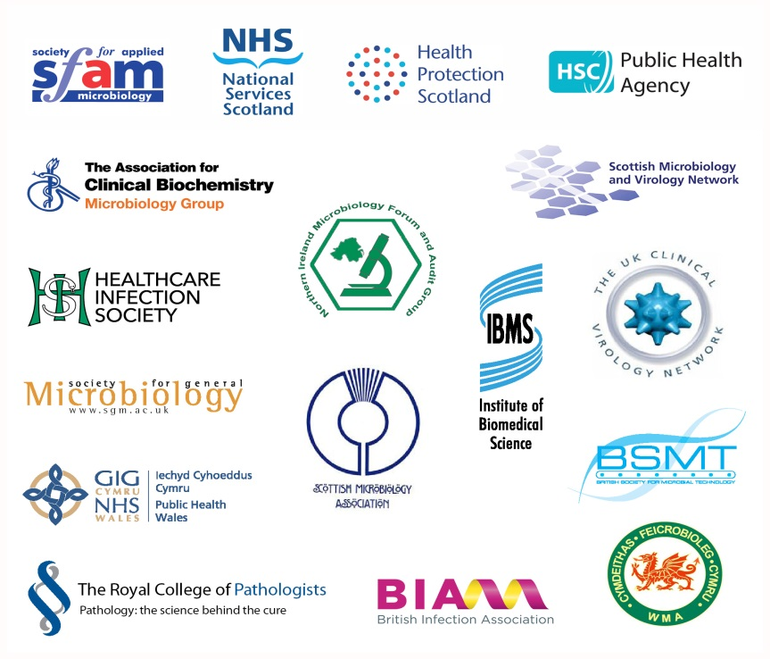
Logos correct at time of publishing.
Contents
Acknowledgments 2
Amendment table 4
UK SMI: scope and purpose 5
Scope of document 7
Introduction 7
Technical limitations/information 15
Safety considerations 16
Public health management 16
Appendix 1: HIV screening 18
Appendix 2: HIV confirmation 21
HIV reporting for patients 23
Notification to PHE, or equivalent in the devolved administrations 26
References 27

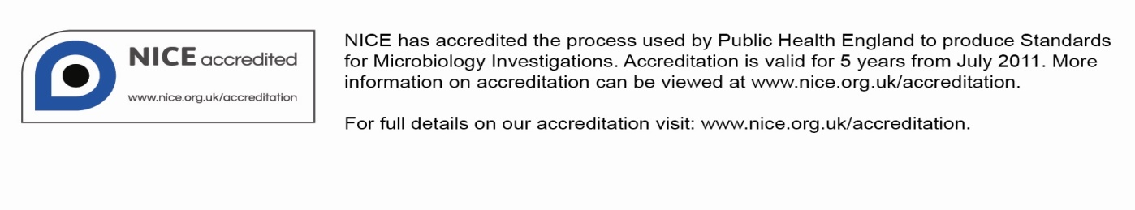
Amendment table
Each SMI method has an individual record of amendments. The current amendments are listed on this page. The amendment history is available from standards@phe.gov.uk.
New or revised documents should be controlled within the laboratory in accordance with the local quality management system.
Amendment no/date. | 5/dd.mm.yy <tab+enter>
Issue no. discarded. | 3.2
Insert issue no.
Section(s) involved | Amendment
Whole document. | This document discusses the laboratory based detection and exclusion of HIV infection using serology and nucleic acid based diagnostics.  Scientific content updated.  The Virology template format updated with new sections.  Technical limitations/information added.  Reporting section included.  Links to documents and websites updated.
Appendix. | The original algorithm in this document has been split into two – one for HIV screening and the other for HIV confirmation. This new recommended algorithm has more accurate laboratory diagnosis of acute and established HIV infection, fewer indeterminate results and faster turnaround times for most test results.

UK SMI#: scope and purpose
Users of SMIs
Primarily, SMIs are intended as a general resource for practising professionals operating in the field of laboratory medicine and infection specialties in the UK. SMIs also provide clinicians with information about the available test repertoire and the standard of laboratory services they should expect for the investigation of infection in their patients, as well as providing information that aids the electronic ordering of appropriate tests. The documents also provide commissioners of healthcare services with the appropriateness and standard of microbiology investigations they should be seeking as part of the clinical and public health care package for their population.
Background to SMIs
SMIs comprise a collection of recommended algorithms and procedures covering all stages of the investigative process in microbiology from the pre-analytical (clinical syndrome) stage to the analytical (laboratory testing) and post analytical (result interpretation and reporting) stages. Syndromic algorithms are supported by more detailed documents containing advice on the investigation of specific diseases and infections. Guidance notes cover the clinical background, differential diagnosis, and appropriate investigation of particular clinical conditions. Quality guidance notes describe laboratory processes which underpin quality, for example assay validation.
Standardisation of the diagnostic process through the application of SMIs helps to assure the equivalence of investigation strategies in different laboratories across the UK and is essential for public health surveillance, research and development activities.
Equal partnership working
SMIs are developed in equal partnership with PHE, NHS, Royal College of Pathologists and professional societies. The list of participating societies may be found at https://www.gov.uk/uk-standards-for-microbiology-investigations-smi-quality-and-consistency-in-clinical-laboratories. Inclusion of a logo in an SMI indicates participation of the society in equal partnership and support for the objectives and process of preparing SMIs. Nominees of professional societies are members of the Steering Committee and Working Groups which develop SMIs. The views of nominees cannot be rigorously representative of the members of their nominating organisations nor the corporate views of their organisations. Nominees act as a conduit for two way reporting and dialogue. Representative views are sought through the consultation process. SMIs are developed, reviewed and updated through a wide consultation process.
Quality assurance
NICE has accredited the process used by the SMI Working Groups to produce SMIs. The accreditation is applicable to all guidance produced since October 2009. The process for the development of SMIs is certified to ISO 9001:2008. SMIs represent a good standard of practice to which all clinical and public health microbiology laboratories in the UK are expected to work. SMIs are NICE accredited and represent neither minimum standards of practice nor the highest level of complex laboratory investigation possible. In using SMIs, laboratories should take account of local requirements and undertake additional investigations where appropriate. SMIs help laboratories to meet accreditation requirements by promoting high quality practices which are auditable. SMIs also provide a reference point for method development. The performance of SMIs depends on competent staff and appropriate quality reagents and equipment. Laboratories should ensure that all commercial and in-house tests have been validated and shown to be fit for purpose. Laboratories should participate in external quality assessment schemes and undertake relevant internal quality control procedures.
Patient and public involvement
The SMI Working Groups are committed to patient and public involvement in the development of SMIs. By involving the public, health professionals, scientists and voluntary organisations the resulting SMI will be robust and meet the needs of the user. An opportunity is given to members of the public to contribute to consultations through our open access website.
Information governance and equality
PHE is a Caldicott compliant organisation. It seeks to take every possible precaution to prevent unauthorised disclosure of patient details and to ensure that patient-related records are kept under secure conditions. The development of SMIs are subject to PHE Equality objectives https://www.gov.uk/government/organisations/public-health-england/about/equality-and-diversity.
The SMI Working Groups are committed to achieving the equality objectives by effective consultation with members of the public, partners, stakeholders and specialist interest groups.
Legal statement
Whilst every care has been taken in the preparation of SMIs, PHE and any supporting organisation, shall, to the greatest extent possible under any applicable law, exclude liability for all losses, costs, claims, damages or expenses arising out of or connected with the use of an SMI or any information contained therein. If alterations are made to an SMI, it must be made clear where and by whom such changes have been made.
The evidence base and microbial taxonomy for the SMI is as complete as possible at the time of issue. Any omissions and new material will be considered at the next review. These standards can only be superseded by revisions of the standard, legislative action, or by NICE accredited guidance.
SMIs are Crown copyright which should be acknowledged where appropriate.
Suggested citation for this document
Public Health England. (YYYY <tab+enter>). HIV screening and confirmation. UK Standards for Microbiology Investigations. V11 Issue #.# <tab+enter>. https://www.gov.uk/uk-standards-for-microbiology-investigations-smi-quality-and-consistency-in-clinical-laboratories/.
Scope of document
Type of specimen
Whole blood, serum / plasma,
Note: Venous blood is the preferred specimen for HIV testing. Dried blood and dried plasma spots have been validated and are commonly used for HIV testing and monitoring ^{1,2}.
This algorithm outlines the laboratory based detection and exclusion of HIV infection using serology and nucleic acid based diagnostics.
It should be noted that this algorithm is not applicable to investigation of potential mother to child transmission of HIV in children under 18 months of age.
Laboratory based HIV diagnostic algorithms should provide appropriate certainty for all patient groups regarding exclusion and detection of HIV-1 and 2 infections in all clinical settings, and should also distinguish HIV-1 from HIV-2 infection.
Refer to Q 7 - Good practice when undertaking serology assays for infectious diseases for information regarding good laboratory practice in serological testing.
This SMI should be used in conjunction with other SMIs.
Definitions
For all antigen, antibody and NAATs testing, the following definitions apply:
During testing process

Reactive – Initial internal stage positive result pending confirmation.

Not-reactive – Initial internal stage negative result.
Indeterminate/ equivocal – Result is not clearly positive or negative. Further testing is required. This is used for preliminary reports.
Reporting stage

Indeterminate – Reactive result that cannot be confirmed. This is used for final or preliminary reports.

Detected – Report stage confirmed reactive result.

Not detected – Report stage not reactive result.
Introduction
Human immunodeficiency virus (HIV) is a retrovirus that infects the cells of the immune system. It is transmitted via exposure to body fluids that contain free infectious viral particles. HIV causes a chronic infection that typically leads to a progressive disease. Without treatment, most persons with HIV develop acquired immunodeficiency syndrome (AIDS) within 10 years of infection, which results in substantial morbidity and premature death. Over 100,000 people are living with HIV infection (diagnosed and undiagnosed) in the UK since 2013 while globally at the end of 2014, there were approximately 36.9 million people living with HIV, with 2 million people becoming newly infected with HIV. Sub-Saharan Africa was the most affected region, with 25.8 million people living with HIV in 2014 and accounts for almost 70% of the global total of new HIV infections³. Accurate laboratory diagnosis of HIV is essential to identify persons who could benefit from treatment, to reassure persons who are uninfected, and to reduce HIV transmission.
There are two recognised HIV types – HIV-1 and HIV-2. HIV-1 is found largely throughout the world including UK, USA and the rest of Europe. It is divided into three groups on the basis of differences in the envelope region, HIV-1 major group (HIV1-M), outlier (HIV1-O) and HIV1-N group. The HIV1-M major group can be classified further into 9 subgroups designated A through to K excluding E and I. These subgroups have envelope gene sequences that vary based on genetic similarities. They differ in geographical distribution, biological characteristics and major mode of transmission etc. HIV-1 groups O and N are more distant to all other HIV-1 subgroups but less so compared to HIV-2. So these are classified under HIV-1 only and have limited distribution in West Africa.
However, HIV-2 is found largely in West Africa and also comprises of a heterogeneous group of viruses that has been divided into 5 subgroups designated A through to E.
Expansion of HIV testing in health care settings has been strongly recommended by ECDC and WHO guidelines, to address the need to improve rates of earlier diagnosis⁴. There are HIV indicator conditions that are considered for recommending HIV testing. These are divided into 3 categories and are:
- patients presenting with potentially AIDS defining conditions as found in those living with HIV
- patients presenting with conditions associated with an undiagnosed HIV prevalence of ˃0.1% or where expert opinion considers HIV prevalence likely to be ˃0.1% but still awaiting further evidence
- conditions where not identifying the presence of HIV infection may have significant adverse implications for the patient’s clinical management
Window period of infection⁵⁻⁹
This is the period between exposure and detection of HIV seroconversion, that is, the normal maximum period in which markers of HIV (such as antibodies and antigens) become detectable – in many cases they may be detectable before this.
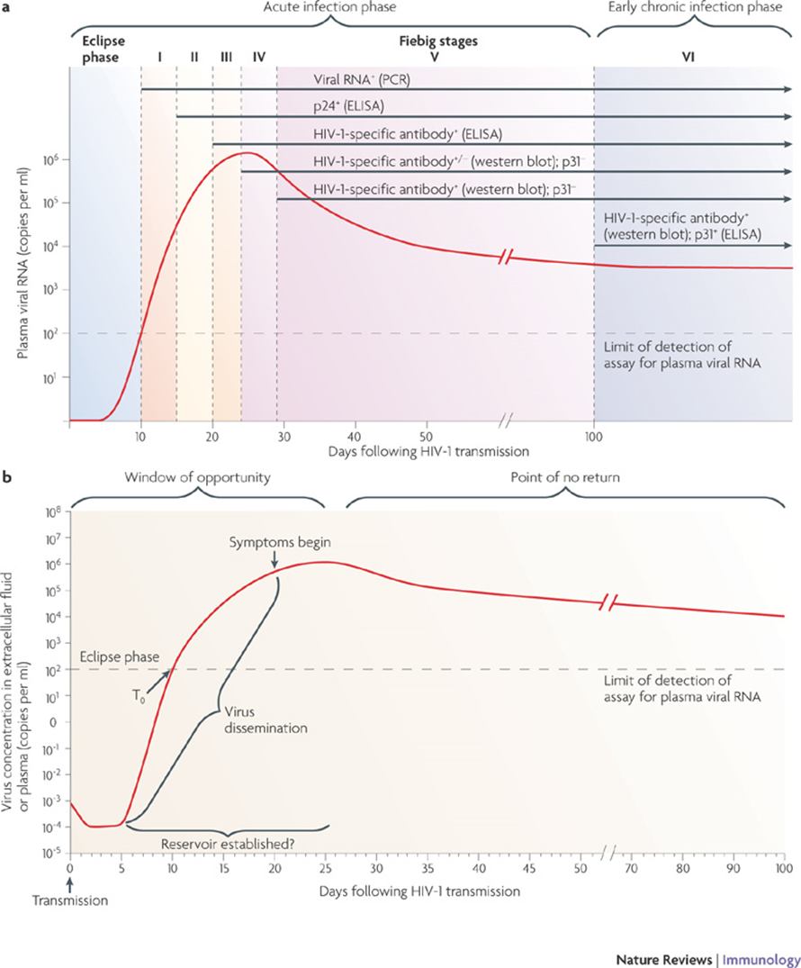
Figure 1: The different window periods in HIV infection. Adapted from AJ McMichael Nature, 2010 ¹⁰.
Depending on the type of screening test and the sample being tested, the window period for detecting HIV infection could be from 4 weeks for 4th generation HIV blood test up to three months for 3rd generation HIV blood tests. This is a virtue of the ability of 4th generation HIV assays to pick up HIV p24 antigen that is detectable within the first 4 weeks after exposure. The 3rd generation HIV assays detect antibodies against HIV-1, HIV-2 alone and not HIV p24 antigen. The antibody response follows p24 antigen and at 12 weeks post-exposure, 99% of all true infections should be picked up by 3rd generation assays. The type of sample is another variable to be considered when ascribing window periods for 4th generation HIV assays. Venous and capillary blood samples will qualify for the 4 week window period in 4th generation assays. Characteristics for saliva, dried blood spot samples are discussed in the sections below.
See below the pictorial presentation of the third and fourth generation windows.

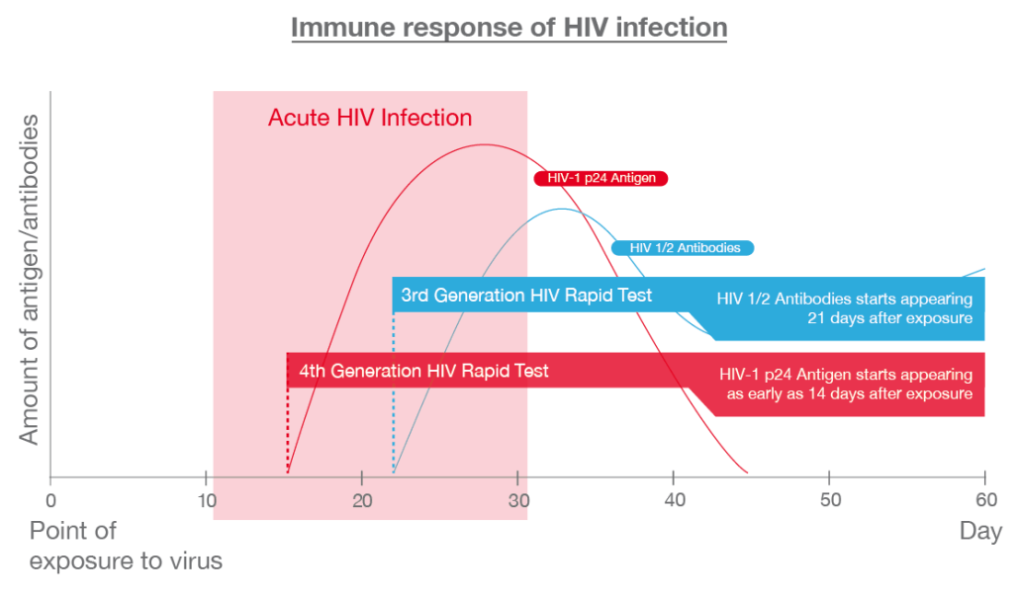Figure 2: Differentiation between third and fourth generation windows of infection. Adapted from Action for AIDS Singapore ¹¹
BASHH/ EAGA statement on HIV seroconversion window period. November 2014¹²:
“HIV testing using the latest (fourth generation) tests is recommended in the BHIVA / BASHH / BIS UK guidelines for HIV testing (2008). These assays test for HIV antibodies and p24 antigen simultaneously. A fourth generation HIV test on a venous blood sample performed in a laboratory will detect the great majority of individuals who have been infected with HIV at 4 weeks after specific exposure.
Patients attending for HIV testing who identify a specific risk occurring less than 4 weeks previously should not be made to wait before HIV testing as doing so may miss an opportunity to diagnose HIV infection (and in particular acute HIV infection during which a person is highly infectious). They should be offered a fourth generation laboratory HIV test and be advised to repeat it when 4 weeks have elapsed from the time of the last exposure.
A negative result on a fourth generation test performed at 4 weeks post-exposure is highly likely to exclude HIV infection. A further test at 8 weeks post-exposure need only be considered following an event assessed as carrying a high risk of infection.
Patients at ongoing risk of HIV infection should be advised to retest at regular intervals.
Patients should be advised to have tests for other sexually transmitted infections in line with advice on window periods for those infections (see BASHH guidelines at: www.bashh.org).

Occupational exposure
The above also applies to healthcare workers who are exposed to HIV infection in the occupational setting^{5,7}.
A negative HIV test result at 12 weeks post-exposure or post cessation of PEP reasonably excludes HIV infection related to the occupational exposure. Exposures to which PEP is indicated are break in the skin by a sharp object that is contaminated with the patient’s blood, bite from a patient with visible bleeding in the mouth, splash of blood (visibly bloody fluid or other potentially infectious material to a mucosal surface), or a non-intact skin (eg dermatitis, chapped skin or open wound) exposure to blood or other potentially infectious materials⁶.
Refer to recommendations from the Department of Health, UK Expert Advisory Group on AIDS (EAGA) https://www.gov.uk/government/uploads/system/uploads/attachment_data/file/203139/HIV_post-exposure_prophylaxis.pdf.

Elite controllers
This is a phenomenon described in HIV-1 infected patients where there is better immunological control of HIV infections with consequent lower average HIV-1 viral load in untreated individuals and higher mean CD4 counts. This is encountered very rarely, approximating 1% in various HIV-1 treatment cohorts^{13,14}. Varying HIV-1 viral load and CD4 thresholds have been employed in different definitions. Recent review and consensus is to classify this cohort as treatment naïve with CD4 >500 cells/mm and plasma viral load below limit of assay detection for over a 6 month period or >90% measurements of <400 copies/ml over a 10 year period as they are best associated with low hazard ratio for disease progression¹⁵. It is important to recognise this rare clinical entity in diagnosing a new HIV infection. HIV proviral DNA testing might be employed in the initial diagnostic stages, although in some viral suppressors, it could still be negative.
Types of HIV tests
There are several test types that could be used for HIV diagnosis. They are as follows:

Serological assays
These assays are based on different design principles and are grouped into “generations”. They are described as follows:
- Fourth generation tests
They are the first line choice tests depending on clinical scenarios and are recommended by BHIVA /BASHH /BIS guidelines in the UK for use for initial testing and are better at detecting acute, established or very late HIV infection than other forms of testing¹². These are synthetic peptide or recombinant protein antigens used in the same antigen sandwich format as third generation assays to detect IgM and IgG antibodies, and monoclonal antibodies are also included to detect p24 antigen. Inclusion of p24 antigen capture allows detection of HIV-1 infection before antibody production. These do not usually distinguish antibody reactivity from antigen reactivity. The window period for these tests can be 15 to 20 days in most patients¹⁶; and clinical guidelines classify the window period as 4 weeks. They are the current standard of care for HIV screening in UK.

- Third generation tests
These tests detect all types of HIV antibodies only. The third generation tests are reactive (detect antibody) at the earliest by 20 to 30 days following exposure¹¹. Although according to the BHIVA /BASHH guidelines 2008, it has been recommended that laboratories move over to using the fourth generation tests, the third generation tests may be used as a supplemental test to differentiate antigen from antibody signals in combined fourth generation assays¹².

Note: There are commercially available third and fourth generation points of care test kits and it should also be noted that their ability to detect antigens levels may be low.

- Fourth generation point of care tests
These rapid tests are screening tests that can be performed on blood or from other sample types. Testing of oral fluid/saliva is not covered in the SMIs. When such samples are received, they should be referred to reference laboratories. Those that use sample types other than blood may be subject to more sampling variation which influences the sensitivity of the test which has to be taken into consideration regarding their suitability as a screening test in a clinic setting. Like fourth generation laboratory tests, these tests also detect HIV antibodies and P24 antigens. Their result output is rapid and comparable to laboratory antibody tests ¹⁷. According to the British Association of Sexual Health and HIV (BASHH), these rapid point of care HIV blood tests are generally satisfactory for detection of uncomplicated HIV infection and gives results within minutes. It will detect most infections within 6 weeks of exposure to HIV. Results are available within 30 minutes of testing. Point-of-care HIV tests may also vary in their ability to discriminate between HIV-1 and HIV-2. The window period for these tests can be 11 days to 1 month. They are recommended only in certain settings, such as community outreach settings and some GUM drop in clinics as well as for screening high risk patients where referral to a phlebotomist is impractical.
Point-of-care tests offered should be overseen by local laboratories that have a robust quality assurance system or must be used under professional supervision with pre and post counselling. Further tests must be performed for all positive rapid test results¹⁸.

- p24 only tests
These tests measure the viral capsid p24 protein in a specimen (blood/serum) that is detectable earlier than HIV antibody during acute infection. These test methods are highly specific, and a positive result suggests infection. However, it should be noted that this result should be confirmed again by testing a further EDTA sample for RNA and testing a latter sample for antibody detection. They can be of value in blood screening, identifying acute infection as well as in diagnosing infection in the newborn and monitoring antiviral therapy.
A major limitation is that these tests may not be sensitive when testing blood because low levels of antigen are difficult to detect and antigenemia occurring only transiently during different stages of infection. Antigen, although transient, can appear as early as 2 weeks after infection and lasts 3 to 5 months. The window period for these tests can be from about 2 weeks to 4 weeks.
Although not recommended by BASHH and rarely used, some laboratories still use these tests for assisting in the resolution of indeterminate immunoblot results.

Nucleic Acid Amplification Tests (NAAT)

NAAT can detect viral genetic material (RNA or DNA). Most assays are for HIV-1 RNA and specific HIV-2 RNA tests are available at a few centres in the UK on an individual patient basis. HIV-1 viral load NAAT can be used as a supplemental test when a patient gives persistently indeterminate immunoblot/immunoassay results⁵, or in suspected primary HIV infection but should only be performed with specialist input¹⁸. NAAT are not recommended for use in initial HIV screening because they are not licenced for use and may give false positive results^{17,19,20}.

Detection of viral RNA is used in blood donor screening to reduce the risk of HIV being transmitted through the transfusion of infected blood donated during the serological window period of antigen and antibody assays ¹⁷.

Proviral DNA testing may be useful in confirming HIV in patients with indeterminate serology and undetectable HIV RNA or sometimes in the testing of infants born to HIV infected women ²¹.

Note: It should be noted that there are currently a few HIV-1 qualitative assays that are commercially available. Although this does not fit into current testing algorithms in the UK, this is mentioned for information²².

Other commercial alternatives

Home testing/sampling kits¹⁹
HIV home test kits are now legalised and licensed in the UK as well as available from various local authorities in the UK via a PHE webpage (see link: https://www.gov.uk/government/news/free-hiv-home-sampling-launched-to-increase-hiv-testing). These are subject to regulation by the Medicines and Healthcare products Regulatory Agency (MHRA). Tests that meet the required standards will be given a CE mark to guarantee that they work properly and are safe. These home kits should be used according to the manufacturer’s instructions but where it is used from the manufacturer’s intended recommendations, it is subject to local validation/verification.
The disadvantages of using HIV self-tests are that they generally have low sensitivity and low specificity. For example, saliva (although not covered in SMIs) contains lower antibody/antigen levels and is less sensitive than blood (venous or capillary whole blood or dried blood spot) in detecting acute HIV infection ¹⁷. In addition to home-testing, home sampling might be considered in efforts to improve patient access to HIV testing. Dried blood spot and capillary blood collection devices are increasingly employed and they can be used only for HIV screening in conjunction with validated/CE marked 4th generation HIV EIAs that are locally verified and validated for the dried blood spot or capillary blood or saliva sample. Depending on the type of sample used, the window period even on the 4th generation assays may be extended. If saliva is used, the window period should be considered as 3 months and if using dried blood spot on validated 4th generation HIV EIAs, the window period may be a few weeks longer than the 4 weeks considered for venous or capillary blood samples ²³.
For further information on the self-test kits, refer to Annex IIa of the In Vitro Diagnostic Medical Devices Directive 98/79/EC on the MHRA website (https://www.gov.uk/government/publications/in-vitro-diagnostic-medical-devices-guidance-on-legislation).

Technical limitations/information
Limitations of UK SMIs
The recommendations made in UK SMIs are based on evidence (eg sensitivity and specificity) where available, expert opinion and pragmatism, with consideration also being given to available resources. Laboratories should take account of local requirements and undertake additional investigations where appropriate. Prior to use, laboratories should ensure that all commercial tests have been verified and in-house tests have been validated and are fit for purpose.
Specimen containers^{1,2}
SMIs use the term “CE marked leak proof container” to describe containers bearing the CE marking used for the collection and transport of clinical specimens. The requirements for specimen containers are given in the EU in vitro Diagnostic Medical Devices Directive (98/79/EC Annex 1 B 2.1) which states: “The design must allow easy handling and, where necessary, reduce as far as possible contamination of and leakage from, the device during use and, in the case of specimen receptacles, the risk of contamination of the specimen. The manufacturing processes must be appropriate for these purposes”.
Home testing/sampling kits
Positive/ negative predictive values can be affected by the prevalence of HIV among the population (particularly in low HIV prevalence populations) and by user errors. Therefore, patients should refer to the kits instructions to explain how they should be used, the possible results that could be obtained from using these kits and their interpretations as well as the possible limitations of the test as recommended by MHRA regulations. It is also advised that individuals with reactive HIV self-test results should seek further testing to confirm the results and engage with local sexual health services.

Safety considerations
Collect specimens in appropriate CE marked leak proof containers and transport in sealed plastic bags. In resource limited countries, dried blood spots (on filter paper) for sample collection are used rather than blood samples because the storage conditions in these settings are impractical. DBS has been shown to keep the viral nucleic acid in good condition during transportation²⁴.
Compliance with postal, transport and storage regulations is essential.
Public health management
Early HIV screening and testing of patients helps in controlling the HIV epidemic and reducing late HIV diagnosis. Programmes that have been introduced to increase HIV testing have been shown to be effective, cost-effective and provide a positive return on investment.
For information regarding notification to PHE (or equivalent in the devolved administrations), refer to page 23.
For further information on public health management of HIV, refer to PHE guidance: https://www.gov.uk/government/collections/hiv-surveillance-data-and-management
For information on healthcare workers who are exposed to blood borne viral infections in the occupational setting, refer to https://www.gov.uk/government/groups/uk-advisory-panel-for-healthcare-workers-infected-with-bloodborne-viruses.
For more information on other guidelines that may be useful with regards to HIV testing see below bearing in mind that practice in some countries differs significantly from UK practice due to regulatory requirements (for example USA requiring FDA approved assays):
Public Health Agency of Canada (PHAC)
http://www.phac-aspc.gc.ca/aids-sida/guide/hivstg-vihgdd-eng.php.
CDC
This link http://www.cdc.gov/hiv/guidelines/testing.html leads to all the links below:
Laboratory Testing for the Diagnosis of HIV Infection: Updated Recommendations
Quick Reference Guide—Laboratory Testing for the Diagnosis of HIV Infection: Updated Recommendations,
Suggested Reporting Language for the HIV Laboratory Diagnostic Testing Algorithm
WHO has important details on rapid tests
http://www.unaids.org/sites/default/files/en/media/unaids/contentassets/documents/unaidspublication/2014/JC2603_self-testing_en.pdf
http://www.who.int/diagnostics_laboratory/evaluations/hiv/en/
http://www.who.int/diagnostics_laboratory/publications/15032_hiv_assay_report18.pdf?ua=1

ECDC
http://ecdc.europa.eu/en/publications/Publications/101129_TER_HIV_testing_evidence.pdf
http://hiveurope.eu/Portals/0/Guidance.pdf.pdf
http://www.iusti.org/regions/europe/pdf/2014/2014IUSTIguidelineonHIVtesting.pdf

Appendix 1: HIV screening^{5,16,18,24-31}

Footnotes relating to HIV screening
- This algorithm is not applicable to investigation of potential mother to child transmission of HIV in children under 18 months of age.
- It is recommended that laboratories use a combined antibody antigen assay, however, the use of separate antibody and p24 antigen assays would be acceptable. Tests should detect antibody to all major groups of HIV-1 and 2, including type 1 group O and should be performed on blood/ serum/plasma according to manufacturer’s specifications.
- BASHH UK national guidelines on HIV testing do recommend point of care rapid tests (in outreach settings, antenatal clinics, gum clinics, urgent source testing and circumstances in which venepuncture is refused); however, if local assessment indicates satisfactory performance, they could be used for screening¹⁸. Such rapid tests (antibody only, or combined antibody/antigen) may be indicated in certain population groups where the overall benefit of increased testing outweighs any potential disadvantage of poorer test performance.
- HIV RNA assays (viral load tests) are not recommended for use in initial diagnostic HIV screening. Although, they offer the marginal benefit in detecting recent HIV infection, they are not for diagnostic use and have the potential to give false positive and false negative results^{1,30,32}. This is not used for HIV-2 detection as most assays are for detecting the more common HIV-1 alone.

- It is recommended that patients presenting with clinical symptoms suggestive of HIV infection and whose screening tests are repeatedly negative should have their specimen referred to a reference laboratory for analysis using alternative tests.
- This patient category might include antenatal screening. Refer to https://www.gov.uk/government/publications/infectious-diseases-in-pregnancy-screening-programme-laboratory-handbook.
- Laboratories may opt to test such samples in two assays rather than rely on a single screening test. The routine screening test should be the most sensitive test available to the laboratory, however, dual testing may add an extra dimension of certainty regarding a negative result since inter assay performance varies and unrecognised laboratory process error is less likely.
- For BASHH statement on HIV seroconversion window period. November 2014¹²: see BASHH guidelines at: www.bashh.org.
- HIV vaccine recipients (having a HIV test) with reactive immunoassay results are encouraged to contact a vaccine trial site for specialised testing to determine their HIV infection status.
- HIV avidity testing distinguishes recent infections from established infections and is primarily used for monitoring at a population level. HIV avidity testing is available as a public health surveillance tool at PHE Colindale, London Edinburgh and in Glasgow, West of Scotland. In England, Wales and Northern Ireland, clinics and laboratories can have specimens tested for evidence of recent HIV Infection by antibody avidity testing through agreeing a memorandum of understanding between with PHE, Colindale. Specimens for HIV avidity testing should be the first confirmed anti-HIV positive specimen from the patient if available, however where not available, the laboratory should ask for another specimen. Clinicians should be aware that the avidity test is not diagnostic and the result should be considered with clinical and other laboratory data. The avidity test can be affected by infecting HIV subtype, current or previous treatment with ARV’s and declining immune status such as found in patients with AIDS.
- If sample is negative on testing in a case of suspected HIV infection, send further sample for retesting within 14 days.
- Results are considered concordant when the initial screening test and the second test using an alternative assay are reactive.
- Results are considered discordant when different results are obtained between the clot sample/ primary collection tube and the aliquot sample, or unrepeatable reactivity is obtained in any assay used in initial confirmatory testing. In this case, it is advised that further investigations will be required and samples from the primary collection tube should be used.

Appendix 2: HIV confirmation^{16,24,30}
Footnotes relating to HIV confirmation
- For confirmation of reactive serology results, the HIV-1/HIV-2 antibody differentiation immunoassay can be used because it distinguishes between HIV-1 and HIV-2. This distinction can have important treatment implications for a patient.
Note: An immunoblot may be used by laboratories to confirm reactive rapid test results but these may give false negative results resulting in delayed diagnosis. Western blot tests are less sensitive than HIV screening tests. Caution should be taken with interpretation of immunoblot results and further testing followed up on. If an immunoblot test result is negative or indeterminate, a HIV-1 RNA test should be performed on the sample to resolve any discrepancy⁵. Patients should be proactively notified and a second sample obtained as soon as possible.
- HIV NAATs are helpful in confirming suspected infection, but local policies should be used to define their use and interpretation.
- Laboratory reports of newly identified HIV antibody positive individuals from clinics and laboratories in England, Wales and Northern Ireland should be reported to the HIV Reporting Section of Public Health England, Colindale and reports collated in Scotland should be reported to Health Protection Scotland.
A definitive positive diagnosis of HIV should not be reported unless a confirmatory laboratory has issued a report confirming tests on the first specimen are consistent with HIV infection and the results are confirmed by a second specimen.
- Repeat serology testing of a new sample is recommended to rule out mislabelling and confirm patient identity. A sample sent for viral load testing which gives a positive result could fulfil the requirement for confirmation of the second sample. Where viral load is lower or undetectable a further sample should be collected for serological testing. Attention should be paid to the final diagnosis, whether HIV-1, HIV-2 or both as it has important treatment implications.
- There are currently no MHRA approved tests for HIV-2 RNA or DNA.
- A confirmed reactive HIV test result should be referred to the appropriate Reference Laboratory for further HIV testing.

HIV reporting for patients³³
There are a summary of the combinations of results that do occur and require individual comments based upon profile and clinical setting, along with a further sample.
 | Tests performed | Test Results | Suggested wording of report comment (see footnotes for further information and actions) | Notes
Screening
1 | Testing sample using the fourth generation assays (HIV-1and HIV-2 antibodies and p24 antigen assay). Test sample from the clot (original sample). | Not reactive | HIV antibody/antigen not detected. No evidence of current or past HIV infection. | - Regular testing is recommended for those who remain at risk of infection or patients exhibiting HIV-related signs or symptoms.  - Please send a further sample taken at least 14 days after the current sample if HIV infection is still suspected.  - Recommend retesting according to window period of infection.
 |  | Reactive | Preliminary result. Further supplementary tests to follow for confirmation.
Confirmation (screening test reactive samples)
2 | Testing HIV screening test reactive samples by using HIV-1/HIV-2 antibody differentiation immunoassay or a further immunoassay followed by a typing assay | Reactive. There could be 3 possible scenarios. They are:  - HIV- 1 reactive and HIV-2 not reactive. | Positive for HIV- 1 antibodies. Consistent HIV-1 infection is present. Please send a repeat sample to confirm.
 |  | - HIV- 1 not reactive and HIV-2 reactive | Positive for HIV- 2 antibodies. Evidence that HIV-2 infection is present. Please send a repeat sample to confirm.
 |  | - Both HIV- 1 and HIV-2 are reactive | Positive for both HIV- 1/HIV-2 antibodies. Evidence that HIV infection is present. HIV antibodies could not be differentiated as HIV-1 or HIV-2.  - Suggest sending sample to reference laboratory for further testing.  - Additional testing for HIV-1 RNA or HIV-2 RNA should be performed. Please send a repeat sample to confirm.
3 | Testing HIV screening test reactive samples by using HIV-1/HIV-2 antibody differentiation immunoassay | Not reactive | HIV antibodies are not confirmed. This report does not need to be reported.  Follow up testing for local HIV p24 antigen algorithm or HIV-1 RNA.  There are two likely report results:  - HIV-1 RNA positive / p24 antigen confirmed – Consistent with acute HIV-1 infection. This should be reported.  - HIV-1 RNA negative / p24 antigen not confirmed – No evidence of acute HIV-1 infection.  - Send EDTA sample to reference laboratory.  - Consider proviral DNA.  - Consider HIV-2.  - Consider different HIV-1 RNA assay. Request a further repeat EDTA sample to confirm. | HIV-2 RNA testing should be performed if clinically indicated.
 |  | Indeterminate

Notification to PHE^{34,35}, or equivalent in the devolved administrations³⁶⁻³⁹
The Health Protection (Notification) regulations 2010 require diagnostic laboratories to notify Public Health England (PHE) when they identify the causative agents that are listed in Schedule 2 of the Regulations. Notifications must be provided in writing, on paper or electronically, within seven days. Urgent cases should be notified orally and as soon as possible, recommended within 24 hours. These should be followed up by written notification within seven days.
For the purposes of the Notification Regulations, the recipient of laboratory notifications is the local PHE Health Protection Team. If a case has already been notified by a registered medical practitioner, the diagnostic laboratory is still required to notify the case if they identify any evidence of an infection caused by a notifiable causative agent.
Notification under the Health Protection (Notification) Regulations 2010 does not replace voluntary reporting to PHE. The vast majority of NHS laboratories voluntarily report a wide range of laboratory diagnoses of causative agents to PHE and many PHE Health Protection Teams have agreements with local laboratories for urgent reporting of some infections. This should continue.
Note: The Health Protection Legislation Guidance (2010) includes reporting of Human Immunodeficiency Virus (HIV) & Sexually Transmitted Infections (STIs), Healthcare Associated Infections (HCAIs) and Creutzfeldt–Jakob disease (CJD) under ‘Notification Duties of Registered Medical Practitioners’: it is not noted under ‘Notification Duties of Diagnostic Laboratories’.
https://www.gov.uk/government/organisations/public-health-england/about/our-governance#health-protection-regulations-2010
Other arrangements exist in Scotland^{36,37}, Wales³⁸ and Northern Ireland³⁹.

References
Modified GRADE table used by UK SMIs when assessing references

Grading of Recommendations, Assessment, Development, and Evaluation (GRADE) is a systematic approach to assessing references. A modified GRADE method is used in UK SMIs for appraising references for inclusion. Each reference is assessed and allocated a grade for strength of recommendation (A-D) and quality of the underlying evidence (I-VI). A summary table which defines the grade is listed below and should be used in conjunction with the reference list.

Strength of recommendation | Quality of evidence
A Strongly recommended | I Evidence from randomised controlled trials, meta-analysis and systematic reviews
B Recommended but other alternatives may be acceptable | II Evidence from non-randomised studies
C Weakly recommended: seek alternatives | III Non-analytical studies, eg case reports, reviews, case series
D Never recommended | IV Expert opinion and wide acceptance as good practice but with no study evidence
 | V Required by legislation, code of practice or national standard
 | VI Letter or other

1. Garrido C, Zahonero N, Corral A, Arredondo M, Soriano V, de Mendoza C. Correlation between human immunodeficiency virus type 1 (HIV-1) RNA measurements obtained with dried blood spots and those obtained with plasma by use of Nuclisens EasyQ HIV-1 and Abbott RealTime HIV load tests. Journal of clinical microbiology 2009;47:1031-6. BII

2. Smit PW, Sollis KA, Fiscus S, Ford N, Vitoria M, Essajee S et al. Systematic review of the use of dried blood spots for monitoring HIV viral load and for early infant diagnosis. PloS one 2014;9:e86461. BIII

3. HIV/AIDS - Key Facts: WHO Media centre; 2015. BIII

4. HIV in Europe. HIV Indicator Conditions: Guidance for Implementing HIV Testing in Adults in Health Care Settings. http://hiveurope.eu/Portals/0/Guidance.pdf.pdf. 1 - 38. BIV

5. Public Health Agency Canada. Human immunodeficiency virus - HIV Screening and Testing Guide. 1- 45. 2012. CIII

6. Zingman B. HIV Prophylaxis Following Occupational Exposure: Guideline and Commentary. Medscape 2013. CIV

7. Department of Health. HIV post-exposure prophylaxis Guidance from the UK Chief Medical Officers’ Expert Advisory Group on AIDS. Department of Health. DH Publications Orderline PO Box 777 London SE1 6XH 2008. 1-71. AV

8. BASHH Guideline Working Group. UK Guideline for the use of HIV Post-Exposure Prophylaxis Following Sexual Exposure (PEPSE) 2015. www.bashh.org 2015. 47. AV

9. George CR, Robertson PW, Lusk MJ, Whybin R, Rawlinson W. Prolonged second diagnostic window for human immunodeficiency virus type 1 in a fourth-generation immunoassay: are alternative testing strategies required? Journal of clinical microbiology 2014;52:4105-8. BIII

10. McMichael AJB, P. Tomaras, G. D. Goonetilleke, N. Haynes, B. F. The immune response during acute HIV-1 infection: clues for vaccine development. Nature reviews Immunology 2010;10:11-23. BIII

11. Action for AIDS SINGAPORE. What is a 4th gen HIV test? http://afa.org.sg/what-is-a-4th-gen-hiv-test/. 2014. BIII

12. BASHH. BASHH/EAGA Statement on HIV window period. www.bashh.org November 2014. AV

13. Killian MS, Vyas GN, Mehta R, Young K, Ebrahim O. Possible transmission of human immunodeficiency virus-1 infection from an elite controller to a patient who progressed to acquired immunodeficiency syndrome: a case report. J Med Case Rep 2012;6:291. BIII

14. Saag M, Deeks SG. How do HIV elite controllers do what they do? Clin Infect Dis 2010;51:239-41. CIII

15. Olson AD, Meyer L, Prins M, Thiebaut R, Gurdasani D, Guiguet M et al. An evaluation of HIV elite controller definitions within a large seroconverter cohort collaboration. PloS one 2014;9:e86719. BIII

16. Branson BO, SM; Wesolowski, LG; Bennett,B; Werner, BG; Wroblewski,KE; Pentella, MA. Laboratory Testing for the Diagnosis of HIV Infection - Updated Recommendations. Available at http://www.cdc.gov/hiv/pdf/hivtestingalgorithmrecommendation-final.pdf 1-66. 2014. AV

17. Pilcher CD, Louie B, Facente S, Keating S, Hackett J, Jr., Vallari A et al. Performance of rapid point-of-care and laboratory tests for acute and established HIV infection in San Francisco. PloS one 2013;8:e80629. BII

18. British HIV Association, British Association for Sexual Health and HIV, British Infection Association. UK National Guidelines on HIV Testing 2008. Available at http://www.bhiva.org/documents/Guidelines/Testing/GlinesHIVTest08.pdf. 2008. AV

19. UNAIDS. A short technical update on self‑testing for HIV. http://www.unaids.org/sites/default/files/media_asset/JC2603_self-testing_en_0.pdf. 1-10. 2013. BIV

20. Guidance on the Microbiological Safety of Human Organs, Tissues and Cells used in Transplantation. Available at https://www.gov.uk/government/publications/guidance-on-the-microbiological-safety-of-human-organs-tissues-and-cells-used-in-transplantationvol 1. Infectious Diseases and Blood Policy, 530 Wellington House, 133-155 Waterloo Road SE1 8UG SaBTO@dh.gsi.go.uk; 2011. p. 60. AV

21. D Asboe CA, M Boffito, C Booth, P Cane, A Fakoya, AM Geretti, P Kelleher, N Mackie, D Muir, G Murphy, C Orkin, F Post, G Rooney, C Sabin, L Sherr, E Smit, W Tong, A Ustianowski, M Valappil, J Walsh, M Williams and D Yirrell. British HIV Association guidelines for the routine investigation and monitoring of adult HIV-1-infected individuals 2011. HIV Medicine 2011:1- 44. AV

22. Michaeli MW, M. Gozlan, Y. Rakovsky, A. Mendelson, E. Mor, O. Evaluation of Xpert HIV-1 Qual assay for resolution of HIV-1 infection in samples with negative or indeterminate Geenius HIV-1/2 results. Journal of clinical virology : the official publication of the Pan American Society for Clinical Virology 2016;76:1-3. BII

23. Pebody R. HIV testing technologies, HIV PREVENTION ENGLAND. Aidsmap 2014:1-6. BIII

24. To SWC, Chen JHK, Yam WC. Current assays for HIV-1 diagnostics and antiretroviral therapy monitoring: Challenges and possibilities. Future Virology 2013;8:405-19. BIII

25. WHO Pan-American Health Organisation. Guidelines for the implementation of reliable and efficient HIV testing. 2008. AV

26. European Centre for Disease Prevention and Control. HIV Testing: increasing uptake and effectiveness in the European Union. Stockholm. 2010. AV

27. World Health Organization. WHO recommendations on the diagnosis of HIV infection in infants and children. 2010. AV

28. Bell J, Brettle R, Chiswick A, Simmonds P. HIV encephalitis, proviral load and dementia in drug users and homosexuals with AIDS. Effect of neocortical involvement. Brain 1998;121:2043-52. BII

29. Parry JV, Mortimer PP, Perry KR, Pillay D, Zuckerman M. Towards error-free HIV diagnosis: guidelines on laboratory practice. CommunDisPublic Health 2003;6:334-50. AV

30. Gokengin D, Geretti AM, Begovac J, Palfreeman A, Stevanovic M, Tarasenko O et al. 2014 European Guideline on HIV testing. Int J STD AIDS 2014;25:695-704. AV

31. Screening Donated Blood for Transfusion-Transmissible Infections: Recommendations WHO Guidelines Approved by the Guidelines Review Committee Geneva: World Health Organization; 2009. AV

32. Pierce VMN, B. and Hodinka, R. L. Evaluation of the Gen-Probe Aptima HIV-1 RNA qualitative assay as an alternative to Western blot analysis for confirmation of HIV infection. Journal of clinical microbiology 2011;49:1642-5. BII

33. Association of Public Health Laboratories. Suggested Reporting Language for the HIV Laboratory Diagnostic Testing Algorithm. http://www.aphl.org/AboutAPHL/publications/Documents/ID_2013Nov_HIV-Reporting-Language.pdf. 1 - 7. 2013. BIV

34. Public Health England. Laboratory Reporting to Public Health England: A Guide for Diagnostic Laboratories 2013. 1-37.

35. Department of Health. Health Protection Legislation (England) Guidance. 1-112. 2010.

36. Scottish Government. Public Health (Scotland) Act. 2008.

37. Scottish Government. Public Health etc. (Scotland) Act 2008. Implementation of Part 2: Notifiable Diseases, Organisms and Health Risk States. 2009.

38. The Welsh Assembly Government. Health Protection Legislation (Wales) Guidance. 2010.

39. Home Office. Public Health Act (Northern Ireland) 1967 Chapter 36. 1967.

# Microbiology is used as a generic term to include the two GMC-recognised specialties of Medical Microbiology (which includes Bacteriology, Mycology and Parasitology) and Medical Virology.

