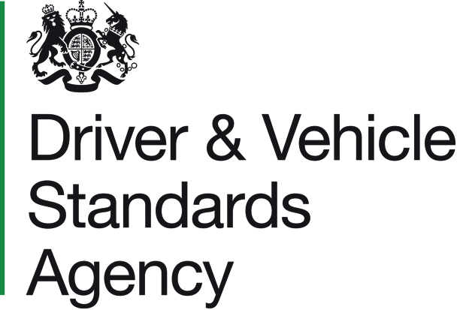 |  |  |  |  |  |  |  | NOTIFICATION OF CHANGE TO A COIF VEHICLE APPROVED TYPE  PSV 400A  Public Passenger Vehicle Act 1981
FAILURE TO COMPLETE THE FORM ACCURATELY OR IN FULL COULD RESULT IN
DELAYS OR REJECTION

1. APPLICANT DETAILS

Title : |  |  |  | Name :
Address :

Postcode : |  |  |  |  |  | Tel No. :
Email :

2. VEHICLE DETAILS

Vehicle Type Approval number(s) and, if applicable, carrying capacity variation
letter(s) : ▼
Chassis  Make : |  |  |  |  |  |  |  |  |  |  |  | Chassis  Model :
Body  Make : |  |  |  |  |  |  |  |  |  |  |  | Body  Model :
VIN of vehicle to be inspected :
Which test location would you prefer? :
Brief details of changes : Please ensure that an amended specification report for this
vehicle type is submitted.

Continued Overleaf ►

PSV 400A
 | 3. DATA PROTECTION, DECLARATION & SIGNATURE DETAILS
DATA PROTECTION – The personal information you provide on this form will be used for
the purposes of DVSA’s statutory functions. It will not be disclosed to other organisations
unless required or permitted by law. For further information, visit the Personal Information
Charter available from www.gov.uk/dvsa.

DECLARATION – I confirm that, as far as I know, all statements in this application are true.
 | Signature : |  | Date : | / /
 | Print Full Name :
Please Note : All ‘Declaration’ sections above must be completed.
A typed ‘Signature’ is acceptable if sending your form electronically.

4. PAYMENT DETAILS

You can pay the application fee by one of the following methods :

- Cheques/postal orders - Payable to the ‘Driver and Vehicle Standards Agency’
(or ‘DVSA’) and only accepted with postal applications.

- Credit/debit card - If you choose to pay by this method, then once your application has been received, you will be contacted by email with instructions on how to arrange your card payment.

- Pre-funded account - If you are a regular user of the scheme this is the quickest method to use. For pre-funded accounts, the signatory on the application must be a delegate authorised to use the account. For more information on setting up a pre-funded account, please go to our website www.gov.uk/dvsa.

Details of the current fees can be found on our website www.gov.uk/vehicleapproval or by telephoning our Customer Contact Centre on 0300 123 9000.

How are you paying for this application? (Please tick one box)
Cheque / Postal Order |  |  | Payable to ‘Driver and Vehicle Standards Agency’ or ‘DVSA’ (only with postal applications).
Credit / Debit Card |  |  | Payment to be made after application is received.
DVSA Pre-funded Account |  |  | PFA No. :
I hereby authorise the Driver and Vehicle Standards Agency to take the amount stated below from my bank / pre-funded account in respect of my application.

 |  | £ .
Signature details : Please sign and print your name below if you are either the card holder
or PFA delegate. A typed ‘Signature’ is acceptable if sending your form electronically.

Signature : |  |  |  |  | Date : | / /
Print Full Name :
ON COMPLETION

Please attach your fully completed application to the ‘Technical Application System’ (TAS) available on : www.gov.uk/dvsa.

Should you experience problems accessing TAS, please try an alternative browser.

DVSA Customer Contact Centre : 0300 123 9000

