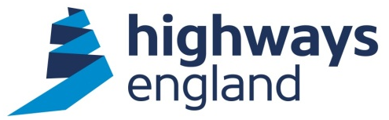  Our ref: 18126390 | Securing Goods and Services Lead - New Area 7  The Cube  199 Wharfside Street  Birmingham B1 1RN  Direct Line:  3 May 2016

Dear

FOI REQUEST - NEW AREA 7 MAINTENANCE CONTRACT WITH AMEY

Thank you for your request for information under the terms of the Freedom of Information Act 2000, requesting an electronic copy of the new Area 7 Maintenance and Response Contract with Amey. We originally received your request on 22 March and clarified this with you on 4 April. I can now advise that we will not have a fully compiled version of the contract until 31 May.

It is intended that the final version of this contract will be publicly available on the government transparency website https://www.gov.uk/contracts-finder in June. However, I will ensure that a copy is sent to you when I get it on 31 May. I would be grateful if you could provide a postal address that I can use to do this.

If you are unhappy with the way we have handled your request you may ask for an internal review. Our internal review process is available at: https://www.gov.uk/government/organisations/highways-england/about/complaints-procedure

If you require a print copy, please phone the Information Line on 0300 123 5000; or e-mail info@highwaysengland.co.uk. You should contact me if you wish to complain.

If you are not content with the outcome of the internal review, you have the right to apply directly to the Information Commissioner for a decision. The Information Commissioner can be contacted at:

Information Commissioner’s Office
Wycliffe House
Water Lane
Wilmslow
Cheshire
SK9 5AF
If you have any queries about this letter, please contact me. Please remember to quote reference number in any future communications.

Yours sincerely

Future Area 7 Project
Email:

