UK Standards for Microbiology Investigations

Investigation of Bone Marrow

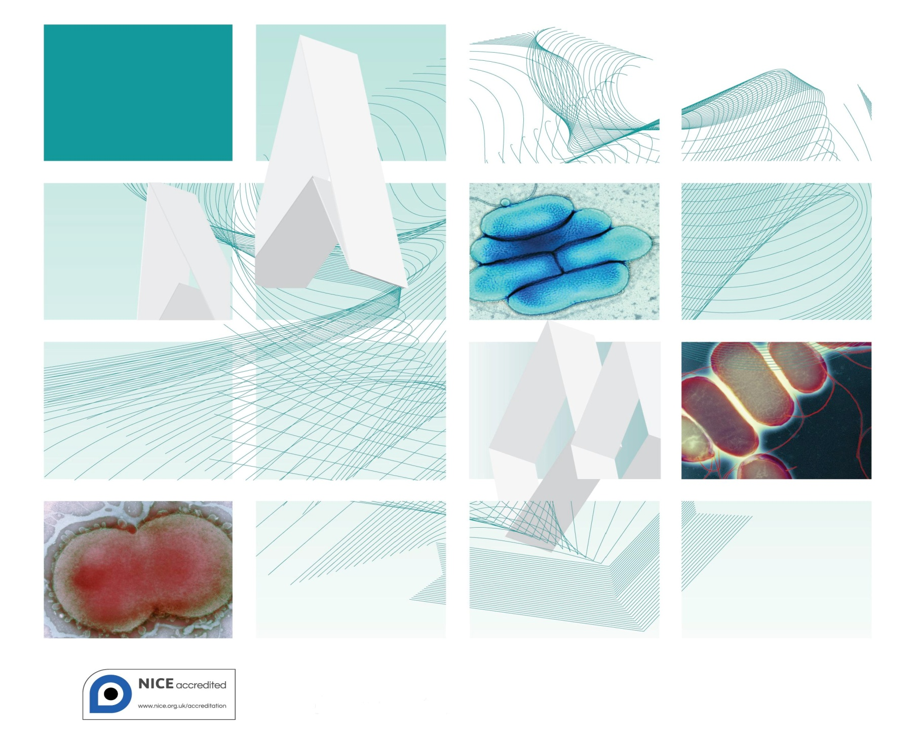

Acknowledgments
UK Standards for Microbiology Investigations (SMIs) are developed under the auspices of Public Health England (PHE) working in partnership with the National Health Service (NHS), Public Health Wales and with the professional organisations whose logos are displayed below and listed on the website http://www.hpa.org.uk/SMI/Partnerships. SMIs are developed, reviewed and revised by various working groups which are overseen by a steering committee (see http://www.hpa.org.uk/SMI/WorkingGroups).
The contributions of many individuals in clinical, specialist and reference laboratories who have provided information and comments during the development of this document are acknowledged. We are grateful to the Medical Editors for editing the medical content.
For further information please contact us at:
Standards Unit
Microbiology Services
Public Health England
61 Colindale Avenue
London NW9 5EQ
E-mail: standards@phe.gov.uk
Website: http://www.hpa.org.uk/SMI
UK Standards for Microbiology Investigations are produced in association with: 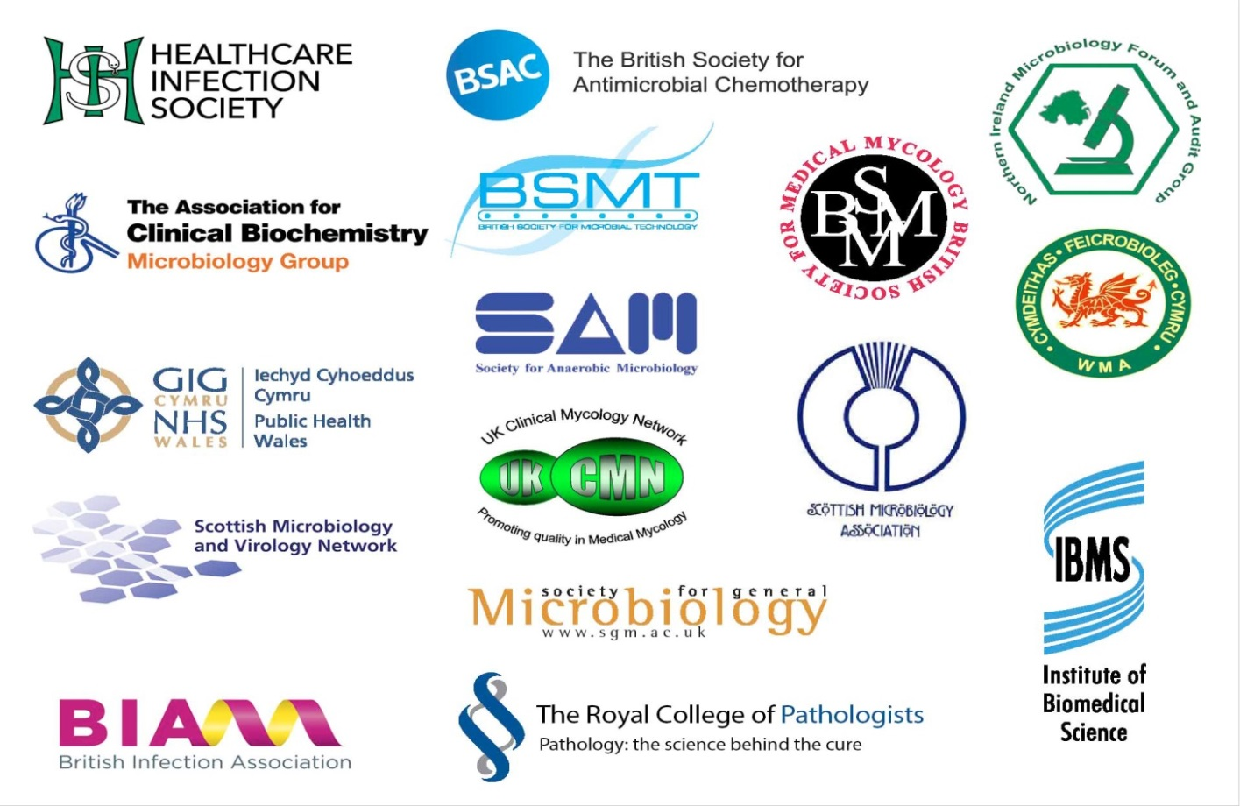

Contents
Acknowledgments 2
Amendment Table 4
UK SMI: Scope and Purpose 5
Scope of Document 7
Introduction 7
Technical Information/Limitations 10
1 Safety Considerations 11
2 Specimen Collection 11
3 Specimen Transport and Storage 12
4 Specimen Processing/Procedure 12
5 Reporting Procedure 14
6 Notification to PHE or Equivalent in the Devolved Administrations 15
Appendix 1: Investigation of Bone Marrow 16
References 17

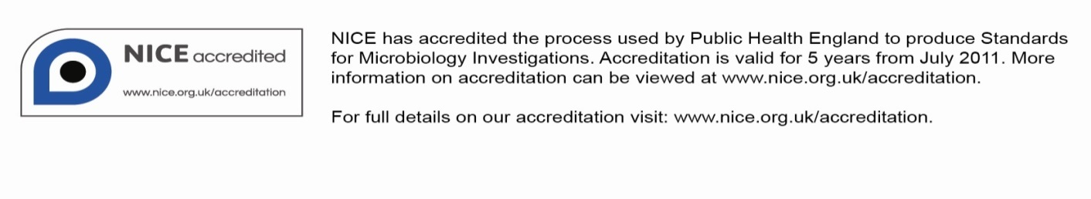
Amendment Table
Each SMI method has an individual record of amendments. The current amendments are listed on this page. The amendment history is available from standards@phe.gov.uk.
New or revised documents should be controlled within the laboratory in accordance with the local quality management system.
Amendment No/Date. | 3/dd.mm.yy <tab+enter>
Issue no. discarded. | 1.2
Insert Issue no. | #.# <tab+enter>
Section(s) involved | Amendment

Amendment No/Date. | 2/20.05.14
Issue no. discarded. | 1.1
Insert Issue no. | 1.2
Section(s) involved | Amendment
Whole document. | Document has been transferred to a new template to reflect the Health Protection Agency’s transition to Public Health England.  Front page has been redesigned.  Status page has been renamed as Scope and Purpose and updated as appropriate.  Professional body logos have been reviewed and updated.  Standard safety and notification references have been reviewed and updated.  Scientific content remains unchanged.
UK SMI#: Scope and Purpose
Users of SMIs
Primarily, SMIs are intended as a general resource for practising professionals operating in the field of laboratory medicine and infection specialties in the UK. SMIs also provide clinicians with information about the available test repertoire and the standard of laboratory services they should expect for the investigation of infection in their patients, as well as providing information that aids the electronic ordering of appropriate tests. The documents also provide commissioners of healthcare services with the appropriateness and standard of microbiology investigations they should be seeking as part of the clinical and public health care package for their population.
Background to SMIs
SMIs comprise a collection of recommended algorithms and procedures covering all stages of the investigative process in microbiology from the pre-analytical (clinical syndrome) stage to the analytical (laboratory testing) and post analytical (result interpretation and reporting) stages. Syndromic algorithms are supported by more detailed documents containing advice on the investigation of specific diseases and infections. Guidance notes cover the clinical background, differential diagnosis, and appropriate investigation of particular clinical conditions. Quality guidance notes describe laboratory processes which underpin quality, for example assay validation.
Standardisation of the diagnostic process through the application of SMIs helps to assure the equivalence of investigation strategies in different laboratories across the UK and is essential for public health surveillance, research and development activities.
Equal Partnership Working
SMIs are developed in equal partnership with PHE, NHS, Royal College of Pathologists and professional societies. The list of participating societies may be found at http://www.hpa.org.uk/SMI/Partnerships. Inclusion of a logo in an SMI indicates participation of the society in equal partnership and support for the objectives and process of preparing SMIs. Nominees of professional societies are members of the Steering Committee and Working Groups which develop SMIs. The views of nominees cannot be rigorously representative of the members of their nominating organisations nor the corporate views of their organisations. Nominees act as a conduit for two way reporting and dialogue. Representative views are sought through the consultation process. SMIs are developed, reviewed and updated through a wide consultation process.
Quality Assurance
NICE has accredited the process used by the SMI Working Groups to produce SMIs. The accreditation is applicable to all guidance produced since October 2009. The process for the development of SMIs is certified to ISO 9001:2008. SMIs represent a good standard of practice to which all clinical and public health microbiology laboratories in the UK are expected to work. SMIs are NICE accredited and represent neither minimum standards of practice nor the highest level of complex laboratory investigation possible. In using SMIs, laboratories should take account of local requirements and undertake additional investigations where appropriate. SMIs help laboratories to meet accreditation requirements by promoting high quality practices which are auditable. SMIs also provide a reference point for method development. The performance of SMIs depends on competent staff and appropriate quality reagents and equipment. Laboratories should ensure that all commercial and in-house tests have been validated and shown to be fit for purpose. Laboratories should participate in external quality assessment schemes and undertake relevant internal quality control procedures.
Patient and Public Involvement
The SMI Working Groups are committed to patient and public involvement in the development of SMIs. By involving the public, health professionals, scientists and voluntary organisations the resulting SMI will be robust and meet the needs of the user. An opportunity is given to members of the public to contribute to consultations through our open access website.
Information Governance and Equality
PHE is a Caldicott compliant organisation. It seeks to take every possible precaution to prevent unauthorised disclosure of patient details and to ensure that patient-related records are kept under secure conditions. The development of SMIs are subject to PHE Equality objectives http://www.hpa.org.uk/webc/HPAwebFile/HPAweb_C/1317133470313.
The SMI Working Groups are committed to achieving the equality objectives by effective consultation with members of the public, partners, stakeholders and specialist interest groups.
Legal Statement
Whilst every care has been taken in the preparation of SMIs, PHE and any supporting organisation, shall, to the greatest extent possible under any applicable law, exclude liability for all losses, costs, claims, damages or expenses arising out of or connected with the use of an SMI or any information contained therein. If alterations are made to an SMI, it must be made clear where and by whom such changes have been made.
The evidence base and microbial taxonomy for the SMI is as complete as possible at the time of issue. Any omissions and new material will be considered at the next review. These standards can only be superseded by revisions of the standard, legislative action, or by NICE accredited guidance.
SMIs are Crown copyright which should be acknowledged where appropriate.
Suggested Citation for this Document
Public Health England. (YYYY <tab+enter>). Investigation of Bone Marrow. UK Standards for Microbiology Investigations. B 38 Issue xx. http://www.hpa.org.uk/SMI/pdf

Scope of Document
Type of Specimen
Bone marrow
Scope
This SMI describes the processing and microbiological investigation of bone marrow submitted for clinical diagnostic purposes. This SMI concentrates on the culture of bone marrow samples for the identification of bacteria and fungi. Other methods of investigation are available for the identification of bacteria, fungi, parasites and viruses, but are not covered in this SMI.
This SMI should be used in conjunction with other SMIs.
Introduction
Microbiological examination of bone marrow is an invasive technique infrequently performed for the investigation of pyrexia of unknown origin (PUO) and occasionally for other indications¹. It is sometimes undertaken when other less invasive investigations and diagnostic imaging have failed to determine a cause, or, more frequently, when infection is part of the differential diagnosis in the investigation of haematological abnormalities². The demonstration of microorganisms in bone marrow by microscopy, culture or nucleic acid amplification techniques is useful for diagnosis of infection with a limited number of bacteria, fungi, parasites and viruses³⁻⁵.
Bone marrow is aspirated from the posterior iliac crest or the sternum; a core biopsy may also be collected, and this can be examined histologically for evidence of granulomata and microorganisms. The aspirate is the preferred specimen for microbiological studies.
Infection in Patients who are Immunocompromised
It has been suggested that bone marrow cultures should not be used for immunocompetent patients, but should be reserved for patients who are severely immunosuppressed⁶. Conditions leading to significant immunosuppression such as advanced HIV infection, bone marrow or solid organ transplant, or high dose corticosteroid therapy predispose patients to infection with opportunistic pathogens and make disseminated infection with other pathogens more likely⁷. In these cases culture of bone marrow may be useful in the investigation of pyrexia of unknown origin (PUO)^{2,8}. Mycobacterium species, Histoplasma capsulatum, Paracoccidioides brasiliensis, Penicillium marneffei and Leishmania species are likely to cause disseminated infection in the setting of immunosuppression⁶.
Organisms which have been Demonstrated in Bone Marrow
Some organisms invade bone marrow as part of a multi-system infection, whereas others have a tropism for bone marrow or the cell lines therein. In several studies, culture of bone marrow has been shown to be a faster and more sensitive method of isolation of certain organisms (eg Brucella species and Salmonella Typhi) compared to blood culture, however in some, similar yields and turnaround times were observed^{5,9-11}. Bone marrow cultures may be positive for patients with acute or chronic infection; whereas blood cultures are more likely to be positive in patients with acute infections¹⁰. Bone marrow aspirates are also more likely than blood culture to be positive in patients who have been treated with antibiotics^{5,12}.
Bone marrow examination is most likely to be performed for the organisms below. The list is not exhaustive; other organisms may be detected or isolated.
Bacteria

Salmonella Typhi and Salmonella Paratyphi
Salmonella Typhi and Salmonella Paratyphi (groups A, B, and C) are the causative organisms of enteric (typhoid) fever and are usually carried by humans, and transmitted via contaminated food or water⁵. Enteric fever is the only bacterial infection for which bone marrow is routinely recommended¹³. Culture of bone marrow is considered to be the ‘gold standard’ method for diagnosis of typhoid fever; compared to blood culture which may lack sensitivity, culture of bone marrow aspirates has been shown to produce a higher yield even when following antimicrobial treatment^{5,13}. In one study it was shown that 1mL of bone marrow gave equivalent result to 15mL of blood¹⁴. Serology is available, but has a low sensitivity and specificity due to cross reactions with other Salmonella species and Enterobacteriaceae¹⁴. Nucleic acid amplification tests (NAATs) on culture positive bone marrow aspirates have been reported, but are not yet in routine use¹⁵. Cultures of S. Typhi and of S. Paratyphi A, B or C, known or suspected, must be handled at Containment Level 3.

Brucella species
Brucella is a zoonotic disease which has a wide range of symptoms and is thought to be greatly undiagnosed. Laboratory diagnostic techniques include culture, NAATs and antibody detection (the presence of antibodies is not always indicative of active brucellosis). Recovery from blood is suboptimal and it has been suggested that culture of bone marrow (liver tissue and lymph nodes) may improve the recovery rate within a shorter time frame^{9,10,16}.

Mycobacterium species
Mycobacterium species are considered an important cause of pyrexia of unknown origin. Tuberculosis is primarily caused by Mycobacterium tuberculosis; a number of non-tuberculous mycobacterial species have been isolated from systemic infections in patients who are HIV positive. Culture is considered the ‘gold standard’ method for laboratory diagnosis, however incubation times may be long³. The use of continuous blood culturing systems reduces culture time; positive results may be available within five to seven days¹⁶. Bone marrow culture assists in aiding diagnosis in uncertain cases of disseminated disease, particularly in those with HIV^{11,17,18}. Molecular methods for detection are currently under development (refer to B 40 – Investigation of Specimens for Mycobacterium Species)³.
Fungi
Infection with dimorphic fungi such as Histoplasma capsulatum, Paracoccidioides brasiliensis or Penicillium marneffei may occasionally be diagnosed by bone marrow examination, but culture sensitivity varies¹⁹. Culture for Histoplasma capsulatum and Paracoccidioides brasiliensis may take between two and six weeks; continuous monitoring blood culture systems have been shown to reduce culture time of Penicillium marneffei to about four days²⁰⁻²². It has been suggested that culture of bone marrow samples may be more sensitive than other tests; however, diagnosis is more frequently made by detection of these organisms in respiratory and tissue specimens¹¹.
Parasites

Leishmania species
There are over 20 species of the protozoan parasite Leishmania. Humans are infected by the bite of infected female sandflies. The disease is endemic in five continents and over eighty countries. Leishmaniasis presents as three distinct syndromes, visceral (also known as Kala-azar), cutaneous and mucosal. Visceral Leishmaniasis, for which bone marrow investigation may be performed, can be fatal if untreated and is characterised by fever, weight loss, hepatosplenomegaly and pancytopenia²³. Co-infection with HIV in endemic areas is associated with a more rapid progression to AIDS and infection has been transmitted through needle-sharing by infected drug users in south west Europe¹.
Following presumptive identification using Giemsa stain to detect amastigotes, samples should be sent to the reference laboratory for confirmation. Rapid diagnostic tests including direct agglutination and immunochromographic tests (ICT) have been developed and evaluated^{1,24}. Serological diagnosis is available but it is significantly less sensitive in those with advanced HIV coinfection than for HIV negative individuals; negative results should not therefore be used to rule out a diagnosis in those with HIV^{4,25}. Cross-reactions can occur in patients with prior exposure to Trypanosoma cruzi. Splenic puncture is the most sensitive test, but bone marrow examination is safer and has a sensitivity of around 70 – 80%^{1,23}.
Viruses
Many viruses can be detected in bone marrow samples. Viral detection indicates infection, but does not necessarily confirm diagnosis of disease. The clinical significance of a positive bone marrow result is dependent on the immune status of the patient and the disease/illness under investigation; positive results from bone marrow samples must therefore be interpreted with caution. Routinely, NAATs or serology on peripheral blood is used for diagnosis of acute viral infection. In the immunocompromised, blood serology results may be negative at the onset of clinical disease. If there is a high clinical suspicion of viral infection, but peripheral blood NAATs results are negative, diagnosis may be confirmed by bone marrow examination.
Rapid Techniques
Molecular methods²⁶⁻²⁸
NAATs - Nucleic Acid Amplification Techniques (eg PCR) for the identification of bacteria, fungi, parasites and viruses from clinical samples have been shown to be highly specific and sensitive. PCR targets conserved genes of the genome, and enables the rapid identification of organisms including those that are slow to grow or are unculturable. Results are available within a short timeframe particularly if multiplex real-time PCR is used.
MALDI-TOF Mass Spectrometry^{29,30}
Recent developments in identification of bacteria and yeast include the use of 16s ribosomal protein profiles obtained by Matrix Assisted Laser Desorption Ionisation – Time of Flight (MALDI-TOF) mass spectrometry. Mass peaks achieved by the test strains are compared to those of known reference strains. It is possible for an organism to be identified from an isolate within a short time frame and it is increasingly being used in laboratories to provide a robust, rapid and effective identification system for bacterial and yeast isolates.
Technical Information/Limitations
Limitations of UK SMIs
The recommendations made in UK SMIs are based on evidence (eg sensitivity and specificity) where available, expert opinion and pragmatism, with consideration also being given to available resources. Laboratories should take account of local requirements and undertake additional investigations where appropriate. Prior to use, laboratories should ensure that all commercial and in-house tests have been validated and are fit for purpose.
Specimen Containers^{31,32}
SMIs use the term “CE marked leak proof container” to describe containers bearing the CE marking used for the collection and transport of clinical specimens. The requirements for specimen containers are given in the EU in vitro Diagnostic Medical Devices Directive (98/79/EC Annex 1 B 2.1) which states: “The design must allow easy handling and, where necessary, reduce as far as possible contamination of, and leakage from, the device during use and, in the case of specimen receptacles, the risk of contamination of the specimen. The manufacturing processes must be appropriate for these purposes”.
1 Safety Considerations³¹⁻⁴⁷
1.1 Specimen Collection Transport and Storage³¹⁻³⁶
Use aseptic technique.
Ideally, specimens should be collected directly into blood culture bottles, however, appropriate CE marked leak-proof containers may be used in some circumstances.
Transport in sealed plastic bags.
Compliance with postal, transport and storage regulations is essential.
1.2 Specimen Processing³¹⁻⁴⁷
Containment Level 2.
All laboratory procedures (including the examination of plates and cultures) must be conducted in a microbiological safety cabinet³⁹.
Where Hazard Group 3 organisms eg Mycobacterium tuberculosis, Salmonella Typhi, Salmonella Paratyphi, dimorphic fungi and Brucella species are suspected, all specimens must be processed in a microbiological safety cabinet under full Containment Level 3 conditions.
Some Hazard Group 3 fungi are thermally dimorphic, and will grow as yeast form in blood culture bottles and sub-cultures at 37°C, but as the highly infective mould form when sub-cultured onto agar plates incubated at 28-30°C. Care should be taken with yeast isolates if there is a relevant travel history, especially in HIV-infected individuals.
If blood culture bottles are employed to provide an enrichment broth then any consequential use and subsequent disposal of syringes and needles must comply with local safety protocols.
Specimen containers must also be placed in a suitable holder.
Refer to current guidance on the safe handling of all organisms documented in this SMI.
The above guidance should be supplemented with local COSHH and risk assessments.
2 Specimen Collection
2.1 Type of Specimens
Bone marrow
2.2 Optimal Time and Method of Collection⁴⁸
For safety considerations refer to Section 1.1.
Collect specimens before antimicrobial therapy where possible⁴⁸.
Specimens should ideally be collected in blood culture bottles. However, in accordance with local requirements, additional specimens may be collected in appropriate CE marked leak-proof containers containing anti-coagulants and placed in sealed plastic bags.
2.3 Adequate Quantity and Appropriate Number of Specimens⁴⁸
As large a sample as possible should be obtained, with the caveat that volumes of >3mL are likely to be contaminated with peripheral blood which may have a dilution effect.
Numbers and frequency of specimen collection are dependent on clinical condition of patient.
3 Specimen Transport and Storage^{31,32}
3.1 Optimal Transport and Storage Conditions
For safety considerations refer to Section 1.1.
Specimens should be transported and processed as soon as possible⁴⁸.
4 Specimen Processing/Procedure^{31,32}
4.1 Test Selection
Select a representative portion of specimen for appropriate procedures such as culture for Mycobacterium species.
Refer to B 40 – Investigation of Specimens for Mycobacterium Species.
4.2 Appearance
N/A
4.3 Sample Preparation
4.3.1 Pre-treatment
If not already done, inoculate blood culture bottles with specimen and load onto the automated continuous monitoring blood culture system. Subculture positive bottles as required (see B 37 – Investigation of Blood Cultures (for Organisms other than Mycobacterium Species)).
4.3.2 Specimen Processing

Standard
Bottles that flag as positive on the automated system should be subcultured according to the same procedure as for blood culture bottles (see B 37 – Investigation of Blood Cultures (for Organisms other than Mycobacterium Species)).
4.4 Microscopy
4.4.1 Standard
Gram Stain
See TP 39 – Staining Procedures

Giemsa Stain
Giemsa stains should be carried out as indicated by local protocols; a smear maybe made at the patient’s bedside or at the receiving laboratory.
(See TP 39 – Staining Procedures)
4.5 Culture and Investigation
Inoculate each agar plate using a sterile pipette (Q 5 - Inoculation of Culture Media for Bacteriology).
For the isolation of individual colonies, spread inoculum with a sterile loop.
4.5.1 Culture media, conditions and organisms
Clinical details/  conditions | Specimen | Standard media | Incubation |  |  | Cultures read | Target organism(s)
 |  |  | Temp °C | Atmos | Time
All clinical conditions | Bone marrow | Blood culture broths (aerobic and anaerobic)  Subculture positive bottles onto subculture plates below. | 35 – 37 | Air | 5 d  + terminal subculture | Continuous monitoring | Any organism
Subculture plates | Bone marrow | Blood agar | 35 – 37 | 5 – 10% CO₂ | 40 – 48hr | ≥40hr | Any organism
 |  | Chocolate agar | 35 - 37 | 5 – 10% CO₂ | 40 - 48hr* | ≥40hr | Any organism
 |  | FAA** | 35-37 | Anaerobic | 5 d | 3 d and 5 d | Anaerobes
For these situations, add the following:
Clinical details/  conditions | Specimen | Supplement-ary media | Incubation |  |  | Cultures read | Target organism(s)
 |  |  | Temp °C | Atmos | Time
Systemic fungal infection | Bone marrow | Sabouraud agar | 28 - 30 | Air | 5 d | Daily | Yeast and Mould
Other organisms for consideration - Mycobacterium species (see B 40 - Investigation of Specimens for Mycobacterium species), fungi, parasites (see B 31 - Investigation of Specimens other than Blood for Parasites) and viruses (see www.hpa.org.uk/smi/pdf/virology).
*Incubation times may be increased up to 5 days if Brucella species infection is suspected.
**Neomycin FAA with metronidazole 5µg disc may be used dependent on local policy.
4.6 Identification
Refer to individual SMIs for organism identification.

4.6.1 Minimum level of identification in the laboratory
All organisms to species level.
Organisms may be further identified if this is clinically or epidemiologically indicated.
Note: Any organism considered to be a contaminant may not require identification to species level.
4.7 Antimicrobial Susceptibility Testing
Refer to British Society for Antimicrobial Chemotherapy (BSAC) and/or EUCAST guidelines.
4.8 Referral for Outbreak Investigations
N/A
4.9 Referral to Reference Laboratories
Organisms with unusual or unexpected resistance and whenever there is a laboratory or clinical problem, or anomaly that requires elucidation should be sent to the appropriate reference laboratory.
Contact appropriate devolved national reference laboratory for information on the tests available, turnaround times, transport procedure and any other requirements for sample submission:
England and Wales http://www.hpa.org.uk/webw/HPAweb&Page&HPAwebAutoListName/Page/1158313434370?p=1158313434370
Scotland
http://www.hps.scot.nhs.uk/reflab/index.aspx
Northern Ireland
http://www.publichealth.hscni.net/directorate-public-health/health-protection
5 Reporting Procedure
5.1 Microscopy
Gram Stain
Report organism detected.
Giemsa Stain
Report as indicated by local protocols.
5.1.1 Microscopy reporting time
Clinically urgent results should be released immediately, within a two hour period, following local policy.
Written or computer generated reports: 16–72hr.
5.2 Culture
Report clinically significant isolates
or
Report other growth
or
Report absence of growth.
5.2.1 Culture reporting time
Clinically urgent results should be released immediately, within a two hour period, following local policy.
Written or computer generated reports: 16–72hr stating, if appropriate, that a further report will be issued.
5.3 Antimicrobial Susceptibility Testing
Report susceptibilities as clinically indicated. Prudent use of antimicrobials according to local and national protocols is recommended.
6 Notification to PHE^{49,50} or Equivalent in the Devolved Administrations⁵¹⁻⁵⁴
The Health Protection (Notification) regulations 2010 require diagnostic laboratories to notify Public Health England (PHE) when they identify the causative agents that are listed in Schedule 2 of the Regulations. Notifications must be provided in writing, on paper or electronically, within seven days. Urgent cases should be notified orally and as soon as possible, recommended within 24 hours. These should be followed up by written notification within seven days.
For the purposes of the Notification Regulations, the recipient of laboratory notifications is the local PHE Health Protection Team. If a case has already been notified by a registered medical practitioner, the diagnostic laboratory is still required to notify the case if they identify any evidence of an infection caused by a notifiable causative agent.
Notification under the Health Protection (Notification) Regulations 2010 does not replace voluntary reporting to PHE. The vast majority of NHS laboratories voluntarily report a wide range of laboratory diagnoses of causative agents to PHE and many PHE Health protection Teams have agreements with local laboratories for urgent reporting of some infections. This should continue.
Note: The Health Protection Legislation Guidance (2010) includes reporting of Human Immunodeficiency Virus (HIV) & Sexually Transmitted Infections (STIs), Healthcare Associated Infections (HCAIs) and Creutzfeldt–Jakob disease (CJD) under ‘Notification Duties of Registered Medical Practitioners’: it is not noted under ‘Notification Duties of Diagnostic Laboratories’.
http://www.hpa.org.uk/Topics/InfectiousDiseases/InfectionsAZ/HealthProtectionRegulations/
Other arrangements exist in Scotland^{51,52}, Wales⁵³ and Northern Ireland⁵⁴.
Appendix 1: Investigation of Bone Marrow

References
1. World Health Organization. The leishmaniasis and Leishmania/HIV co-infections. WHO. 2007.
2. Volk EE, Miller ML, Kirkley BA, Washington JA. The diagnostic usefulness of bone marrow cultures in patients with fever of unknown origin. Am J Clin Pathol 1998;110:150-3.
3. Singh UB, Bhanu NV, Suresh VN, Arora J, Rana T, Seth P. Utility of polymerase chain reaction in diagnosis of tuberculosis from samples of bone marrow aspirate. Am J Trop Med Hyg 2006;75:960-3.
4. Cota GF, de Sousa MR, Demarqui FN, Rabello A. The diagnostic accuracy of serologic and molecular methods for detecting visceral leishmaniasis in HIV infected patients: meta-analysis. PLoS Negl Trop Dis 2012;6:e1665.
5. Parry CM, Wijedoru L, Arjyal A, Baker S. The utility of diagnostic tests for enteric fever in endemic locations. Expert Rev Anti Infect Ther 2011;9:711-25.
6. Riley UB, Crawford S, Barrett SP, Abdalla SH. Detection of mycobacteria in bone marrow biopsy specimens taken to investigate pyrexia of unknown origin. J Clin Pathol 1995;48:706-9.
7. Bishburg E, Eng RH, Smith SM, Kapila R. Yield of bone marrow culture in the diagnosis of infectious diseases in patients with acquired immunodeficiency syndrome. J Clin Microbiol 1986;24:312-4.
8. Jha A, Sarda R, Gupta A, Talwar OP. Bone marrow culture vs. blood culture in FUO. JNMA J Nepal Med Assoc 2009;48:135-8.
9. Smitha B, Peerapur BV. Utility of bone marrow culture in the definitive diagnosis of human brucellosis. J Commun Dis 2010;42:169-70.
10. Mantur BG, Mulimani MS, Bidari LH, Akki AS, Tikare NV. Bacteremia is as unpredictable as clinical manifestations in human brucellosis. Int J Infect Dis 2008;12:303-7.
11. Kilby JM, Marques MB, Jaye DL, Tabereaux PB, Reddy VB, Waites KB. The yield of bone marrow biopsy and culture compared with blood culture in the evaluation of HIV-infected patients for mycobacterial and fungal infections. Am J Med 1998;104:123-8.
12. Farooqui BJ, Khurshid M, Ashfaq MK, Khan MA. Comparative yield of Salmonella typhi from blood and bone marrow cultures in patients with fever of unknown origin. J Clin Pathol 1991;44:258-9.
13. Wain J, Pham VB, Ha V, Nguyen NM, To SD, Walsh AL, et al. Quantitation of bacteria in bone marrow from patients with typhoid fever: relationship between counts and clinical features. J Clin Microbiol 2001;39:1571-6.
14. Wain J, Diep TS, Bay PV, Walsh AL, Vinh H, Duong NM, et al. Specimens and culture media for the laboratory diagnosis of typhoid fever. J Infect Dev Ctries 2008;2:469-74.
15. Nga TV, Karkey A, Dongol S, Thuy HN, Dunstan S, Holt K, et al. The sensitivity of real-time PCR amplification targeting invasive Salmonella serovars in biological specimens. BMC Infect Dis 2010;10:125.
16. Ozturk R, Mert A, Kocak F, Ozaras R, Koksal F, Tabak F, et al. The diagnosis of brucellosis by use of BACTEC 9240 blood culture system. Diagnostic Microbiology and Infectious Disease 2002;44:133-5.
17. Rose PC, Schaaf HS, Marais BJ, Gie RP, Stefan DC. Value of bone marrow biopsy in children with suspected disseminated mycobacterial disease. Int J Tuberc Lung Dis 2011;15:200-4, i.
18. van Schalkwyk WA, Opie J, Novitzky N. The diagnostic utility of bone marrow biopsies performed for the investigation of fever and/or cytopenias in HIV-infected adults at Groote Schuur Hospital, Western Cape, South Africa. Int J Lab Hematol 2011;33:258-66.
19. Guarner J, Brandt ME. Histopathologic diagnosis of fungal infections in the 21st century. Clin Microbiol Rev 2011;24:247-80.
20. Munoz C, Gomez BL, Tobon A, Arango K, Restrepo A, Correa MM, et al. Validation and clinical application of a molecular method for identification of Histoplasma capsulatum in human specimens in Colombia, South America. Clin Vaccine Immunol 2010;17:62-7.
21. Buitrago MJ, Bernal-Martinez L, Castelli MV, Rodriguez-Tudela JL, Cuenca-Estrella M. Histoplasmosis and paracoccidioidomycosis in a non-endemic area: a review of cases and diagnosis. J Travel Med 2011;18:26-33.
22. Wong SY, Wong KF. Penicillium marneffei Infection in AIDS. Patholog Res Int 2011;2011:764293.
23. Pintado V, Martin-Rabadan P, Rivera ML, Moreno S, Bouza E. Visceral leishmaniasis in human immunodeficiency virus (HIV)-infected and non-HIV-infected patients. A comparative study. Medicine (Baltimore) 2001;80:54-73.
24. World Health Organization. Diagnostic evaluation Series No.4: Visceral leishmaniasis rapid diagnostic test performance. 2011.
25. Pintado V, Martin-Rabadan P, Rivera ML, Moreno S, Bouza E. Visceral leishmaniasis in human immunodeficiency virus (HIV)-infected and non-HIV-infected patients. A comparative study. Medicine (Baltimore) 2001;80:54-73.
26. Antinori S, Calattini S, Longhi E, Bestetti G, Piolini R, Magni C, et al. Clinical use of polymerase chain reaction performed on peripheral blood and bone marrow samples for the diagnosis and monitoring of visceral leishmaniasis in HIV-infected and HIV-uninfected patients: a single-center, 8-year experience in Italy and review of the literature. Clin Infect Dis 2007;44:1602-10.
27. Espy MJ, Uhl JR, Sloan LM, Buckwalter SP, Jones MF, Vetter EA, et al. Real-time PCR in clinical microbiology: applications for routine laboratory testing. Clin Microbiol Rev 2006;19:165-256.
28. Martagon-Villamil J, Shrestha N, Sholtis M, Isada CM, Hall GS, Bryne T, et al. Identification of Histoplasma capsulatum from culture extracts by real-time PCR. J Clin Microbiol 2003;41:1295-8.
29. Carbonnelle E, Mesquita C, Bille E, Day N, Dauphin B, Beretti JL, et al. MALDI-TOF mass spectrometry tools for bacterial identification in clinical microbiology laboratory. Clin Biochem 2011;44:104-9.
30. van Veen SQ, Claas ECJ, Kuijper EJ. High-Throughput Identification of Bacteria and Yeast by Matrix-Assisted Laser Desorption Ionization-Time of Flight Mass Spectrometry in Conventional Medical Microbiology Laboratories â–¿. J Clin Microbiol 2010;48:900-7.
31. European Parliament. UK Standards for Microbiology Investigations (SMIs) use the term "CE marked leak proof container" to describe containers bearing the CE marking used for the collection and transport of clinical specimens. The requirements for specimen containers are given in the EU in vitro Diagnostic Medical Devices Directive (98/79/EC Annex 1 B 2.1) which states: "The design must allow easy handling and, where necessary, reduce as far as possible contamination of, and leakage from, the device during use and, in the case of specimen receptacles, the risk of contamination of the specimen. The manufacturing processes must be appropriate for these purposes".
32. Official Journal of the European Communities. Directive 98/79/EC of the European Parliament and of the Council of 27 October 1998 on in vitro diagnostic medical devices. 7-12-1998. p. 1-37.
33. Health and Safety Executive. Safe use of pneumatic air tube transport systems for pathology specimens. 9/99.
34. Department for transport. Transport of Infectious Substances, 2011 Revision 5. 2011.
35. World Health Organization. Guidance on regulations for the Transport of Infectious Substances 2013-2014. 2012.
36. Home Office. Anti-terrorism, Crime and Security Act. 2001 (as amended).
37. Advisory Committee on Dangerous Pathogens. The Approved List of Biological Agents. Health and Safety Executive. 2013. p. 1-32
38. Advisory Committee on Dangerous Pathogens. Infections at work: Controlling the risks. Her Majesty's Stationery Office. 2003.
39. Advisory Committee on Dangerous Pathogens. Biological agents: Managing the risks in laboratories and healthcare premises. Health and Safety Executive. 2005.
40. Advisory Committee on Dangerous Pathogens. Biological Agents: Managing the Risks in Laboratories and Healthcare Premises. Appendix 1.2 Transport of Infectious Substances - Revision. Health and Safety Executive. 2008.
41. Centers for Disease Control and Prevention. Guidelines for Safe Work Practices in Human and Animal Medical Diagnostic Laboratories. MMWR Surveill Summ 2012;61:1-102.
42. Health and Safety Executive. Control of Substances Hazardous to Health Regulations. The Control of Substances Hazardous to Health Regulations 2002. 5th ed. HSE Books; 2002.
43. Health and Safety Executive. Five Steps to Risk Assessment: A Step by Step Guide to a Safer and Healthier Workplace. HSE Books. 2002.
44. Health and Safety Executive. A Guide to Risk Assessment Requirements: Common Provisions in Health and Safety Law. HSE Books. 2002.
45. Health Services Advisory Committee. Safe Working and the Prevention of Infection in Clinical Laboratories and Similar Facilities. HSE Books. 2003.
46. British Standards Institution (BSI). BS EN12469 - Biotechnology - performance criteria for microbiological safety cabinets. 2000.
47. British Standards Institution (BSI). BS 5726:2005 - Microbiological safety cabinets. Information to be supplied by the purchaser and to the vendor and to the installer, and siting and use of cabinets. Recommendations and guidance. 24-3-2005. p. 1-14
48. Baron EJ, Miller JM, Weinstein MP, Richter SS, Gilligan PH, Thomson RB, Jr., et al. A Guide to Utilization of the Microbiology Laboratory for Diagnosis of Infectious Diseases: 2013 Recommendations by the Infectious Diseases Society of America (IDSA) and the American Society for Microbiology (ASM). Clin Infect Dis 2013;57:e22-e121.
49. Public Health England. Laboratory Reporting to Public Health England: A Guide for Diagnostic Laboratories. 2013. p. 1-37.
50. Department of Health. Health Protection Legislation (England) Guidance. 2010. p. 1-112.
51. Scottish Government. Public Health (Scotland) Act. 2008 (as amended).
52. Scottish Government. Public Health etc. (Scotland) Act 2008. Implementation of Part 2: Notifiable Diseases, Organisms and Health Risk States. 2009.
53. The Welsh Assembly Government. Health Protection Legislation (Wales) Guidance. 2010.
54. Home Office. Public Health Act (Northern Ireland) 1967 Chapter 36. 1967 (as amended).

# Microbiology is used as a generic term to include the two GMC-recognised specialties of Medical Microbiology (which includes Bacteriology, Mycology and Parasitology) and Medical Virology.

