Summary of Economic Estimates for the Creative Industries and the Digital Sector
April 2016

Background

This release provides a summary of economic estimates for the Creative Industries and the Digital Sector. These two sectors have been included in this combined publication due to the significant overlap in the sectors. Definitions for the Creative Industries and Digital Sector including the full list of standard industrial classifications that make up these definitions can be found in the Creative Industries Economic Estimates and Digital Sector Economic Estimates publications.

This release draws together a range of data already published to make it available in one place and makes further detailed analysis by standard industrial classification available. The following economic estimates are included in this release:

- Gross value added (GVA)
- Number of enterprises
- Employment
- Exports of services

The accompanying tables provide a breakdown for each of these measures by SIC code.

Additional analysis can be found in related ad-hoc statistical releases.

The estimates in this statistical release have been produced using Office for National Statistics (ONS) sources (the Annual Business Survey, the Annual Population Survey and International Trade in Services data). The methodology used to produce these estimates, along with limitations and assumptions, can be found in the Creative Industries and Digital Sector Economic Estimates Methodology note.

Gross Value Added (GVA), 2009 – 2014
All GVA estimates in this release are measured in current prices (i.e. not adjusted for inflation). In 2014:
- GVA of the Creative Industries was £84.1bn accounting for 5.2 per cent of the UK economy.
- GVA of the Digital Sector was £118.3bn, accounting for 7.3 per cent of the UK economy.
- £57.8bn of this contribution to GVA is counted as part of the Creative Industries and part of the Digital Sector, giving a total GVA for both sectors of £144.6bn.
Both the Creative Industries and the Digital Sector increased at a faster rate than the UK economy between 2013 and 2014, with the Creative Industries increasing 8.9 per cent on the previous year and the Digital Sector increasing by 7.2 per cent, compared with a 4.6 per cent increase for the whole UK economy between 2013 and 2014. Figure 1 shows growth in these industries since 2009 (2009 = 100).

Figure 1: GVA of the Creative Industries and Digital Sector indexed to 2009 = 100, 2009 - 2014
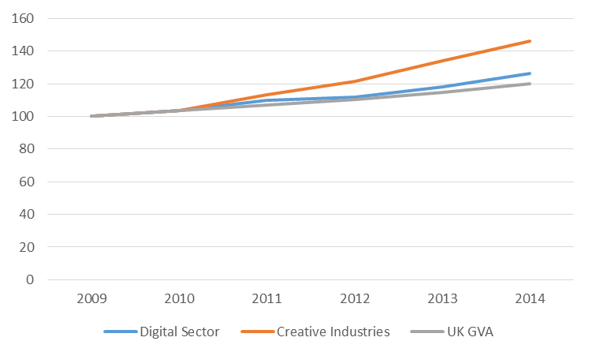
Creative Industries
- ‘IT, software and computer services’ was the Creative Industry group responsible for the highest proportion of Creative Industries GVA in 2014. This sector was worth £35.6bn, making up 43.5 per cent of total Creative Industries GVA.
- The SIC code that was responsible for the highest proportion of Creative Industries GVA was 62.02 (Computer consultancy activities). This sector was worth £24.2bn (28.8 per cent of total Creative Industries GVA).
Digital Sector
- ‘Computer programming, consultancy and related activities’ was the Digital Sector group with the highest contribution to Digital Sector GVA in 2014. This group was worth £46.0bn, responsible for 38.9 per cent of total Digital Sector GVA.
- The SIC code that was responsible for the highest proportion of Digital Sector GVA was 61.9 (Other telecommunications activities). This sector was worth £28.3bn (23.9 per cent of total Digital Sector GVA).
Table 1 in the accompanying spreadsheet provides GVA by SIC code for each SIC making up the Creative Industries and Digital Sector (2008 – 2014).

Number of Enterprises, 2008 – 2014
In 2014 there were 296,810 enterprises across the Creative Industries and Digital Sector in the UK, based on the Annual Business Survey definition of enterprises. The Creative Industries has a greater number of enterprises (248,770) than the Digital Sector (199,188) despite the Digital Sector having a higher GVA, 151,148 of these enterprises are categorised as Creative Industries and Digital Sector. This shows that the Creative Industries have a larger number of smaller businesses relative to the Digital Sector. The number of enterprises in the Creative Industries and the Digital Sector has been increasing since 2010 (see figure 2).
Figure 2: Number of enterprises in the Creative Industries and the Digital Sector, 2008-2014
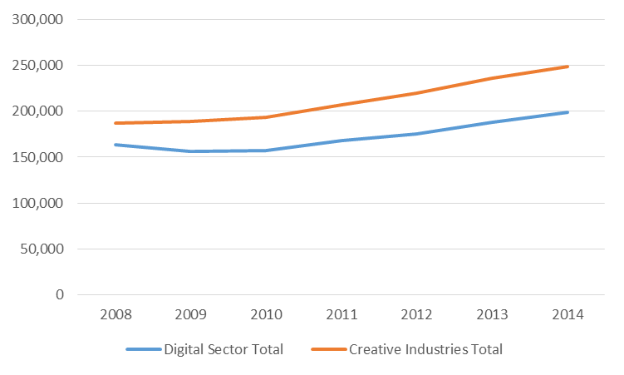
Table 2 in the accompanying spreadsheet provides the number of enterprises by SIC code for each SIC making up the Creative Industries and Digital Sector (2008 – 2014).
Number of exporting and importing enterprises, 2011 - 2014
At the Great Britain (GB) level, data are also available on the number of exporting and importing enterprises. In 2014:
- 49,300 Creative Industries enterprises were either exporting or importing goods or services (20.0% of Creative Industries enterprises in GB), up from 39,200 in 2011.
- 38,800 Digital Sector enterprises were either exporting or importing goods or services (19.7% of all Digital Sector enterprises in GB), up from 34,200 in 2011.
Figure 3 shows how this splits between those importing and those exporting.
Figure 3: Percentage of enterprises importing and exporting goods and services
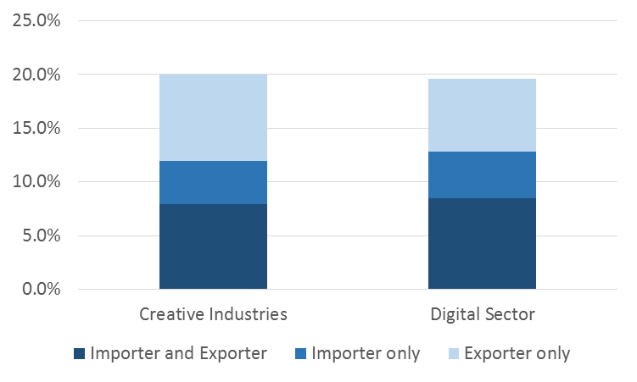

Employment, 2014
In 2014, there were 1.8 million jobs in the Creative Industries in the UK, and 1.4 million jobs in the Digital Sector. This was an increase on 2013 for both the Creative Industries and the Digital Sector, with a 5.5 per cent and 1.3 per cent increase respectively. Due to the overlap in definitions for Digital Sector and Creative Industries, in 2014, 961,000 jobs counted towards the totals for both sectors, see figure 4.
Figure 4: Overlap of jobs in the Creative Industries and Digital Sector, 2014
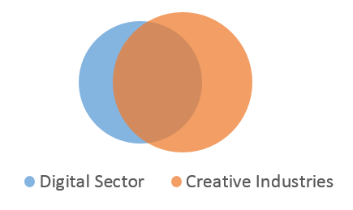

Table 3 in the accompanying spreadsheet provides the number of jobs by SIC code for each SIC making up the Creative Industries and Digital Sector (2014).

Exports of Services, 2009 – 2013
All exports of services figures are given in current prices (i.e. not adjusted for inflation). In 2013:
- UK Creative Industries exported £17.9bn worth of services, 8.7 per of all UK exports of services and 3.5 per cent more than 2012.
- UK Digital Sector exported £27.6bn worth of services, 12.8 per cent of total UK exports of services and 5.7 per cent more than 2012.
The SIC code that contributed the highest proportion of exports of services was the same across both sectors, and was also the same SIC code that was responsible for the highest proportion of Creative Industries GVA and employment (62.02, computer consultancy activities). The value of exports of services from the UK for this industry in 2013 was £5.0bn, this made up 28.2 per cent of exports of services in the Creative Industries and 18.3 per cent of exports of services in the Digital Sector.
Figure 5 shows the change in value of exports of services by the UK Creative Industries and Digital Sector between 2009 and 2013.
Figure 5: Exports of services by the Creative Industries and the Digital Sector, 2009-2013

Data on exports of services from the UK are also available by continent and key market (though not at the SIC level due to potential disclosure issues). For both Digital and Creative, 57 per cent of total exports of services go to Europe, see figure 6. For the Digital Sector, three quarters (75%) of exports to Europe are to European Union Countries, this makes up 43 per cent of all Digital Sector exports from the UK. For the Creative Industries, 76 per cent of exports to Europe are to European Union Countries, 43 per cent of all Creative Industries Exports from the UK.
Figure 6: Exports of services by continent, 2013
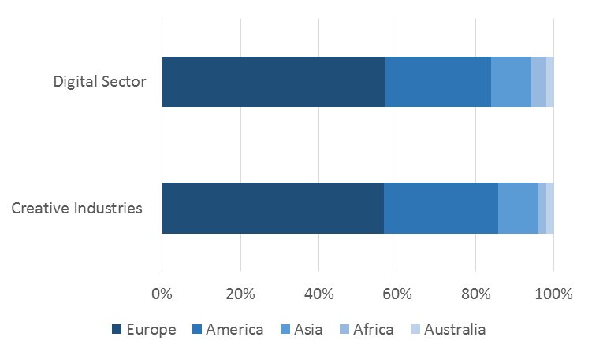
Table 4 in the accompanying spreadsheet provides estimates of exports of services by SIC code for each SIC making up the Creative Industries and Digital Sector (2009 - 2013). Information for a number of SIC codes has been supressed to avoid disclosure.

Background Information
The responsible statistician for this release is Becky Woods. For enquiries on this release please contact Becky on 020 7211 6143 or evidence@culture.gov.uk.
For general enquiries please contact:
Department for Culture Media and Sport
100 Parliament Street
London
SW1A 2BQ
The UK Statistics Authority
This release is published in accordance with the Code of Practice for Official Statistics (2009), as produced by the UK Statistics Authority. The Authority has the overall objective of promoting and safeguarding the production and publication of official statistics that serve the public good. It monitors and reports on all official statistics, and promotes good practice in this area.
© Crown copyright 2016
You may re-use this information (not including logos) free of charge in any format or medium, under the terms of the Open Government Licence.
To view this licence, visit www.nationalarchives.gov.uk/doc/open-government-licence/ or write to the Information Policy Team, The National Archives, Kew, London TW9 4DU, or
email: psi@nationalarchives.gsi.gov.uk

For the UK, GVA in current prices (nominal GVA, not adjusted for inflation) increased by 20 per cent between 2009 and 2014, compared with an increase of 10 per cent for GVA in constant prices (real GVA, adjusted for inflation) over the same period.
These data were released as an ad-hoc statistic in March 2016: https://www.gov.uk/government/statistical-data-sets/ad-hoc-statistical-analysis-201516-quarter-4
http://www.ons.gov.uk/ons/guide-method/method-quality/specific/business-and-energy/annual-business-survey/quality-and-methods/annual-business-survey--glossary-of-terms.pdf
These data were released as an ad hoc publication by the Office for National Statistics in March 2016: https://www.ons.gov.uk/businessindustryandtrade/business/businessservices/adhocs/005468 userdefinedsectorsofexportersandimportersofgoodsandorservicesannualbusinesssurvey2011to2014.

