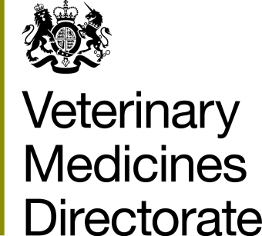 | Veterinary Medicines Directorate  Woodham Lane, New Haw  Addlestone, Surrey  KT15 3LS  United Kingdom  Tel: +44 (0)1932 336911  Search for VMD on GOV.UK

SUBMISSION OF QRD TEXT FOR NATIONALLY AUTHORISED MARKETING AUTHORISATIONS (MAs)

- Product Name:

- Vm No:

- Your Contact Details:

Name:

Email Address:

This form should be used when submitting QRD text for review, as requested by the VMD in MAVIS Ed. 98.

We will check your QRD text against the latest authorised mock-ups and SPC. If any changes are needed, we will make these to the text before issuing the agreed version to you.

We will aim to issue the approved QRD text within 90 days from receipt.

Once QRD text is agreed, please ensure you submit revised QRD text with any future application that affects it to make sure it is kept up-to-date and accurate.

If you wish to make changes to your QRD text and / or submit mock-ups for approval alongside the QRD text, please submit under cover of a Type IB variation (C.II.6(b)) instead.

Joint-labelled products: As no changes can be made to the mock-ups during this review, there is no need to submit QRD text to Ireland.

Declaration

I confirm that no changes have been made to the QRD text, which reflects the latest authorised mock-ups and SPC for the above named product.

I understand that the VMD may make changes to the QRD text to ensure it matches the latest authorised mock-ups.

I confirm that there are no ongoing applications that affect the mock-ups of the above named product. If I do submit such an application while the QRD text I under review, I will let the VMD know.

Signature |  | Date

