This document was archived in February 2016 because it is no longer current.

Effective performance management driving school improvement: Ecclesfield School

URN: 107142
Local authority: Sheffield
Date published: 20 September 2012
Reference: 120223
Brief description

This example describes the three key aspects that have been crucial to improvement at Ecclesfield School: highly effective performance management for teachers and leaders; ensuring that governance is an integral aspect of the school’s improvement; and empowering students to have a strong influence on their own learning. This is one of 12 case studies about the schools featured in the report Getting to good, published by Ofsted in September 2012.
Overview – the school’s message


‘Our teaching is consistently good or outstanding because we have established a learning culture in which teachers are keen to share good practice, to seek support – both internally and externally, and to improve and to take risks in order to provide effective and exciting learning experiences. In addition, students take an important role in shaping their own learning experiences and there is a commitment from all that this will be a powerful and positive influence on the school’s development in the future.
Our commitment to high-quality professional learning experiences is crucial, as is the way in which systems and procedures are constructed and applied to support the core activity of teaching and learning. Professional learning programmes are tailored to meet the needs of teachers dependent upon their skills and abilities, and are aspirational in their design and purpose. Leadership and management have been distributed as widely as possible so all staff share responsibility. We also recognise the importance of middle leaders as agents for change and improvement and have invested in their development.’
Rob Rossides, interim headteacher
The good practice in detail

First steps
Rob Rossides was appointed as interim headteacher following the inspection in 2010 when teaching and leadership were judged to be satisfactory, and achievement and governance were judged inadequate. From that point, improvement has been rapid – so much so that the school was judged to be good at its inspection in 2011. Currently, achievement is good and standards are the highest in the school’s history.
How could you drive school improvement in an environment of complacency, low expectations and denial among leaders that there were weaknesses to overcome? This was the problem that Rob and other senior leaders had to address urgently in 2010. Another problem, as Rob recalls, was that systems and functions, such as those to manage performance, to monitor and evaluate the work of the school and to collect and analyse assessment information did not work. The staff were ready and willing to change and improve; they just needed to be better led and trained.
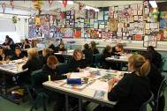
Decisive first steps were taken. In order to gain the trust of staff, senior leaders became visible around the school leading by example such as at break times. They took effective steps to improve behaviour both in school and in the local community at lunch times. An effective senior leadership team was established who had a clear understanding of their job and what was expected of them. Senior leaders then implemented a range of measures to improve teaching, learning, leadership and achievement.
Effective performance management
How do you establish a procedure for performance management that fosters a sense of common purpose by balancing the development requirements of the school with those of the individual? The senior leadership team had to start from scratch as performance management prior to 2010 had no impact on school improvement or professional development. It was merely the statutory procedure by which staff were rewarded financially without having to demonstrate any significant improvement in practice. Rob drew on the expertise of senior leaders to implement robust procedures for quality assurance and performance management. Senior leaders modelled how to conduct performance management meetings for leaders. Objectives for staff were sharpened up and moderated by senior leaders to ensure consistency.
The management of assessment information has been strengthened so that teachers and leaders are effectively held to account for their teaching and the progress of students. Procedures for collecting and analysing data have improved following the appointment of a data manager. Regular and detailed reports about the progress of groups and the effectiveness of departments are used to set aspirational targets for students and to hold teachers and leaders to account. Data are also used successfully to inform effective interventions with individual students. Good marking and guidance for students ensure that they take responsibility for their own learning.
A detailed assessment spreadsheet for each member of staff has been developed to support effective performance management. This compiles information from lesson observations, book scrutinies, data about student progress, exam results and targets that have been set. It aids a comprehensive appraisal of a teacher’s effectiveness and supports an assessment of the effectiveness of the training programmes.
Improved teaching and learning
A bespoke programme to improve the quality of teaching has been established. Teachers are matched to appropriate programmes based on the monitoring and evaluation of their ability. For example, different programmes support those who need to improve their teaching to satisfactory and those who want to improve from good to outstanding. A lessons study model where small groups of teachers work together to plan and teach has proved to be a powerful means of improvement, particularly benefiting staff who need to improve from satisfactory to good. A positive spin-off is that outstanding teachers, some at early stages in their careers, have been identified and encouraged to take on leadership roles within the school. Good practice is shared effectively among staff.
Other successful steps have been the personalisation of the curriculum to engage students whose circumstances make them hard-to-reach and pastoral interventions have been greatly improved. Almost all students now leave Year 11 with a qualification and transfer into further education and training, which was not the case in the past. Improvements to assessment and marking ensure that students take responsibility for their learning.
Effective middle leadership
High-quality middle leadership is crucial to driving and embedding school improvement. In 2010 this was a weak and inconsistent aspect of leadership. Now middle leadership is much more effective, although Rob readily agrees that a few inconsistencies in leadership remain. The first step was to strengthen departments with an additional member of staff of proven ability who was responsible for teaching. Senior leaders then supported middle leaders to carry out departmental reviews of provision and achievement. In the first year, using the Ofsted subject survey reporting style, they modelled how they should be carried out. In the second round of reviews, middle leaders were expected to carry them out, demonstrating their ability to do this job. Now, these reviews form part of middle leaders’ performance management.
A bespoke programme of middle leadership training supports this process. So for example, the modern languages department has demonstrated the ability to conduct rigorous reviews and drive school improvement. Therefore, they receive a lighter touch from senior leaders. Other departments receive a more structured programme of support and challenge to ensure greater consistency in middle leadership and improved outcomes for students. Middle leaders also have to demonstrate that the curriculum is personalised to meet the needs of all groups of students. The strengthened procedures to monitor and evaluate interventions for different groups of students rigorously hold middle leaders to account for their effectiveness in accelerating student progress.
Better governance
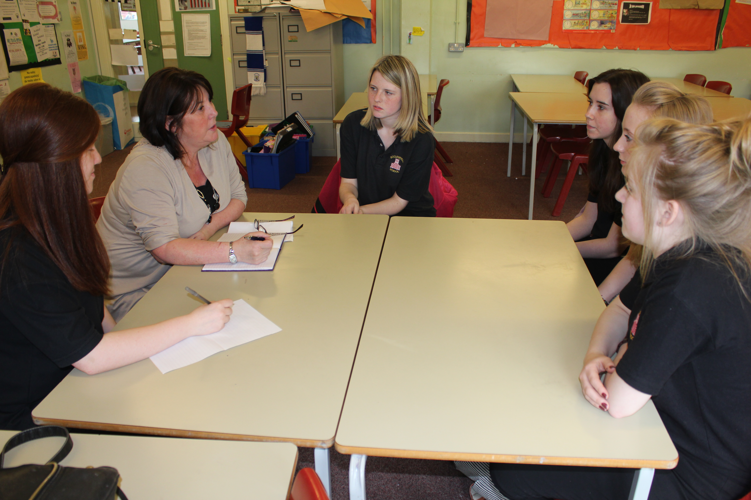
The governing body provides an excellent model of governance. In 2010 they were inadequate. The chair of governors describes this judgement as a ‘wake-up call’. So how has this impressive improvement been accomplished? One important step taken was to strengthen the leadership of the governing body. The local authority appointed a highly experienced school governor who led by example and showed other governors what their role was and how business should be conducted. The chair of governors and headteacher modelled the questions they should be asking to hold the school to account for its work. Governors also benefitted from training support from the local authority that equipped them with the knowledge and skills to carry out the role effectively. Now governors have very high expectations of themselves. They are linked closely to departments and direct and plan which leaders will report to them about improvements to teaching and learning. School leaders have quickly learnt that these meetings are tough and that they must come well prepared with the evidence to back up assertions about improvement. Middle leaders appreciate stronger governance and welcome governors’ greater visibility around the school and the effective challenge and support they provide.
Student voice
Students have an influential role in shaping teaching and learning. A prefect system has been introduced and students regularly report and attend the teaching and learning innovation meetings. Individual students take responsibility for linked work with different subjects and for other aspects of the school’s work, such as behaviour management. They contribute well to lesson observations and the recruitment of staff. Prefects also represent views and suggestions on behalf of other students.
The school’s background

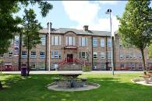
Ecclesfield School is a large secondary school serving the Ecclesfield community north of Sheffield. Most students are White British.
Other examples featured in the report Getting to good

Primary schools
All Saints CofE Primary School
Brookside Primary School
Jubilee Park Primary School
Mendell Primary School
St Benedict Biscop CofE Primary School
St Clement Danes CofE Primary School

Secondary schools
Dronfield Henry Fanshawe School
Highfields Science Specialist School
Highlands School
Stockland Green School
Woodside High School

