This document was archived in February 2016 because it is no longer current.

Outstanding support for disadvantaged learners: Roots and Shoots Limited

URN: 54175
Area: London
Date published: 19 July 2012
Reference: 120177
Brief description

This example demonstrates how the provider uses available resources, particularly community groups and volunteers, to offer individualised and rigorous programmes that help disadvantaged young learners gain skills, self-respect and the possibility of future employment.
Overview – the provider’s message

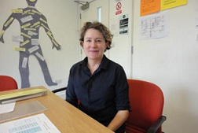
‘We have strong links with the community which we use to ensure that potential learners are referred, and to offer work placements and other interesting and relevant experiences which will motivate our disadvantaged learners. What’s important is to offer learners not just something they will like, but also the opportunity to gain qualifications which will help them in the future.’
Ruth Mitchell, Education Coordinator
The good practice in detail

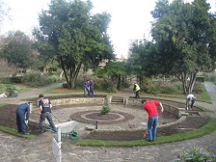
During the inspection in 2011, inspectors were impressed by how successfully the provider was engaging its hard-to-reach learners, 80% of whom are going into work or on to other training programmes. Inspectors reported: ‘Roots and Shoots Ltd makes outstandingly effective provision for young people who start with significant disadvantages.’ Linda Philips and Ruth Mitchell, the director and education coordinator, believe that the key features are the programme design which helps young people to learn self-discipline, and the opportunities provided through community links.
The learners
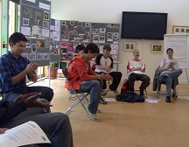
Learners on these courses have not, in the main, had a positive experience of education. They may have failed to attend school, and often have personal barriers to learning such as poor literacy skills, a history of offending, specific learning difficulties, or anger management problems. It can take some time for them to settle and to realise that although attendance is not compulsory, it will benefit them. Some learners are referred from school or through Connexions, and others self-refer. Because the organisation has been operating for 30 years, and has a positive presence in the community, learners and their families know of its existence and do not associate it with school or college.
The programmes
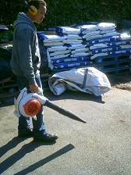
Foundation Learning programmes in horticulture and retail provide a wide choice of further vocational options. Alongside units in retail or horticulture, learners gain qualifications in literacy and numeracy, an art award and an enterprise award. They design their own learning outcomes within the programme, and are helped to set individualised targets and measure progress towards achieving them. Learning to perform as part of a group is an important part of the programme, but the work is also individualised to support learners’ differing individual needs.

As well as the Foundation Learning programme, provision is available for 14 to 16-year-olds at risk of being excluded from school, including an ‘Access to Apprenticeship’ programme. Apprenticeship programmes are being developed, in response to the large numbers of requests from employers who have positive experiences of learners on work placements. The aim of each of the programmes is to help learners to develop enough self-discipline to become independent learners and to manage their lives. Trainers see themselves as supporters of learning rather than as teachers. For example, the part of the course which focuses on art is used to teach young people to make saleable art and craft items. Similarly, the enterprise award is given for learners who have demonstrated dedication and self-discipline by selling the products at local craft fairs and street markets.
Ruth values the benefits of the structure and rigour of assessment in the Foundation Learning Programme: ‘Our programmes have always been holistic. They combine “hard” outcomes such as qualifications with “soft” ones such as improved behaviour and willingness to take responsibility. The balance of the two changes over time, and varies from learner to learner. But these young people, like others in mainstream provision, need qualifications to be able to compete for jobs – and with the right support, they can get them. The Foundation Learning Programme works better than Entry to Employment which is less structured, and does not make such demands on the learners.’
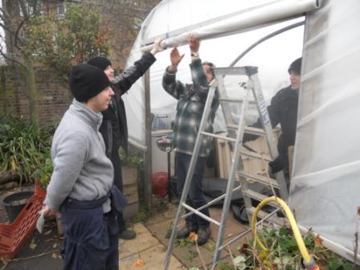
Community links
Managers are dedicated to growing their links with the local and wider community to benefit the learners. Linda represents south London on the London Gardeners’ Network, and as a result the learners have opportunities to work in local parks, to exhibit at Chelsea Flower Show, and to provide 750 young elm trees being re-introduced to London’s parks through a high-profile project funded by the National Lottery and the Mayor of London’s Fund. The organisation’s high profile generates further interest and opportunities. For example, learners have recently seen Her Majesty The Queen, met Joanna Lumley, and were visited by His Royal Highness The Prince of Wales who bought their entire stock of apple juice.

Other community groups, such as the London Beekeepers’ Association, use the provider’s facilities and offer further opportunities for the learners. Work placements are normally on one day each week and there are opportunities to work ‘in house’, in the garden or the ‘pop-up’ shop which appears when events are being hosted. Learners produce apple juice which they sell through the in-house shop and through the retail programme. They have decorated the local Action Centre, waited on tables for older clients’ lunch clubs, and participated in the Waterloo Carnival, in partnership with a local primary school.
Use of volunteers

For £15 a year, members can join the ‘Friends of Roots and Shoots’ group. Members can visit and work with learners once a year and their subscriptions help to support learners whose families could not otherwise afford the cost of travel and tools, for example. Other community groups, such as adult reading volunteers, also use the premises. This promotes a greater understanding of what the organisation is doing for its learners, and increases the pool of potential work placements. Professionals, such as a florist and a solicitor, offer specific workshops at the centre, and others provide support, such as help with writing CVs.
Provider background


Roots and Shoots Ltd was set up in 1982 to help disadvantaged young people from Lambeth and Southwark prepare for the world of work. It is situated in Lambeth, South London, and became an independent charity in 1997. Up to 33 learners aged 16 to 24, who have experienced difficulties in the traditional education system, spend 40 weeks in a full-time training programme which helps develop their skills and confidence, and equips them for work. The site provides training facilities for horticulture and retail studies, and incorporates a wildlife garden used as an environmental resource. The wildlife garden and study centre also provide environmental education for schools and the local community.
Are you thinking of putting these ideas into practice; or already doing something similar that could help other providers; or just interested? We'd welcome your views and ideas. Get in touch here.
To view other good practice examples, go to: www.ofsted.gov.uk/resources/goodpractice

