This document has been archived in February 2016 because it is no longer current.

Employability and enterprise education: Queens Park Community School

URN: 101560
Local authority: Brent
Date published: 1 September 2011
Reference: 120408
Brief description

Students’ employability and enterprise skills are developed throughout the curriculum and through innovative projects developed with employers.
Overview – the school’s message


‘It is well known that enterprise and employability skills are a vital set of attributes for young people to possess to ensure that they have the capability of being effective in the workplace. We encourage employability skills and enterprise education in much of what we do. Our approach has always been to develop a number of very effective strategies to ensure many of the necessary skills are built into good curriculum delivery without inhibiting the content and pedagogy within the classroom. From the ‘customer service’ notion developed in Key Stage 3 with work experience supporting the school’s facilities, the students start to understand the need to accept responsibility and self-management at an early age in our school. At Key Stage 4 and Key Stage 5 the value of work experience and internship engenders real work-placed experiences with an emphasis on post-experience evaluative workshops supported by employers.
We believe that enterprise education plays an important role in the school’s improvement strategy and do not just see it as a separate addition to the curriculum. We look for opportunities to develop enterprise skills within all lesson planning; this is reflected in our lesson observation criteria used for our subject and faculty reviews. We are committed to enhancing the curriculum for our students through enterprise education to nurture enquiring minds, independence, problem-solving, initiative and a positive approach to their studies.’
Mike Hulme, Headteacher
The good practice in detail

The school has a clear vision for enterprise education and work-related learning throughout the curriculum from Years 7 to 13. This involves a wide range of high-quality provision that has a significant impact on students’ understanding of the world of work and their development of employability skills. So how do lessons in drama, humanities, science and ICT contribute to students’ chances of sustained employment in the future?

How do enterprise days, curriculum extension days and internships develop a ‘can do’ attitude and increase students’ ability to handle uncertainty and respond to change?
1. Embedding employability across the curriculum
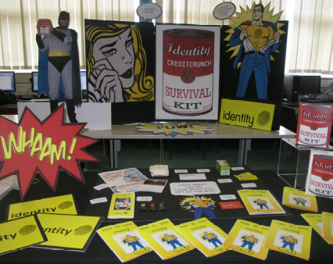
There is a whole-school approach to developing students’ enterprise and employability skills and providing them with innovative and stimulating projects to apply these skills in real or realistic work-related environments. The school provides students with a good education that prepares them well for the future, and particularly for their entry into the world of work. Specialist status is used most effectively to raise standards and enrich the curriculum. It successfully helps students achieve effective business and enterprise skills through well-developed links with local business and industry and partnerships with other educational establishments. A wide range of curricular, extra-curricular and enterprise opportunities promote community cohesion extremely effectively.
An enterprise project about how to survive the credit crunch
The keys to success include:

- vision and commitment from the headteacher and senior leadership team to ensure that enterprise is a whole-school priority; one which is given time through a flexible curriculum and additional resources to promote and support enterprise projects and work-related learning
- teaching enterprise skills across all subjects and throughout the curriculum with a strong focus on developing knowledge, skills and application. All schemes of work, whatever the subject, include personal, enterprise, thinking and learning skills and students are used to encountering enterprise activities in all their subjects
I love enterprise days, we get to work in teams, make things and showcase our work to the class through presentations at the end of the event.
Year 7 student

- excellent support from a full-time business and community liaison coordinator with designated responsibility to develop links with businesses and community groups, coordinate work experience and the internship schemes, and to develop enterprise projects with staff
- effective use of six enterprise and curriculum extension days per year for each year group that successfully draws faculties together to encourage students’ creativity and provide opportunities to be innovative in a wide variety of interesting and motivating contexts, such as:
- building and testing rockets in science
- measuring the energy stored from homemade wind turbines in geography
- holding a Mathematics Olympics

The range of extra-curricular opportunities for students includes:
Students at the school carnival modelling costumes
- contributing to an annual international music festival
- participation in ambitious performing arts productions, such as West Side Story
- numerous opportunities to take part in local sport competition, run an allotment, and raise funds for local, national and international charities
- recognising students’ achievements and showcasing their work through the school magazine Shout and the summer carnival.
There is a culture in the school of collaborating and sharing good practice, innovative ideas and specialist expertise across faculties and subject areas to build the capacity of all staff and develop a strong sense of purpose in promoting enterprise and employability throughout the school. Outcomes are systematically reviewed and monitored including:
- using meetings of faculty and subject heads to evaluate recent activities, plan future innovations and review and update the enterprise skills audit
- using the school’s lesson observation scheme to evaluate how well lessons develop employability and enterprise skills and to identify good practice
- giving enterprise education a high priority in the school’s self-evaluation and quality improvement arrangements.
2. Outcomes for students
Students recognise that direct experience is just as valuable as business theory and they build on the skills they develop from Year 7 through to Year 11 and into the sixth form. In particular, they develop skills and confidence in working with different people in a wide range of contexts and handling situations that are new to them. Their communication skills are consistently of a very high standard.
Now I’m in year 12, I’ve realised how much I have built on the communication skills I’ve developed since I joined the school five years ago. ’
Year 12 student

Students interviewed were keen to discuss what they believed to be the benefits of attending a school where enterprise and employability are part and parcel of their everyday learning. Typical examples of the skills students said they gain included:
- making presentations
- working in different teams, especially with students from the years above and below them
- learning in a different way
- overcoming the reluctance to ask questions
- working with adults outside the school and having to take responsibility for real projects that make a difference
3. Employability and enterprise education in action; the Careers Academy
For the past five years, the school has run a successful Career Academy Programme which is part of Career Academies UK. The two-year programme involves an annual investment by the school and provides employability skills, training, communication with a business mentor and a business-based six-week paid internship at a major company.
Enterprise day has really helped to build my confidence, and develop my marketing and communications skills...
Year 10 student

Up to 15 students from Year 12 are selected each year, across the ability range, including students studying A-level business studies and economics and those studying BTEC national business or finance programmes.
The programme is particularly successful in: raising aspirations and opportunities; developing students’ confidence and skills in participating in the world of work; negotiating work activities; taking responsibility for individual tasks; and reviewing their progress and studies with a business professional. Employers consistently praise the students’ very high standards of work, their hard work and enthusiasm, and their focus on understanding what is required of them and how their work fits in with that of the whole company.
The scheme involves:
- commitment and support from the senior leadership team
- selecting students (aged 16-19) from all levels of business or finance programmes
The programme raises aspirations, develops confidence and provides excellent opportunities for students to develop and demonstrate high-level employability skills. Students rated it very highly and some had been offered future employment with the firms with which they undertook an internship.
Ofsted March 2010

- providing clear information about the programme, so students know what to expect
- effective pre-placement training in employability skills
- very good operational management and support from the business and community liaison coordinator
- placements in high-profile businesses
- excellent communication with businesses and the business mentors
- good initial training and guidance for the students at the start and throughout the programme
- good use of previous students who act as role models
- high-profile celebration of achievement.
4. Work experience
Work experience for Year 10 and sixth form students is very well coordinated. The school has excellent links with a wide range of employers and students are well matched to appropriately supportive but challenging working environments. Each work placement involves good collaboration with the students, employers, teachers and parents. Students make good use of a well-designed Work Experience Record Book that provides: guidance and tips on preparing for an interview, working safely and setting targets; a daily log; reviews of the first day, enterprise skills, communications skills and using mathematics at work; an overall student evaluation, with comments from parents and carers; and a reference from the employer.
Our aim is to help students become enterprising individuals who are well equipped for the opportunities, responsibilities and experiences of adult life.

‘The school seems to have so many links with different businesses. They are always very good at helping you find the right type of work experience’, says a Year 12 student.

BTEC first students in business studies undertake work experience as part of their course.
- Prior to their work placement they undertake a range of activities to prepare them for the world of work.
- Before their work placement they participate in mock interviews. A local business person interviews them for a specific position and then awards the job to a successful candidate.
- The students then participate in an analysis and evaluation session with the employer who gives each student feedback on their interview performance.
- They complete a log book of the activities while on placement to keep a record of their work and evaluate their progress.
- They meet with a careers advisor after their placement in order to receive information advice and guidance about their options for work or further study.
5. Gaining an insight into the world of work in the classroom
By making the curriculum more relevant and by participating in schemes such as ‘Girls into Technology’, work shadowing, work experience and mini-enterprises, the school gives students an insight into the world of work and the many different options available.
Extra support is provided by the enterprise days organised in Years 7 to 11. Representatives from industry, advice agencies and colleges of higher education are invited to work with students focusing on the way forward when statutory school life ends. ‘Enterprise day has really helped to build my confidence, and develop my marketing and communications skills. It has made me better prepared in my other subjects, especially ICT’, says a Year 10 student.
Teachers successfully develop their own understanding of enterprise and employability and integrate these skills and concepts into all their lessons. For example, in a design and technology lesson, the students work through the whole process from the initial concept of a product to mass production and costing. The initial practical activity introduces the concepts that are reinforced throughout the course. This is a typical example of how thinking, problem-solving and collaboration skills are fully imbedded into the curriculum and it is especially effective because this process is reinforced in all subjects from Years 7 to 13.
The school’s background

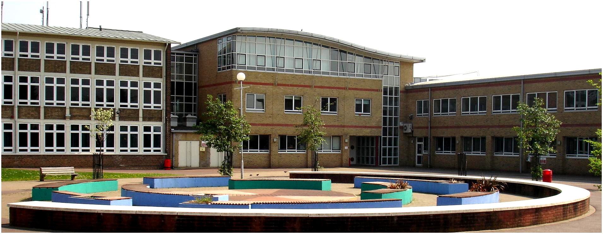
Queens Park Community School is a larger than average size secondary school for 11-18-year-olds situated in Queens Park, North West London in the southern tip of Brent. It was designated a specialist business and enterprise school in 2003. A high percentage of the students are from minority ethnic backgrounds and, of these groups, pupils of Black or Black British Caribbean heritage represent the largest group. The proportion of students who speak English as an additional language is high with 76 languages spoken. The proportion of students with special education needs statements is approximately twice the national average. The school’s campus includes a City Learning Centre and a Children’s Centre.
Are you thinking of putting these ideas into practice; or already doing something similar that could help other providers; or just interested? We'd welcome your views and ideas. Get in touch here.
To view other good practice examples, go to: www.ofsted.gov.uk/resources/goodpractice

