Cost to UK Consumers of Mobile Roaming in the EEA.
February 2016

Cost to consumers of mobile roaming.

Data collected by Ofcom shows that UK mobile operators received EUR 450m (£350m) in annual roaming revenue from UK customers travelling to European Economic Area countries. Ofcom collected these data directly from mobile operators using their statutory powers and have provided the aggregated figure to DCMS to inform policy development. Removing roaming charges will lead to this cost being removed for UK consumers.

However, as the price of calling/using data is much higher when roaming than at home, consumers use their mobile much less abroad than they do at home. If the price of mobile roaming fell to the same level as domestic usage, consumers would be expected to use their mobile more when abroad, potentially to the same level as they do at home. DCMS have estimated what the total amount spent on roaming would be if UK consumers, when roaming, behaved the same as they do domestically in terms of consumption.

Data from Ofcom shows that consumers use approximately 5 billion MBs per year in the EEA. ONS figures show that UK consumers spent 343 million nights abroad in the EU. This equates to 14.56 MB per day, or 443 MB (0.443 GB) per month.

Estimates of the average mobile data usage by UK consumers range from 750MB to 1.8GB per month.,, Taking the high estimate of 1.8 GB per month, we can estimate that domestic consumption of data (1.8MB per month) is 4.07 times larger than roaming consumption (0.443 GB per month).

Applying this uplift of approximately 4x to the current spend on roaming charges provides an estimate of the potential spend on roaming charges, if consumers behaved the same when roaming as they do at home.

4 x EUR 450m (£350m) is EUR 1.8 billion (£1.4bn).

Current spend on roaming charges by UK consumers in the EEA: EUR 450m / £350m
Potential spend on roaming charges if consumers behave as they do at home: EUR 1.8bn / £1.4bn

© Crown copyright 2015

You may re-use this information (not including logos) free of charge in any format or medium, under the terms of the Open Government Licence.

To view this licence, visit www.nationalarchives.gov.uk/doc/open-government-licence/ or write to the Information Policy Team, The National Archives, Kew, London TW9 4DU, or email: psi@nationalarchives.gsi.gov.uk
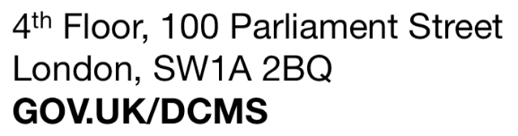

Exchange rate at 1.2921, sourced on 20/02/2016 from http://www.bloomberg.com/quote/GBPEUR:CUR
Annual revenue, excluding VAT, in year to September 2015
Travel Trends 2014, Section 3, Table 3.05 http://www.ons.gov.uk/ons/publications/re-reference-tables.html?edition=tcm%3A77-391781
http://www.mobiles.co.uk/mobile-internet-data-usage-infographic.html
http://www.ericsson.com/res/docs/2015/mobility-report/emr-nov-2015-regional-report-europe.pdf
https://www.vodafone.com/content/annualreport/annualreport15/assets/pdf/full_annual_report_2015.pdf

