This document has been archived in February 2016 because it is no longer current.

Embedding education for sustainable development into key skills: McDonald’s Restaurants Ltd

URN: 53281
Area: National
Date published: 7 February 2012
Reference: 130095
Brief description

McDonald’s has designed its key skills programme to make it relevant to apprentices and aligned to company drivers. One chief area covered is enhancing apprentices’ environmental awareness. Assignments are designed to encourage apprentices to make a positive contribution by helping the company to improve its environmental performance, positively engaging with customers to share environmental messages and making changes in their behaviour which have a beneficial impact on the environment.
Overview – the provider’s message


‘Making a positive impact on the environment is a key aspect of McDonald’s mission. We’ve made good progress through a range of initiatives, such as reusing cooking oil as biodiesel, using low-energy light bulbs and reducing packaging. However, over a third of our energy saving comes from changes in the behaviour of employees. Embedding environmental issues into our key skills workbook has given a structure and consistency to this message and provided an opportunity to make key skills relevant to our apprentices while enhancing their environmental awareness. Their contributions to improve the environmental performance of our restaurants and to help our customers understand what the company is doing and why, is a major factor in our success.’
Iain Bogie, Apprenticeship Consultant-
The good practice in detail

There are many ways in which McDonald’s can reduce impact on the environment in restaurant operations and procedures, and the company wants the apprentices to be fully involved and able to contribute effectively. Sue Husband, National Education Manager says: ‘We can reduce environmental impact by improving the design of products and processes, reducing the amount of waste we produce, reusing items where possible, and recycling. It’s essential that apprentices see that we are working hard to reduce our environmental footprint to ensure our operations today do not have a negative effect on the lives of future generations and that they have a role to play in this.’
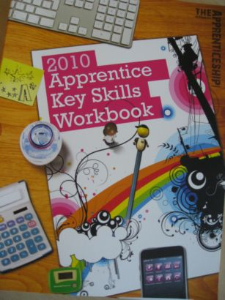
Louise Ellis, education officer, adds: ‘The key skills workbook was designed to provide a structure and consistency to this environmental message for apprentices. It contains a variety of tasks that enable apprentices to analyse ways in which they can reduce energy and waste in the restaurants and understand food quality better. These tasks reinforce the environmental messages given during induction and embedded in working practices. We saw a real opportunity to make key skills relevant to the learners and at the same time benefit the company. We wanted to ensure that every employee understood our environmental commitment, would be able to positively engage with customers to share these messages, and would benefit in their private lives by taking the learning home and to their local community. Many learners tell us that they have made changes in their lives which benefit the environment and save them money.’

Assignment examples
A numeracy assignment focuses on energy use: apprentices calculate costs, consider how energy can be reduced by good housekeeping and display their results in a number of formats. This learning occurs in the workplace using real information from the restaurants; apprentices work individually or in groups and every restaurant has a computer for them to access online materials. They enjoy this project and are able to benefit from what they have learnt by making savings at home. Imran, an apprentice, says: ‘When I did the energy project at work, Renata, my crew trainer, suggested I did the same project at home and I have reduced my energy bills considerably.’
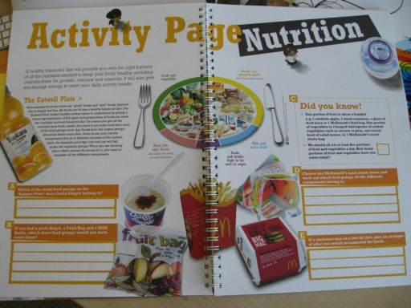
A second assignment requires apprentices to take part in regular litter patrols in the vicinity of their restaurants. They record the amount of litter collected, analyse the contents, and note where it originates from. They present this information using a range of charts and graphs, and consider what the results tell them about people’s behaviour and how businesses can reduce their impact on the local environment.
A communication element is about sourcing ingredients for products and food quality – apprentices develop a leaflet on McDonald’s products. Other assignments focus on the provenance and quality of the ingredients. To reinforce learning, apprentices have the opportunity to visit the farms from where McDonald’s sources its 100% organic milk and free-range eggs. As well as reducing the energy use in restaurants, the company is encouraging its supply chain to reduce its carbon footprint, and supporting high welfare and organic farming methods.
Outcomes for learners
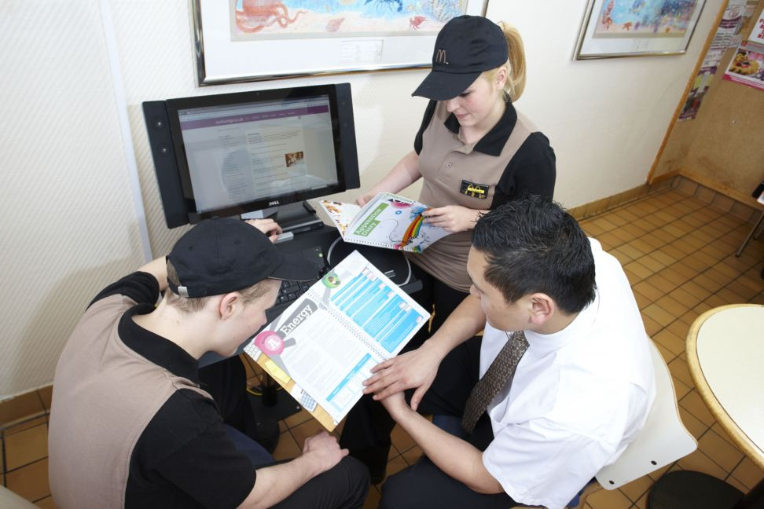
Learners are encouraged to make a positive contribution to environmental activities, and the benefits to the business can be significant. Improved understanding has led to changes in behaviour, and careful housekeeping by apprentices and former apprentices is responsible for 30% of McDonald’s’ energy saving. The key skills training has also empowered apprentices to contribute valuable suggestions. One simple idea via the staff suggestion scheme ‘How About’, led to McDonald’s printing calorific values of its products on tray liners instead of producing a separate leaflet, achieving major environmental savings by reducing manufacturing, paper use, and transport.
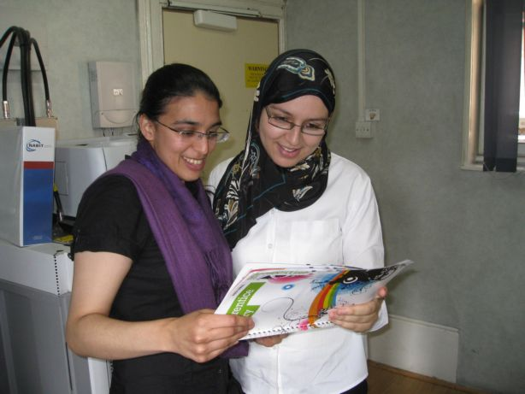
Anisa, an apprentice, says: ‘I have developed my confidence and my ability to inform customers about food quality and to pass on information to other local businesses and to other members of staff.’ Another apprentice, Sheza, adds: ‘I’m enjoying key skills. I understand the importance of switching off lights and putting grills on stand-by to reduce energy and carbon emissions as well as saving money, but I especially enjoyed learning about food sources and quality.’
Anisa and Safae
Renata, a crew trainer and former apprentice, is now much more environmentally conscious: ‘I’ve become more aware of my health and what I am eating since I did key skills. I learned a lot about the environment and how it affects me. To be honest, I wasn’t really bothered about it before.’

Louise believes that you can’t overestimate the benefit of training employees. ‘Once apprentices understand the bigger picture, they are engaged and they value the ways in which the training allows them to make a difference. Their commitment helps the management team to push forward and introduce new initiatives.’ Staff can increase their knowledge, even after they have completed the apprenticeship, by participating in McDonald’s ‘Planet Champions’ venture. This voluntary scheme builds on the knowledge gained in the apprenticeship, and gives the Champions status and a mandate to help in the company. There are already plans to develop it into a qualification. Catalina is pleased to continue as a Planet Champion, saying: ‘It’s interesting for me to put theory into practice. I am very aware of the impact my employers can have on the environment and how we Champions can help to improve environmental issues in the company. I hope that I can have a career in environmental planning in the future.’
Catalina, Planet Champion
In summary, Louise says: ‘We are a people business. We believe that the most powerful thing we can do is to change people’s behaviour so that it has an impact at home and in the community.’ This view is shared by Nurdan, a customer care assistant who has recently completed her apprenticeship: ‘I did have some knowledge of environmental issues from home but this training has enabled me to see that care for the environment is part of business as usual at McDonald’s. I can also take the skills home and use them in my community. If everyone does the things we have learned in key skills, it will be easier to live.’
Provider background


McDonald's Restaurants Ltd (McDonald’s) was founded in the United States of America in 1955 and came to the United Kingdom in 1974. The company’s UK head office is in East Finchley, London. The UK has around 1,200 McDonald’s restaurants, serving about three and a half million people each day. McDonald’s own approximately 35% of its restaurants in the UK and the rest are franchised businesses. The company and its franchisees employ 85,000 people, 60% of whom are under 21 years of age. McDonald’s are one of the largest employers of under 21 year olds in the country.
Are you thinking of putting these ideas into practice; or already doing something similar that could help other providers; or just interested? We'd welcome your views and ideas. Get in touch here.
To view other good practice examples, go to: www.ofsted.gov.uk/resources/goodpractice

To view other good practice examples, go to: www.goodpractice.ofsted.gov.uk

