This document was archived in February 2016 because it is no longer current.

Outstanding curriculum innovation in science: City and Islington College
URN: 130409
Area: Islington
Date published: 27 October 2011

Brief description
City and Islington College is one of the biggest national providers of science in further education. It has developed a broad range of cutting-edge science provision and established itself as a regional centre of excellence for science.


Overview – the provider’s message
‘The college has developed an extensive range of provision in the sciences and related vocational areas. We have doubled our recruitment to science courses in the past three years and this has widened participation and progression opportunities for an ethnically diverse range of students who come from areas with high levels of social exclusion.’

Mary Rimington, Deputy Principal

The good practice in detail
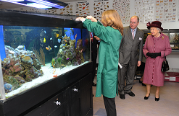
Innovative curriculum development in sciences
Her Majesty The Queen visiting the College
Steve Jones, Director of the Centre for Applied Sciences, attributes the success to ‘wide-ranging and innovative course provision - our unique science-based education and training for 16 to 18-year-olds and adults covers both the traditional academic route and innovative industry related courses’.
Science provision is based at the Centre for Applied Sciences and the Sixth Form College, both located in the heart of the Angel, Islington. The course offer is extensive ranging from A-levels in biology, chemistry and physics to national diplomas and BTECs in medical, sports science, animal care and general sciences among others. The college is the only FE institution to offer foundation degrees in ophthalmic dispensing and forensic crime scene investigation. Access to Higher Education courses are widely recognised by universities and offer strong progression into niche areas such as optometry, pharmacy, dentistry, radiography and physiotherapy. The Access to Higher Education in Medicine course has two students joining London medical schools in 2011. The college has been named recently by the Government’s Department for Business, Innovation and Skills as the first national centre of excellence for biotechnology.
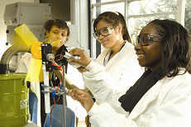
The college was judged to be outstanding in its recent inspection report with strong partnerships being highlighted as one of the college’s key strengths. Mary Rimington, Deputy Principal, believes that ‘collaborative working is essential to our success. Courses have been developed in partnership with industry to ensure that students gain relevant professional skills.’ Links with prestigious universities prepare students for higher education, for example the partnership with UCL which promotes progression on to science degree courses and medicine. Representatives from the British Transport Police sit on the programme management board for the college’s forensics degree. Links with other countries include a joint optics project with Beijing Business School that has enabled students to visit China and present their work. Work with Arsenal Football Club’s engagement in the community team has encouraged hard-to-reach students to study sports science and many have progressed to the sports science degree and coaching.
Progression opportunities in science

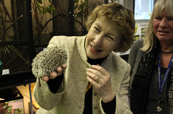

Applications to study science at the college have doubled in the last three years. This has taken place in a community where 80% of students are from areas of social and economic deprivation and the large majority are of minority ethnic heritage. Around 80% of advanced level students progress to university. In 2010, this amounted to over 340 students who progressed from science-related courses in the Centre for Applied Sciences and the Sixth Form Centre. Mary Rimington, Deputy Principal, says: ‘The College has made science relevant to students by providing real opportunities for progression to higher education and to employment in science-based professions. Many of our students come from households with no experience of education or professional careers – we instil a work ethic that the students appreciate.’
Professor Alison Wolf with Mary Rimington
Xenia Langlau
Xenia Langlau, an advanced level student on the BTEC Diploma Animal Management course, remarked: ‘I chose to come to the College as it has so many different exotic animals. I am learning a lot about animals and when I finish my course, I am interested in becoming a veterinary nurse.’
Responsive curriculum in science

The curriculum is responsive to student, employer and higher education needs, serving three purposes: ensuring up-to-date training; developing and deepening an understanding of science; and providing employers and universities with highly motivated and capable individuals. Programmes enable students to work with relevant employers, such as the Forensic Service. Opportunities for students to learn about science extend beyond the classroom walls and the syllabus, with enrichment clubs in a wide variety of subjects, including robotics, medical links, physics and chemistry.
Mary Rimington believes that recruiting the right staff is central to the college’s success: ‘We attract experts from science-based professions and train them to become educators. Our forensic courses are delivered by former crime scene examiners and DNA analysts and our tutors for optics and sports have industry experience. This way, students learn how to apply knowledge in a professional situation, preparing them for progression directly into employment or higher education’.
Science learning resources

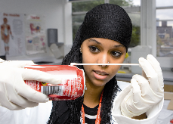
Science students use the latest technology in their studies. Steve Jones says: ‘Laboratories have been designed by our employer partners and specialist practitioners. In many cases they exceed industry specifications. The Optics Department has a large and extensive range of optical equipment. There is also a small dispensing clinic providing an opportunity for students to work with real patients. This enables learning to take place within an up-to-date, relevant context. For example, we have purpose-built simulated crime scenes where students are trained to use digital forensic photography and the forensics laboratory is equipped with the latest apparatus for DNA analysis and finger-printing cyanoacrylate technologies.’

Provider background
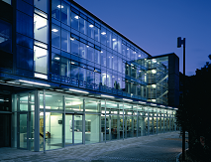
City and Islington College is a large general further education college operating from four main sites and over 25 satellite sites and community venues in the London Borough of Islington. The Borough is an area of great social contrast, with prosperity mixed with poverty and deprivation. It is rated as the sixth most deprived local authority. It is an ethnically diverse area and 53% of students classify themselves as belonging to a minority ethnic group. In 2009/10, there were around 4,000 full time and 340 part-time 16 to 18-year-old learners, and 1,704 full-time and 4,739 part-time adult learners. The college offers programmes in all sector subject areas.
To view other good practice examples, go to: www.goodpractice.ofsted.gov.uk/

