

**Entering Help to Buy Bids in IMS**

*Guidance for Providers v1.2*

|  |  |  |
| --- | --- | --- |
| **Version** | **Date Issued** | **Details** |
| 1.2 | 14th May 2014 | 3rd issue – 14/15 update |

1. Introduction 3

Purpose of this guidance 3

About Help to Buy 3

Business process 3

Overview of Help to Buy process from Bid to sale completion 4

Steps to submitting Help to Buy bids in IMS : 4

Step 1: Set up Partnership Record for 2011-15 5

1.1 Navigating to the Partnership Screen 5

1.2. Creating an IMS Partnership Record 6

1.3. Adding Organisations to your Partnership 8

Step 2: Set up Agreement record for 2011-15 11

2.1 Finding the Agreement screen 11

2.2 Creating an Agreement 11

Step 3 Inputting a HELP TO Buy Project 13

3.1 Navigating to the Project screen 13

3.2 Creating a New Help to Buy Project 13

3.3 New Project screen – Scheme Tab 15

3.4 New Project Screen – Location tab 16

Step 4 Inputting HELP TO Buy Sub Products 17

4.1 Navigating to the Sub Product screen 17

4.2 The Sub Product Screen 18

4.3 Sub Product Screen – General Tab 19

4.4 Sub Product Screen – Forecasts Tab 20

4.5 Forecast Tab - update Active organisations 22

4.6 Validating the Individual Sub Product 23

Step 5: Submit the Individual Sub Product 25

Step 6: Partnership, Grant Agreement and Contract sign-off 27

# 1. Introduction

**Purpose of this guidance**

This guidance is written for Providers who are bidding for Help to Buy through the Homes and Communities Agency. *[Providers should ensure they are using their HCA log-in access code rather than a GLA log-in code for all bidding activity (including inside London)]* It provides step-by-step guidance on how Providers enter bids directly to the Homes and Communities Agency’s Investment Management System (IMS). Separate Help to Buy Guidance is available within the help function of IMS covering the steps required for scheme and payment processing.

**About Help to Buy**

Help to Buy is an incentive product offered on selected new build developments and operates in a similar way to the FirstBuy product introduced in 2011. Purchasers will be offered an equity loan of between 10% and 20% of the purchase price of a new build home and this will be wholly funded by the Homes & Communities Agency (HCA). Purchasers will raise the remainder (80% to 90%) of the finance in the normal way through a combination of deposit and conventional mortgage. The mortgage will be secured by a first charge on the property; the equity loan will be secured by a second charge.

The maximum property price is £600,000. Values over this amount can only be approved by exception. There is no maximum household income level for Help to Buy.

**Business process**

The developer is the principal provider in the process. However, there are two developer groupings involved:

**Developers accessing IMS directly**

These developers will be the Lead provider and will do everything other than the Help to Buy Agent (HBA) role (previously called local Homebuy agents). The agent role (in schemes) will be carried out by the existing Help to Buy agents for the location of the home being purchased. Grant will be paid to the developer on the scheme. The HBA Allowance will be paid to the HBA.

**Smaller Developers not accessing IMS directly (generally providing less than 40 units overall and are not registered on IMS)**

These developers will bid under the auspices of the HBA responsible for the location of the scheme in terms of HBA zones. This may involve the smaller developer making these arrangements offline with a number of HBA’s. Each HBA will input bids on behalf of the developer. The developer will act in the developing organisation role in the partnership. The HBA will be responsible for maintaining the Projected Forecasts (allocations) and also scheme processing. They will also perform the traditional HBA role in terms of the HBA Eligibility task in the schemes process. Grant will be paid to the developer on the scheme. The HBA Allowance will be paid to the HBA. A flow diagram providing information on notice day required will be issued once you have signed your contract.

Where a developer is NOT registered (as an Unregistered Provider) in IMS, they will need to register with the HCA in order for the HBA to include that developer in the developing organisation role in their partnership. These developers’ payee details will also need to be notified to HCA Finance.

**Overview of Help to Buy process from bid to sale completion**

The Help to Buy process in IMS is similar to that of the FirstBuy process in IMS used previously:

1. Provider inputs bulk bid for Help to Buy units in year 2014/15 following submission of registration (as per this guide)
2. HCA checks and approves bid which creates allocation
3. To drawdown HCA equity contribution - Provider opens an IMS scheme for each individual sale purchase.

**Steps to submitting Help to Buy bids in IMS :**

**Step 1 Creating a Partnership record**

If there is no existing HCA Partnership record for 2011-15, Providers must create one.

**Step 2 Creating an Agreement record**

Create an Agreement record attached to the Partnership created in step 1 above - ***there is no requirement for a separate agreement record for processing Help to Buy bids.***

**Step 3 Inputting a Help to Buy Bid Project record**

The Project is the first of the two parts of a bid and acts as a header for the bid;

**Step 4 Inputting a Help to Buy Bid Sub-Product**

The Sub Product record is linked to the Project(s) record inputted in step 3 above. The Sub Product is part 2 (of 2) of the bid.

**Step 5 - Submitting your Help to Buy Bid Sub Product record(s) to the HCA**

**Step 6 - Signing off the Help to Buy grant agreement**

Step 1: Set up a Partnership Record for 2011-15

**1.1 Navigating to the Partnership Screen**

***IMS System Manager*** *>* ***Bids Menu*** *>* ***Bidding System:***

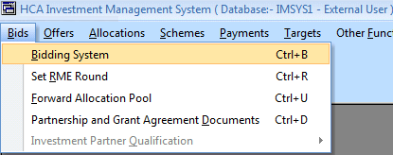

***Bidding System screen > Partnerships Menu > Select***

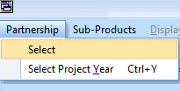

The following Partnership screen will be displayed listing all existing Partnerships for the provider:

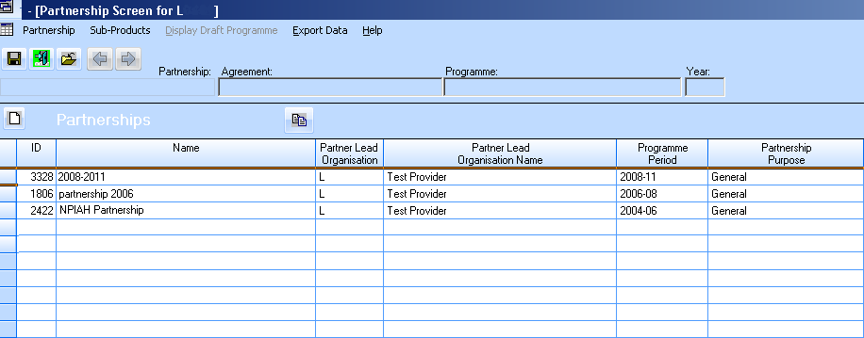

If there is an existing HCA Partnership for 2011-15, the provider should use this to create their Help to Buy projects. This is achieved by right-clicking on the appropriate **Partnership** and then choosing **Review Agreement**, right clicking again and selecting **Review Projects**.

These providers may be able to jump ahead in this guide to Step 3 on page 13.

**1.2. Creating an IMS Partnership Record**

In the Partnerships screen above, select the Create New Partnership icon:

The following Partnership screen will be displayed:

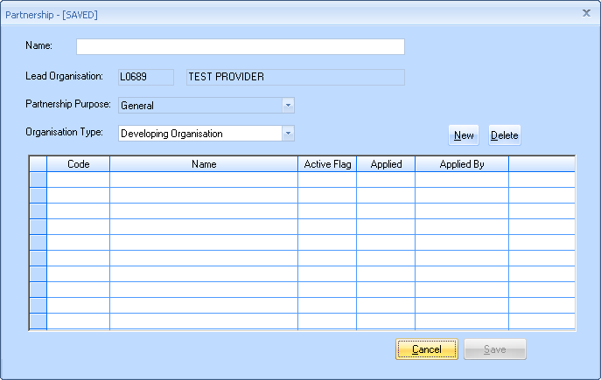

*Partnership screen (not completed)*

**Name**

Enter the name for your 2011-15 Partnership. [Please note: this partnership record will also be used for inputting any new Affordable Housing Programme bids in 2011-15 if the provider moves on to work beyond Help to Buy alone]

Select ‘Save’. The system then automatically adds the lead organisation in the list of **Developing**, **Owning** and **Owners of Land During Development** organisations.

**Developing Organisation:**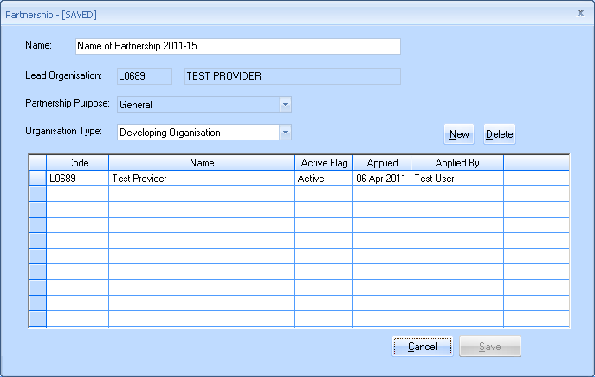

**Owning Organisation:**

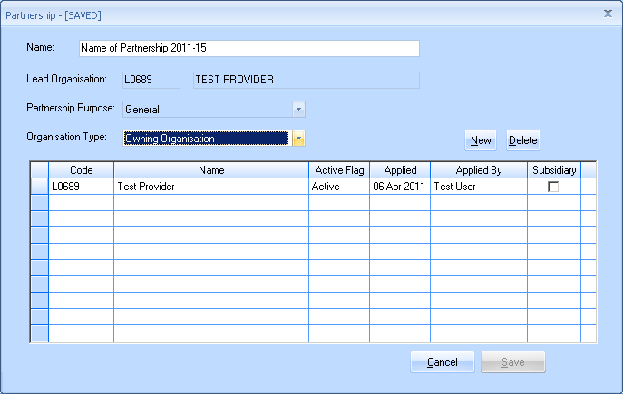

**Owners of Land During Development:**

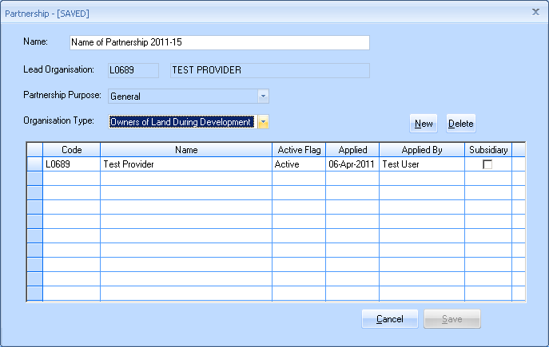

**1.3. Adding Organisations to your Partnership**

Lead Organisations can add other organisations to the Partnership as follows:

* Developing Organisations
* Owning Organisations
* Owners of land during development

In the Partnership screen below, highlight the row for the 2011-15 Partnership, right-click and select Edit Partnership:

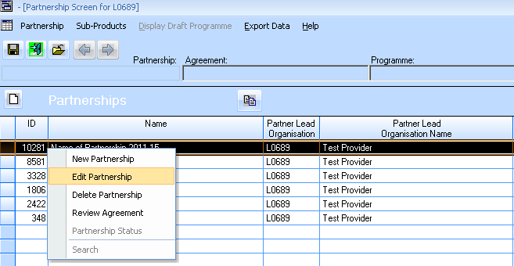

The Partnership screen is displayed:



Use the **Organisation Type** drop-down menu in the screen above to select whether to add either **Developing**, **Owning** or **Owners of land during development**

In the example below, an owning organisation is added by selecting  and then entering the code for that organisation.

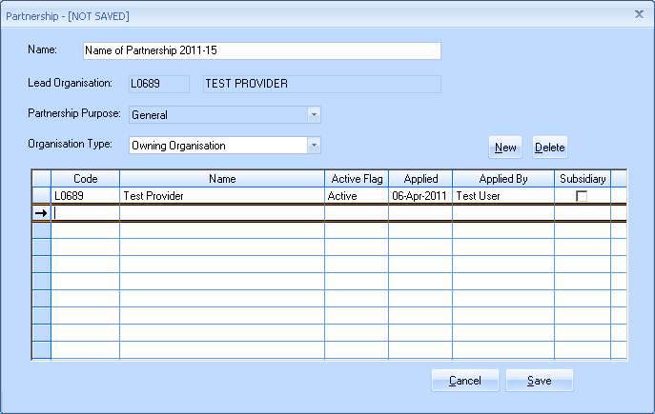

*Edit partnership Screen*

To find the code, put the cursor in the code column of the new row and right-click. The following **Select Owning Organisation** window is displayed:

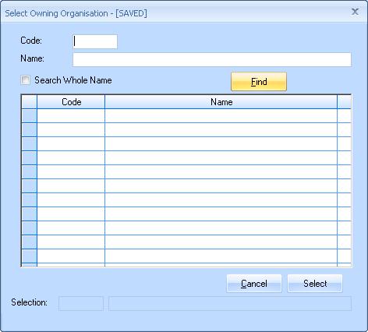

Users can type in a partial name and select Find. The system will return a list of matches.

Once the list is populated, highlight the row for the appropriate organisation and then press Select:

The entry will now appear as per the screen below. Select save to save the details.

Please note: For **Owning Organisation** and for **Owners of Land During Development** there is now a Subsidiary check-box in IMS. Providers can tick this where the organisation is a subsidiary of the lead organisation.

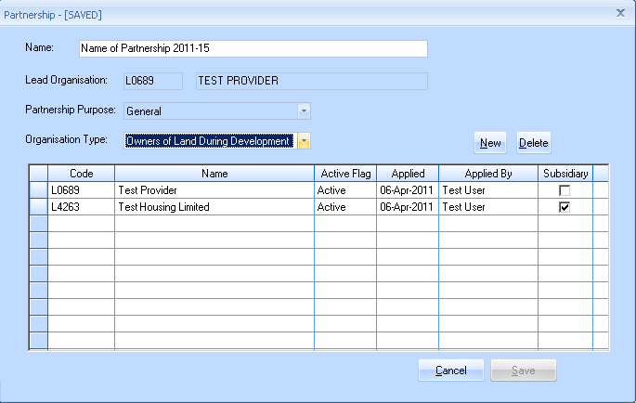

Step 2: Set up Agreement record for 2011-15

**2.1 Finding the Agreement screen**

From the Partnership screen highlight the 2011-15 Partnership, right-click and select **Review Agreement**



The Agreement screen will then be displayed:



**2.2 Creating an Agreement**

Select the Create New Agreement  icon in the Agreements screen

There can only be a single Agreement for a Partnership, therefore, if one is already set up and the New Agreement button is pressed then the following error message is generated:

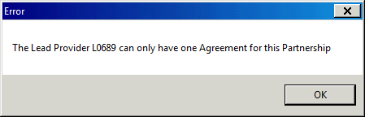

If there isn’t an Agreement in place then the following screen will be displayed:

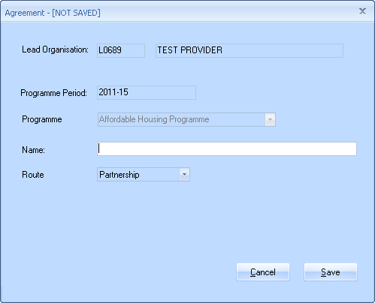

*New Agreement screen (not completed)*

**Name**: Enter a name for the Agreement (10 characters minimum) and select save to create the Agreement

The new Agreement will then be displayed in the Agreements screen:

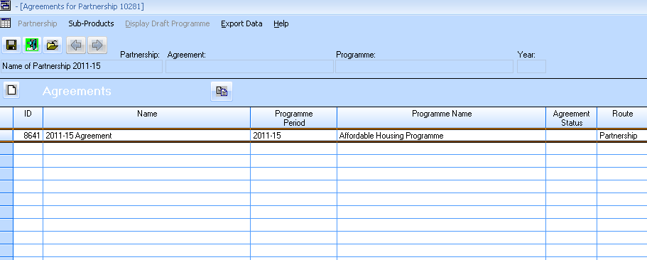

Step 3 Inputting a Help to Buy Project

The Project record represents the first of the two parts of the bid. The second part of the bid is entered through sub-products attached to the Project.

It is expected that Help to Buy bids will be grouped together into bids representing multiple units for an area. Multiple units submitted via one bid can subsequently be scheduled into individual single unit schemes later in the process after the bid has been accepted so that the processing of individual purchases can take place.

**3.1 Navigating to the Project screen**

In the **System Manager** screen select **Bids** > **Partnership/Specialists** > **Partnership** > **Select**> double-click on the **Help to Buy Partnership** row > double-click on the **Help to Buy Agreement** row. You should then be able to see the following Projects screen listing all the projects that have been entered:

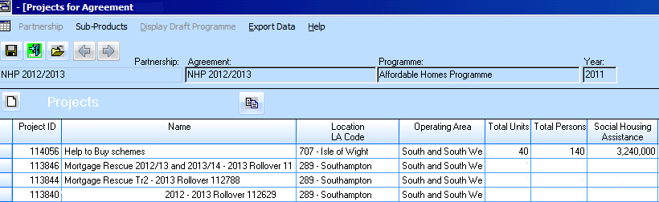

*Projects Screen (with 4 existing Projects listed)*

**3.2 Creating a New Help to Buy Project**

In the Projects Screen (shown above) select the Create New Project icon . The following New Project screen will be displayed. There will be two active tabs within this view, **Scheme** and **Location.**

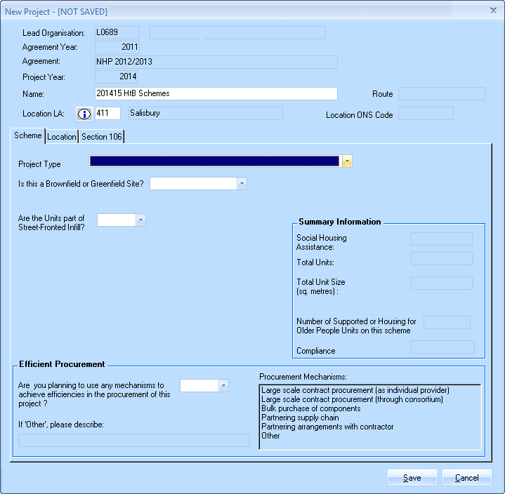

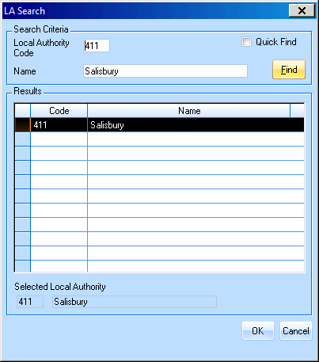*New Project Screen showing Scheme tab (not completed)*

**New Project Mandatory fields:**

**Location LA (Local Authority).**

As with incentive products in the past, although Help to Buy is bid at an Operating Area level, providers will be expected to select a nominal LA within the operating area in which they wish to bid;

Either enter the three digit code for the Local Authority or, if the LA code is not known, then right-click in the Location LA field in the project and the LA Search screen opposite will open.

A partial LA code or Name information can be entered, select **Find** and the search screen will return records that match the partial characteristics.

Once the desired Local Authority has been identified, highlight the row and select **OK**. The LA Search screen will close and then providers will be returned to the Project screen where the Location LA field will be populated with the code for the LA selected.

**3.3 New Project screen – Scheme Tab**

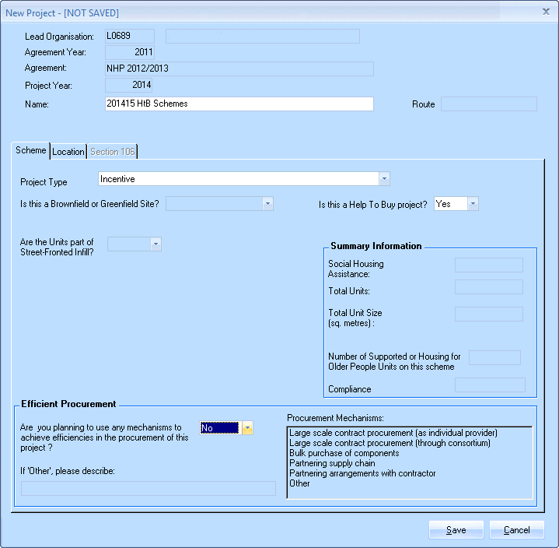

**Name:** Select a name for this Help to Buy bid

**Project Type:** Select ***Incentive***

**Is this a Help to Buy project?:** Select Yes

**Efficient Procurement:** **“Are you planning to use any mechanisms…”** - Select Yes/No. If Yes please select option(s) from list of Procurement Mechanisms. If ‘Other’ selected please describe.

**3.4 New Project Screen – Location tab**

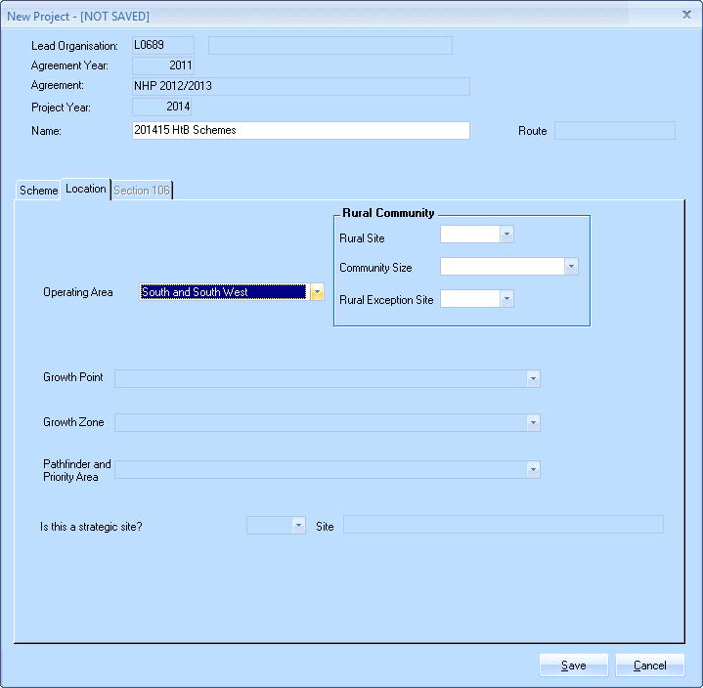

Once ‘Incentive’ has been selected as the *Project type* on the *Scheme* tab, the HCA Operating Area needs to selected.

**Rural Site** –can be left unselected as some areas may have both rural and non-rural units which will be specified at the individual scheme stages, otherwise, please select Yes/No if appropriate.

Step 4 Inputting Help to Buy Sub Products

Sub Products are linked to a Project and represent the second part of the two parts of the bid. This is where the majority of the data is entered for the bid. We would expect only one sub product to be entered for each area project.

**4.1 Navigating to the Sub Product screen**

From the **System Manager** screen select **Bids** > **Partnership/Specialists** > **Partnership** > **Select**> double-click on your 2011-15 **Partnership** row > Double-click on the **Agreement** row > Double-click on the row of the **Project** to add the Sub Product to. The following Sub Product screen will be displayed which will display all Sub Products input for that Project:

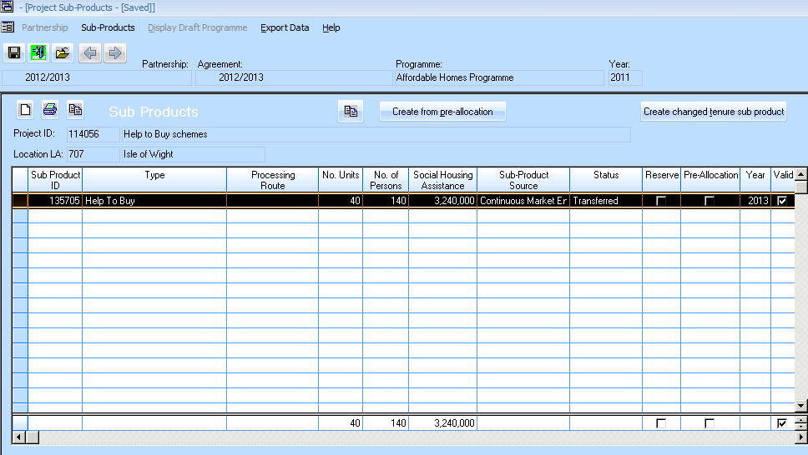

*Sub Product screen with a single Sub Product listed*

In the above Sub-Product screen select the new sub product icon to view the Sub-Product screen

**4.2 The Sub Product Screen**

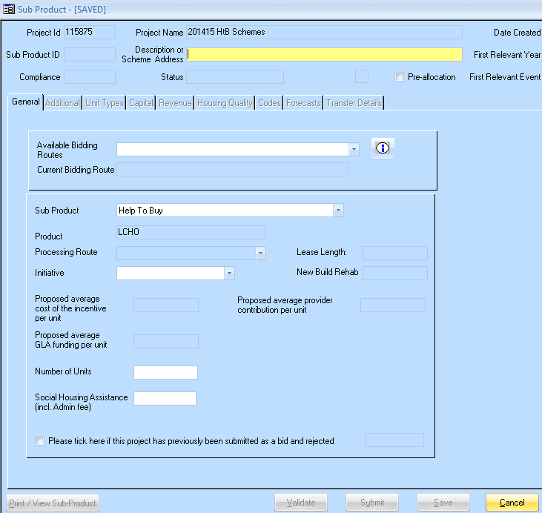

**Description or scheme address**

This is a mandatory field and the description entered will be carried forward to allocation if the bid is successful. Please try to ensure that the description entered for each sub-product is one which will make it easily identifiable in any subsequent list of allocations.

**4.3 Sub Product Screen – General Tab**

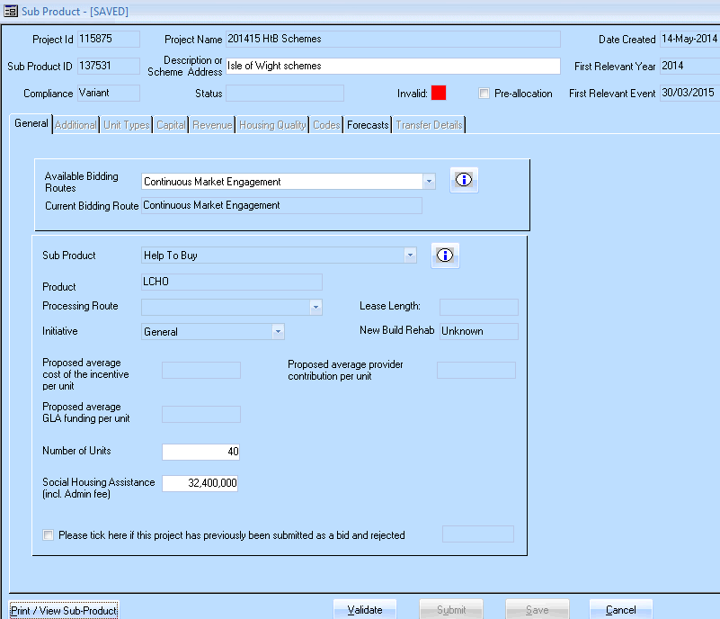

*Sub Product Screen showing a completed Product tab*

**Mandatory fields:**

**Available Bidding Route:** Select ***Continuous Market Engagement***

**Sub Product:** Select ***Help to Buy***

**Initiative:** Select ***General***

**Number of units:** total units

**Social Housing Assistance:** Total of net grant (total HCA Equity contribution) + HBA allowance (£600 x number of units)

Once data is entered, select **Save** to save and move on.

**4.4 Sub Product Screen – Forecasts Tab**

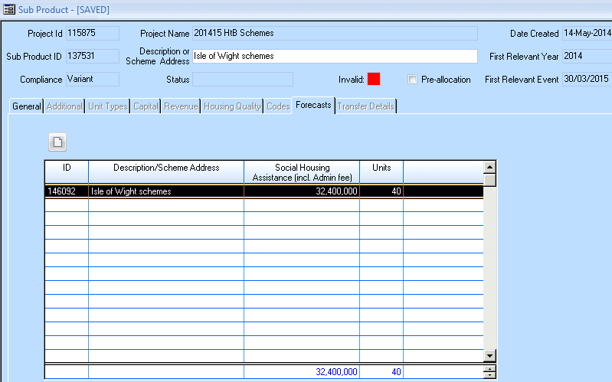

**Forecast Tab - To Enter Forecast Milestone Events**

Double click on the relevant line (shown in above example highlighted in black) in order to amend and/or review the forecasts.

The following Enter Sub-Product Milestone Event screen will be displayed:

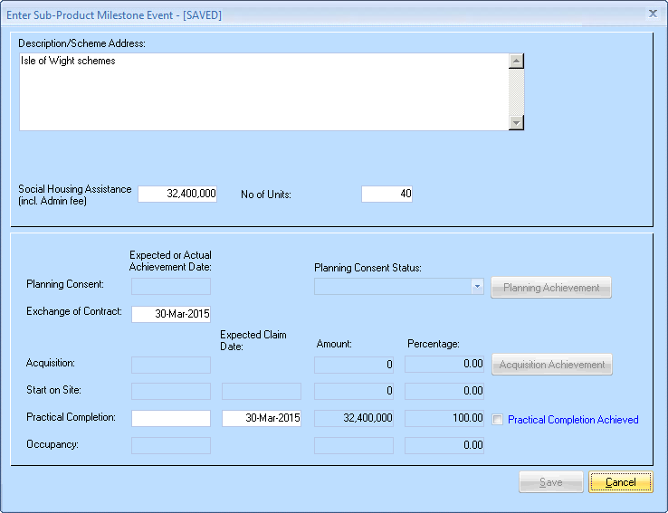

*‘Enter Sub-Product Milestone Event’ screen*

Most fields are pre-populated from previous data entered. All white fields are available to be amended if necessary.

**Description / Scheme Address**

**Social Housing Assistance:** net grant claimed + admin fee – this is a calculated field

**No of Units:**

**Exchange of Contract** –Date field which has been pre-filled with the penultimate date in the year [this is advisable to be set within the last month of bidding year to prevent lapsed forecasts messages appearing throughout the year but can be amended if required]

**Practical Completion** – Date field which has been pre-filled with the penultimate date in the year [this is advisable to be set within the last month of bidding year to prevent lapsed forecasts messages appearing throughout the year but can be amended if required]

**4.5 Forecast Tab - update Active organisations**

Once the milestone forecast data has been saved, a forecast record will be listed in the Forecasts tab (shown below). Highlight the record, right-click and select **Update Active Organisations**

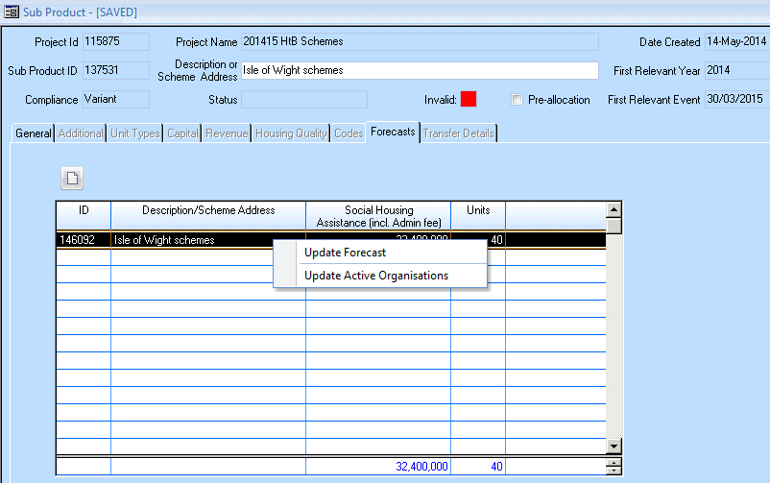

The following **Update Active Organisations** screen will be displayed. The organisations listed will be those listed in the Partnership record added in Step 1. **Please note: Providers can return to the Partnership record and add further organisations if required.**

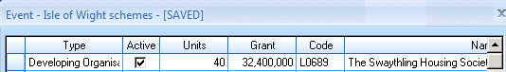

These fields have been automatically completed by ticking the active boxes.

**4.6 Validating the Individual Sub Product**

The Validation process is built into the Define Sub Product screen. Once all data has been entered and saved, select the  button in the Define Sub Product screen.

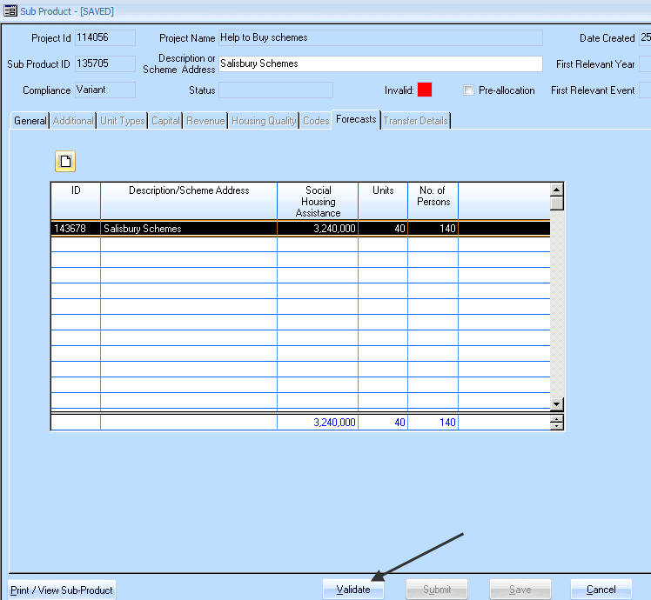

If there are no errors in the Sub Product then the following message will be displayed:

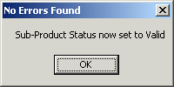

If there are any errors the system will display them in an errors window:

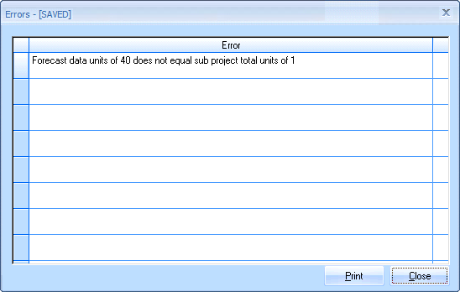

*Validation Errors*

Once any errors are corrected, validate the Sub Product again in order to change the Sub Product Status to Valid.

The Valid indicator will then change from Red to Green in the Define Sub Product screen:

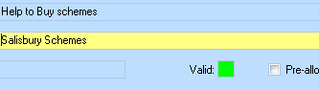

**Step 5: Submit the Individual Sub Product**

The submit Sub Product process is built into the Define Sub Product screen. Once all data has been entered, saved and validated, select the  button in the Define Sub Product screen below.

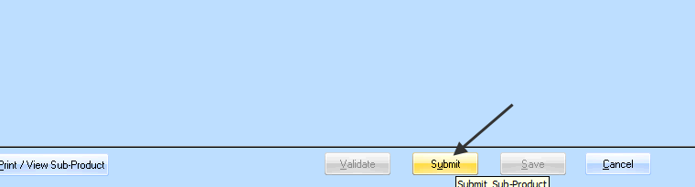

*Sub Product screen with highlighted Submit button*

The following Update Status screen will be displayed:

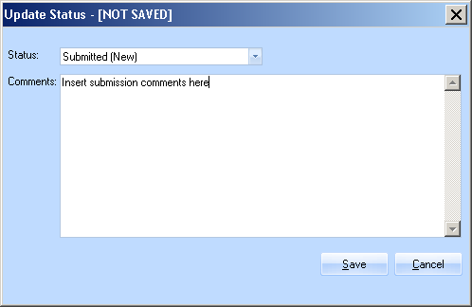

In the above **Update Status** screen select **Submitted (New)** in the Status field and add a comment (minimum 20 characters).

Select **Save** to submit the bid.

Once submitted – the Sub Product status will be set to New and cannot be amended.

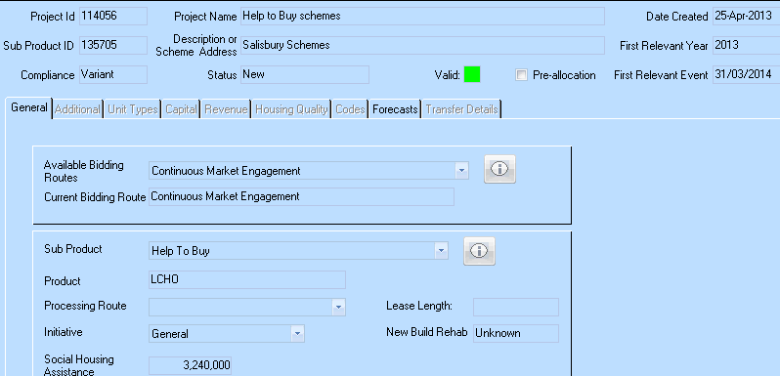

**Step 6: Partnership, Grant Agreement and Contract sign-off**

Once the HCA has approved the Help to Buy bid in IMS and the allocation has been created, providers will then need to sign-off the Help to Buy grant agreement.

Select **Bids> Partnership** **and Grant Agreement documents**

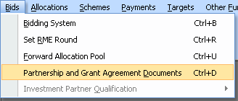

Highlight the row for the appropriate 2011-15 Partnership, right click and select ‘Review/Update Contract Types’:

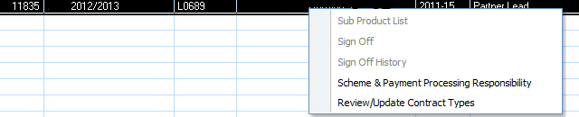

Highlight the Help to Buy row, right-click and select ‘Review Sign-Off’

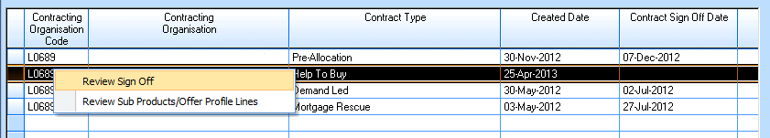

The Sign-Off screen shown overleaf will then be displayed (please note – the top row shown as blank in the screen below will be populated with your Provider code and name:

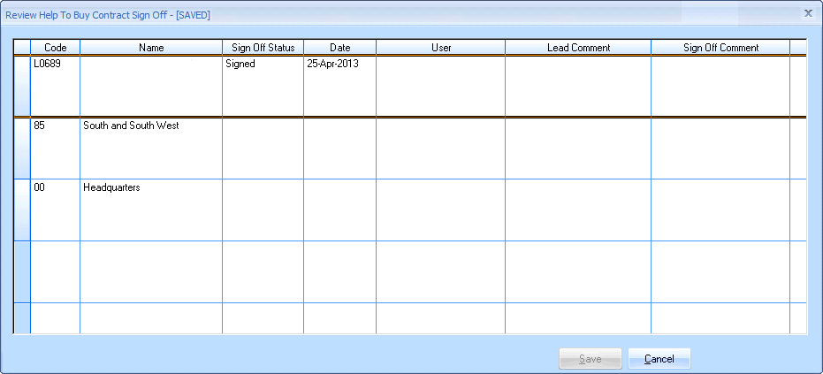

Highlight the row, right-click and select sign-off:

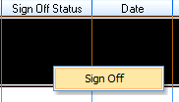

Once this is complete, and a subsequent sign-off by the Lead Operating Area at the HCA is also complete in the same screen providers will be able to start processing Help to Buy sale completions.