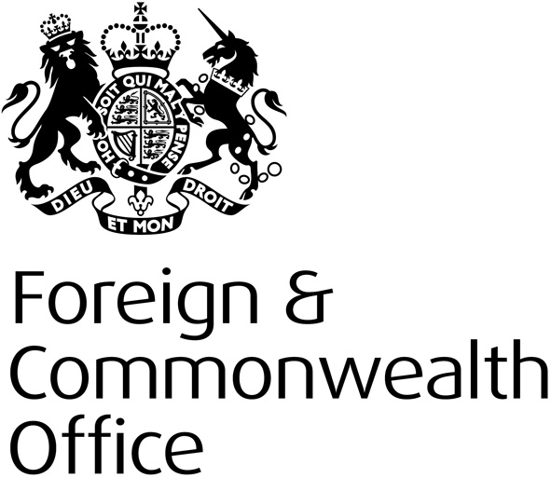

Human Rights and Democracy Programme

STRATEGY

Please Protect until 18 January

Financial Year 2016-17
Human Rights and Democracy Department

PROGRAMME STRATEGY

EXECUTIVE SUMMARY
The Human Rights and Democracy Programme (HRDP) is the FCO’s dedicated strategic programme fund supporting our global human rights and democracy work. Through targeted projects, it aims to further British interests overseas by supporting the promotion and protection of human rights, democracy and the rule of law.
The HRDP is a strategic programme; we therefore assess every bid we receive carefully for impact and fit with both the overarching HRDP strategy, and the UK objectives for that country.

THEMES
For 2016, Ministers have agreed a new approach to the FCO’s human rights and democracy work in line with manifesto commitments. The previous approach of eight “thematic priorities” risked implying a hierarchy of rights, and reduced our flexibility to respond to developments and to capture all the human rights work carried out by our overseas network. The FCO has therefore reconfigured its human rights work around three interconnected themes, which will also provide the basis for our funding strategy:
- Democratic values and the rule of law - Uphold universal rights, democracy and the rule of law as key building blocks for more secure and prosperous societies

- The rules-based international order - Support an effective rules-based international order that stands up for universal rights

- Human rights for a stable world - Promote a more stable world by upholding universal rights in tackling conflict and extremism

WHERE WE WORK
HRDP projects complement the human rights work of individual British Embassies or High Commissions across the globe, so proposals for all countries are eligible. However, please note that 97% of our funding must be allocated to projects in ODA countries.
Our designated HRDP priority countries are those where we actively encourage project bids; we aim to dedicate approximately 65% of funding to those countries. The 2016-17 HRDP priority countries are listed in Annex A. These are countries that feature as one of the FCO’s human rights priorities (formerly “countries of concern”), country case studies, or thematic case studies as set out in the 2014 Annual Human Rights and Democracy Report, published in March 2015.
Proposals from non-priority countries are also strongly encouraged, but please note there is less funding available.

TOTAL ANNUAL BUDGET FOR PROJECTS
For the financial year 2016-17, the project budget for HRDP is approximately £10.5 million (not yet announced, please protect). Please note, this may be subject to change, and the HRDP Programme Team will retain flexibility to support urgent bids submitted later in the year, or to hold a second bidding round, if additional funds become available.

ELIGIBILITY

The HRDP accepts project bids from civil society, commercial organisations, governments, think tanks, other UK government departments and international organisations.

We encourage our Embassies and High Commissions to work closely with both local and international implementers, in order to identify potential projects that are of the greatest relevance to the UK’s human rights focus for that country.

MONITORING & EVALUATION
Robust monitoring and evaluation (M&E) is an integral part of the HRDP. The HRDP team encourages new approaches and partners, while at the same time ensuring rigorous M&E, so that impact can be measured and any problems during project implementation can be caught early and addressed.

Quarterly Reports
Project implementers are required by grant contract to submit quarterly progress reports, and quarterly financial reports to the local Embassy or High Commission, or to the relevant Project Manager (for some multi-country projects). Project implementers are required to produce Project Completion Reports.

Quarterly reports inform the programme-wide quarterly review to the HRDP Senior Responsible Owner (SRO). The review is intended to provide an overview of the programme and assess potential risks to its delivery.

In-Depth Project Evaluations
London-based members of the HRDP team evaluate approximately 10% of projects on an annual basis. This is to ensure that project impact and value for money are assessed, and to gather lessons learned which could inform future projects and programme development. Previous evaluations of non-sensitive projects are available here.

The HRDP team will also consider evaluating any project valued £150,000 or over. Other considerations taken into account when choosing projects to evaluate are:

- projects which HRDP are keen to replicate elsewhere
- projects on a specific theme or an area of FCO interest
- projects which had implementation difficulties

PROGRAMME OBJECTIVES AND INDICATORS

OBJECTIVE | INDICATOR | INDICATIVE TYPES OF ACTIVITY
- Uphold universal rights, democracy, and the rule of law as key building blocks for more secure and prosperous societies | - Widen Democratic Space  Increased democratic space and better protection of journalists and civil society space | - Changing laws, policies, or practices which limit civil society space, freedom of expression or assembly  - Promoting and protecting media freedoms, including the safety of journalists and freedom of expression  - Supporting the protection of human rights defenders
 | - Strengthen Democratic Governance and the Rule of Law  Increased awareness and capability of parliaments, courts, the criminal justice system, and the executive to uphold universal rights  Work under this indicator will also be supported by the Magna Carta Partnerships fund | - Strengthening democratic processes in line with international standards, including support for free and fair elections  - Developing transparent and accountable democratic institutions based on the rule of law, and reducing corruption  - Reforming criminal justice systems, tackling impunity, and improving citizens’ access to justice in line with international human rights standards, including capacity building and reform of police, the judicial system, and prisons; and measures to secure abolition of the death penalty, prevent torture, and eradicate extra-judicial executions by law enforcement actors
 | - Increase Equality and Non-Discrimination  Increased respect for equality and non-discrimination for all members of society | - Removing or amending discriminatory laws, policies and practices which target particular members of society (e.g. women, LGBT, religious minorities), and providing legal identity for all including protecting the right to a nationality and birth registration  - Reducing hate speech, violence or harassment based on discrimination  - Increasing the participation of women or members of marginalised groups in political and public life, including in positions of leadership and influence
- Support an effective rules-based international order that stands up for universal rights | - Implement International Standards and Principles  Better understanding and implementation of international human rights standards | - Implementing the outcomes of UN human rights mechanisms (e.g. Universal Periodic Review (UPR), Treaty Bodies, Special Rapporteurs) and international instruments, (e.g. ICCPR, OPCAT, UN Guiding Principles on Business and Human Rights))  - Supporting UN human rights field presences
 | - Strengthen Human Rights Institutions and Mechanisms  More effective international, regional and national human rights mechanisms | - Carrying out studies or initiatives to strengthen and implement the UN human rights system  - Supporting engagement of human rights defenders with UN human rights mechanisms, including the Human Rights Council and UPR.  - Establishing and strengthening of independent national human rights protection mechanisms, such as Ombudsmen and National Human Rights Institutions that promote human rights and protect human rights defenders
- Promote a more stable world by upholding universal rights in tackling conflict and extremism | - Promote Tolerance and Counter Violent Extremism  The roots of violent extremism are addressed by tackling hate speech and promoting equality and non-discrimination, including freedom of religion or belief | - Supporting effective multilateral human rights processes to combat extremism  - Promoting respect for human rights, including freedom of religion or belief and tackling hate speech.  - Supporting increased understanding of universal rights, tolerance and the nature of prejudice, in societies where these are under threat.  - Ensuring that the lessons of history, including from the Holocaust, are not forgotten, but rather used in preventing extremism.
 | - Uphold Universal Rights in Conflict  Increased prevention and reduction of sexual violence in conflict, and increased participation of women in peace processes and wider peacebuilding | - Countering traditional assumptions about sexual violence in conflict, challenging attitudes that make women and girls particularly vulnerable, and working to end stigmatisation (including of men and boys)  - Tackling impunity and promoting greater accountability through domestic judicial / legal reform, or awareness raising of their rights/redress  - Implementing the International Protocol on the Documentation and Investigation of Sexual Violence to improve the capacity of local actors and first responders. Building the evidence base through documentation  - Building the capacity of women and local women’s organisations to contribute to peace/post-conflict processes
 | - Human rights in Security and Justice Assistance  Increased human rights compliance in the security and justice sector | - Encouraging countries to embed human rights within their security and justice reforms, including reducing the risk of the use of torture or the death penalty

Annex A: 2016-17 Human Rights and Democracy Programme Priority Countries

These are countries that feature as one of the FCO’s human rights priority countries (formerly “countries of concern”), country case studies, or are the focus of thematic case studies, as set out in the 2014 Annual Human Rights and Democracy Report, published in March 2015.

Afghanistan
Bahrain
Bangladesh
Brazil
Belarus
Burma
Burundi
Cambodia
Central African Republic
China
Colombia
Cuba
Democratic People’s Republic of Korea
Democratic Republic of Congo
Egypt
Eritrea
Ethiopia
Fiji
Gambia, The
Honduras
India
Iran
Iraq
Israel and Occupied Palestinian Territories
Laos
Libya
Mexico
Nigeria
Pakistan
Russia
Rwanda
Saudi Arabia
Somalia
South Sudan
Sri Lanka
Sudan
Swaziland
Syria
Thailand
Tunisia
Turkmenistan
Ukraine
Uzbekistan
Vietnam
Yemen
Zimbabwe

