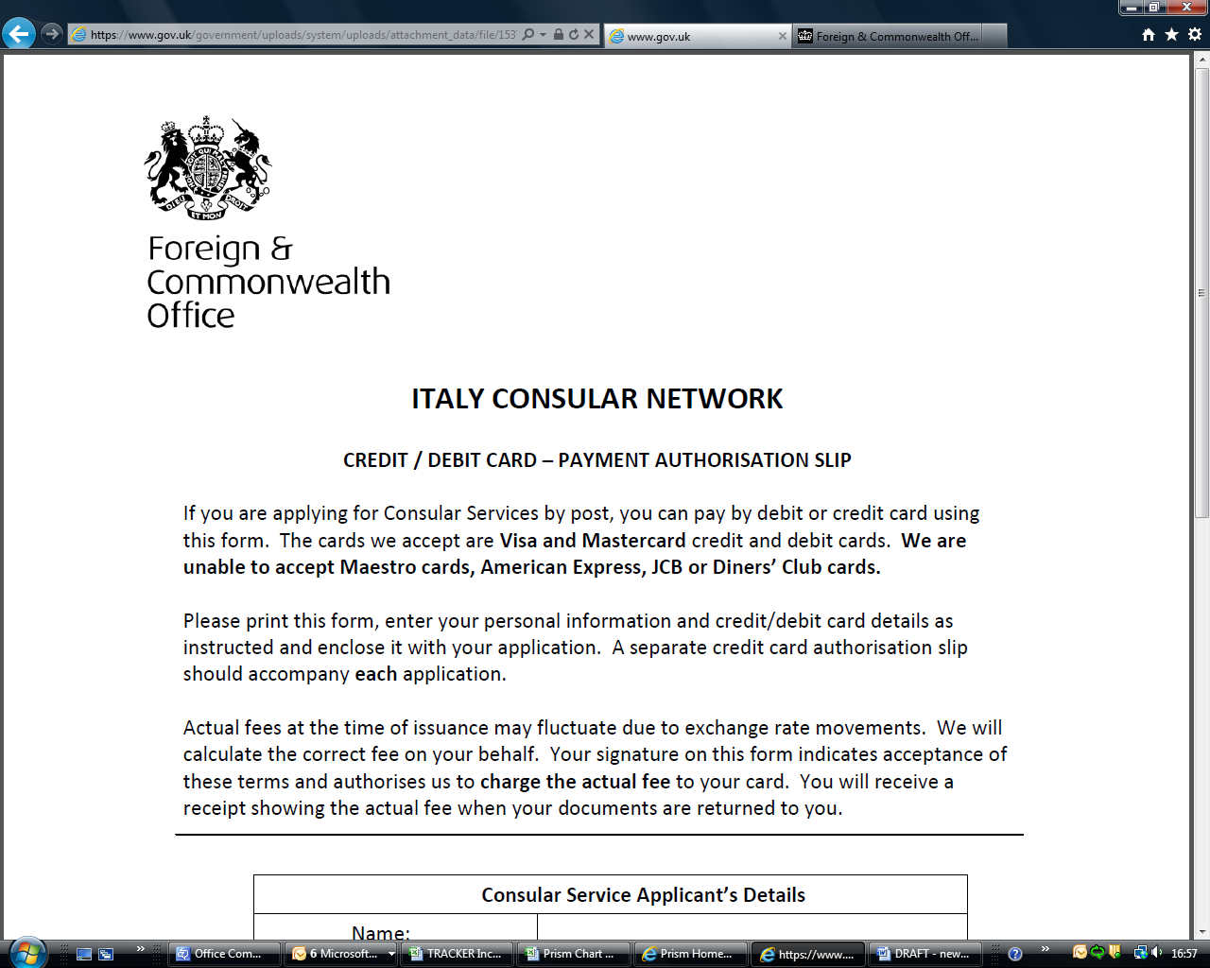

Application for a Certificate of Custom/law for marriage in Belgium:

Explanatory Notes

Please check that all necessary documents and photocopies are included and that all details are correct. We can only process complete applications submitted with the required documents. We will therefore return any incomplete applications to the address provided on the form.

This application process, when completed, will provide you with documentation that covers the following requirements:

Certificate of nationality
Certificate of Single Status
Custom and Law
Proof of address

Your application should take 10 working days (2 weeks) to process from the date we receive it. We are unable to answer queries about receipt of your application within this period. You should send your application by registered post if you wish to have a trace of its receipt. Certificates are issued in Dutch or French and may need legalisation from the Belgian Ministry of Foreign Affairs.

Please send your application to:

British Consulate General Brussels (Marriage)
Ave d’Auderghem 10
Brussels 1040

WE ONLY ACCEPT POSTAL APPLICATIONS

Application for a Certificate of Custom/law for marriage in Belgium:

Application Form: Please complete the form electronically, then print and sign.

Forename(s)

Surname

Date of Birth

Marital Status

Current/valid UK Passport Number

Current Address

Email

Telephone No

Proposed date of marriage

Place of marriage
(name of Commune/Gemeente)
Name and address where you wish the certificate to be sent
DECLARATION:
By signing this document I do solemnly and sincerely declare that the information provided is true

Signature of applicant
Date

Application for a Certificate of Custom/law for marriage in Belgium:

Checklist: Please be sure to include all necessary documents

1 | The completed and signed application form
2 | A photocopy of your valid British Passport
3 | A photocopy of your birth certificate (if you were born in the UK, a copy of the long version, copies can be obtained from the GRO)
4 | If you have been previously married, a photocopy of documentary evidence of valid termination of the earlier marriage (divorce decree absolute/death certificate)
5 | If you are under the age of 18, the written consent of both parents or of your legal guardian, witnessed by a third party
6 | Please choose preferred language of documentation:
 | Dutch
 | French
7 | Payment. Please complete the attached credit card payment sheet.
8 | Postage. Your documents and certificate will be returned by registered post. A cost of £5 will be added to the fee.
9 | A self-addressed A4 envelope.

Application for a Certificate of Custom/law for marriage in Belgium:

Payment Authorisation Slip

Please print this form and enter your personal information and credit/debit card details as instructed. Once fully completed and signed, please post to: British Embassy Brussels, Ave d’Auderghem 10, Brussels 1040.

APPLICATION DETAILS

Name of applicant:
Service requested Fee 11 Certificate of Custom/law £50
Postage £5

PAYMENT DETAILS

Name on card:

Contact number of payee:
Relation to applicant (if not applicant):
Type of card: Visa Visa Debit Mastercard Mastercard Debit
Card Number:

Expiry Date: / Currency to charge in: GBP
--------------------------------------------------------------------------------------------------------------------------


I authorise the Foreign & Commonwealth Office to charge my card ending

for the service of Fee 11 Certificate of Custom/law £50
Postage £5

The Foreign & Commonwealth Office (FCO) accepts no responsibility for this form until it is received by the British Consulate General Brussels.

Signed by the Cardholder: Date:

A receipt will be provided and returned to you along with the Certificate of Custom/law

