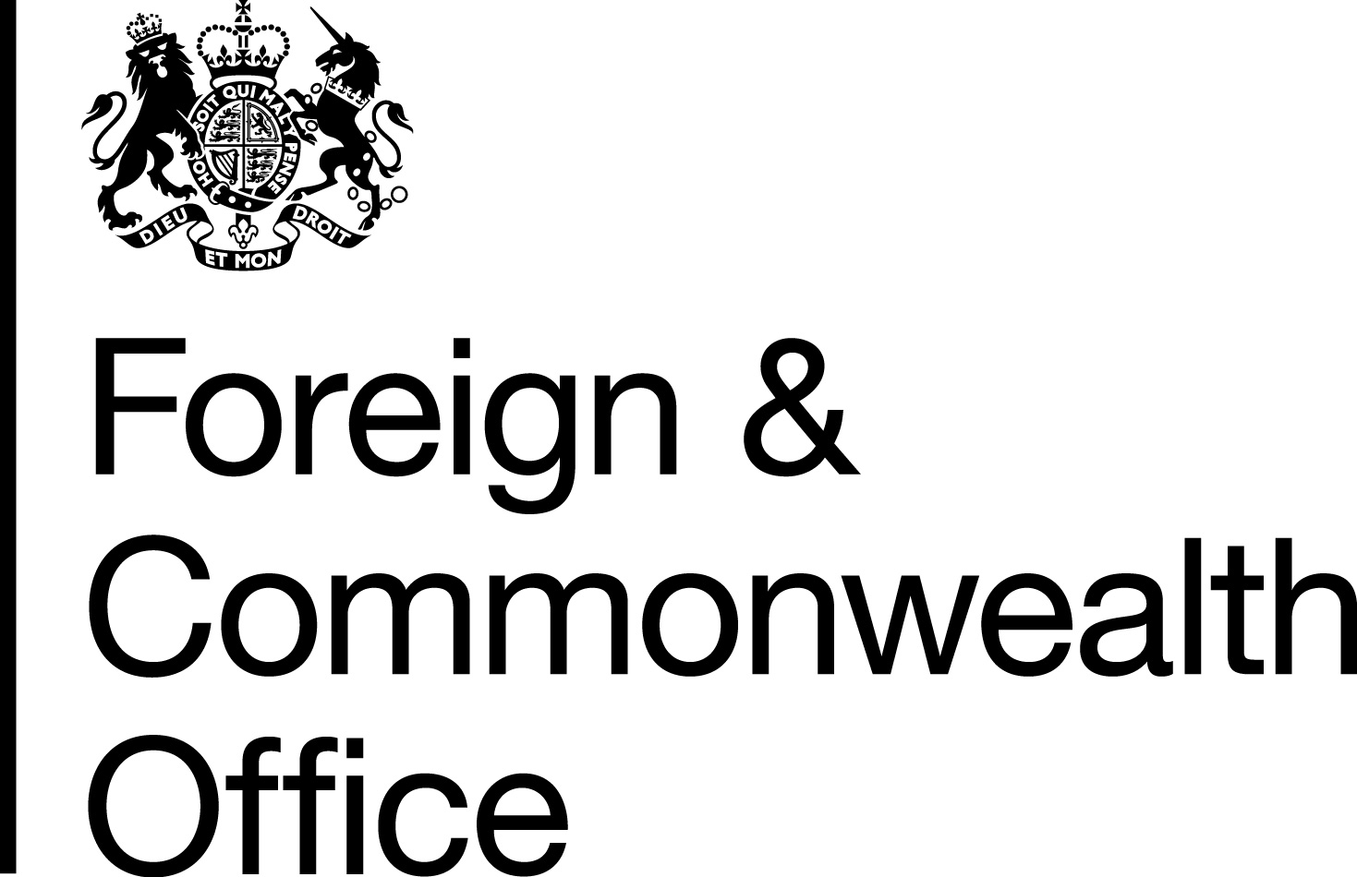

PROJECT CONCEPT FORM

This form should be submitted prior to putting forward a full Project Proposal. The Post may accept or reject Project Concepts.

When the Post agrees a Concept, and invites implementers to put forward a full Project Proposal, it is not a guarantee that the full Project Proposal will be approved for funding. It signals the Post’s interest in receiving more details about the proposed project. Before you complete this form, check the website of the British Embassy/High Commission in the country in which you are proposing to work and/or speak to the Post’s Project Officers to find out about the Programme Strategy applicable for that country, and to check project viability.

Project Title

Purpose
This must be NO MORE than one sentence
Implementing Agency
Name; Address; Telephone Numbers; Email; Website
What change will this project deliver?
Why do we need to run this project? And what will be the longer term impact?
Keep this short, you should be able to articulate why the project is needed in a couple of sentences
Background
In no more than 200 words, provide the background to the issue this project will change and why the UK is the best donor

Risks
Provide brief details of any serious risks to the success of the project and how these will be mitigated
Cost  What is the TOTAL cost of the Project  Please note, project funds are paid quarterly in arrears. | FY16/17 |  | £ | If co-funding has or is being sought, please also show the cost to the FCO and provide details of the co-funding organisations |  | FY 16/17 | £
 | FY 17/18 |  | £ |  |  | FY 17/18 | £
Timing | Planned start date: |  |  |  | Planned completion  date:
Post Comments

Include which fund or business plan objective this project will help deliver.

Should this Concept now be worked up into a Full Proposal  If No, give explanation |  | Yes/No
Date

