Floods destroy: Email signature instructions
Based on Microsoft Office Outlook 2007) | October 2015

Go into Microsoft Office Outlook
Click ‘Tools’ on the toolbar and select ‘Options’
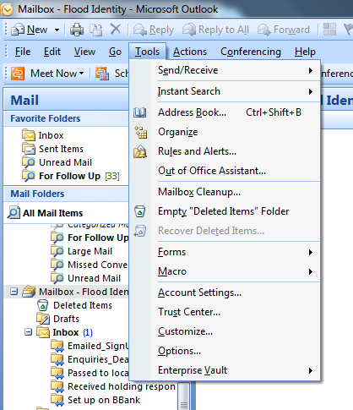

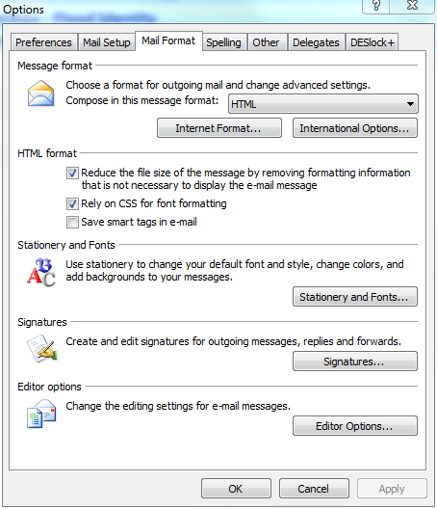
Select ‘Mail Format’ tab and click on ‘Signatures’

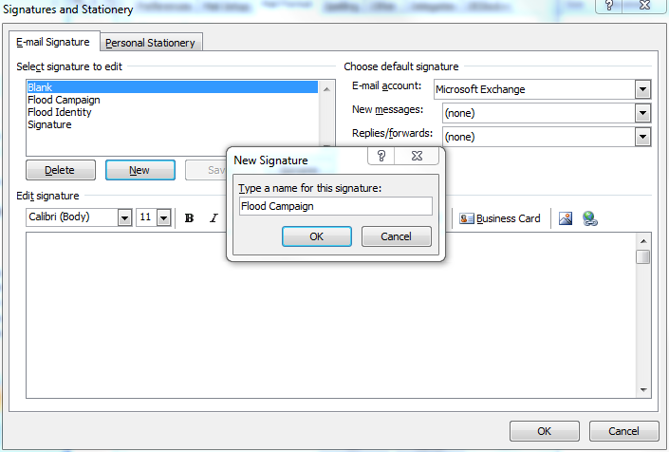
Click ‘New’ and type in ‘Flood Campaign’ then click ‘OK’

Add your usual contact details, such as name, title, telephone numbers, and email address.
Copy and paste the link and image below into the email signature box below your contact details.

www.gov.uk/floodsdestroy


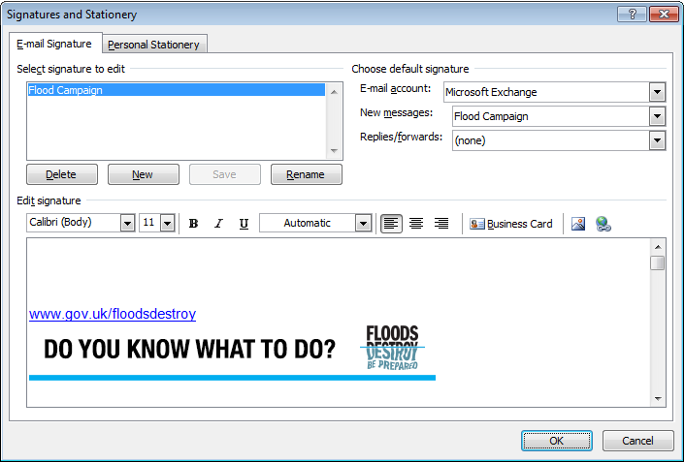
If you want the flood campaign to be your standard email signature, then chose ‘Flood Campaign’ in the ‘New messages’ drop-down box and do the same for ‘Replies/forwards’.
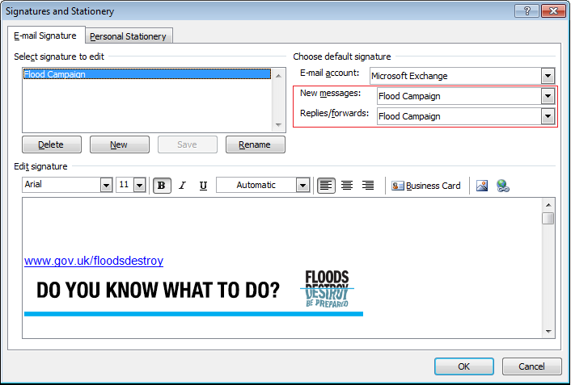

Click ‘OK’ and ‘OK’ once more to take you out of the options box.
Our flood campaign signature should now appear at the bottom of all your emails.


