G.A.S. Report Quick Start Terminal Operator Guidance: ANNEX A

STEP 1. Log on to https://itportal.decc.gov.uk/eng/fox/live/PORTAL_LOGIN/login
STEP 2. From your work basket click on Edit Report
STEP 3. Complete your contact details
STEP 4. Complete Forecast aggregate maximum production availability to national GRID NTS
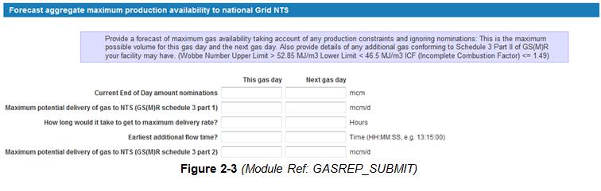STEP 5 The additional information field is optional. Please submit any additional information that you feel would benefit NG.

STEP 6 (Optional) you can Save and Exit to save any data entered whilst, for example, you collect other information up until NG locks the GAS Report.

STEP 7 Submit GAS Report to send information to NG

Before the GAS Report has been locked by NG, you can Update Report from your work basket. By pressing Save and Exit, changes are automatically forwarded to NG.

If the GAS Report has been locked and you have missed the deadline, made a mistake or have an update please contact NG who will be able to make any changes for you.

Comprehensive guidance is also available in Help Documentation on the left hand side menu on the GAS Report page of the Portal for e.g. how to extract pdf documents of individual terminal G.A.S. Reports, more information on the audit trail functionality.

