UK Standards for Microbiology Investigations

Pneumonia

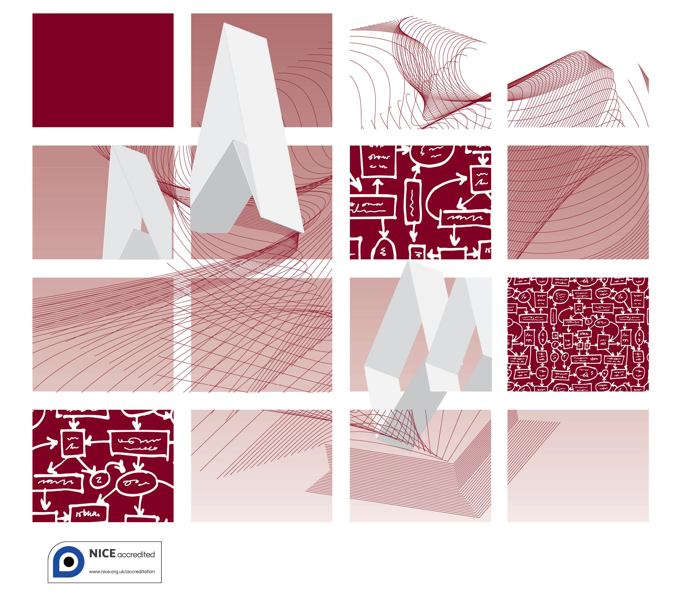

Acknowledgments
UK Standards for Microbiology Investigations (SMIs) are developed under the auspices of Public Health England (PHE) working in partnership with the National Health Service (NHS), Public Health Wales and with the professional organisations whose logos are displayed below and listed on the website http://www.hpa.org.uk/SMI/Partnerships. SMIs are developed, reviewed and revised by various working groups which are overseen by a steering committee (see http://www.hpa.org.uk/SMI/WorkingGroups).
The contributions of many individuals in clinical, specialist and reference laboratories who have provided information and comments during the development of this document are acknowledged. We are grateful to the Medical Editors for editing the medical content.
For further information please contact us at:
Standards Unit
Microbiology Services
Public Health England
61 Colindale Avenue
London NW9 5EQ
E-mail: standards@phe.gov.uk
Website: http://www.hpa.org.uk/SMI
UK Standards for Microbiology Investigations are produced in association with:
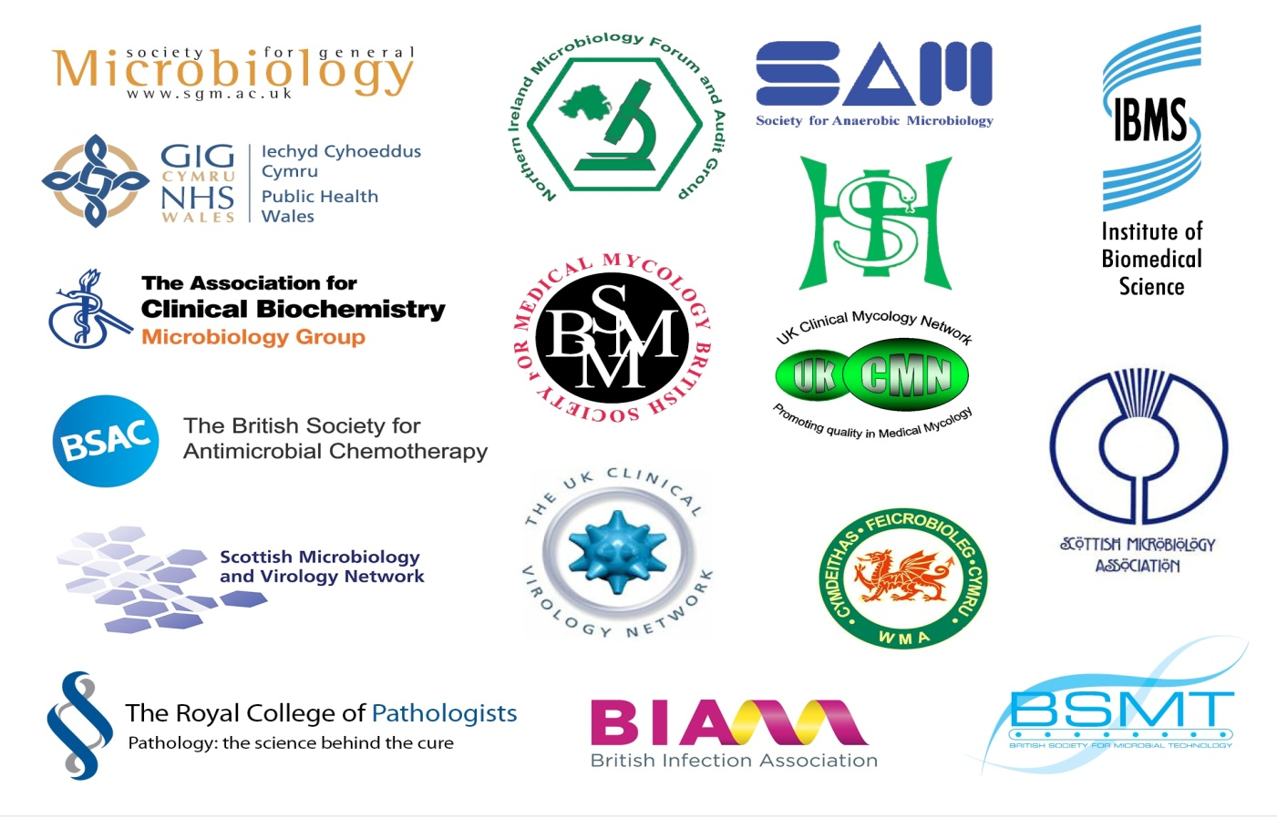

Contents
Acknowledgments 2
Amendment Table 4
UK Standards for Microbiology Investigations: Scope and Purpose 5
Scope of Document 8
Pneumonia in Immunocompetent Adults 10
Pneumonia in Immunocompromised Adults 11
1 Notification to PHE or Equivalent in the Devolved Administrations 14
References 15

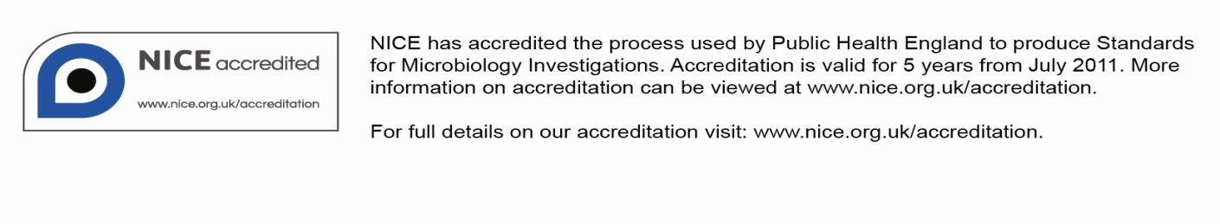

Amendment Table
Each SMI method has an individual record of amendments. The current amendments are listed on this page. The amendment history is available from standards@phe.gov.uk.
New or revised documents should be controlled within the laboratory in accordance with the local quality management system.
Amendment No/Date. | 2/17.03.14
Issue no. discarded. | 1.1
Insert Issue no. | 1.2
Section(s) involved | Amendment
Whole document. | Document has been transferred to a new template to reflect the Health Protection Agency’s transition to Public Health England.  Front page has been redesigned.  Status page has been renamed as Scope and Purpose and updated as appropriate.  Professional body logos have been reviewed and updated.  Standard safety and notification references have been reviewed and updated.  Scientific content remains unchanged.

Amendment No/Date. | 1/24.12.12
Issue no. discarded. | 1
Insert Issue no. | 1.1
Section(s) involved | Amendment
References. | Hyperlink removed.

UK Standards for Microbiology Investigations#: Scope and Purpose
Users of SMIs
- SMIs are primarily intended as a general resource for practising professionals operating in the field of laboratory medicine and infection specialties in the UK.
- SMIs provide clinicians with information about the available test repertoire and the standard of laboratory services they should expect for the investigation of infection in their patients, as well as providing information that aids the electronic ordering of appropriate tests.
- SMIs provide commissioners of healthcare services with the appropriateness and standard of microbiology investigations they should be seeking as part of the clinical and public health care package for their population.
Background to SMIs
SMIs comprise a collection of recommended algorithms and procedures covering all stages of the investigative process in microbiology from the pre-analytical (clinical syndrome) stage to the analytical (laboratory testing) and post analytical (result interpretation and reporting) stages.
Syndromic algorithms are supported by more detailed documents containing advice on the investigation of specific diseases and infections. Guidance notes cover the clinical background, differential diagnosis, and appropriate investigation of particular clinical conditions. Quality guidance notes describe laboratory processes which underpin quality, for example assay validation.
Standardisation of the diagnostic process through the application of SMIs helps to assure the equivalence of investigation strategies in different laboratories across the UK and is essential for public health surveillance, research and development activities.
Equal Partnership Working
SMIs are developed in equal partnership with PHE, NHS, Royal College of Pathologists and professional societies.
The list of participating societies may be found at http://www.hpa.org.uk/SMI/Partnerships. Inclusion of a logo in an SMI indicates participation of the society in equal partnership and support for the objectives and process of preparing SMIs. Nominees of professional societies are members of the Steering Committee and Working Groups which develop SMIs. The views of nominees cannot be rigorously representative of the members of their nominating organisations nor the corporate views of their organisations. Nominees act as a conduit for two way reporting and dialogue. Representative views are sought through the consultation process.
SMIs are developed, reviewed and updated through a wide consultation process.
Quality Assurance
NICE has accredited the process used by the SMI Working Groups to produce SMIs. The accreditation is applicable to all guidance produced since October 2009. The process for the development of SMIs is certified to ISO 9001:2008.
SMIs represent a good standard of practice to which all clinical and public health microbiology laboratories in the UK are expected to work. SMIs are NICE accredited and represent neither minimum standards of practice nor the highest level of complex laboratory investigation possible. In using SMIs, laboratories should take account of local requirements and undertake additional investigations where appropriate. SMIs help laboratories to meet accreditation requirements by promoting high quality practices which are auditable. SMIs also provide a reference point for method development.
The performance of SMIs depends on competent staff and appropriate quality reagents and equipment. Laboratories should ensure that all commercial and in-house tests have been validated and shown to be fit for purpose. Laboratories should participate in external quality assessment schemes and undertake relevant internal quality control procedures.
Patient and Public Involvement
The SMI Working Groups are committed to patient and public involvement in the development of SMIs. By involving the public, health professionals, scientists and voluntary organisations the resulting SMI will be robust and meet the needs of the user. An opportunity is given to members of the public to contribute to consultations through our open access website.
Information Governance and Equality
PHE is a Caldicott compliant organisation. It seeks to take every possible precaution to prevent unauthorised disclosure of patient details and to ensure that patient-related records are kept under secure conditions.
The development of SMIs are subject to PHE Equality objectives http://www.hpa.org.uk/webc/HPAwebFile/HPAweb_C/1317133470313. The SMI Working Groups are committed to achieving the equality objectives by effective consultation with members of the public, partners, stakeholders and specialist interest groups.
Legal Statement
Whilst every care has been taken in the preparation of SMIs, PHE and any supporting organisation, shall, to the greatest extent possible under any applicable law, exclude liability for all losses, costs, claims, damages or expenses arising out of or connected with the use of an SMI or any information contained therein. If alterations are made to an SMI, it must be made clear where and by whom such changes have been made.
The evidence base and microbial taxonomy for the SMI is as complete as possible at the time of issue. Any omissions and new material will be considered at the next review. These standards can only be superseded by revisions of the standard, legislative action, or by NICE accredited guidance.
SMIs are Crown copyright which should be acknowledged where appropriate.
Suggested Citation for this Document
Public Health England. (2014). Pneumonia. UK Standards for Microbiology Investigations. S 2 Issue 1.2. http://www.hpa.org.uk/SMI/pdf.

Scope of Document
UK Standards for Microbiology Investigations (SMIs) comprise a collection of recommended algorithms for initial test selection and testing methods and confirmatory strategies. UK SMIs also contain guidance notes that describe the recommended standard set of investigations consistent with current good practice in different infective disease presentations, as well as examples of standard laboratory practice and general information on clinical syndromes.
The syndromic algorithms form part of the pre-analytical stage of the investigative process and are intended to guide clinicians and diagnostic laboratory staff in the choice of the correct pathway for the investigation of a sample based upon the clinical context. It is recognised that clinical details are essential to the optimal processing of samples and the documents perform best when sufficient, relevant, clinical details are provided at the time of sample submission. The algorithms are presented in flowchart format to give a clear overview of how to proceed with the testing of specimens and the possible outcomes using the clinical history provided. If the primary testing set does not identify a causative pathogen, secondary testing should be performed if clinical and/or epidemiological features support such testing. Laboratories may wish to undertake second line tests either after, or at the same time as, the primary testing set according to the clinical and local epidemiological setting and laboratory operational capabilities. The flowcharts are intended to reflect current recommended practice, accounting for prevalence of infections in the UK, public health needs, and availability of tests, with references and links to more detailed guidance. National surveillance programmes for specific organisms should be taken into consideration when using the algorithms.
This document should be read in conjunction with relevant SMIs for laboratory processing and reporting of target organisms and public health actions.
S 2 – Pneumonia: Scope
The term “Lower Respiratory Tract Infection” (LRTI) often encompasses a broad range of respiratory conditions such as pneumonia, bronchitis / bronchiolitis, exacerbations of chronic obstructive pulmonary disease / asthma¹. This syndromic algorithm is intended to deal specifically with pneumonia. Pneumonia is defined as the presence of clinical signs and symptoms of LRTI, along with radiological changes that are consistent with pneumonia. An assessment of illness severity should be made clinically, supported by reference to CURB-65ª scoring (in patients under 30 years of age, the CURB-65 score may be a less reliable indication of severity). On this basis, this algorithm deals with the investigation of patients presenting with pneumonia that is judged to be either clinically mild or severe. Pneumonia that may be judged to be moderate can still reflect a significant risk of mortality and therefore, should be investigated as for severe pneumonia. The collection of diagnostic samples (respiratory, urine and blood) should be carried out before the administration of antimicrobials in order to increase the likelihood of a microbiological diagnosis but initiation of treatment should not be delayed in severe cases. If this is not possible, then samples taken for bacterial diagnosis should be collected at a maximum of 24 hours from the start of antimicrobial therapy whenever possible.
In patients who are immunocompromised, microbiological investigation should be carried out to the same extent if they are judged to have mild or severe pneumonia. This is due to the fact that the presentation of pneumonia in this patient group can be atypical and the CURB-65ª scoring system has not been validated for them. In addition, progression from mild to severe illness can be rapid.

Pneumonia in Immunocompetent Adults^{1-8, b}

Pneumonia in Immunocompromised Adults^{1-8, b}

Footnotes
- CURB-65, also known as CURB, criteria is a clinical prediction rule that has been validated for predicting mortality in community acquired pneumonia. It is recommended by the British Thoracic Society¹.
- The microbiological investigation of pneumonia outlined in this algorithm is based on the assumption that the results of such investigations will be acted on in a timely manner. A positive microbiological diagnosis should lead to a narrowing down of the spectrum of antimicrobial treatment from the initial empirical therapy, in the interests of reducing adverse effects of broad-spectrum antimicrobial treatment, and contributing to antimicrobial stewardship.
- Gram or Giemsa staining of sputum and BAL samples in addition to examination by microscopy is only appropriate where sufficient laboratory expertise and a validated methodology exist.
- Respiratory samples for viral PCR screening are ideally lower respiratory tract samples such as an induced sputum, BAL or endo-tracheal aspirate. Where this is not possible, a nose/throat swab is acceptable. The preferred samples for PCR of M. pneumoniae and Chlamydophila species are lower respiratory tract samples or throat swab.
- Literature on the interpretation of HSV and CMV by PCR testing is not clear for sputum specimens. PCR should be performed on sputum according to clinical discretion, for example, when BAL samples are not available.
- The serological investigation of M. pneumoniae is increasingly being replaced by PCR detection in respiratory samples. Serological diagnosis of
M. pneumoniae is valuable, but may not provide a definitive result until the convalescent phase of the illness. Serological diagnosis may be unreliable in patients who are immunocompromised. Serology can be useful in some circumstances but PCR is being increasingly used for both Chlamydophila pneumoniae and Chlamydophila psittaci. For the purpose of this algorithm Chlamydophila species include Chlamydophila pneumoniae and Chlamydophila psittaci.
- Viral PCR screen is the same for patients who are immunocompetent and immunocompromised. The minimum targets for viral PCR screen should be based on local assessments, and may include: Influenza A, Influenza B, RSV, Adenovirus and Parainfluenza viruses.
- Legionella PCR can detect Legionella pneumophila non-serotype 1 and other Legionella species.
- Investigations for Mycobacterium species should be carried out where there is a clinical suspicion of tuberculosis, such as upper lobar cavitation on chest X-ray.
- Immunocompromised patients may present with only mild clinical symptoms, and therefore may not be able to produce a sputum sample without either physiotherapy or other methods such as aerosolised saline inhalation. Therefore, it may be understandably difficult to obtain a sample before the administration of antimicrobials.
- The possible adverse effects of bronchoalveolar lavage, such as the risk of requiring subsequent ventilation, should be taken into account when considering performing the procedure on a sick patient who is not already on ventilation. Where a BAL is performed, it should be preferably ‘directed’, but if this is not available, then a ‘blind’ BAL is acceptable.
- Consider the testing of serum for Cryptococcus antigen and Aspergillus antigen (galactomannan).
- Non-tuberculous mycobacteria (NTM), also known as environmental mycobacteria, atypical mycobacteria and mycobacteria other than tuberculosis (MOTT), are mycobacteria which do not cause tuberculosis but have been recognised as causing human disease in patients who are immunocompromised and PCR for these organisms should be considered as a secondary test.

Additional footnotes for information and not stated in the flowcharts:
- Consider other uncommon pathogens that may be responsible for infection, for example Coxiella burnetii. Travel history is relevant to considering exotic fungal pathogens, eg, Histoplasma sp, Coccidioides sp, and meliodosis, while even a distant travel history may be relevant in Strongyloides stercoralis in the immunocompromised.
- A lung biopsy, if taken, should be sent for both microbiology and histopathology investigation.
- Some patients who present with features of LRTI may have non-infective causes, such as vasculitis or cancer.
- It should be remembered that patients not known to be immunocompromised, eg, an undiagnosed HIV infection, and without recognised risk factors can present with pneumocystis pneumonia.
- Patients with mild pneumonia can require testing in influenza season for influenza A and B, particularly if co-morbidities are present which may be valuable in local clinical settings.

1 Notification to PHE^{9,10} or Equivalent in the Devolved Administrations¹¹⁻¹⁴
The Health Protection (Notification) regulations 2010 require diagnostic laboratories to notify Public Health England (PHE) when they identify the causative agents that are listed in Schedule 2 of the Regulations. Notifications must be provided in writing, on paper or electronically, within seven days. Urgent cases should be notified orally and as soon as possible, recommended within 24 hours. These should be followed up by written notification within seven days.
For the purposes of the Notification Regulations, the recipient of laboratory notifications is the local PHE Health Protection Team. If a case has already been notified by a registered medical practitioner, the diagnostic laboratory is still required to notify the case if they identify any evidence of an infection caused by a notifiable causative agent.
Notification under the Health Protection (Notification) Regulations 2010 does not replace voluntary reporting to PHE. The vast majority of NHS laboratories voluntarily report a wide range of laboratory diagnoses of causative agents to PHE and many PHE Health protection Teams have agreements with local laboratories for urgent reporting of some infections. This should continue.
Note: The Health Protection Legislation Guidance (2010) includes reporting of Human Immunodeficiency Virus (HIV) & Sexually Transmitted Infections (STIs), Healthcare Associated Infections (HCAIs) and Creutzfeldt–Jakob disease (CJD) under ‘Notification Duties of Registered Medical Practitioners’: it is not noted under ‘Notification Duties of Diagnostic Laboratories’.
Other arrangements exist in Scotland^{11,12}, Wales¹³ and Northern Ireland¹⁴.

References
1. The British Thoracic Society. Guidelines for the Management of Community Acquired Pneumonia in Adults. 23-1-2009.
2. American Thoracic Society. Guidelines for the Management of Adults with Hospital-Acquired, Ventilator-Associated, and Healthcare-Associated Pneumonia. Am J Respir Crit Care Med 2005;171:388-416.
3. Mandell LA, Wunderink RG, Anzueto A, Bartlett JG, Campbell GD, Dean NC, et al. Infectious Diseases Society of America/American Thoracic Society consensus guidelines on the management of community-acquired pneumonia in adults. Clin Infect Dis 2007;44 Suppl 2:S27-S72.
4. Masterton RG, Galloway A, French G, Street M, Armstrong J, Brown E, et al. Guidelines for the management of hospital-acquired pneumonia in the UK: report of the working party on hospital-acquired pneumonia of the British Society for Antimicrobial Chemotherapy. J Antimicrob Chemother 2008;62:5-34.
5. Torres A, Ewig S, Lode H, Carlet J. Defining, treating and preventing hospital acquired pneumonia: European perspective. Intensive Care Med 2009;35:9-29.
6. Torres A, Ewig S, Lode H, Carlet J. Hospital-acquired pneumonia in Europe. Eur Respir J 2009;33:951-2.
7. Woodhead M, Blasi F, Ewig S, Huchon G, Leven M, Ortqvist A, et al. Guidelines for the management of adult lower respiratory tract infections. Eur Respir J 2005;26:1138-80.
8. Scottish Intercollegiate Guidelines Network. Community Management of Lower Respiratory Tract Infection in Adults. 2009.
9. Public Health England. Laboratory Reporting to Public Health England: A Guide for Diagnostic Laboratories. 2013. p. 1-37.
10. Department of Health. Health Protection Legislation (England) Guidance. 2010. p. 1-112.
11. Scottish Government. Public Health (Scotland) Act. 2008 (as amended).
12. Scottish Government. Public Health etc. (Scotland) Act 2008. Implementation of Part 2: Notifiable Diseases, Organisms and Health Risk States. 2009.
13. The Welsh Assembly Government. Health Protection Legislation (Wales) Guidance. 2010.
14. Home Office. Public Health Act (Northern Ireland) 1967 Chapter 36. 1967 (as amended).

#Microbiology is used as a generic term to include the two GMC-recognised specialties of Medical Microbiology (which includes Bacteriology, Mycology and Parasitology) and Medical Virology.

