Aim:
- To centralise the strategic management of public sector radio spectrum in order to better prioritise spectrum management and maximise the economic and social value of spectrum (while maintaining operational effectiveness) by:
  - Taking better account of spectrum usage across the whole public sector;
  - Improving the coordination of spectrum usage across the public sector; and
  - Managing public sector spectrum holdings as a national asset, incorporating greater shared use of spectrum and release for commercial use wherever practicable.

Role of the central unit
- The Central Management Unit (CMU) will be a small team within the Shareholder Executive.
- The CMU will be responsible for identifying realistic opportunities to ensure the efficient allocation of public sector spectrum including the release and/or additional sharing of existing allocations in order to generate wider benefits and reviewing new spectrum allocations where required.
- Its role is one of strategic, objective and long-term co-ordination of public sector spectrum use (not operational management of spectrum used by Departments), taking due account of the Government’s strategy for spectrum and other policy objectives. It should also join up with parallel work being undertaken by Ofcom on spectrum planning for the private sector side to ensure the two strategies are consistent.

Role of Ofcom
- Ofcom will provide technical advice to the CMU. This will be based on Ofcom expertise (drawing on external resource where needed), discussions with affected and potential users of the spectrum band under consideration (both direct and indirect), international considerations, information from current users about actual and planned use, technical specifications and co-existence studies about the potential for users to share spectrum bands.
- The CMU will be required to take account of Ofcom recommendations and advice, and draw on that expertise, together with that of Departments, in order to fulfil its role.
- For the avoidance of doubt, the statutory duties and powers of Ofcom are unchanged.

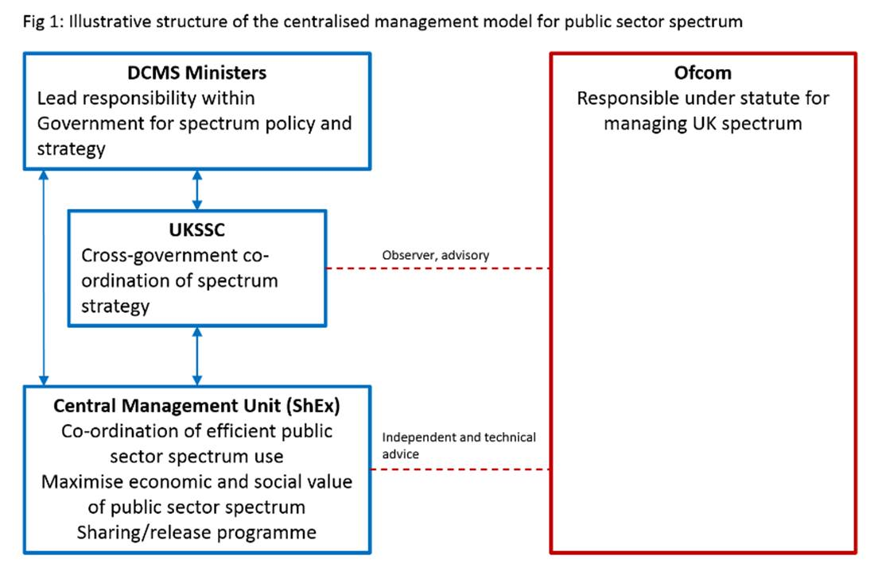

Sharing and release target
- The first task of the CMU will be to commission a review by Ofcom of the current release target and delivery programme.
- Ofcom shall consult with Departments and other national and international stakeholders before submitting a report to the CMU containing their recommendations.
- The CMU may also commission high-level information requests from departments as to their current and future requirements for public sector spectrum.
- The CMU will make a final recommendation on the release target, together with a strategic plan to deliver that target, and for the co-ordination of public sector spectrum use.
- This will be discussed with Departments before going to the Secretary of State of the Department for Culture, Media and Sport (DCMS) for approval.
- The plan should include:
  - clarity over high, medium and low priority bands, with transparency over the valuation methodology;
  - actions required in respect of each of the bands, informed as below (and which may include those pertaining to new or renewed use insofar as these may impact the plan); and
  - a clear timetable and milestones for delivery of the target.
- The CMU will work closely with spectrum-using departments, DCMS, HM Treasury (HMT) and Ofcom and convene and chair the necessary working and/or steering group(s) to progress the different workstreams and provide a forum for collaborative and cross-Departmental working.
- Departments shall be responsible for determining their Operational Requirements for their various uses of spectrum. The CMU is responsible for ensuring the best use of spectrum to meet those requirements and Departments shall provide such information and evidence (subject to security requirements) in support of that use as is reasonably requested by the CMU when it is examining different bands.
- Where new needs arise in the future the CMU will be responsible for identifying suitable spectrum.
- The CMU will commission in the first instance any necessary technical and market analysis of what spectrum band(s) can deliver existing or new public services in order to meet the operational requirements (as specified by Departments). The CMU will ensure that any associated cost benefit analysis captures all the related and consequential costs to the government.
- The findings of the studies will be shared with Departments and the CMU will recommend the way forward for discussion at a collective working group. This will include setting a clear timetable for migration where there is a change in spectrum use.
- Following any representation and clarification of the assessment of impact/risks of any change, the CMU will issue its final decision.
- The CMU’s decision should include the availability of spectrum that meets in full Departments’ operational needs and requirements, including technological viability.
- The assessment should take full account of the costs, benefits and impact to both HMG and the wider economy. This includes where benefits are non-monetary (economic) rather than yielding capital (financial) receipts, and where a single decision may come at a net cost while still recommended as part of a wider or longer-term benefit-releasing programme.
- The CMU may update or refine the plan in light of further work and actions carried out in paragraphs 14-21. Revisions to the plan will be discussed with Departments before going to the DCMS Secretary of State for approval.
- Departments are expected to follow the CMU’s decision with regards to the most efficient use of spectrum, although ultimately will need to weigh this up in the context of broader public sector considerations. The process below should be followed.
- In the event that Departments do not or cannot take forward the CMU’s decision (in recognition of individual Departmental factors that may also need to be taken into account, but also without prejudice to the collective undertaking to drive efficiencies), the relevant Department should first seek an exemption from a panel convened (in person or virtually) by the CMU to include representatives from HMT and DCMS.
- Such an exemption request would need to submit evidence as to why, from the Department’s perspective, the solution is not possible or appropriate. The CMU’s evidence will also be considered.
- If the exemption is granted, the Department can proceed independently of the CMU’s decision.
- If the exemption is not granted, Departments are expected to act on the original CMU decision, or else the matter should be escalated through the respective Ministerial chains to reach resolution.
- On the basis of the evidence the panel may also modify the original CMU decision, such as in respect of timeframe. Paragraph 26 or 27 may subsequently apply.

Costs
- Within an agreed threshold (to be agreed as part of the Annual Incentive Payment (AIP) setting process), the CMU will be able to vary AIP fees to meet upfront costs of bespoke studies, such as by abatement of fees. Other options, or where costs fall outside of this threshold, must be referred to HMT.
- Any abatement granted is repayable if progress against the agreed delivery timetable is held up by factors wholly within a Department’s control. Interest will be charged at Base Rate + 100bps for the duration of the abated period.
- However, any abatement granted is not repayable if the work it funds proves there are (previously unknown) external obstacles to taking forward clearance. Fees will revert to the original level.
- Also within the agreed threshold, the CMU will be able to increase AIP fees on the most valuable bands and reflect those premium fees within whole of life CBA.
- AIP fees must not be increased in this way in single or unique solution cases where operational capability would be affected (i.e. a penalty premium cannot be exacted if a public service can only be delivered in one particular band).
- The CMU must notify HMT of decisions taken under paragraphs 30-34.
- Actual delivery of most decisions will incur costs beyond those that can be mitigated by the financial levers at the CMU’s disposal (although they may be deployed to meet some or all of such costs).
- If Departments agree with the CMU’s decision, but are unable to meet (some or all of) the costs from within their budgets, they should apply to HMT for extraordinary funding.
- Such claims should attach the CMU’s evidence-base, together with the Department’s own analysis of any funding shortfall, to allow for robust decision-making.
- In addition, HMT will consult spending teams and the CMU to inform its advice to the Chief Secretary.
- The Chief Secretary’s final decision will be communicated to Departments and the CMU in writing.

Authorisation to radiate
- Alongside the review of the release target, the CMU will also further explore options for implementing a permission or authorisation-based system for coordinated use of public sector spectrum.
- This will be carried out in consultation with spectrum-using Departments and supported by HMT, DCMS and Ofcom.
- The CMU’s recommendations will be subject to agreement by Departments, and ultimately approval of the DCMS Secretary of State before they can be implemented.

Accountability
- The CMU will be accountable to its responsible Minister for its internal performance.
- The CMU will be accountable to the DCMS Secretary of State for its performance against the approved plan. DCMS remains responsible for overall policy on spectrum and digital communications.
- The CMU will attend the UK Spectrum Strategy Committee (UKSSC) to report on its progress. The UKSSC will continue to co-ordinate the government’s spectrum strategy.
- The CMU will write a formal annual report on its work completed over the course of the year and progress against that plan.
- The report will be circulated to Departments, including DCMS and HMT, and tabled at UKSSC.

Variation
- As the lead on spectrum policy within HMG, DCMS is responsible for ensuring that this Terms of Reference document remains fit for purpose and will keep it under review.
- The CMU, Departments and HMT may request specific amendments at any time. DCMS will consider any such requests and decide whether and when they may be actioned.
- Departments must be consulted and agree any changes. Ofcom must also be consulted.
- Notwithstanding paragraph 50, these arrangements may be terminated by joint agreement of the Chancellor of the Exchequer and the Secretary of State for DCMS.

