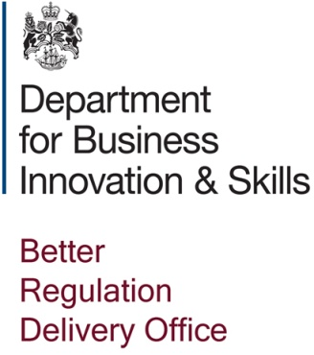
BRDO Masterclass in Regulatory Management Expression of Interest form

Applicant Information
Last Name |  |  |  | First Name |  |  |  | NaNname |  | Date
Street Address |  |  |  |  |  |  |  | City
State |  |  |  | ZIP |  |  |  | Country
Phone |  |  |  | E-mail Address

CURRENT JOB ROLE
Name of organisation:

Current position: | Date held from:
Please provide a brief description of your current duties (maximum of 200 words.)

Level of education (Work Based Qualifications, Bachelors Degree, Masters etc)

FURTHER INFORMATION
What is your current relationship with BRDO?

Who is your main contact at BRDO?

What are your anticipated learning objectives of attending the BRDO Masterclass in Regulatory Management? (250 words maximum)

Please indicate if you have any further queries about the Masterclass?

THANK YOU !!!

