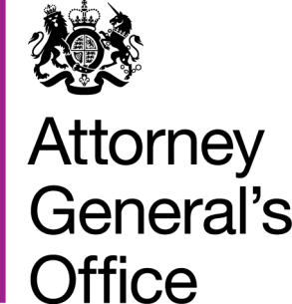 |  |  | www.gov.uk/ago
 | FOI|126|15 |  | June 2015
Freedom of Information Request

You requested:

Please can you tell me how much your organisation spent on stationery between 1st April 2013 - 31st March 2014

I have now been able to consider your request, and I can confirm the following information under section 1 (1) (a) of the Act:

The recorded information for the financial year 2013-14 shows that the Attorney General’s Office spent £8155 on stationery. This information is taken from reports provided to us by the Government Legal Department who provide a finance function to the AGO under a shared services agreement. It is possible that this figure includes non-stationery items that were purchased from suppliers who we purchase stationery from but we are unable to determine this from the information that we hold.

