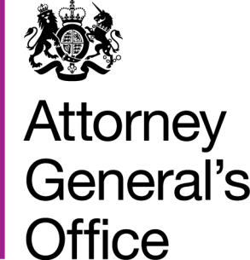 |  |  | www.gov.uk/ago
 | FOI|120|15 |  | June 2014
Freedom of Information Request

You requested:

Can you please tell me, under the Freedom of Information Act, whether your department has a style guide for staff when writing?

I have now been able to consider your request, and under section 1 (1) (a) of the Act I have attached the AGO Writing Style Guide.

