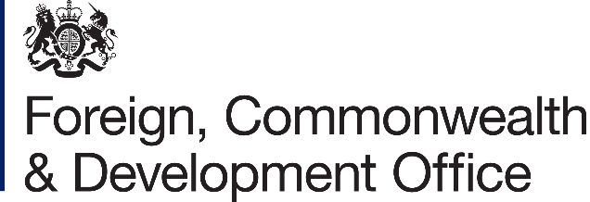

List of medical facilities/practitioners in Pyongyang

Prepared by British Embassy Pyongyang

www.gov.uk

The following list of medical facilities/practitioners has been prepared by the British Embassy Pyongyang for the convenience of British Nationals who may require these services and assistance in DPRK. It is provided on the understanding that we (the British Embassy) do not assume or undertake any legal responsibility, to you, or those affected, if you choose to take it into account when instructing a medical facility or practitioner.

Further and alternatively, we cannot accept any liability to any person or company for any financial loss or damage arising from the use of this information or from any failure to give information.

Our aim is to provide our customers with as much relevant information to enable them to make better informed decisions but our lists are not recommendations and should not be treated as such.
List of medical facilities/practitioners in DPRK

Updated: 2 September 2020


Please note health facilities in DPRK are poor. Standards of clinical hygiene in hospitals are low. Anaesthetics are sometimes unavailable.
Evacuation is likely to be necessary for serious illness or injury. Avoid surgery if at all possible. Facilities for dental treatment are also poor.

The United Nations medical facility admits foreign visitors and expatriates who develop a medical emergency whilst in Pyongyang. Contact details are Dr Hayford Etteh, United Nations Physician, Munsu-dong Diplomatic Quarter, Pyongyang, DPRK. Tel (mobile): +850 191 250 0624. Email hayford.etteh@undp.org.

If hospitilisation is unavoidable, the Friendship Hospital caters for foreigners in the DPRK. The address is Friendship Hospital, Munsu-dong Diplomatic Quarter, Pyongyang, DPRK, tel 382 7688. (This is a ‘local’ number that your guide or sponsor for your visit to the DPRK will need to call on your behalf.)
Feedback Form for Customers

If you do decide to use any of the medical facilities/practitioners on this list, we would like to hear from you. While there is no obligation on your part to provide feedback on the services you receive, any feedback you can give us is helpful.

Once completed, please return the form to the Embassy by post to British Embassy, Munsu-dong Diplomatic Compund, Pyongyang, DPRK or by email to pyongyangenquiries@fcdo.gov.uk. Thank you for your help.

1. Name of firm: Name of medical practitioner:

2. Date of contact:

Are any of the details on our list regarding this provider wrong? (e.g. address, telephone number, etc.)

- What service did you need?

- Why did you need this service?

Please circle the appropriate boxes below:

- If the service provided English speaking services, how would you rate the standard of English?

Excellent Good Average Poor Very Poor

(b) How would you rate the professionalism of the staff?

Excellent Good Average Poor Very Poor
(c) How would you rate the overall service received?

Excellent Good Average Poor Very Poor

(d) How would you rate the value for money?

Excellent Good Average Poor Very Poor

5. Do you have any other comments?

We would like to share this information with other customers but if you would prefer it not to be seen by others please tick the box □

Feedback provider’s name: | Tel. No.:
Email: | Date:

