Submission to DCMS TV licence enforcement review
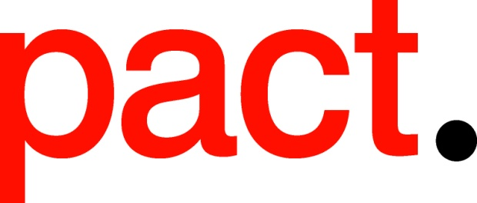

April 2015

Introduction

- Pact is the UK trade association representing and promoting the commercial interests of independent feature film, television, digital, children's and animation media companies.

- The UK independent television sector is one of the biggest in the world. Despite the difficult economic climate, independent television sector revenues have grown from £1.3 billion in 2005 to nearly £3.1 billion in 2013.

- In 2013, the BBC spent £476 million on commissions from UK independent producers. This was a decrease from £507m in 2012. The BBC commissioned 36% of eligible television content from external producers.

- Pact is a supporter of the licence fee and recognises the important role that the BBC plays in British broadcasting.

- It is therefore extremely important that the BBC continues to be properly funded in the future.

- Pact would welcome the BBC licence fee being tied to inflation at the time of the next settlement. Anything less would result in a further real-terms decline in what is already a stretched BBC content budget.

- We understand and support the Government’s decision to commission an independent review by David Perry QC in order to consider whether the sanctions currently in place for failure to hold a TV licence are appropriate and fair, and whether the current regime represents value for money for licence fee payers.

- Pact wishes to highlight the importance of also considering the potential impact of any proposed changes on the BBC’s ability to continue to invest in high-quality, original, public service content.

- For further information, please contact Pact’s Head of Policy, Emily Davidson, at emily@pact.co.uk or on 020 7380 8232.

Pact is a strong supporter of the BBC licence fee

  - The BBC – as the UK’s largest public service broadcaster – plays an important role in our broadcasting ecology.
  - At £145.50 per year, the licence fee helps to fund a wide range of public service content across the BBC’s television, radio and digital services.
  - The BBC is an important commissioner of external content, as well as producing content in-house via its production entity.
  - In 2013, the BBC spent £476 million on commissions from UK independent television producers (less than in 2012).
  - The BBC is unique in that it is funded by the licence fee, which is set periodically following a review between the BBC Trust, the BBC Executive and the UK Government.
  - Pact is concerned that the last licence fee settlement led to a decrease of the BBC licence fee over five years in real terms and to top-slicing of funding away from BBC core-services towards non-TV services such as funding broadband roll-out.
  - This decrease in the BBC’s ability to invest in high-quality original content has been countered through increased efficiencies and independent producers bringing deficit funding to the table by generating revenues through secondary sales.
  - However, a further decrease in the BBC’s content budget would have serious consequences for the broadcaster’s ability to continue to invest in UK original content.
  - Therefore, in order to sustain the high-level of investment in original UK content, it is important that the BBC licence fee is tied to inflation for the next licence fee period. Anything less than this would lead to a reduction in the BBC’s budget which could have far reaching implications both on and off screen.
Pact supports a proportionate approach to TV licence enforcement, provided that it does not lead to any reduction in the BBC’s licence fee income
  - Pact, like the BBC, wants a licence fee enforcement system that maximises licence fee income in the public interest, to support public service broadcasting, whilst being proportionate to the offence.
  - Given that the level of licence fee evasion in the UK is relatively low by international standards (5%), the current system appears to be working with regards to securing the lowest possible level of evasion.
  - Under the existing system, the BBC looses approximately £200 million per annum from non-payment of the licence fee.
  - Should evasion rates rise to closer to 9% under a civil model, as predicted by the BBC, this could have a severe impact on the BBC’s ability to invest in high-quality original UK content.
  - This would have a negative effect on the whole of the UK broadcasting ecology. Licence fee payers would be unlikely to receive the same level of content on-screen, on radio or on digital devices and the BBC would not be able to invest in creative businesses in the external market at current levels.
  - Furthermore, Ofcom recently found in its public service broadcasting consultation that ITV 1’s level of investment in original UK content is tied to that of its main competitor, BBC One. Therefore, should the BBC reduce its content budget on BBC One as a result of higher licence fee evasion rates, this is likely to have a negative effect across all UK PSB investment.
  - A reduction in BBC commissioning budgets would also harm a thriving £3 billion UK independent production sector which employs more people than the UK PSBs combined and – with sector revenues over £3 billion - generates significant income for the UK Treasury.
  - In light of the potential risk to the BBC licence fee income if the current system were to be changed, Pact supports the retention of the current system, either in its current form or under option 2, with additional reforms.
  - Pact looks forward to reading the findings of David Perry QC’s review. Should evidence show that the licence fee system could be revised to an alternative criminal enforcement method, or to a civil enforcement option, in a way which would secure a low rate of evasion, then we would welcome a further discussion about how this option could be pursued in a way which would not harm the ability of the BBC to invest in high-quality, original, PSB content.

Pact Census Independent Production Sector Financial Census and Survey 2013, by Oliver & Ohlbaum Associates Ltd (July 2014)
Pact Census Independent Production Sector Financial Census and Survey 2013, by Oliver & Ohlbaum Associates Limited (July 2014)
BBC Annual Report 2013-14

