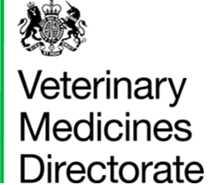 | Woodham Lane, New Haw, Addlestone, Surrey KT15 3LS  Telephone +44 (0)1932 336911

REPORTING A VETERINARY MEDICINAL PRODUCT UK SUPPLY PROBLEM
For completion by the Marketing Authorisation Holder ONLY.
This form should ONLY be completed by a Marketing Authorisation Holder who has identified or foresees issues with the availability of an authorised veterinary medicinal product(s) within the UK. Please complete all sections of the form.

Section 1 – Marketing Authorisation Holder Particulars
Company Address:
Contact Name:
Contact E-mail address:
Contact Telephone No:
Section 2 – Veterinary Medicinal Product Details
Full Product Name:

Marketing Authorisation Number:
Pack Size (where relevant):
Section 3 – Reason(s) for Availability Issue:
Section 4 – Availability Issue Resolution Date:
Please provide an estimated or known date when the veterinary medicinal product is expected to be available to purchase in the UK (dd/mm/yyyy):

Section 5 – Known Alternatives
Please provide the details of any known alternatives that UK veterinary surgeons could use during this availability issue period:

Section 6 – Contact Point for Public Enquiries:
Please provide contact details that we can direct any public enquiries relating to this availability issue to (please include: name, address, telephone number and email address, as appropriate)

Please email this completed form to:
supply@vmd.gov.uk.

