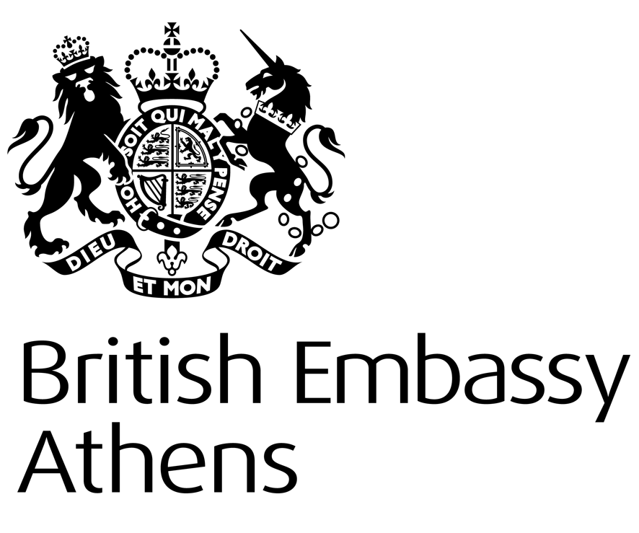
British Embassy
https://www.gov.uk/government/world/organisations/british-embassy-athens

INFORMATION NOTE:

CHANGE OF NAME IN THE UK

‘TO WHOM IT MAY CONCERN

An explanation of change of name in the United Kingdom
Surnames
Under UK law, a person may change their surname at will. The law concerns itself only with the question whether the individual has in fact assumed and has come to be known by a surname different from that by which they were originally known. So long as that is the case the change of surname will be valid. The process is not subject to any documentary formalities although there are various facilities to do so in the constituent parts of the UK. In England and Wales a birth registration cannot be amended (save for some very limited and exceptional cases). In Scotland it is possible to apply for a change in the registered name (surname and forenames) in the birth record with the National Records of Scotland. In Northern Ireland it is possible to apply to change the registered name with the General Registrar for Northern Ireland. In the UK (England and Wales, Northern Ireland and Scotland) it is also possible to apply to evidence a name change by “deed poll” (a legal document which is registered in court) or a statutory declaration (a legal document which is not registered) administered by a notary public or lawyer.
Forenames
As long as it is not done for fraudulent or other unlawful purposes, a person may assume any forename without any formalities and can identify themselves with, and be identified by, the assumed name. There is some uncertainty in English law as to whether a Christian (Baptismal) forename can be legally displaced. A determination of a person’s legal forename can only be made by a UK Court. However an assumed forename used in place of the name given on baptism is still valid for the purposes of legal identification if it is by this name that the individual has generally become known.
Marriage
Upon marriage, while it is traditional for the woman to take the man’s surname, it is also perfectly acceptable for the woman to keep her maiden name or the couple to create their own ‘double-barrelled’ or hyphenated surname by using both of their original surnames. Civil Partnerships also allows for each partner to keep their original surname, take their partner’s or create their own double-barrelled or hyphenated surname by using both of their original surnames. The British Marriage Certificate states the surnames of the parties prior to their marriage and is supporting evidence of a request by either party to change their surname. No additional documentation is required under UK law. The British Embassy is not able to issue a certificate to confirm that hyphenated names are acceptable in the UK
Upon divorce either party may retain their married surname or assume the surname they used prior to marriage.
Children
Parents may give their child any forename or surname. No additional documentation is required under UK law although there is a facility for doing so through the UK courts by way of a Deed Poll or Statutory Declaration. The surname given to a child when its birth is registered in the UK is generally, but not always, that of the father. However it sometimes happens, especially in the case of persons born outside marriage, that the surnames of the parents, in any order, are used (hyphenated or not) to provide a double-barrelled surname. English law places no restrictions as to what surname may be registered for a child in the UK.
The surname of a child may be changed by parents acting jointly or, after divorce, in the absence of any order of the court to the contrary, by the parent having custody of that child. If, therefore, the mother has custody of the child and remarries, she may cause the child to be known by the surname of her new husband, even though he is not the father of the child.
Deed Poll
If the individual changing their name so wishes, evidence of a change of name (forename and/or surname) may be provided by a procedure known as “deed poll”. Under this procedure, a person desiring to change their name executes a deed in a well-established form renouncing the former name and adopting the new surname, and that deed is then enrolled in an office of the High Court. Copies of the deed from the High Court are regarded as the best possible evidence of a change of name.
However, the deed poll procedure is entirely optional. Public authorities in the United Kingdom will recognise a change of forename or surname on presentation of any proper evidence that the person concerned has been known by the new name for all purposes for a substantial period of time and do not require proof of a change of name by deed poll.
A change of name will not necessarily be reflected on any UK birth or marriage certificates issued before the change. A birth/marriage certificate records the details at the time of the event any subsequent changes are not recorded therein and the individual will not be issued with an updated birth/marriage certificate. In the case of a child whose name has been changed while they were still a minor an annotated birth certificate may be issued at the request of the parents but the original name will remain on the document.
The information contained in this note is general and should not be taken as a definitive statement of law.’

Consular Section
British Embassy Athens

