

Apply for a motorcycle compulsory basic training site inspection
DVSA CBT Form 2

Approved Training Body
(ATB) name
ATB reference number
Proposed site name and address
(inc postcode)
What3Words location i.e. : https://w3w.co/burst.tribe.cafe
ATB contact name, telephone number and email address

(Please note that this telephone number will be published if the application is successful)
Site contact name and telephone number (if different)
Type of inspection  (tick as appropriate) | New | Re-Inspection

Has this site been previously approved for CBT? (It is the responsibility of the site owner and each ATB to agree access) | Yes / No | If Yes, please provide site number (if known):

Have all relevant planning permissions and other approvals been obtained for this site? (see planning permission notes below) | Yes/No

Size of training area (see site plan notes below)  Diagram with measurements attached?  Aerial images of area and photos of specific hazards attached? | Size:  Diagram attached: Yes / No  Images attached: Yes / No

Notes

You must have permission from the owner of site before any training takes place. If it is later found that you do not hold relevant permission, authority to use the site could be removed.

Size; Must be a minimum of 80ft X 30ft (2400 sq ft) of usable space for two trainees. This does not include the mandatory run off space. For advice regarding minimum run off space, please contact your local CBT Examiner.

Site plan: Please provide a detailed diagram of the proposed site showing accurate measurements, boundaries and where it is situated in relation to any surrounding buildings/roads etc. If possible, please provide an aerial image of the site (Google Maps or similar) and digital photographs highlighting any hazards on or near to the proposed area. See example below.

Your application will be rejected if you do not include all of the required information. Please contact your local CBT Examiner for further support if needed.

Declaration

In submitting this application you are confirming that all aspects of Element E can be completed within a reasonable distance of this proposed training site.

I declare that I have the owner’s permission to use this site for the purposes of motorcycle training.

I declare that the information given on this form is correct and I understand that full site authorisation could take up to 8 weeks from submission of all correctly completed paperwork.

I confirm all instructors at this ATB will be fully briefed on the correct and proper use of the training site and provided with a copy of the training site plan.

Please submit a separate form for each site

Authority holder signature: ___________________________________________

Name: ___________________________________________

ATB name: ___________________________________________

Date: ___________________________________________

When completed please email this form to: cbt@dvsa.gov.uk. You can include multiple attachments in the same email
If you are unable to email your forms you may post them to;

CBT Section
Driver and Vehicle Standards Agency
1 Unity Square
Queensbridge Road
Nottingham
NG2 1AY
Example.
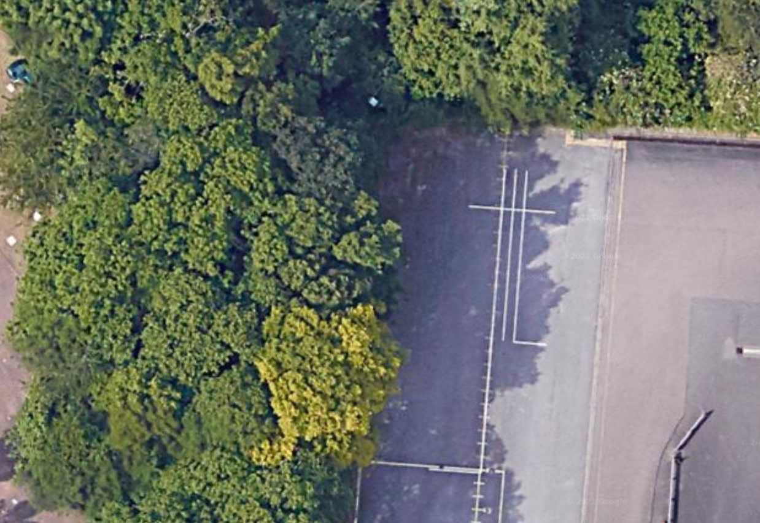
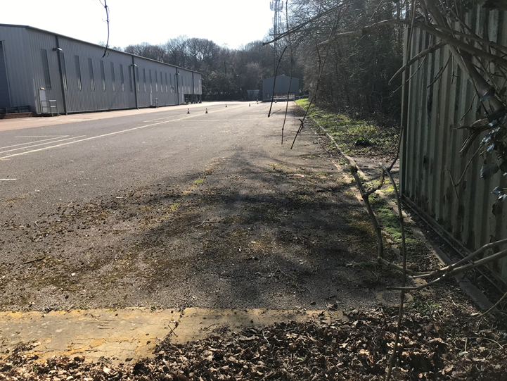
Gillingham GVTS, Ambley Road, Gillingham, Kent ME8 0SJ
https://w3w.co/rinse.lifeboats.feathers Training Area 4120sqft.

103ft
40ft
Container & undergrowth potential hazards

