Inspection of adoption support agencies
A report on the responses to consultation
Between 10 December 2014 and 22 January 2015, Ofsted held a consultation about its proposals for the inspection of adoption support agencies. This is a report on the outcomes of that consultation.
If you would like a version of this document in a different format, such as large print or Braille, please telephone 0300 123 1231 or email enquiries@ofsted.gov.uk.
Age group: 0+
Published: March 2015
Reference no: 140022

Contents
Introduction 4
Overview of responses 4
Business engagement assessment 6
Next steps 6
Annex A. Key findings 7
Annex B. Type of respondents 13

Introduction
- Ofsted recently consulted on changes to how we inspect adoption support agencies. In line with our other inspection remits we are replacing the judgement of ‘adequate’ with the judgement of ‘requires improvement’. The revised criteria for the inspection of adoption support agencies will be implemented in April 2015.
- The consultation set out new evaluation criteria for ‘good’ and ‘outstanding’ in each judgement area. In addition, we proposed that a judgement of ‘inadequate’ in any judgement area will always limit the overall effectiveness judgement to ‘inadequate’.
- Between 10 December 2014 and 22 January 2015 we asked key stakeholders to share their views about these proposals. The consultation consisted of a questionnaire (online and hard copy), meetings with providers, webinars and telephone discussions with representatives from adoption support agencies. We also set up a webinar for service users, although no one chose to attend. There were 20 responses to the questionnaire. Eight agencies were represented at meetings/discussions. To put this into context, there are 36 adoption support agencies in England.
- During the consultation, we consulted on the impact on adoption support agencies of the proposed changes through a business engagement assessment. Responses to the assessment are at paragraph 16.
- The comments received have helped in finalising the inspection framework. We are grateful to all individuals and organisations who took the time to respond to the consultation.

Overview of responses
- From April 2015 we will introduce the revised inspection judgement structure of:
- overall effectiveness
- the experience and progress of, and outcomes for, service users
- quality of service provision
- safeguarding children, young people, adults and families
- leadership and management.
- The majority of respondents agreed with the proposed characteristics of a ‘good’ adoption support agency. We have made some minor changes and additions to the descriptors in response to comments from stakeholders. We have:
- reviewed the grade criteria relating to safeguarding and agree that some of the criteria better describe ‘good’ than ‘outstanding’
- added an additional criterion to the ‘good’ descriptor to reference the use of research to improve practice
- emphasised that adoption support agencies ensure that assessments of service users’ needs are effective and involve children and young people where appropriate
- added where appropriate that those working with children, families and adults receive specialist supervision.
- Most respondents agreed with the grade criteria for ‘outstanding’ across each of the judgement areas. However, some providers did not think that the criteria for ‘outstanding’ were sufficiently specific, measurable and achievable. For example, providers stated that they were not clear what ‘exceptional’ meant.
- We have listened to feedback and revised the ‘outstanding’ grade descriptors to include:
- making best use of current research
- the need to ensure that innovative practice is measured for effectiveness
- that leaders and managers share good and effective practice about adoption support to enable improvement beyond the individual agency
- that ‘exceptional progress’ is progress that significantly exceeds what would be a reasonable expectation of progress
- that there are examples of excellent practice that are worthy of wider dissemination.
- Some respondents felt that words such as ‘inspirational’ and ‘ambitious’ are not sufficiently measurable ways to describe leaders. We have considered this view and think that these are important elements of outstanding leadership and that the impact of these characteristics will be evidenced in the quality of the service. Inspectors will use their professional judgement to evaluate these characteristics.
- We have amended the grade criteria to reflect that some agencies consist of an individual operating alone.
- We proposed that a judgement of ‘inadequate’ in any of the judgement areas should always limit the overall effectiveness judgement to ‘inadequate’. Nearly all respondents agreed or strongly agreed with the proposal. There were mixed views from providers that attended meetings.
- We will be implementing this proposal. The criteria for ‘inadequate’ for each judgement area include widespread or serious failures that result in the welfare of people receiving an adoption support service not being safeguarded and promoted. In our view it is therefore reasonable to say that an agency will be inadequate overall where there is such a level of failure described in the ‘inadequate’ criteria.

Other comments
- All adoption support agencies are inspected on a three-year cycle. Where agencies are judged to require improvement, they have suggested they should be inspected sooner. We are only required to inspect agencies on a three-year cycle and we make risk-based decisions on how best to use our resources.
- There was also a view that the framework would judge more harshly agencies that worked with service users with higher levels of risk and need. We have not found any evidence to support this view. We will continue to monitor this and ensure that the issue is raised with inspectors in training.

Business engagement assessment
- Two responses were received in response to the business engagement assessment. Both respondents agreed with our overall assessment of the impact of the changes on providers. However, one respondent expressed concern that the registration and inspection of adoption support agencies are not proportionate and act as a barrier to some providers becoming adoption support agencies and this impacts on the availability of adoption support services. Some providers reported that some individuals had decided not to register as adoption support agencies due to the perceived cost and burden of regulation and therefore service users have not been able to access this service. This concern has been raised with the Department for Education (DfE). However, stakeholders were supportive of the inspection of adoption support agencies.

Next steps
- The framework will be implemented in April 2015. It will incorporate the changes identified in this report. You can view the framework on our website at www.ofsted.gov.uk/resources/140022.
- A review of the new inspection framework will be carried out six months after implementation.

Annex A. Key findings
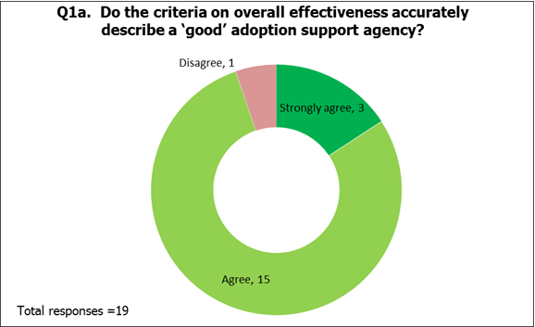

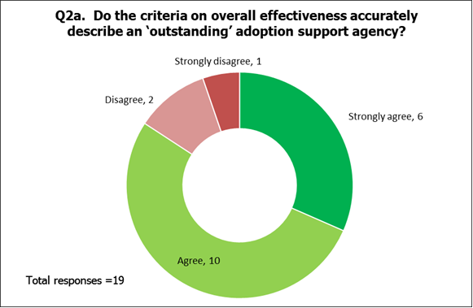

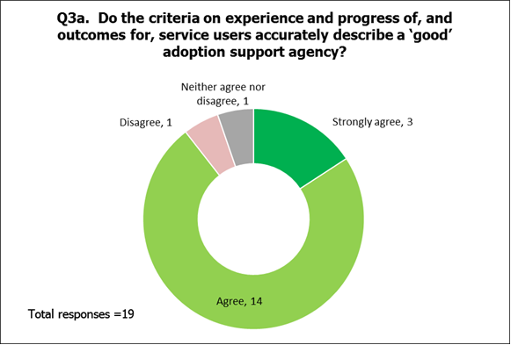

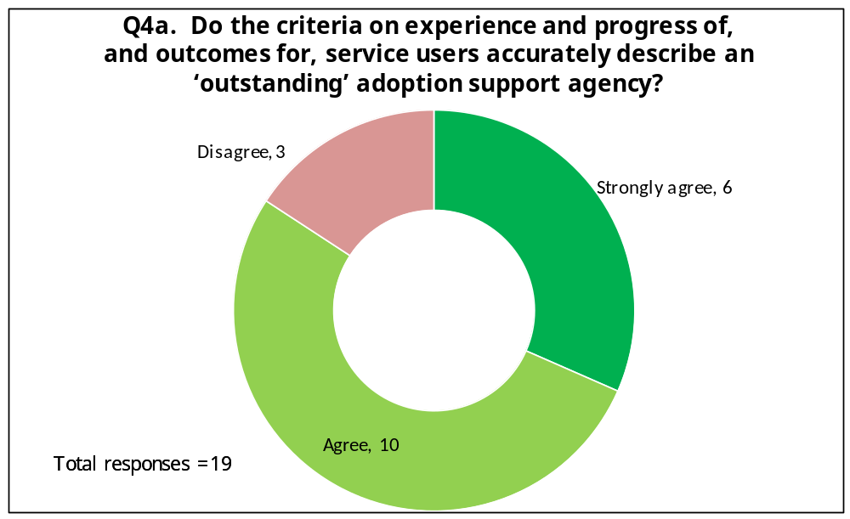

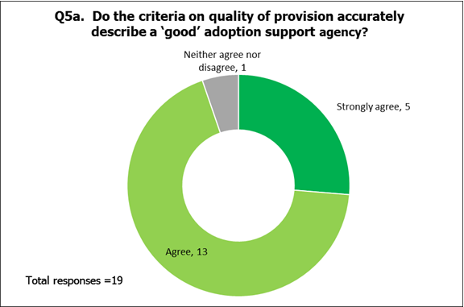

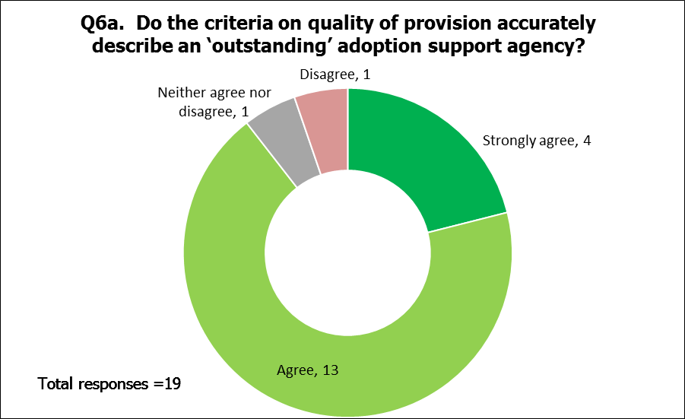
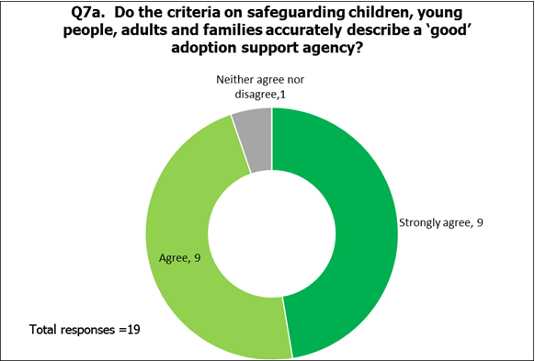

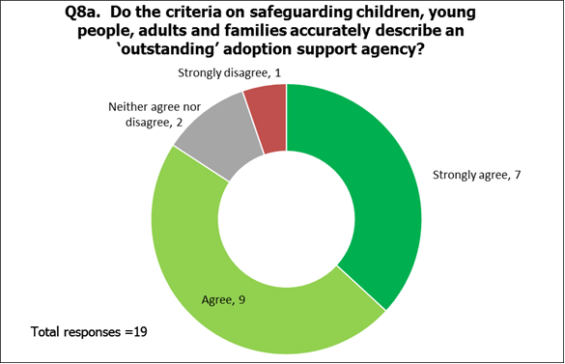

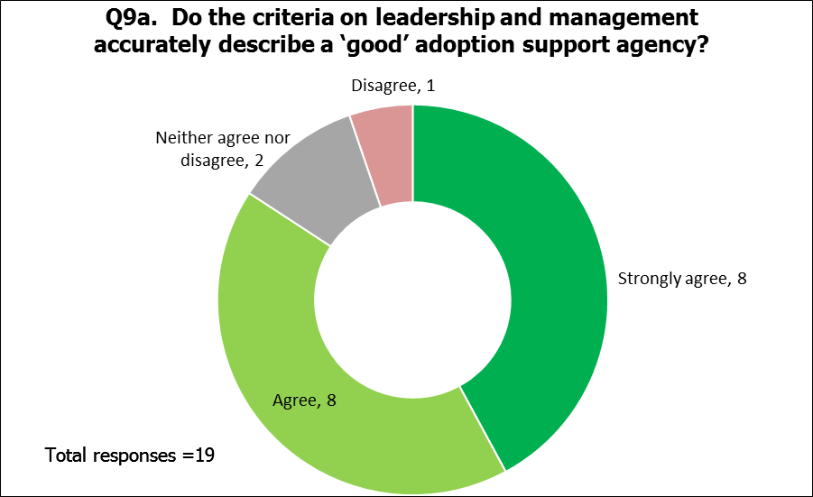

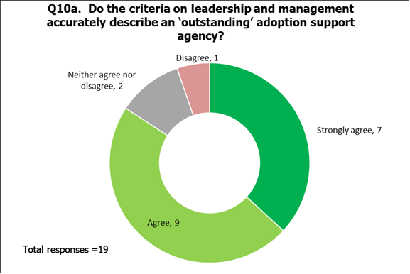

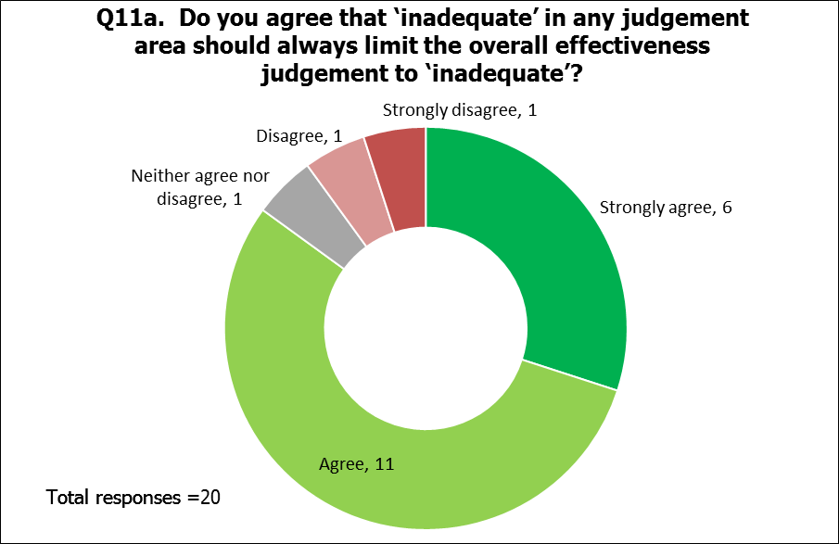

Annex B. Type of respondents

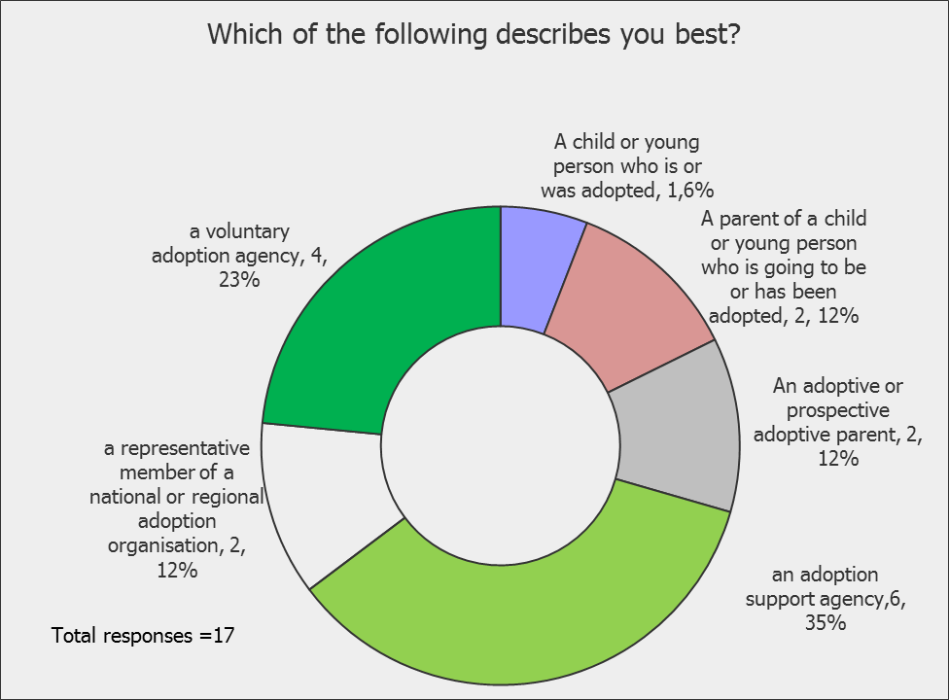

Under recent guidance issued by the Department for Business, Innovation and Skills, non-economic regulators, of which Ofsted is one, are obliged before implementing any significant policy changes to assess the impact of such changes on those regulated, by completing a business engagement assessment. For further information please see the Regulator’s Code: www.gov.uk/government/publications/regulators-code.

