Investigation: school leaders’ views on the impact of inspection

Introduction
- Ofsted conducts an evaluation survey immediately after section 5 inspections. This survey (referred to in this report as a ‘post-inspection survey’) asks school leaders, staff and governors for their views on a range of issues, including the quality and conduct of the inspection, its likely impact on their school and what changes they intend to make (see Annex A).
- In order to get a more detailed picture of the longer-term impact of inspection, Ofsted surveyed school leaders four months after their inspection. This survey (referred to as the ‘impact survey’) asked leaders about the changes they were making, or had already made, as a result of their school’s most recent inspection (see Annex B).
- This investigation report summarises the findings from both surveys. Part A outlines the findings from 22,800 responses to Ofsted’s post-inspection survey (2009–14). Part B examines the findings from the responses of 829 school leaders to the online impact survey (2013–14).

Key findings

The post-inspection survey 2009–14
- Almost all respondents said that they would use the inspection recommendations to improve their school (98%).
- Around nine out of 10 respondents (92%) reported that the demands of being inspected were reasonable and that the judgements were fair and accurate.
- Most respondents agreed that the benefits of inspection outweigh the pressures of being inspected (82%).

The impact survey 2013/14
- Nearly nine out of 10 school leaders (88%) reported that they had made changes to their school as a result of inspection.
- Most leaders (81%) said that inspection helped them to improve by providing an accurate analysis of their strengths and weaknesses.
- A large majority of leaders (79%) had found inspection helpful in confirming that they were taking the right actions.
- Around seven out of 10 school leaders (73%) agreed that the inspection report would help their school to improve.
- Over half of school leaders (56%) identified that ongoing professional dialogue with inspectors was the most useful aspect of the inspection process.

Part A. The post-inspection survey
- Following a section 5 inspection, all schools are invited to complete a post-inspection survey so that feedback about the process can be considered and incorporated into the future development of inspection.
- The response rate for the post-inspection survey has risen over the past few years (see Table 1). About three quarters of inspected schools routinely complete the survey following inspection.
Table 1: Response rates to the post-inspection survey, by academic year
Year | Responding
2009/10 | 57%
2010/11 | 70%
2011/12 | 73%
2012/13 | 76%
2013/14 | 76%

- Since 2009/10, around 22,800 responses have been made to the post-inspection survey for schools (see Table 2).

Table 2: Cumulative responses to the post-inspection survey from September 2009 to August 2014
Statement | Positive responses
The demands placed on me by the inspection team were reasonable | 92%
The inspection team challenged constructively the judgements and evidence we provided in our self-evaluation summary | 94%
Inspection judgements about the school are fair and accurate | 92%
The inspection identified clear recommendations for improvement | 98%
I will use the inspection recommendations to move the school/my teaching forward | 98%
The benefits of the inspection outweigh the negative aspects | 82%

Positive responses are the combined totals of ‘strongly agree’ and ‘agree’.

- Overall, the findings from the post-inspection survey present a relatively positive view of inspection. When asked about the fairness of inspection and its likely impact on improvement, more than nine out of 10 respondents were positive. A slightly lower proportion agreed that the benefits of inspection outweighed the negative aspects. However, even on this much-debated issue, more than eight out of 10 schools agreed that the benefits outweighed the negatives.
- Inadequate schools had lower response rates to the post-inspection survey. In general, their views tended to be more negative than those of schools with higher inspection judgements. For inadequate schools, the least positive responses were to the question about the benefits of inspection outweighing the negatives, with just over half of inadequate schools responding positively. Despite this, they still intended to use the inspection findings to improve. For example, 93% of inadequate schools that responded agreed that the inspection recommendations were clear and 94% agreed that they would use them to improve the school or teaching. This was only slightly below the 98% responses for all schools.

Part B. The impact survey
- The post-inspection survey results reflect initial responses and leaders’ intentions to make improvements. Between April 2013 and July 2014, Ofsted conducted an impact survey to establish what changes leaders had already made, or were making, as a result of their inspection four months previously.
- Surveying four months after inspection gave school leaders time to reflect on their report, consider what changes they wanted to make and start to make those changes. Overall, responses to the impact survey support the broadly positive views expressed in Ofsted’s post-inspection survey.

Methodology
- The impact survey was conducted in four waves. In each wave, all schools that had been inspected four months previously were sent an invitation for the headteacher, or another senior individual on their behalf, to respond to an online survey.
- Each survey wave asked the same core questions, with some additional questions included from survey wave 2 onwards (see Annex B). The timing and number of responses to each survey are presented in Table 3.
- Respondents had the option to include their position in the school, though not all chose to do so. The findings presented in this report are based on those 829 respondents who identified themselves as either headteachers or senior school leaders.
Table 3: Timing of and responses to the inspection impact survey, by survey wave
Survey wave | Approximate timing of the surveyª | Number of headteacher/senior leader responses
Wave 1 | April 2013 | 253
Wave 2 | November 2013 | 192
Wave 3 | February 2014 | 188
Wave 4 | July 2014 | 196

a. The month the survey was first sent. Responses remained open for several months.

- We received replies from headteachers and senior leaders from a cross-section of schools.

Figure 1: Percentage of declared overall effectiveness judgements of respondents’ schools
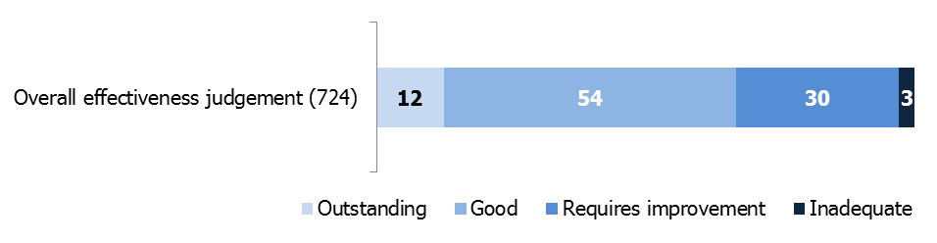

Percentages are rounded and may not add to 100.
The number of respondents is included in the brackets.
Figures are based on respondents rather than schools. Consequently, individual schools may be represented more than once.

School leaders’ views on the focus of inspection
- In the impact survey, headteachers and senior leaders responded to a series of questions about the extent to which they felt inspectors focused on three key areas of the inspection framework: teaching; leadership and management; and outcomes (see Figure 2).
- Results were similar across the three key areas, indicating that respondents did not see any greater emphasis on outcomes than they did on leadership and management or teaching. Around nine in 10 respondents agreed or strongly agreed that inspectors focused sharply on these three key aspects. Only around 7–8% disagreed or strongly disagreed that these key aspects were a focus of the inspection.

Figure 2: Percentage of responses to the question ‘To what extent do you think that inspectors focused sharply on…’ for key areas of the inspection framework
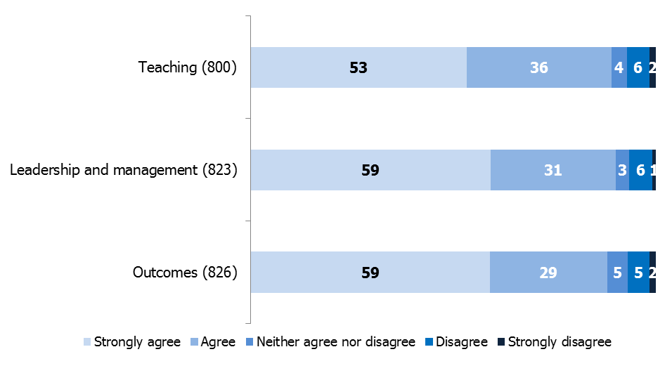
Percentages are rounded and may not add to 100.
The number of respondents is included in brackets.

- In the impact survey, we also asked whether leaders felt Ofsted’s strong emphasis on governance and the impact of the school’s use of the pupil premium funding would lead to improvement (see Figure 3).
- Around two thirds of school leaders believed that the increased focus on governance would lead to improvement. However, just over two fifths were undecided or disagreed that the increased inspection focus on the pupil premium would lead to improvement, despite the pupil premium being one of the common weaknesses identified by inspections in 2013/14.
- It should be noted, however, that when data for the first impact survey wave was collected, inspectors could only review how schools were spending their additional pupil premium funding. At that time, there was understandably a lack of any clear data that showed the impact of that spending. Also, schools were still adapting to the new requirement to publish details of their spending on their websites – a change that resulted partly from inspection findings that schools were not always able to provide an analysis of their spending.
Figure 3: Percentage of respondents who agreed that the renewed inspection focus on the pupil premium and governance has led to improvement
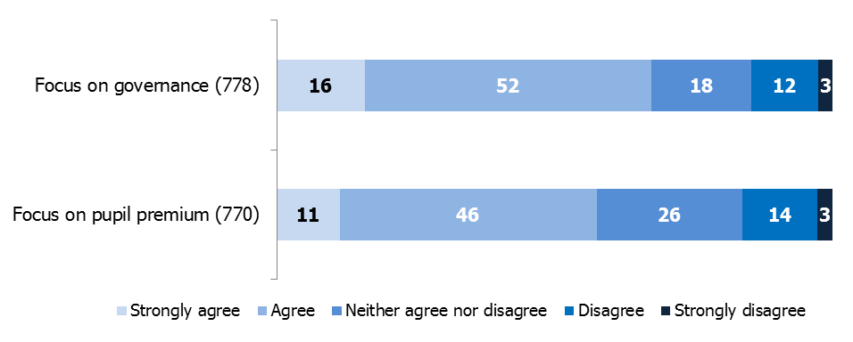

Percentages are rounded and may not add to 100.
The number of respondents is included in brackets.

Questions were:

- To what extent do you agree or disagree that the renewed focus on governance has raised expectations of good practice and assisted in strengthening leadership and management?
- To what extent do you agree or disagree that the focus on the impact of pupil premium has raised expectations of good practice and assisted in improving pupils’ achievement?

School leaders’ views on the rigour and accuracy of inspection
- In the impact survey, we asked if headteachers and senior leaders agreed that the inspection of their school four months previously had been rigorous and accurate. Of those who responded, 87% agreed or strongly agreed that the inspection was rigorous (see Figure 4).

Figure 4: Percentage of respondents who agreed that ‘the inspection was rigorous in reaching its judgements’
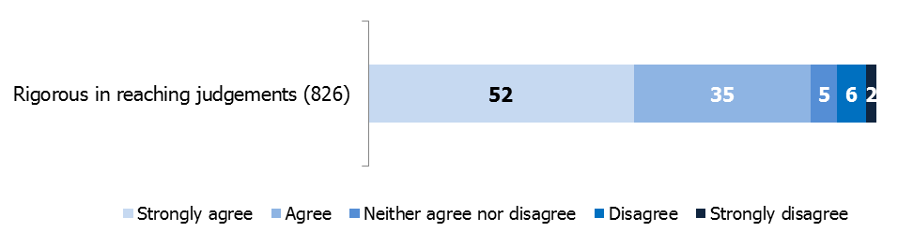

Percentages are rounded and may not add to 100.
The number of respondents is included in brackets.

- Headteachers and senior leaders were also asked to consider whether they thought inspectors had accurately identified the strengths and weaknesses of the school (see Figure 5). Eight in 10 (81%) headteachers and senior leaders surveyed agreed or strongly agreed that inspectors had correctly identified the strengths and weaknesses of the school.

Figure 5: Percentage of respondents who agreed that inspectors accurately identified the stronger and weaker areas of the school
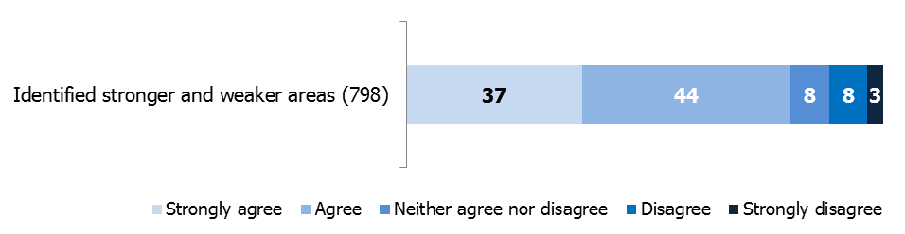

Percentages are rounded and may not add to 100.
The number of respondents is included in brackets.

School leaders’ views on inspection methods
- The inspection impact survey also sought to gauge school leaders’ views on how successfully inspectors had engaged with managers, parents and young people during the inspection (see Figure 6). Results show that a large majority of headteachers and senior leaders had positive views about how well inspectors worked with others during the inspection, particularly by including managers in the dialogue.

Figure 6: Percentage of respondents’ views on how well inspectors worked with others during the inspection
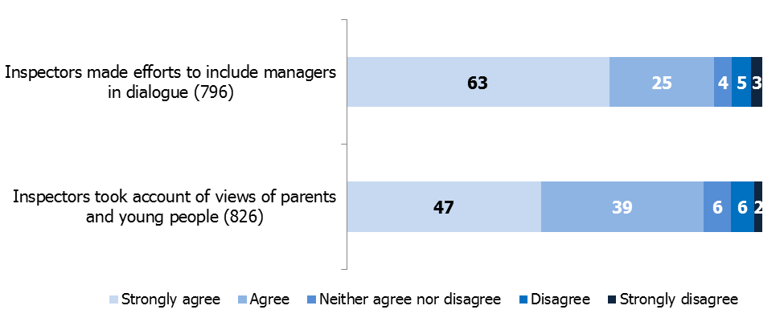
Percentages are rounded and may not add to 100.
The number of respondents is included in brackets.

School leaders’ views on impact of inspection on improvement
- The impact survey asked how useful the inspection report was in explaining improvement to staff, parents and pupils. It also asked for views on whether their school was likely to improve as a result (see Figure 7).
- Almost three quarters of headteachers and senior leaders agreed that inspection findings would help them to improve. However, around one in 10 still felt negatively about the impact of inspection at that stage, four months later. Those with negative views were mainly respondents whose school grade was lower than they expected or who were judged as requires improvement. Almost no respondents from outstanding schools said that the findings would not help improvement.

Figure 7: Percentage of respondents who agreed that the inspection report was helpful for improvement and useful in explaining how their school can improve
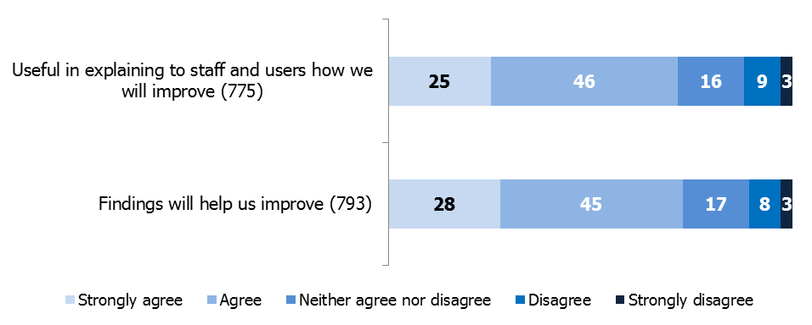

Percentages are rounded and may not add to 100.
The number of respondents is included in brackets.

- Around nine in 10 respondents said that their school had already made changes as a result of inspection (see Figure 8).

Figure 8: Percentage of headteachers and senior leaders reporting that their school had already made changes as a result of the inspection
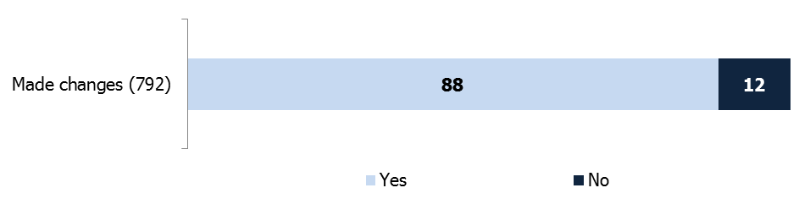

Percentages are rounded and may not add to 100.
The number of respondents is included in brackets.

- Almost eight in 10 respondents agreed that the inspection helped by confirming that they were taking the right steps towards improvement. Interestingly, respondents said that this confirmation from inspectors was as significant as any new insight (see Figure 9).

Figure 9: Percentage of respondents who agreed with the statement: ‘The recent inspection helped by confirming we were taking the right steps to improve our school or maintain its qualities’
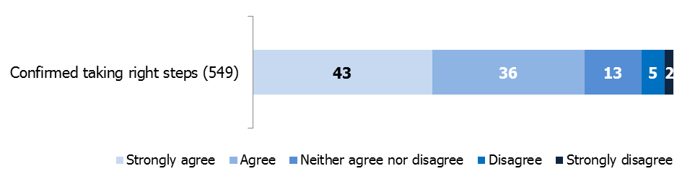

Percentages are rounded and may not add to 100.
The number of respondents is included in brackets.
This question was not included in survey wave 1 so the number of responses is lower.

Written comments from school leaders on the impact of inspection
- Written comments from school leaders support the view that inspection does not have to deliver new insight in order to help a school seeking improvement. School leaders’ written comments describe a number of particular benefits.
- One headteacher in a school judged to require improvement wrote:
‘Inspectors pointed out that we had already identified all the things we needed to do to improve. But the outcome of the inspection has given the school an impetus and given me a mandate for change that has only helped.’
- A new headteacher explained how the inspection gave them and their new leadership team confidence in securing improvement:
‘As a new headteacher, the inspection was very helpful to confirm that the impact and actions put in place were the correct path. Inspectors gave confidence to the leadership team that we were taking effective action and validated our judgements, evidence and improvement plans. Inspectors discussed inspection openly and gave feedback along the way to provide challenge and reassurance to a new leadership team.’
- Another headteacher saw value in re-ordering priorities:
‘All three points for future action were known about and receiving attention. However, it is worth knowing that an independent view arrives at the same conclusions and it was also the case that the inspection team ordered these priorities differently, which made us rethink the level of emphasis and resource we will now give to these aspects.’
- A recently appointed headteacher commented on the impact of the ‘requires improvement’ judgement and the subsequent monitoring visit:
‘I was a new head to the school and middle managers and some members of the senior leadership team were not proactive, also several UP3 teachers were not acting as expected re: roles and responsibilities.
I used performance management in October to set clear expectations regarding accountability. However, the general perception by staff was that provision, teaching and learning were good to outstanding, despite…[other evidence]…and SEND [special educational needs and disabilities] and PP [pupil premium] data gaps in progress.
Ofsted RI however has enabled me to bring about rapid change with the support of governors… I am restructuring [at senior manager level]… Staff remaining and NQTs I have employed for September are ‘on board’ and passionate about education and their own CPD!’

Leaders’ views on the most helpful aspects of school inspection
- The impact survey also explored which aspects of the inspection – from start to finish – were most helpful to school leaders in planning improvements (see Figure 10).
- Over half of the respondents gave the highest weighting very clearly to the importance and impact of professional dialogue during inspection. These leaders reported that their own interaction with the lead inspector throughout the inspection was most helpful in understanding the reasons and evidence behind the judgements. In this context, the final feedback and the published report emerged as less important. By this stage, the headteachers and senior leaders already had a thorough understanding of the judgements and the actions they needed to take to improve their school.

Figure 10: Aspects of inspection that leaders found most helpful
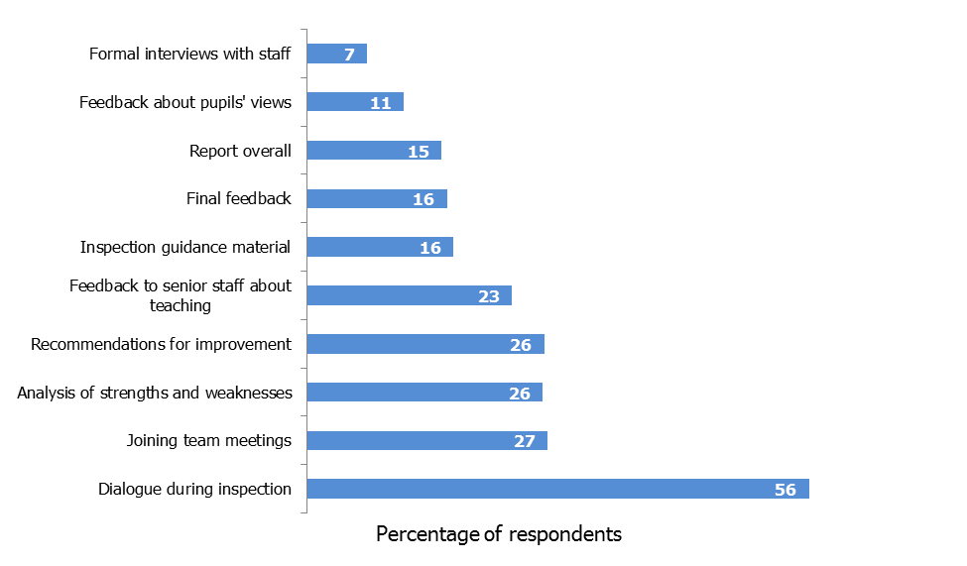

- Five hundred and twenty five respondents to survey waves 2, 3 and 4 provided at least one response when asked to rank the most helpful aspects of inspection.

School leaders’ views on the revised inspection guidance and methodology
- A little under two thirds of respondents strongly agreed or agreed that the revised inspection guidance and grade descriptors were helpful. Around one fifth had no clear opinion and around one in six disagreed that the revised guidance was helpful (see Figure 11).

Figure 11: Percentage of respondents who agreed that the revised guidance and grade descriptors were helpful in raising standards
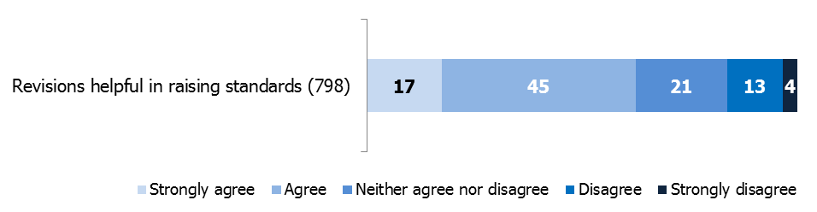
Percentages are rounded and may not add to 100.
The number of respondents is included in brackets.

- One set of questions asked about changes to specific areas of the inspection methodology and whether these changes were improvements (see Figure 12).
- School leaders’ responses provide some clear messages about how the inspection system can have greater impact. However, answers to these questions should be treated with caution as some schools had not been inspected under the previous inspection methodology.
- The shorter report format was seen as a considerable improvement by around two thirds of respondents. Around half of respondents thought that the shorter notice period had increased the impact of the inspection.
- A slightly higher proportion of respondents disagreed, rather than agreed, that the change from the satisfactory judgement to the requires improvement judgement would lead to more rapid improvement.
- The majority of respondents did not see the online Parent View arrangement as very effective. Ofsted will need to monitor this over time to see how it can be improved.

Figure 12: Percentage of respondents who agreed that the various changes to the inspection methodology were improvements
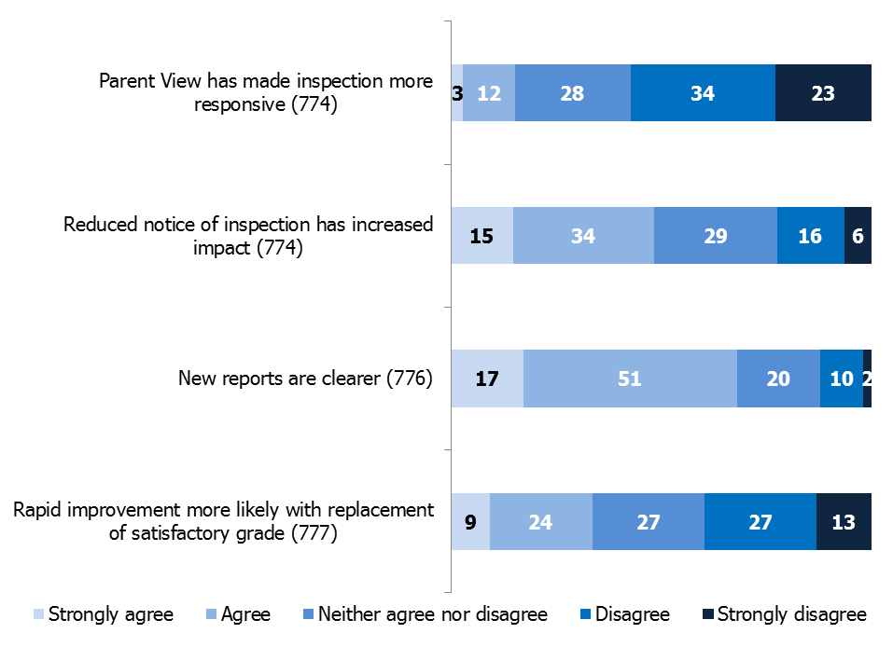
Percentages are rounded and may not add to 100.
The number of respondents is included in brackets.

Changes that school leaders made following inspection
- We invited headteachers and senior leaders to give examples of changes they made after their inspection. Ofsted analysed written comments from survey wave 4 and looked in particular at how headteachers and senior leaders responded differently according to the judgement their school had received.

Changes in schools judged to be outstanding
- Twenty nine respondents from survey wave 4 identified themselves as being from schools that were judged as outstanding. Of these, 23 indicated that they had implemented changes as a result of their recent inspection.
- Where respondents made particular reference to changes, these were wide-ranging in scope. However, a number of common changes emerged, including improvements to feedback and marking strategies, specific mathematics interventions and enhanced programmes of professional development.
- Two respondents mentioned that being judged as outstanding had encouraged them to do more work with other schools. One respondent wrote that they had taken action to:
‘… support other settings and staff to carry out observations and monitoring within own setting. Head and deputy are being trained with ECERS (Early Childhood Environment Rating Scale) to support other schools. Lots of visitors to setting to look at environment and practice from local authority and outside local authority. We have led training days for other schools looking at planning and assessment and observation.’

Changes in schools judged to require improvement
- Of the 60 respondents from schools judged to require improvement, around four fifths gave examples of the changes they had made following inspection. Most of these related to improving the management or quality of aspects of teaching and learning. Common actions included:
- developing clearer strategies for marking and assessment
- improving professional development and training programmes
- introducing tighter processes for monitoring and evaluation
- improving approaches to managing behaviour
- making better use of data for tracking and evaluation.

Changes in schools judged to be inadequate
- In general, the six respondents from inadequate schools gave very detailed written comments. Their responses were typified by the following examples.
- One respondent listed the improvements they had made as:
- making changes to teaching staff and new senior leaders
- re-constituting the governing body
- improving consistency in the way school policies were applied, for example in managing behaviour
- increasing levels of parental involvement.
- Another respondent gave a comprehensive list of improvements made at their school:
- addressing underperformance of staff
- implementing a new calculation policy
- raising expectations for all learners
- conducting a special educational needs (SEN) review
- planning a more strategic deployment of the middle leadership tier of staff for September
- focusing on progress as well as attainment
- implementing a planned programme of target-setting, performance management and pupil progress meetings
- setting up a parent forum
- communicating the school’s improvement focuses with all stakeholders on a weekly basis
- improving governance, including roles and responsibilities and monitoring.

Annex A. Post-inspection survey questions
Ofsted school inspection survey – Responses to the survey by overall effectiveness outcome: How good is the school?
 |  |  |  | Response
Question |  | OE Outcome* |  | Strongly agree |  |  | Agree |  |  | Don't know |  |  | Disagree |  |  | Strongly disagree
Overall, I am satisfied with the administration provided by the inspection service provider. |  | All outcomes |  | 13687 | 60% |  | 8345 | 37% |  | 30 | 0% |  | 518 | 2% |  | 196 | 1%
 |  | 1 |  | 2204 | 79% |  | 545 | 19% |  | 4 | 0% |  | 38 | 1% |  | 10 | 0%
 |  | 2 |  | 7800 | 64% |  | 4077 | 33% |  | 9 | 0% |  | 211 | 2% |  | 74 | 1%
 |  | 3 |  | 3369 | 49% |  | 3184 | 46% |  | 14 | 0% |  | 212 | 3% |  | 81 | 1%
 |  | 4 |  | 314 | 33% |  | 539 | 57% |  | 3 | 0% |  | 57 | 6% |  | 31 | 3%
The demands placed on me by the inspection were reasonable. |  | All outcomes |  | 9994 | 44% |  | 11029 | 48% |  | 81 | 0% |  | 1108 | 5% |  | 538 | 2%
The demands placed on me by the inspection were reasonable. |  | 1 |  | 1824 | 65% |  | 902 | 32% |  | 6 | 0% |  | 58 | 2% |  | 16 | 1%
The demands placed on me by the inspection were reasonable. |  | 2 |  | 5740 | 47% |  | 5690 | 47% |  | 38 | 0% |  | 474 | 4% |  | 206 | 2%
The demands placed on me by the inspection were reasonable. |  | 3 |  | 2211 | 32% |  | 3892 | 57% |  | 29 | 0% |  | 471 | 7% |  | 251 | 4%
The demands placed on me by the inspection were reasonable. |  | 4 |  | 219 | 23% |  | 545 | 58% |  | 8 | 1% |  | 105 | 11% |  | 65 | 7%
The inspection team challenged constructively the judgements and evidence we provided in our self-evaluation summary. |  | All outcomes |  | 14152 | 62% |  | 7112 | 31% |  | 95 | 0% |  | 858 | 4% |  | 507 | 2%
 |  | 1 |  | 2401 | 86% |  | 370 | 13% |  | 7 | 0% |  | 18 | 1% |  | 4 | 0%
 |  | 2 |  | 8342 | 69% |  | 3394 | 28% |  | 21 | 0% |  | 250 | 2% |  | 131 | 1%
 |  | 3 |  | 3146 | 46% |  | 2923 | 43% |  | 46 | 1% |  | 467 | 7% |  | 264 | 4%
 |  | 4 |  | 263 | 28% |  | 425 | 45% |  | 21 | 2% |  | 123 | 13% |  | 108 | 11%

The lead inspector provided appropriate opportunities for the headteacher/senior staff to engage productively with the inspection team. |  | All outcomes |  | 16546 |  | 73% |  |  |  | 5015 |  | 22% |  |  |  | 49 |  | 0% |  |  |  | 688 |  | 3% |  |  |  | 459 |  | 2%
 |  | 1 |  | 2562 |  | 91% |  |  |  | 223 |  | 8% |  |  |  | 3 |  | 0% |  |  |  | 16 |  | 1% |  |  |  | 2 |  | 0%
 |  | 2 |  | 9549 |  | 79% |  |  |  | 2272 |  | 19% |  |  |  | 17 |  | 0% |  |  |  | 197 |  | 2% |  |  |  | 122 |  | 1%
 |  | 3 |  | 4036 |  | 59% |  |  |  | 2194 |  | 32% |  |  |  | 23 |  | 0% |  |  |  | 369 |  | 5% |  |  |  | 230 |  | 3%
 |  | 4 |  | 399 |  | 42% |  |  |  | 326 |  | 35% |  |  |  | 6 |  | 1% |  |  |  | 106 |  | 11% |  |  |  | 105 |  | 11%
Inspection judgements about the school are fair and accurate. |  | All outcomes |  | 12803 |  | 56% |  |  |  | 8098 |  | 36% |  |  |  | 89 |  | 0% |  |  |  | 1120 |  | 5% |  |  |  | 554 |  | 2%
 |  | 1 |  | 2526 |  | 90% |  |  |  | 269 |  | 10% |  |  |  |  |  | 0% |  |  |  | 6 |  | 0% |  |  |  | 4 |  | 0%
 |  | 2 |  | 7652 |  | 63% |  |  |  | 4057 |  | 33% |  |  |  | 25 |  | 0% |  |  |  | 287 |  | 2% |  |  |  | 112 |  | 1%
 |  | 3 |  | 2445 |  | 36% |  |  |  | 3346 |  | 49% |  |  |  | 50 |  | 1% |  |  |  | 640 |  | 9% |  |  |  | 310 |  | 5%
 |  | 4 |  | 180 |  | 19% |  |  |  | 426 |  | 46% |  |  |  | 14 |  | 1% |  |  |  | 187 |  | 20% |  |  |  | 128 |  | 14%
The oral feedback and the written report were consistent. |  | All outcomes |  | 14207 |  | 63% |  |  |  | 7176 |  | 32% |  |  |  | 56 |  | 0% |  |  |  | 847 |  | 4% |  |  |  | 432 |  | 2%
The oral feedback and the written report were consistent. |  | 1 |  | 2507 |  | 89% |  |  |  | 274 |  | 10% |  |  |  | 2 |  | 0% |  |  |  | 13 |  | 0% |  |  |  | 6 |  | 0%
The oral feedback and the written report were consistent. |  | 2 |  | 8352 |  | 69% |  |  |  | 3394 |  | 28% |  |  |  | 17 |  | 0% |  |  |  | 274 |  | 2% |  |  |  | 103 |  | 1%
The oral feedback and the written report were consistent. |  | 3 |  | 3087 |  | 45% |  |  |  | 3062 |  | 45% |  |  |  | 30 |  | 0% |  |  |  | 432 |  | 6% |  |  |  | 226 |  | 3%
The oral feedback and the written report were consistent. |  | 4 |  | 261 |  | 28% |  |  |  | 446 |  | 47% |  |  |  | 7 |  | 1% |  |  |  | 128 |  | 14% |  |  |  | 97 |  | 10%
Overall, I am satisfied with the clarity of the inspection report. |  | All outcomes |  | 13513 |  | 60% |  |  |  | 7941 |  | 35% |  |  |  | 66 |  | 0% |  |  |  | 776 |  | 3% |  |  |  | 411 |  | 2%
 |  | 1 |  | 2474 |  | 88% |  |  |  | 317 |  | 11% |  |  |  | 3 |  | 0% |  |  |  | 5 |  | 0% |  |  |  | 4 |  | 0%
 |  | 2 |  | 8011 |  | 66% |  |  |  | 3821 |  | 31% |  |  |  | 17 |  | 0% |  |  |  | 197 |  | 2% |  |  |  | 88 |  | 1%
 |  | 3 |  | 2787 |  | 41% |  |  |  | 3340 |  | 49% |  |  |  | 34 |  | 0% |  |  |  | 446 |  | 7% |  |  |  | 230 |  | 3%
 |  | 4 |  | 241 |  | 26% |  |  |  | 463 |  | 50% |  |  |  | 12 |  | 1% |  |  |  | 128 |  | 14% |  |  |  | 89 |  | 10%
The inspection identified clear recommendations for improvement. |  | All outcomes |  | 14642 |  | 65% |  |  |  | 7542 |  | 33% |  |  |  | 32 |  | 0% |  |  |  | 316 |  | 1% |  |  |  | 167 |  | 1%
 |  | 1 |  | 2331 |  | 83% |  |  |  | 448 |  | 16% |  |  |  | 3 |  | 0% |  |  |  | 12 |  | 0% |  |  |  |  |  | 0%
 |  | 2 |  | 8341 |  | 69% |  |  |  | 3592 |  | 30% |  |  |  | 6 |  | 0% |  |  |  | 123 |  | 1% |  |  |  | 63 |  | 1%
 |  | 3 |  | 3593 |  | 53% |  |  |  | 3006 |  | 44% |  |  |  | 15 |  | 0% |  |  |  | 145 |  | 2% |  |  |  | 79 |  | 1%
 |  | 4 |  | 377 |  | 40% |  |  |  | 496 |  | 53% |  |  |  | 8 |  | 1% |  |  |  | 36 |  | 4% |  |  |  | 25 |  | 3%
I will use the inspection recommendations to move the school/my teaching forward. |  | All outcomes |  | 15894 |  | 71% |  |  |  | 5901 |  | 26% |  |  |  | 104 |  | 0% |  |  |  | 274 |  | 1% |  |  |  | 167 |  | 1%
 |  | 1 |  | 2351 |  | 85% |  |  |  | 389 |  | 14% |  |  |  | 6 |  | 0% |  |  |  | 19 |  | 1% |  |  |  | 3 |  | 0%
 |  | 2 |  | 8812 |  | 74% |  |  |  | 2920 |  | 24% |  |  |  | 35 |  | 0% |  |  |  | 123 |  | 1% |  |  |  | 66 |  | 1%
 |  | 3 |  | 4207 |  | 63% |  |  |  | 2252 |  | 34% |  |  |  | 47 |  | 1% |  |  |  | 118 |  | 2% |  |  |  | 74 |  | 1%
 |  | 4 |  | 524 |  | 57% |  |  |  | 340 |  | 37% |  |  |  | 16 |  | 2% |  |  |  | 14 |  | 2% |  |  |  | 24 |  | 3%
I am satisfied that the views of pupils were explored by inspectors. |  | All outcomes |  | 14845 |  | 66% |  |  |  | 6964 |  | 31% |  |  |  | 107 |  | 0% |  |  |  | 405 |  | 2% |  |  |  | 178 |  | 1%
 |  | 1 |  | 2420 |  | 87% |  |  |  | 323 |  | 12% |  |  |  | 13 |  | 0% |  |  |  | 14 |  | 1% |  |  |  | 1 |  | 0%
 |  | 2 |  | 8666 |  | 72% |  |  |  | 3152 |  | 26% |  |  |  | 45 |  | 0% |  |  |  | 107 |  | 1% |  |  |  | 49 |  | 0%
 |  | 3 |  | 3481 |  | 51% |  |  |  | 2973 |  | 44% |  |  |  | 37 |  | 1% |  |  |  | 204 |  | 3% |  |  |  | 82 |  | 1%
 |  | 4 |  | 278 |  | 30% |  |  |  | 516 |  | 55% |  |  |  | 12 |  | 1% |  |  |  | 80 |  | 9% |  |  |  | 46 |  | 5%
The benefits of the inspection outweigh the negative aspects. |  | All outcomes |  | 9421 |  | 42% |  |  |  | 8998 |  | 40% |  |  |  | 544 |  | 2% |  |  |  | 2184 |  | 10% |  |  |  | 1209 |  | 5%
 |  | 1 |  | 1898 |  | 68% |  |  |  | 733 |  | 26% |  |  |  | 35 |  | 1% |  |  |  | 86 |  | 3% |  |  |  | 20 |  | 1%
 |  | 2 |  | 5442 |  | 46% |  |  |  | 4924 |  | 41% |  |  |  | 291 |  | 2% |  |  |  | 924 |  | 8% |  |  |  | 375 |  | 3%
 |  | 3 |  | 1926 |  | 29% |  |  |  | 2992 |  | 45% |  |  |  | 184 |  | 3% |  |  |  | 991 |  | 15% |  |  |  | 620 |  | 9%
 |  | 4 |  | 155 |  | 17% |  |  |  | 349 |  | 38% |  |  |  | 34 |  | 4% |  |  |  | 183 |  | 20% |  |  |  | 194 |  | 21%
Overall, I am satisfied with the way the inspection was carried out. |  | All outcomes |  | 13754 |  | 61% |  |  |  | 6963 |  | 31% |  |  |  | 100 |  | 0% |  |  |  | 908 |  | 4% |  |  |  | 702 |  | 3%
 |  | 1 |  | 2360 |  | 85% |  |  |  | 386 |  | 14% |  |  |  | 3 |  | 0% |  |  |  | 20 |  | 1% |  |  |  | 9 |  | 0%
 |  | 2 |  | 8105 |  | 68% |  |  |  | 3402 |  | 28% |  |  |  | 30 |  | 0% |  |  |  | 270 |  | 2% |  |  |  | 181 |  | 2%
 |  | 3 |  | 3034 |  | 45% |  |  |  | 2779 |  | 41% |  |  |  | 54 |  | 1% |  |  |  | 495 |  | 7% |  |  |  | 375 |  | 6%
 |  | 4 |  | 255 |  | 28% |  |  |  | 396 |  | 43% |  |  |  | 13 |  | 1% |  |  |  | 123 |  | 13% |  |  |  | 137 |  | 15%
* Overall effectiveness: how good is the school? (1) outstanding, (2) good, (3)satisfactory/requires improvement, (4) inadequate.
All responses received between 01/09/09 and 31/08/14.
Percentages are rounded and may not add up to 100%.

Annex B. Impact survey questions
- What grade were you awarded at your recent inspection?
- If this was not the grade you expected, please tell us the grade you did expect.
- To what extent do you agree or disagree that this inspection was rigorous in reaching its judgements?
- To what extent do you agree or disagree that the inspectors focused sharply on the outcomes for young people and learners?
- To what extent do you agree or disagree that inspectors focused sharply on leadership and management?
- To what extent do you agree or disagree that the inspectors made efforts to take account of the views of the service users such as parents/carers or young people?
- To what extent do you agree or disagree that the revised inspection guidance and grade descriptors are helpful in raising standards?
- To what extent do you agree or disagree that inspectors focused sharply on the quality of teaching?
- To what extent do you agree or disagree that inspectors accurately identified the stronger and weaker areas of your provision?
- To what extent do you agree or disagree that inspectors made efforts to include you or other managers in dialogue about the inspection?
- To what extent do you agree or disagree that the findings of the inspection will help you to improve your provision?
- Have you already made changes as a result of the inspection?
- Which recommendation in the inspection report have you found most helpful?
- Which of the following have you discussed the findings of the report with:
- leaders and managers
- governors
- staff at your provision
- young people or parents
- local authority
- other stakeholders.
- To what extent do you agree or disagree that the report is helpful in explaining to staff and users how your provision can improve?
- Which aspects of inspection did you find most helpful in planning improvements in your school? Please place these in rank order:
- feedback to senior staff about teaching observed by the inspectors
- feedback about what the pupils said about their school
- analysis of the school’s strengths and weaknesses
- the section of the report ‘what does the school need to do to improve further?’
- the inspection guidance material
- dialogue with inspectors during the inspection
- questions posed during formal interviews with staff
- the final feedback
- the report and its recommendations for improvement
- joining team meetings.
- Do you consult Ofsted reports in order to help you make improvements?
- To what extent do you agree or disagree that the replacement of the ‘satisfactory’ judgement with ‘requires improvement’ has made rapid improvement more likely?
- To what extent do you agree or disagree that the new inspection reports are clearer?
- To what extent do you agree or disagree that the reduced notice of inspection has increased the impact of inspection?
- To what extent do you agree or disagree that Parent View has made inspection more responsive to the views of parents and carers?
- To what extent do you agree or disagree that the focus on the impact of pupil premium has raised expectations of good practice and assisted in improving pupils’ achievement?
- To what extent do you agree or disagree that the renewed focus on governance has raised expectations of good practice and assisted in strengthening leadership and management?
- Do you agree with the statement: ‘The recent inspection helped by confirming we were taking the right steps to improve our school or maintain its qualities’?
- If you answered ‘Strongly agree’ or ‘Agree’ to the above question, please give some examples of areas where the inspection was helpful.

The framework for school inspection, Ofsted, July 2014, paragraph 69; www.gov.uk/government/publications/the-framework-for-school-inspection.
Between September 2009 and August 2014, 55% of schools judged inadequate gave a positive response to this question.
Answers are not directly comparable to the questions in Figure 2 as schools’ governance and schools’ use of the pupil premium do not receive graded judgements.
Schools were asked to rank 10 aspects of inspection. Answers are based on the number of ‘top two’ votes for each aspect. Figures are based on responses to survey waves 2, 3 and 4.
Survey wave 2 onwards.
Survey wave 2 onwards.
Survey wave 2 onwards.
Survey wave 2 onwards.
Survey wave 2 onwards.
Survey wave 2 onwards.
Survey wave 2 onwards.

