Greening Government ICT
2014 Annual Report

Reducing carbon. Reducing cost

Date 20/01/15
Version 2.1 Final

Contents

Foreword 3
Introduction 5
Key highlights 6
Key challenges 8
Maturity Model Assessment 9
Roadmap Assessment 12
Assessments of the operational energy use of IT 14
Commitments 16
Case studies 18
Looking forward 23

Foreword

The government launched its Greening Government IT Strategy in 2011 with a commitment to report transparently. This is the third year of a four year strategy and we can report continuing good progress towards our goals.

Since the strategy was published there have been major changes in the government’s approach to technology and digital services. These are entirely consistent with driving improved sustainability for government technology. The move to cloud based, commodity, re-useable and digital by default services, provides opportunities to have greener IT and to use technology to help departments’ operations be more sustainable overall.

There is a strong central commitment through the Way We Work (TW3) programme to ensure that civil servants have the modern tools they need to enable them to work effectively together and with customers. New greener digital technologies and working practices will help do just that.

This report shows the progress we are making and provides case studies of how departments are using a wider range of digital services from modern communication and collaboration tools to cloud-sourced data storage.

All new significant technology proposals now have to be assessed against the GDS Technology Code of Practice. One criteria used in that assessment is to “ensure best sustainability practices, whether in-house or via external suppliers, including compliance with Greening Technology” (Technology Code of Practice item 13).

Departments’ response to implementing the challenges in the Greening Government ICT Strategy and delivering greener services is a good example of cross-government collaboration. The Green ICT Delivery Unit (GDU) is a light touch virtual organisation which identifies and shares best practice. It is focused on developing supporting tools and guidance and then transparently reporting on progress. The GDU also reaches out to the UK ICT industry, through organisations such as TechUK, JISC (Joint Information Services Committee for Higher Education) and the BCS(British Computer Society), working together to identify opportunities and to push for improvement.

Sustainable technology is contributing towards delivery of Greening Government Commitments which are targets for central government departments and their agencies to significantly reduce waste, water usage and carbon emissions by 2015, together with making their ICT procurements more sustainable. This is set out in the Greening Government Commitments 2013/14 Annual report. The two strategies were formed at different times but are now more closely aligned, with technology and our Strategy providing essential services for helping departments meet their Greening Government Commitments (GGC), including those for waste and travel. However readers will need to be bear in mind that the GGC programme uses a different reporting methodology and does not cover the same departments in all its assessments.
Whilst we have come a long way, there remain significant opportunities and challenges in weaving sustainability through the changes underway to modernise government, to use Cloud services through central frameworks and to digitise customer services, whilst managing resources and improving the way we work.


Jeremy Boss
Chair of the Green ICT Delivery Unit (GDU)
DECC Technology Leader

Introduction

Over the last twelve months good progress has continued to be made on implementing the Greening Government ICT strategy. All central Departments and an increasing number of their arms-length bodies have again provided assessments of progress towards achieving a Level 3 for the Green ICT Maturity of our Technology Services and adoption of 10 out of the 14 key target outcomes on the Roadmap. This year we also have a comprehensive return of assessments for the energy consumed by departmental technology estates.
In line with the Strategy Plan we have extended the range of information required of departments to encompass statistics on collaboration tools and services, government buying standards and recycling and disposals. It is clear from the data returned that departments are adopting a range of digital tools and services to improve the way they work and the access, processing and storage of their data and information.
More widely

- The Cabinet Office/Government Digital Service (GDS) Digital by Default and Ways of Working programmes bring with them the implementation of new digital tools and services that inherently have positive sustainability impacts.
- The implementation of the Public Services Network (PSN) is driving sustainable savings and efficiencies by removing duplicate network connections. It also allows public sector employees to work in more flexible, collaborative ways by creating a common network of networks and moving towards ubiquitous access for staff from any government office.
- The Government Service Design Manual includes a Technology Code of Practice that requires compliance with the Greening Government ICT Strategy as well as driving departments towards common platforms and use of agile approaches to development. These approaches are starting to result in further sharing and rationalisation of digital services across government.

This report:
- conveys the highlights from those assessments.
- the work done by the GDU throughout 2013-14.
- identifies areas where departments are being challenged by the Green Technology agenda and commitments.
- sets out broadly the work that lies ahead for the GDU to help all departments achieve the targets by March 2015.
Key highlights

These include:
- the average level of Maturity, being an assessment of the degree to which departments are embedding sustainability in their day to day IS services, rising from 2.6 to 2.9, with nine departments already achieving the Level 3 target ahead of the target date.
- 80% or above of departments have now reached a Level 3 maturity in greening their end user support arrangements, consolidation of devices, travel reduction, space and energy optimisation, and corporate reporting, with significant improvements shown for Information and Data management, investment decisions, and electronically enabling customer services.
- Three departments have achieved ten or more Key Target Outcomes from the Roadmap.
- the average energy consumption per member of staff has reduced by 324kWh/y or 90kgCO₂ kwh.
- there are over 500 video conference installations reported across the survey respondents’ estates.
- staff are being provided with access to a wide range of collaborative working tools from shared working spaces to video and audio conferencing facilities and social media, allowing them to work together and with customers, at a wider range of locations. This has facilitated not only more efficient working practises and more timely outcomes, but also helped to reduce travel costs by allowing staff not to have to travel to meetings.
- nine departments have provided statistics on their reusing, recycling and disposing of redundant IT assets, covering some 91,700 items weighing 945 tonnes and achieving nearly 94% level of landfill/incineration avoidance

The GDU continues to support departments in improving the sustainability of their technology. This year saw the formation of two working groups, Print Management and Reuse and Disposal, and the provision of assistance to departments in adopting the EU Code of Conduct for energy efficient data centres.
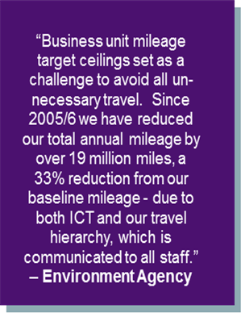
The government and its partner organisations spend substantial amounts of money each year on printing. The Print Management Working Group will look at printing more efficiently, understanding what is being printed, and why. This will help reduce the need for print and thereby for ‘being in the office’ facilitating flexible working, and estate reductions with significant gains in efficiency and in cost reduction.
The longer term aim of this group is to target the elimination of all paper. While this is not currently possible, print management should help identify what paper output can be replaced with digital access and processes, and output that still has to be printed should be done so in the most efficient and cost effective way possible.
Across government, the Reuse and Disposal Working Group aims to ensure that wherever possible our ICT and other assets are reused and disposed of responsibly. HM Revenue and Customs is leading a pilot project on the reuse of stationery, office supplies and ICT equipment. The pilot will run in parallel with an ICT disposal pilot which cover items that are either not re-used or not suitable for recycling and therefore can be considered for responsible disposal. The aim is for both pilots to work together to provide an end-to-end function for reuse/recycling/disposal of ICT kit. The front-end will be a digital platform to enable re-use across the four departments taking part. A preferred supplier has been selected for this platform, and it is expected that the pilot will launch in the second half of 2014-15. Our ambition is that evaluation will lead to a cross-government and potentially wider public sector reuse and disposal service covering a comprehensive range of surplus resources.
Key challenges

Greening the project lifecycle
It is clear that we must continue to improve our performance in the areas of incorporating green information and metrics into running projects and making investment decisions. Incorporating sustainability impact assessments into the design of projects is still proving hard, and adding such impacts to investment decisions can impact value for money calculations if whole lifecycle costs are not included. This has been particularly difficult at a time when departments are under significant financial pressure and government is changing its project delivery methodology and becoming more agile and customer-focused. Inclusion of compliance with our Strategy in the government’s Technology Code of Practice is an important step. Going forward, we now need to highlight the key items for such compliance to be most beneficial.

Is the Cloud green?
Whilst clearly offering significant gains in terms of enabling the sharing of services and capacity, the energy efficiency and location of the underlying hosting infrastructure for Cloud services is not readily visible, and assumptions about its efficiency could be misplaced. With more services being delivered from the Cloud and the amount and source of any emissions being less obvious it will become both more complex and challenging to meet our obligations to report on supply chain emissions. Difficulties include estimating the proportion of a Cloud service that is used, assessing emissions from intervening network components when services are shared with other customers, and direct measurements are not readily available.. We must find ways to address these if we are not to lose track of the footprints of our Technology services as we move these to Cloud solutions.
Defra Agency Natural England completed a first round of application rationalisation enabling the following annual savings totalling £243k pa, by cancelling or merging licences and support as follows
• Access to Nature £67,100
• Magic (GIS) £62,200
• Nature on the Map £94,000
• Countryside Walks Website £20,000

Green Skills
We are clearly making progress in the areas of procurement, architecture and project management but there is still room for improvement in these fields and we need to investigate whether individuals with skills in these areas are lacking specific green awareness as part of their skill set. We will seek to address this shortfall by further raising awareness and promoting appropriate training for Green ICT as well as links both with the GDS Technology function skills and capability review and with the current revision of the SFIA ( Skills Framework for the Information Age).
Maturity model target
9 departments have already met or exceeded the 2015 target of level 3 of the maturity model.
Green data reporting
It has continued to be a challenge to gather and report good quality green data and statistics in order to measure our progress. This can often be because we are asking for data that departments and/or suppliers do not collect or which suppliers charge to gather and process. With the end of some major contracts across government, we hope that this can be improved by incorporating sustainability reporting requirements in new contract terms and conditions, including those used for central digital contracts and frameworks.

Maturity Model Assessment

Sixteen departments completed the maturity assessment, with the NHS dropping out. However the coverage was wider than before with some thirty-two government agencies and arm’s length bodies being encompassed in returns.
Nine out of the sixteen (16) departments have now achieved the target Level 3 Maturity:
An average score for all departments calculated from staff weighted averages shows progress towards the Level 3 (practised) target:
- Last year, departments achieved an average score of 2.55, this year it is 2.88
- Last year, the average level of departmental ambition was to achieve a level of 3.56, this year it is 3.57
The following charts illustrate our progress.

Chart 1
The first portrays the percentage of departments reaching Level 3 or above this year against the levels achieved last year (green) and similarly compares the desired levels across both years (red).
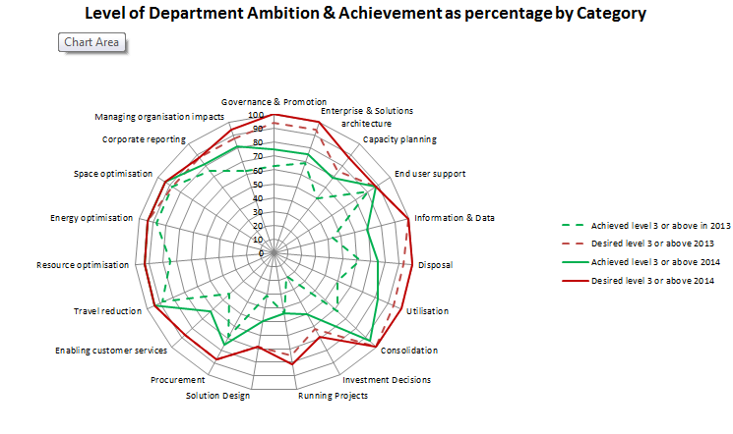

Chart 2
Chart 2 below shows the proportion of departments achieving Level 3 or higher for each category in 2013 (blue) and in 2014 (red). This is useful for illustrating which categories of IT services are most mature and the areas in which departments face more challenge as well as highlighting the areas where the greatest amount of progress has been made.

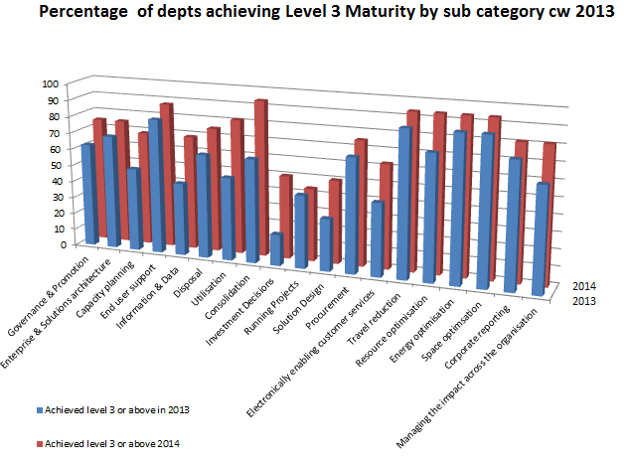
Chart 3
The final chart provides an indication of how close departments are to gaining Level 3 maturity for each category. This again reveals those areas where departments are struggling, in particular with investment decisions, running projects and solution design
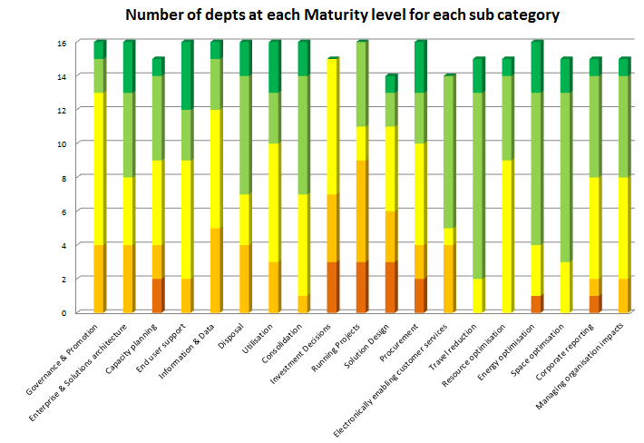

Looking at themes from the analysis, we have achieved significant improvements in
- consolidation/utilisation
- investment decisions
- information and data management
- electronically enabling customer services
With much lower levels of improvement in
- governance
- architecture
- procurement
- corporate reporting
Our weakest areas remain
- investment decisions
- running projects
- solution design

Roadmap Assessment

Fourteen Government Departments provided assessments – three fewer than last year - demonstrating their achievement of Key Target Outcomes (KTO) through the utilisation of best practices from the Green Technology Workbook.
Three departments (HMT, Defra and DH) have already met the target of achieving ten or more KTOs while eight departments have sufficient KTOs in progress to achieve ten next year.

Chart 4
This shows the number of Key Target Outcomes achieved or in progress for each department
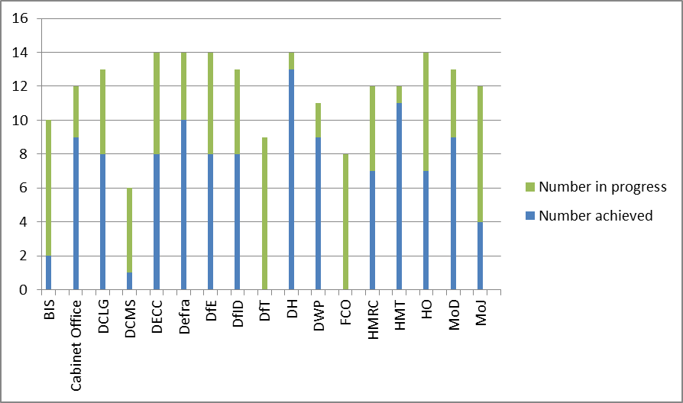
Chart 5

This shows the percentage of departments achieving each Key Target Outcome

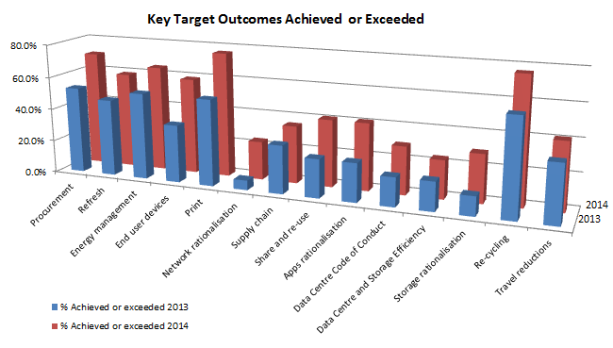

In summary KTOs for Recycling, Print and Procurement are major successes with significant improvements being made in End User Devices and both Application and Storage Rationalisation.
Less improvement has been shown in the KTO for Network Rationalisation where some departments have returned to ‘planning’ and ‘in progress’ as they plan their move to PSN. Departments are making improvements with the KTOs for Supply Chain, Share/re-use and Data Centre Code of Conduct but more slowly than in other areas.
Assessment of the operational energy use of IT

This is the second year that the GDU has gathered figures for the IT operational energy footprint. This is the assessment, if not measurement, of the energy taken to run our IT. The GDU again used the tool developed with the Joint Information Systems Committee for Higher Education (JISC) last year.

Fourteen organisations provided returns showing their ICT operational energy consumption
Chart 6

The total footprint figures for these 14 organisations are as follows
NB - NHS figures copied forward from 2013, no figures for DCMS, and Met office included in BIS assessment

Category |  | Energy Use (kWh/y) | % |  | Energy Cost (£/y) | CO₂ emissions (kg/y) | Average kWh/y staff | Average £/ staff | Average kg CO₂/ staff
Audio Visual |  | 8,570,838 | 1.8% |  | 824,491 | 3,658,303 | 26 | 2 | 11
End User |  | 131,180,018 | 27.3% |  | 13,761,400 | 62,733,184 | 240 | 25 | 115
Imaging |  | 40,464,395 | 8.4% |  | 4,285,089 | 19,364,023 | 74 | 8 | 35
Networks |  | 53,900,110 | 11.2% |  | 5,650,263 | 25,619,114 | 159 | 17 | 76
Servers |  | 224,277,514 | 46.7% |  | 23,287,079 | 106,315,179 | 410 | 43 | 194
Telephony |  | 21,911,339 | 4.6% |  | 2,319,454 | 10,380,451 | 66 | 7 | 31
TOTAL |  | 480,304,215 | 100% |  | 50,127,777 | 228,070,254 | 1091 | 114 | 518
Chart 7

Shows last year’s figures adjusted to provide a fair comparison

N.B. Re-baselined last year - 2012-13 (DfT, DCLG & DFID 2013 figures copied back from 2014, no figures for DCMS )
Category | Energy Use (kWh/y) |  |  | % | Energy Cost (£/y) | CO2 emissions (kg/y) | Average kWh/y staff | Average £/ staff | Average kg CO2/ staff
Audio Visual | 8,230,543 |  |  | 1.4% | 712,557 | 4,203,669 | 26 | 2 | 13
End User | 148,900,936 |  |  | 25.4% | 14,692,239 | 83,543,734 | 313 | 31 | 176
Imaging | 44,433,811 |  |  | 7.6% | 4,475,285 | 25,306,175 | 94 | 9 | 53
Networks | 71,635,963 |  |  | 12.2% | 3,799,037 | 20,123,136 | 214 | 11 | 60
Servers | 288,834,664 |  |  | 49.3% | 19,201,788 | 108,717,219 | 608 | 40 | 229
Telephony | 23,806,448 |  |  | 4.1% | 2,073,879 | 11,152,434 | 75 | 7 | 35
TOTAL | 585,842,365 |  |  | 100% | 44,954,786 | 253,046,367 | 1467 | 113 | 634

Chart 8
The following chart shows the change in the footprint for each component.
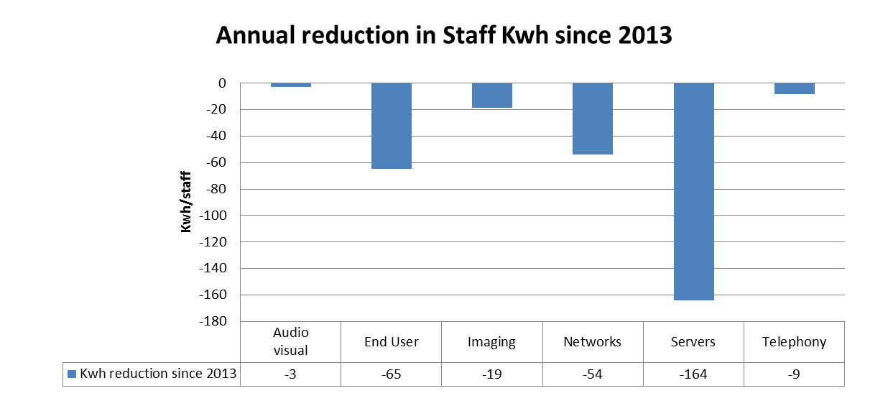

In summary the results show that although there has been a rise in the number of staff covered by the survey there has been a reduction in the average amount of energy used per annum per member of staff of 324kWh/y or 90kgCO2. The cost of the energy consumed has gone up but this is due to increases in energy prices rather than any significant changes in supply arrangements. Although the amounts of energy used have reduced over the past year, the percentages for each type of asset have remained roughly the same. The largest elements are still end user devices and servers.
Commitments

The Greening Government: ICT Strategy sets out a number of commitments and actions. The table below summarises progress made on each where reported by departments.
Commitments and actions |  |  | No of Depts meeting commitment | No of Depts making progress towards | RAG for percentage of Depts meeting commitment
Measurement and Progress Reporting
Commitment | 1 | Government to reach level 3 (practiced and moving forward) of Green ICT Maturity Assessment Model
Actions | 1.1 | Green ICT Maturity Model fully adopted by government, self assessed and peer reviewed | 16 | 1 | 94%
Actions | 1.2 | Government to have improvement plans in place where below level 3 | 5 | 12 | 29.4%
Commitment | 2 | Government to adopt at least 10 of the 14 key areas set out in the Roadmap for improving its Green ICT practices.
Actions | 2.2 | Government will implement at least 10 of the 14 actions from the Green ICT Roadmap for each of its departments/agencies | 3 | 14 | 17.7%
Commitment | 3 | Government to report on operational ICT energy consumption using agreed standards for products and services
 | 3.2 | Government to measure or estimate operational ICT energy consumption and provide a trajectory of expected consumption out to March 2015 | 4 | 8 | 28.57%
Greening the ICT Infrastructure
Commitment | 4 | The Government will work with suppliers and technology industry groups to encourage green practices
Actions | 4.1 | Government will ensure Government Buying Standards (GBS) are embedded in all new contracts, awarding contracts that appropriately encompass green solutions. | 5 | 7 | 35.71%
Commitment | 5 | Government will operate a greener ICT lifecycle, purchasing and using less ICT by appropriate sharing and re-use.
Actions | 5.1 | Government will identify the surplus and redundant ICT equipment and applications that can be switched off and removed | 6 | 8 | 42.86%
Actions | 5.2 | Government will share and re-use infrastructure and services through programmes like PSN and Cloud | 4 | 9 | 28.57%
Commitment | 6 | Government to adopt the EU Code of Conduct for energy efficient Data centres
Action | 6.1 | Government to be registered as endorsers of EU code of conduct for energy efficient data centres and server rooms | 3 | 5 | 21.43%
 | 6.2 | Government to require any data centre or cooled server room used in delivering a new ICT service to be registered as Participants under the EU Code of Conduct for energy efficient data centres | 1 | 5 | 7.14%
Commitment | 7 | All redundant ICT to be recycled in whole or component parts or materials, or donated to charities and voluntary organisations as part of the Big Society. Reductions in line with the Government Waste Strategy and Hierarchy
Action | 7.1 | Government to account and track redundant ICT recycled, donated or disposed | 9 | 3 | 64.29%
Exploiting ICT to Green Government
Commitment | 8 | The Government will use ICT to make its processes more effective and efficient and promote new ways of working
Actions | 8.1 | Government will make available (to staff appropriate to location and type of work) and exploit collaboration tools,(e.g. audio/video/web conferencing services) and mobile working technologies to avoid unnecessary travel | 7 | 7 | 50.00%
 | 8.2 | Government will deploy collaboration services locally and across Government to support cross-Government joined up working | 3 | 4 | 21.43%
Exploiting ICT to Green Public Services
Commitment | 9 | The Government will seek to improve public service provision, to achieve reductions in greenhouse gas emissions, energy use, waste, travel, paper/print, office space and procurement; to increase agility and capability; to support business outcomes and a UK green economy
Actions | 9.1 | Government will exploit technologies such as social media and mobile working to drive Public Services on-line and deliver green benefits | 5 | 7 | 35.71%

Returns are patchy but one can discern key areas where focus will be required from the GDU to assist departments including:
- preparing trajectories for footprint reductions
- sharing and re-using infrastructure
- continuing to promote the adoption of EU Code of Conduct for energy efficient Data Centres and server room efficiencies
- exploitation of collaboration tools

Case studies

Home Office
: Improved Footprint Report
In order to develop a more detailed IT carbon footprint than was reported last year the Home Office decided to partner with a Cloud-supplier. The department wanted to be able to go into more detail and use more sophisticated assumptions than the JISC tool had allowed previously. Data was gathered in a similar way to last year through reports from the HO Configuration Management Database but it was then uploaded into the Cloud-supplier system to calculate emissions. The output was used to create a more detailed report identifying areas where there was opportunity for further improvements and where efforts would be most cost effective. Overall the department’s
- IT usage accounts for 20.5% of total electricity consumption.
- Annual electricity cost from IT usage was £2.99 million.
- IT emissions were 15,607 tCO₂e

Department for Energy and Climate Change
: Green IT and Sustainability in a new multi- supplier IT contract
In May 2014, DECC moved to a new multi-supplier tower model for the provision of its core IT services. Most of the department’s IT is now commodity and cloud based and therefore typically greener by design.
However to be sure our key suppliers were able to meet our green aspirations DECC set clear requirements around Green IT and Sustainability during the procurement phase. During discovery sessions with suppliers, we emphasised the department’s vision and objectives on being green and sustainable. The aim of this approach was to be sure suppliers understood our goals and drivers and demonstrate how they could help us deliver them.
We included some very specific requirements in our Invitations to Tender, some of these included:
- Define your approach and credentials for delivering a green and sustainable IT service.

- For each Service Element, define how the greening of IT credentials have been considered and referenced in the solution wherever necessary.

- Confirm reporting information will be supplied on a frequent basis to enable DECC to report against the HMG Green Maturity Model and identify areas of opportunity for continually improving the score.
The DECC bid evaluation criteria drove a positive response from suppliers. As a result of these requirements, the chosen supplier has helped DECC move from a score of 3.2 to 4 on the HMG Green Technology Maturity Model within six months of going live. DECC and CGI will hold quarterly sustainability reviews to discuss current performance and areas of opportunity. DECC also have a number of projects in the pipeline, which will help further reduce the department’s IT carbon footprint.

The Department for Transport
: Reducing the number of printers in use and improving the service
The department was able to reduce the number of printers in service from more than 500 down to 130, while providing a higher quality solution. DfT reduced the cost of stocking several dozen different types of print media by concentrating on six models and simplified the number of different printer drivers.
DfT reduced the number of desktop PCs from 2800 to 1615 thin client PCs that are much faster to logon and more reliable, at a saving of £225k. It also reduced the number of laptops from 1450 to 1300 with over 550 repurposed as thin clients at a saving of £430k.
The department participated in a pilot of the Cabinet Office’s The Way We Work (TW3) initiative which aims to encourage more effective use of office space and to promote a change in the working culture.
On beginning the pilot DfT had a mixed economy of laptops and PCs and initially considered providing all staff with laptops but based on cost, business-fit and environmental grounds opted for a mix of thin clients and laptops. There was considerable support rolling out new thin clients and laptops for all staff. However, while a number of the PCs were aging, a significant proportion still had the potential for many years of useful life. DfT successfully argued to repurpose the newer PCs as thin clients; ensuring a significant cost saving as well as reducing the volume of devices sent for recycling. More than 50% of PCs were repurposed.
DfT also looked at the working patterns of mobile staff and those who wished to become more mobile. It became apparent that many of those staff would only be working from home or in the office. For those staff they developed a thin client laptop; providing more than 500 thin clients all based upon repurposed laptops which otherwise would have been redundant.
They subsequently took advantage of the TW3 initiative to replace the proliferation of local printers with a smaller number of multi-functional devices thereby increasing the ratio to 1:35 and with the added benefit of a 30% reduction in the volume of printing produced.

Ministry of Justice
: Power saving for PC estate
The Ministry of Justice is set to save more than £217,000 a year and make a substantial contribution to reducing its carbon emissions by deploying the NightWatchman. A survey showed that on average 7,000 computers across MoJ's estate were left switched on overnight. The NightWatchman is an innovative piece of software which identifies desktop PCs that have been left on overnight and automatically shuts them down. Any unsaved work is automatically saved so no data is lost. Since rolling this out last year, at 7pm every evening the NightWatchman starts shutting down all desktop PCs that have been left on and have been inactive for 30 minutes.

Ministry of Defence
: Virtualisation of DBS Finance Oracle R12 estate:
Ministry of Defence has successfully completed the pilot for upgrading its Finance Oracle R12, using virtualisation, including partition mobility. The footprint for the new machines sees a huge reduction in the number of racks required with additional space to add another server into the same cabinets to meet future needs. Once the new servers are installed, the power saving and the reduction in heat displacement surveys will be completed. MOD believes that the power reductions once quantified will be substantial. As an added benefit, because of the additional processing power of the modern servers, MOD expects to make a saving on the Oracle licensing due to the decrease in cores required.

Department of Business Innovation and Skills – National Oceanography Centre
: Data Centre energy efficiencies
The National Oceanography Centre is wholly owned by the Natural Environmental Research Council, part of the Department of Business Innovation and Skills. The Southampton site has a legacy data centre which over the last 6 years has substantially increased its IT performance and capacity (from 220 TB to over 1 PB of disk storage) whist reducing its energy usage by about 50%.
The approach taken is the same as that by the cycling coach Dave Brailsford - "The Aggregation of Marginal Gains", mainly due to the high cost of developing a new facility. A working group was set up including users, Estates and IT representatives. The group looked at all possibilities, conventional and otherwise for improvement; these were assessed for impact, return on investment, prioritised and where possible implemented. This group has continued to review changes, and to discover and develop new ways for further improvements with a longer term aspiration to register the data centre as Participant in the EU Code of Conduct for energy efficient data centres.
The changes made so far include automatic metering, increased air inlet temperatures, increased humidity range, free air cooling air conditioning supplemented with sea water cooling, server virtualisation, thermal containment curtains, air flow balancing, under floor baffles to improve airflow, and environmental considerations for all purchases and changes.
This resulted in the facility being voted runner up in the 2012 Minister of Energy awards but the team has continued to make improvements as ideas, resource and funding become available. Future plans include the reuse of heat waste energy from the room and extension to the existing 117kWp solar array at the Centre to boost renewable energy generation.
The facility now has an average Power Usage effectiveness (PUE) of 1.5 which is comparable with most new build data centres and is exceptional for a legacy data centre.

Department of Business Innovation and Skills - National Environment Research Council
: Integrating Room Based and Desktop Video Conferencing
The Natural Environmental Research Council (NERC), one of the BIS Partner Organisations, has a requirement to interact with many internal and external organisations and people. There was a challenging requirement for video conferencing that would integrate and work with existing room based systems and Windows, Mac, iOS, Linux and Android operating systems.
Following trials and product evaluation, a pilot was implemented using VisiMeet for Janet. The pilot has proved to be hugely successful with benefits of increased productivity, improved quality and a reduction in travel. Such were the benefits that the pilot was expanded and became operational almost immediately as it became an indispensable way of working.

Looking forward

Progress in implementing greening technologies such as collaboration and conferencing tools is now underpinning other HMG Digital and Efficiency programmes including The Way We Work (TW3), Digital by Default and Greening Government Commitments (GGC). Further exploitation of technology is essential for improving efficiency and sustainability, and reducing costs.
As well as assisting departments in their progress towards meeting the Greening Government: ICT Strategy commitments, it is critical to join up with the Government Digital Service (GDS) in its longer term work towards delivering government as a platform, to ensure that solutions adopted are sustainable and energy efficient. The increasing procurement of G-Cloud, Digital Service Frameworks, Cloud and Open sourced services, and Agile techniques, poses challenges for the Green agenda that must be addressed if their potential to deliver a more sustainable government is to be realised.
Underpinning this is the need to pass on the skills and experience we now have in the GDU to help other public sector staff improve their awareness of the sustainability and efficiency opportunities from using Technology and Digital services – exploiting further the legacy estate as well as moving to new digital services.
In seeking these longer term objectives, the GDU has to address how we take our work forward on completion of the targets for the current Strategy in March 2015, and formulating the next Greening Government Technology Strategy to support the wider programmes for change already referred to above. It must also not lose sight of the need for a final push to complete the actions and meet commitments set out in the current Strategy. We will need to maintain and to continue to harvest the positive commitment and enthusiasm of departmental GDU representatives without which we would not have made the substantial progress and commitments seen across all departments over the last 3 years.

Level 1 – Foundation, Level 2 – Embedded, Level 3 – Practiced, Level 4 – Enhanced, Level 5 - Leadership
SFIA is a model to help match the IT skills of a workforce to an organisation’s needs. It is managed by the SFIA Foundation a not-for-profit organization with 4 corporate members - the Institution of Engineering and Technology (IET), e-skills UK, the British Computer Society (BCS), and the IT Service Management Forum (itSMF)
https://www.gov.uk/government/collections/ict-strategy-resources#greening-government-ict
https://www.gov.uk/government/publications/greening-government-ict-strategy
PUE is commonly used across the data centre industry being the ratio of the total amount of energy consumed by a data centre to the energy taken by the ICT equipment in that data centre
JANET is a UK government-funded organisation providing networking and collaboration services for research and education establishments in the UK. All Research Councils and Universities are connected.

