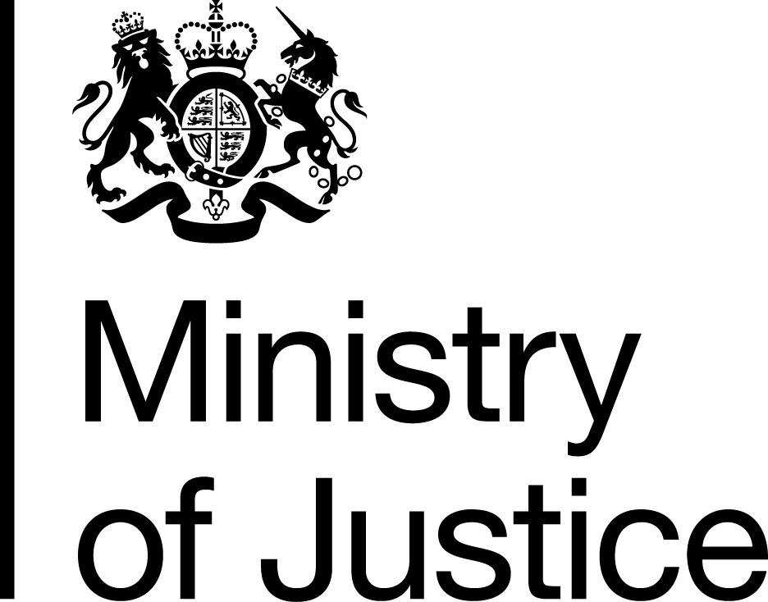Form for making complaints about the CMR Unit’s service
Claims Management Regulation (CMR) Unit
Complaints about our service

What complaints can we deal with?
We can deal with complaints about the service we have provided—for example, if you feel we have not treated you fairly or we took too long to deal with your case.
Please make your complaint as soon as possible after the problem arose—we will only look at a complaint if we receive it within six months of the problem arising (unless there are good reasons for any delay).
Please note that this form is not for making a complaint about a claims management company (CMC). Visit www.gov.uk/complain-about-claims-company to find out how to complain about a CMC.

Complaints we cannot deal with
We cannot consider a complaint if for example you disagree with the decision we have reached following investigation of a complaint about a CMC—unless you have concerns about our handling of that complaint. We also cannot consider complaints that are frivolous, vexatious or malicious or previous complaints about the same issue.

How do I make a complaint?
The easiest way to make a complaint is by completing this form which is designed to be read and completed in Microsoft® Word. The form fields will expand as you type.
- If you wish to return the form by email, complete the form, save it locally, and send it (as an attachment) to:

contactus@claimsregulation.gov.uk
- If you wish to return the form by post, complete the form, print it and send it to the address provided below:
Claims Management Regulation Unit
57-60 High Street
Burton- upon-Trent
Staffordshire
DE14 1JS

Timescales
We will acknowledge your complaint within 5 working days. You can normally expect a full response to your complaint within 20 working days but sometimes a full response can take a little longer.

What if I am still unhappy?
If having exhausted our service complaints procedure you remain dissatisfied about any aspect of any service you have received from us or think we have not acted properly or fairly, you can take the matter to the Parliamentary and Health Service Ombudsman.

Complaints to the Ombudsman must be made through your MP. For further information about the Ombudsman’s service please visit their website at www.ombudsman.org.uk or call their Helpline on 0345 015 4033.

We aim to give the best possible service to all our customers. But if you are unhappy or dissatisfied with our service, you can use this form to tell us. (The form fields below will expand as you type.)
1. Your details

Your name

Your address

Your telephone number

Your email
2. What do you think we did wrong?
Tell us what you think we have done wrong and give us details of the evidence you would like us to consider. If you think we should have treated you differently, tell us how.
3. Reference number
Please tell us any reference number we previously gave you.
4. CMR staff
Please give the names of any CMR staff you dealt with.
5. Declaration
The information I have provided is accurate, to the best of my knowledge.
I agree.

