Official Statistics Release
Policy area: | Fostering 2013-14
Theme: | Education, children’s services and skills
Published on: | 14 January 2015
Coverage: | England
Period covered: | 1 April 2013 - 31 March 2014
Status: | FINAL
Issued by: | Office for Standards in Education, Children’s Services and Skills (Ofsted)  125 Kingsway  London  WC2B 6SE
Statistician: | Adam King
Statistician’s Telephone Number: | 0300 013 0020
Public enquiries: | enquiries@ofsted.gov.uk
Press enquiries: | pressenquiries@ofsted.gov.uk
Link to official statistics release web page: | www.gov.uk/government/statistics/fostering-in-england-1-april-2013-to-31-march-2014
Publication medium: | Ofsted website
Publication frequency: | Annually
Next publication date: | Autumn 2015

Key points

Fostering capacity in England has increased | There were 81,190 fostering places in 42,490 fostering households (excluding short breaks) at 31 March 2014. Both the number of fostering places and households had increased by 6% compared to 31 March 2013.
More children in placements but occupancy decreased | There were 51,315 children in fostering placements on 31 March 2014, a 1% increase from the number in 2013. Of the approved places, this equated to an occupancy level of 63%; a three percentage point decrease.
More brothers and sisters were placed together | Placements commenced in 2013-14 for 11,790 brothers and sisters; a 16% increase from 2012-13. The large majority (69%) were placed together. This represented a three percentage point increase in the proportion of brothers and sisters being placed together.
Number of instances of children going missing continued to rise | There were 13,305 instances of children going missing during 2013-14; an increase of 36%. The large majority of this increase was attributed to children going missing in Independent Fostering Agencies (IFAs).
Missing instances were unevenly distributed across provision types | During the year 59% of missing instances were reported by IFAs, despite having 33% of children in placements.

Introduction

These official statistics report on the numbers and profile of foster carers and foster places and placements, in both local authority (LA) and independent fostering agencies (IFAs), covering the period between 1 April 2013 and 31 March 2014. , It also gives data relating to types of foster care, registrations, de-registrations and a range of other subjects.
These statistics are based on data supplied by LAs and IFAs; supplementary provider level data will be published by February 2015. Ofsted will publish these data annually and the next release is currently scheduled for autumn 2015.
Contents

Key points 2
Introduction 3
Key findings 6
Children and young people 6
Number of children fostered 6
Characteristics of children 6
Children’s experiences 10
Safeguarding 12
Children going missing 12
Allegations and referrals 15
National fostering capacity 15
Types of placements 15
Occupancy rates 16
Households 17
Foster carer profile 20
Ethnicity 20
Post approval training 21
Recruitment and retention 22
Overview of recruitment in the year 22
Application outcomes 22
De-registration of fostering households 23
Complaints and allegations of misconduct 24
Complaints 24
Allegations of misconduct 25
Methodology 26
Response rates 26
Coherence and comparability 27
Additional information 27
Glossary 27

Chart 1: Ethnicity of fostered children by provision type, as at 31 March 2014 7
Chart 2: Proportion of brothers and sisters with placements commencing in the year, by placement achieved 8
Chart 3: Proportion of unplanned endings by type 11
Chart 4: Number of missing incidents during years ending 31 March, by provision type 12
Chart 5: Proportion of children in foster care who went missing, by total duration 13
Chart 6: Number of services offering foster care, by placement type 16
Chart 7: Proportion of fostering places by status and provision type, as at 31 March 2014 17
Chart 8: Proportion of fostering households by size (number of children approved for) and provision type, as at 31 March 2014 18
Chart 9: Ethnicity of foster carers by provision type, at 31 March 2014 20
Chart 10: Ethnicity of children and foster carers, by provision type, at 31 March 2014 21
Chart 11: Proportion of applications concluded during 2013-14, by outcome 23
Chart 12: Proportion of de-registrations during 2013-14, by reason 24

Table 1: Number and proportion of missing instances, by provision type and missing reason 12

Key findings

Children and young people

Number of children fostered
- During the year 1 April 2013 to 31 March 2014, there were 84,450 children and young people who lived in fostering placements at some point in the year. This is an increase of five per cent compared to 2012-13 (80,680). (A2.1)
- During 2013-14, two thirds of children were reported in placements within LA fostering services while children in IFAs accounted for one third of placements: 56,470 and 27,980 children respectively. (A2.1)
- As at 31 March 2014, there were 51,315 children in fostering placements; a 1% increase on the previous year’s figure (50,617). (A1.2)

Characteristics of children

Age
- The large majority (68%) of all those children fostered during the year 2013-14 were in either education or training. A total of 51,555 children (61%), were aged 5 to 15. Seven per cent (6,125 young people) were required to attend some form of education or training under Raising the Participation (RPA) scheme, which was introduced in summer 2013. (A2.1, A2.2-2.3)
- Approximately 26,775 (32%) of children fostered in the year were under five. (A2.1, A2.2-2.3)

Ethnicity
- Data about ethnic backgrounds were supplied for 51,495 fostered children as at 31 March 2014. The following charts display the ethnic profile of children in fostering placements, all looked after children and also profiles by provision types. (B2.1-2.20)

- As at 31 March 2014, 22% of the children looked after population in England were from Black and Minority Ethnic (BME) backgrounds while the large majority (78%) were White. This ethnic profile was reflected very closely in the children placed with fostering services on the same date: with 21% BME, 78% White and 2% unknown. (B2)
Chart 1: Ethnicity of fostered children by provision type, as at 31 March 2014
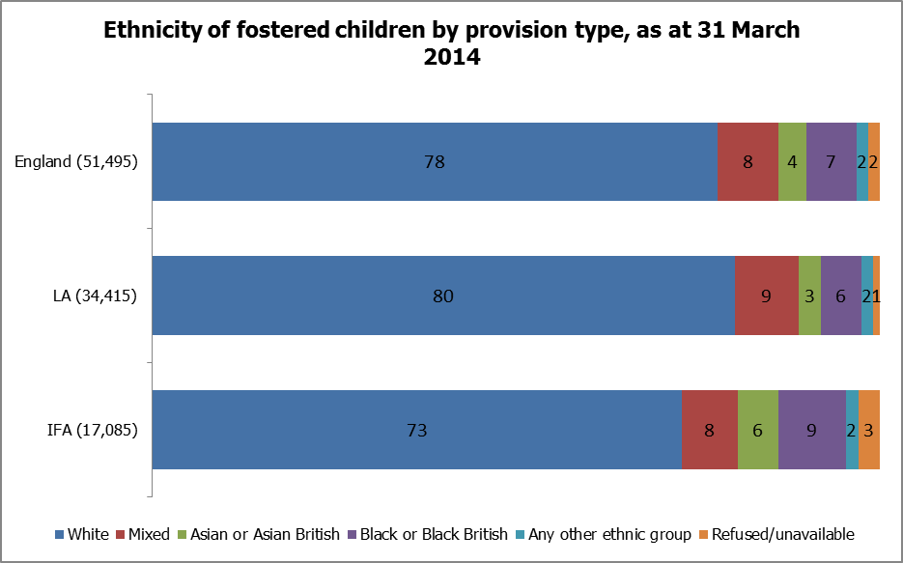
Source: B2
Percentages are rounded and may not sum to 100
- A higher proportion of children were from BME backgrounds in IFAs than in LA fostering services. Among children in IFAs almost one in four (24%) were BME while in LAs almost one in five (19%) were from BME backgrounds. (B2)
- Asian/Asian British children were slightly more likely to be placed with IFAs compared to children of other ethnic groups. Despite IFAs accounting for one third of all children fostered, around half (49%) of Asian/Asian British children were placed with them. (B2)

Disability
- A very small minority (7%) of children in fostering placements were reported as disabled: 5,595 of the 84,450 children who were placed at any point during the year. (A2.1, A2.4)
- The number of children reported as disabled in fostering placements in England increased by 12% from the previous year. In 2013-14 there were 5,595 disabled children, over 600 more than in 2012-13 (4,990). This increase was more pronounced among IFAs, who reported having over 350 more disabled children than in the previous year: an increase of 21%. (A2.4)

Brothers and sisters
- More brothers and sisters had placements which commenced during 2013-14 than in the previous year. There was a 16% increase in such fostering placements, as 11,790 brothers and sisters had placements starting during 2013-14; over 1,640 more children than in 2012-13. (A4.1-4.3)
Chart 2: Proportion of brothers and sisters with placements commencing in the year, by placement achieved
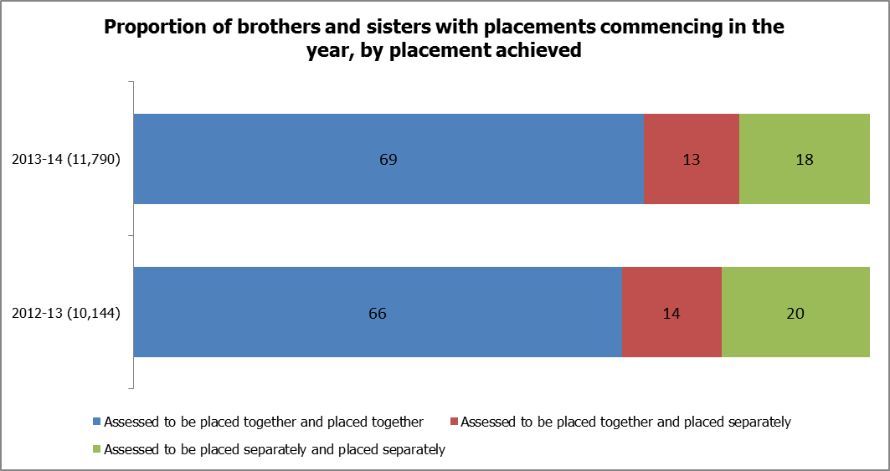
Source: A4.1-4.3
Percentages are rounded and may not sum to 100
- The large majority (69%) of brothers and sisters were placed together. During 2013-14, 8,175 children were placed together of the 11,790 brothers and sisters whose placements started in the year. This represented a three percentage point increase in the proportion being placed together. (A4.1)
- There was a decrease in the proportion of brothers and sisters who were assessed to be placed separately. During 2013-14, 18% of brothers and sisters were assessed and placed separately, compared to 20% the previous year. (A4.3)
- The proportion of children who were assessed to be placed together, but were placed separately, decreased by one percentage point, although the number of children increased by around 140. (A4.2)

Education
- The total number of compulsory school aged children has increased by 2%, from 50,584 in 2012-13 to 51,555 in 2013-14. (A2.2)
- Of these children, 2,705 experienced a change in school or educational placement during the year as a result of a foster placement move. This was a 20% increase in the number of children changing school necessitated by placement moves; almost all of this increase occurred with children fostered in LA fostering services. (D8.1)
- The number of children affected by school moves (2,705) equated to 5% of the children who were of compulsory school age and fostered during the year ending 31 March 2014. This proportion, however, was only a one percentage point increase from the previous year at 4%. (D8.1, A2.2)
- A total of 670 fostered children had no educational arrangements at some point during the year ending 31 March 2014. This was 1% of compulsory school aged-children and the same proportion as the previous year. Of the 670 children who had no educational arrangements, 295 (44%) were placed with LAs and 380 (56%) were placed with IFAs. (D8.3, A2.2)
- In the year ending 31 March 2014, 2,465 (5%) fostered children attended alternative education. The number of children in alternative education had increased by 7% from last year (2,293), however, as a proportion of compulsory school-aged children, there was no change. (D8.2, A2.2)
- There were 2,070 fostered children who were persistently absent from school in the year ending 31 March 2014. This number had increased by 8% from 1,906 in 2012-13 but the proportion of school-aged children who were persistently absence stayed the same at 4%. A very large majority (83%) of the persistently absent children in 2013-14 were fostered in LA provision. (D8.4, A2.2)

Children’s experiences

Placement stability
- During 2013-14, there were 5,240 unplanned endings of fostering placements. This was an increase of 21% on the figure for unplanned endings reported last year (4,328). Some of the increase may be accounted for by the five per cent increase to overall number of children placed. The higher number of unplanned endings of placements reported, however, may also have arisen from a revision to the collection, which now includes additional categories to capture more detail of unplanned endings. (A5.1-5.3)
- As a proportion of all fostered children in 2013-14, unplanned endings affected a maximum of 6% of children: 5,240 of 84,450. This was one percentage point higher than in the previous year 2012-13. (A5.1-5.3)
- Of the 5,240 unplanned endings of placements, 58% (3,050) were placements in LA provision while 42% (2,190) were placements in IFA provision. (A5.1-5.3)
Chart 3: Proportion of unplanned endings by type
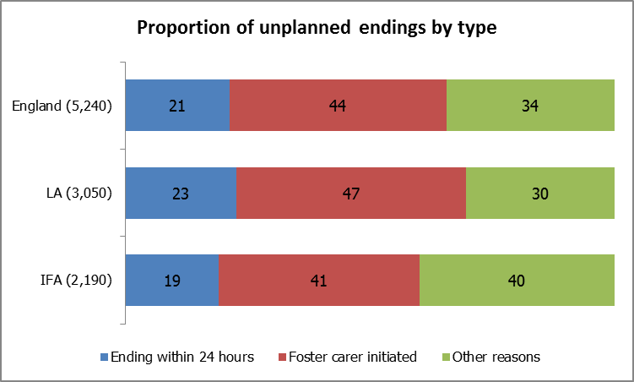
Source: A5.1-5.3
Percentages are rounded and may not sum to 100
- Less than half (44%) of the unplanned endings were initiated by foster carers. A third (34%) of unplanned endings were for ‘other’ reasons which included: children/young people requiring secure placements; returning home to live with parents; and allegations. (A5.1-5.3)
- Unplanned endings that took less than 24 hours were slightly more prevalent among LAs than IFAs; by four percentage points. (A5.1)
- The proportion of unplanned endings for ‘other’ reasons was higher among IFAs than LA fostering services by ten percentage points: 40% and 30% respectively. (A5.3)
- There was a small increase of 4% in the number of fostered children who were subject to concurrent planning during the year 2013-14, compared to 2012-13. This increase was in line with the overall increase in numbers of all fostered children, therefore there was no change to the proportion of children who were subject to concurrent planning. A total of 1,220 children were subject to concurrent planning, which equated to 1% of fostered children at any point during the year. (A2.1, A2.5)

Restraint
- There were 1,230 incidents of physical restraint during 2013-14, involving 580 children or young people. Of the children fostered at any point during 2013-14, this equated to 1%, the same proportion as reported in the previous year. (D3.1-3.2, A2.1)
- Although only a third of children placed during the year were placed with IFA provision, three quarters of the children reported to be subject to restraint were reported by IFAs. Notably, also, there was a difference in the trend in number of physical restraints when compared across provision types. Between 2012-13 and 2013-14, the number of incidents of reported physical restraint in LA fostering provision decreased by 14%, in contrast with the 18% increase in reported incidents in IFA provision. (D3.1-3.2, A2.1)

Staying put
- A higher number (3,340) of young people in foster care turned 18 in the year ending 31 March 2014 than in the previous year; a 6% increase on the previous year (1,685). (A7.1)
- Of the young people who turned 18, just over half (52%) remained living with their former foster carers after their birthday. There was very little difference in the proportion of young people who stayed put in 2013-14 across the provision types (52% in LAs and 54% in IFAs). (A7.1-7.2)

Safeguarding

Children going missing
Chart 4: Number of missing incidents during years ending 31 March, by provision type
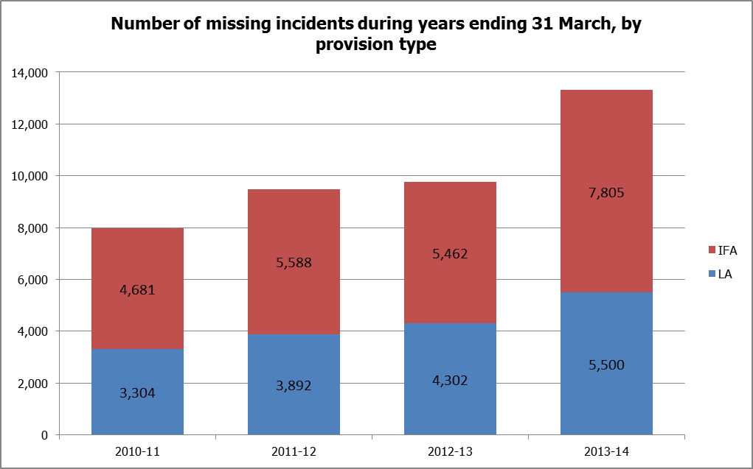
Source: D4.1-4.2
- There has been a substantial increase in the reported number of incidents of children and young people going missing from foster care. The number of occasions rose from 9,764, in 2012-13, to 13,305, in 2013-14: an increase of 36%.
- While IFAs had a 43% increase in the number of incidents, to 7,805, LAs increased by 28%, to 5,500. (D4.1-4.2)
- In the year ending 31 March 2014, a total of 4,245 fostered children and young people were reported to have gone missing, which was over 900 more children than the number who went missing the previous year. The number increased by 27% and 28% respectively, in both IFA and LA fostering services in 2013-14, compared to the previous year. (D4.1-4.2)
- Five per cent of fostered children went missing during 2013-14. This figure is the number of children who went missing, calculated as a proportion of the total number of children who were placed at any point during the year. A difference emerges, however, between provision types: 3% of children placed with LA fostering services went missing which was lower than the 8% among IFA services. Therefore, although one third of fostered children were with IFAs, they accounted for just over half (54%) reported missing. (D4.1-4.2, A2.1)
- Of the children who went missing, the majority (54%) were missing for a total period of time less than 24 hours. Almost a third (32%) were missing for between one to six days in total. A few children (13%) were missing for a total length of time longer than one week. (D5.1)

Chart 5: Proportion of children in foster care who went missing, by total duration
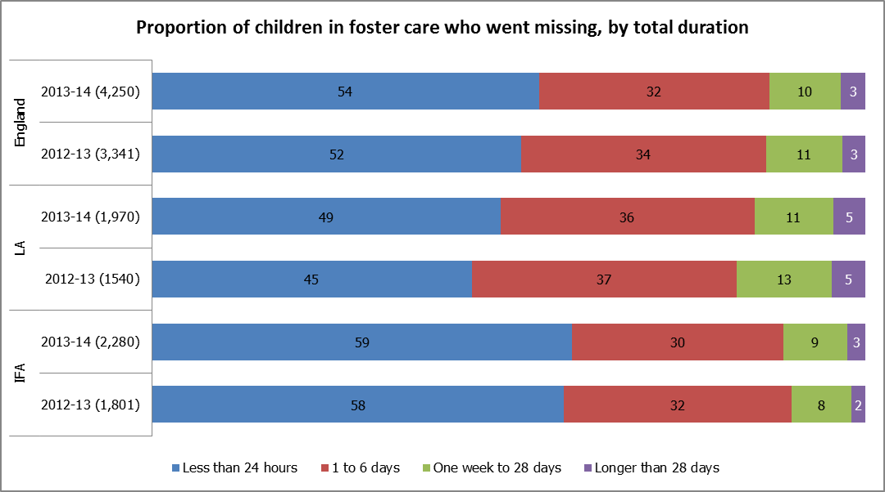
Source: D5.1
Percentages are rounded and may not sum to 100
- The profile of total duration for which children were missing was similar in 2013-14 compared to 2012-13. The proportion of children missing for the shortest period of time, less than 24 hours, increased slightly by two percentage points. Children going missing for the shortest total duration, less than 24 hours, was also more prevalent in IFAs compared to LA services with a difference of ten percentage points: 59% and 49% respectively. (D5.1)
- Fifty five fostered children were missing as at 31 March 2014: 25 from LA and 35 from IFAs. (D5.2)
Table 1: Number and proportion of missing instances, by provision type and missing reason
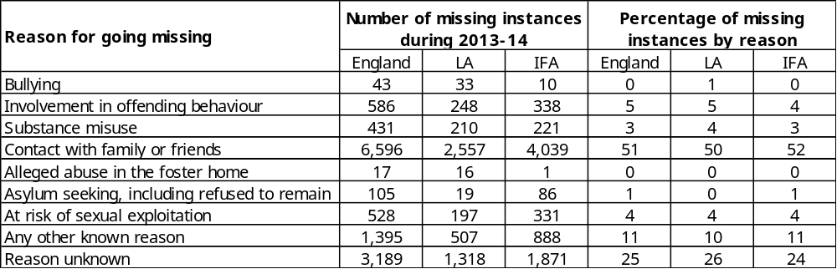
Source: D6
Percentages are rounded and may not sum to 100
- For a quarter of incidents (3,190), agencies were unable to give the reason for going missing. As a new data item to the 2013-14 collection, this may indicate that reasons why children go missing are not routinely confirmed and recorded. (D6.9)
- The most common reason for children going missing during 2013-14 was regarding contact with family or friends; accounting for 51% of missing incidents. One in ten (11%) of missing incidents were attributed to any other known reason, with stress triggers at school or in placement frequently cited. (D6)

Allegations and referrals
- During 2013-14, there were 1,445 referrals made to local authority child protection teams and 825 s47 enquiries conducted that involved allegations against foster carers. Compared to the previous year, 2012-13, the number of referrals was very similar while the number of s47 enquiries decreased by 5%. (D2.1-2.2)

National fostering capacity

Types of placements
- Fostering services were asked to confirm the types of foster care they provided and the number of services offering each placement type is shown in the graph below.
Chart 6: Number of services offering foster care, by placement type
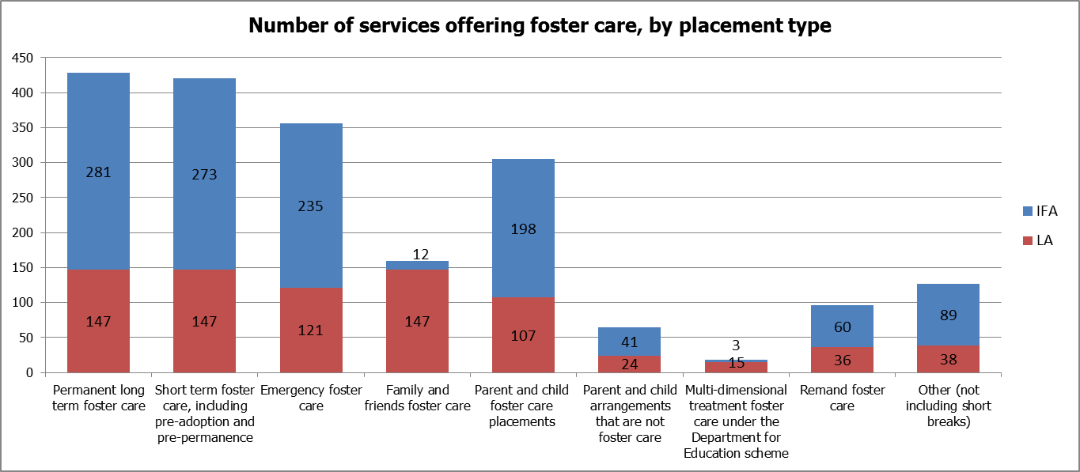
Source: A3.1-3.9
- The highest number of services offered permanent/long term and short term foster care, with over 400 services indicating these as part of their provision. The next highest number of services offered emergency foster care (356 services) followed by parent and child placements (305 services). Only 18 services, 15 LAs and three IFAs, offer multi-dimensional treatment foster care through the DfE scheme. (A3.1-3.9)
- All local authorities that submitted data offered, either directly or through joint arrangements, the following types of foster care: permanent/long term, short term and family and friends foster care. (A3.1-3.2, A3.4)
- Around three quarters (73%) of LAs offered parent and child placements while one quarter offered remand foster care (24%) or ‘other’ foster care (26%). (A3.5, A3.8-3.9)
- Excluding LAs with joint arrangements, there were 26 LAs (18%) that reported they did not directly offer emergency foster care. (A3.3)

Occupancy rates
- Overall the number of approved fostering places has increased by 6%, from 76,563 places to 81,190 as at 31 March 2014. Approved places have increased in both LAs and IFAs, resulting in very little change in the proportion of places attributed to each provision type. (A1.1)
- Occupancy of fostering places had marginally decreased by three percentage points as at 31 March 2014 compared to the previous year: 63% of places were filled. One in five fostering places were vacant on the 31 March 2014, while almost one in six places were not available; 7% not available due to the needs of other children in placement and 8% not available due to the circumstances of the foster carers. (A1.2-1.5)
Chart 7: Proportion of fostering places by status and provision type, as at 31 March 2014
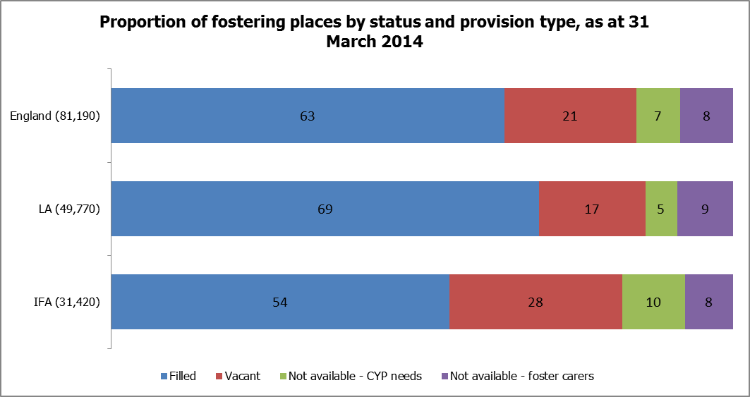
Source: A1.2-1.5
Percentages are rounded and may not sum to 100
- The proportion of filled places was higher in LA fostering services than in IFAs, by 14 percentage points, with the difference mostly accounted for by a higher proportion of vacant places among IFAs. Therefore, although 61% of approved foster places were LA places, 67% of filled places were within LA fostering services. (A1.2-1.5)

Households
- On 31 March 2014 there were 4% more fostering households than on the same date in the previous year. There were 44,780 fostering households, compared to 42,951 in 2013. The total households were broken down as 83% (37,205) fostering households, 12% (5,285) family and friends or connected persons fostering households and 5% (2,295) fostering households that provided exclusively short breaks. (C1.1-1.4)
- The 4% increase in the number of households at 31 March 2014 from the previous year, is partly explained because the number of new approved households exceeded the number of de-registered households during the year. There were 7,175 households that were approved and 5,880 households de-registered in 2013-14, from which we can infer a net increase of 1,295 fostering households during the year. (C2.4, C3.1)
- The majority (60%) of fostering households, excluding family and friends and short breaks, were in LA fostering services and 40% were in IFAs as at 31 March 2014. This was similar to the split by provision type as found in the previous year. (C1.1)
- In local authority services, one in six fostering households in LA services were either family and friends (13%) or connected persons (5%) fostering households as at 31 March 2014. (C1.2-1.3)
- The profile of household size, in terms of the number of children fostering households were approved to care for, showed a prevalence of households for two children at 39% of all households. The proportions approved for a single child and three children were similar at 32% and 29% respectively. Very few households (1%) were approved for more than three children. The profile of household size at 31 March 2014 very closely reflected the profile from the previous year. (C1.5-1.8)
Chart 8: Proportion of fostering households by size (number of children approved for) and provision type, as at 31 March 2014
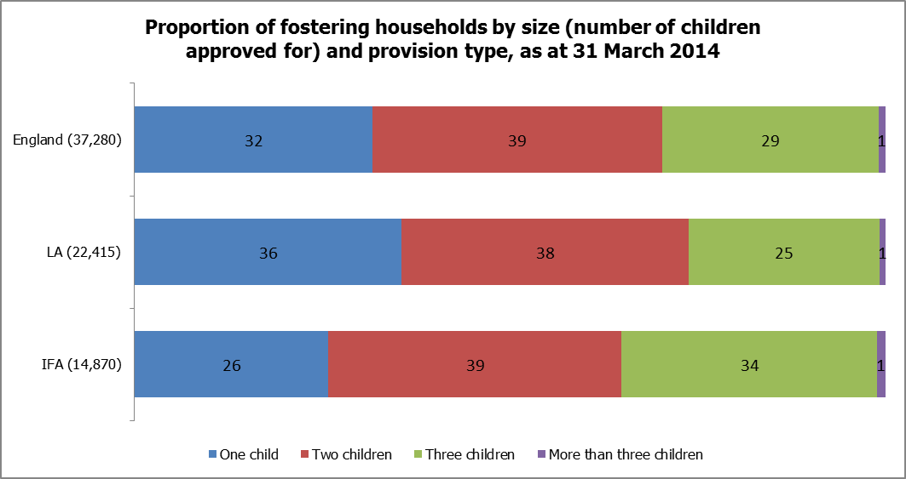
Source: C1.5-1.8
Percentages are rounded and may not sum to 100
- Local authorities had a higher proportion of fostering households that were approved for single children than found in IFA households. As at 31 March, over a third (36%) of LA fostering households were approved for single children, while just over a quarter (26%) of IFA households were for single children. Correspondingly, IFAs had a higher proportion of households approved for three children than among LAs; a difference of nine percentage points. (C1.5-1.8)
- During 2013-14 there were 1,255 exemptions in operation, which was an 18% decrease from 2012-13 (1,531). Most exemptions (84%) were in LA fostering households with only a few (16%) in IFAs. (A6.1)

Foster carer profile

Ethnicity
- Data about ethnic backgrounds were supplied for 73,835 foster carers as at 31 March 2014. The following chart displays ethnicity of foster carers in England and by provision type. (B2)
Chart 9: Ethnicity of foster carers by provision type, at 31 March 2014
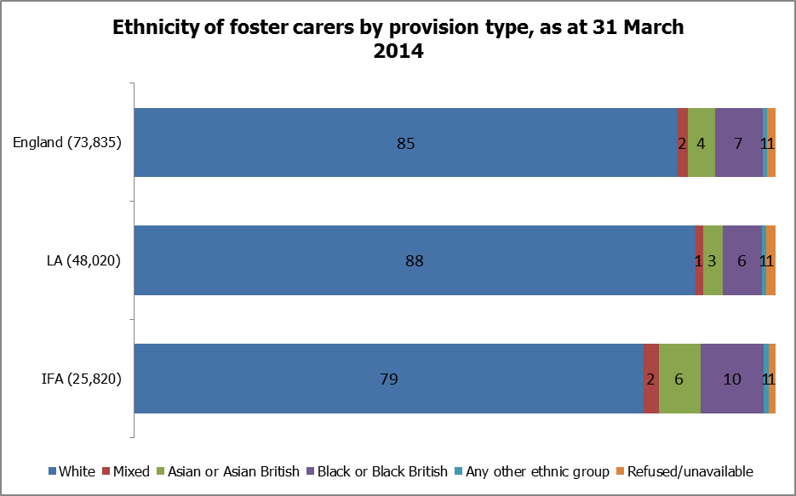
Source: B2
Percentages are rounded and may not sum to 100
- Most foster carers were White. On the 31 March 2014 there were 62,555 (85%) of foster carers who were White, while 14% were from BME backgrounds. This was very similar to the ethnic profile among the adult (aged 20 and older) resident population in the 2011 census: with 87% of adults who were White and 13% of adults who were of BME backgrounds. Within ethnic groups, Asian and Asian British foster carers were slightly underrepresented and Black and Black British carers were slightly overrepresented compared to the adult population. (B2, 2011 census)
- A higher proportion of foster carers were from BME backgrounds in IFAs than in LA fostering services. In IFAs, one in five foster carers were from BME backgrounds whereas, in LAs, just over one in ten carers were from BME backgrounds; 20% and 11% respectively. (B2)
Chart 10: Ethnicity of children and foster carers, by provision type, at 31 March 2014

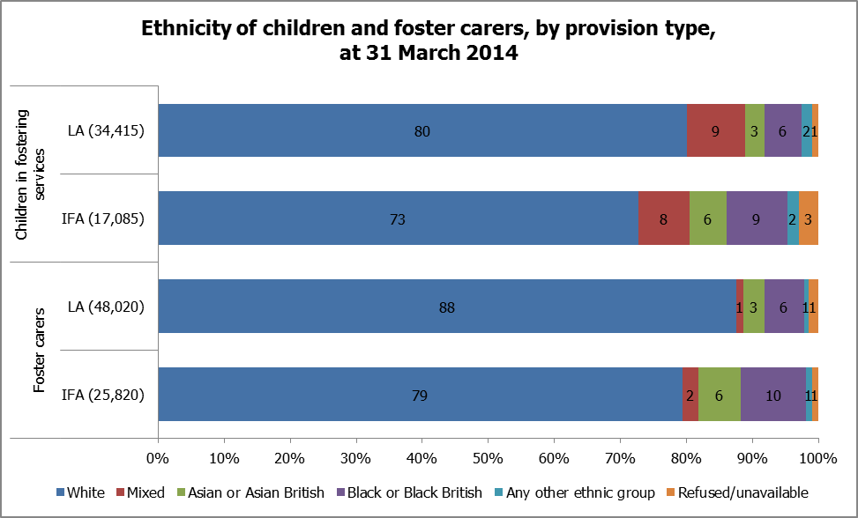
Source: B2
Percentages are rounded and may not sum to 100
- A higher proportion of both foster carers and children were from BME backgrounds in IFAs than in LA fostering services. In IFAs, one in five foster carers were from BME backgrounds whereas, in LAs, just over one in ten carers were from BME backgrounds; 20% and 11% respectively. Among children in IFAs almost one in four (24%) were BME while in LAs almost one in five (19%) were from BME backgrounds. (B2)

Post approval training
- The level of post approval training of foster carers as at 31 March 2014 remained broadly similar to the same date in the previous year. The number of foster carers who had completed the DfE’s Training Support and Development (TSD) standards had increased by 3%, from 36,948 in 2013 to 38,180 in 2014. As a proportion of approved foster carers on 31 March 2014 this was 61%, as it had been in 2013. The proportion of carers who had completed TSD standards for family and friends carers and short breaks carers increased by four and three percentage points, respectively, in 2014 compared to 2013. (C6.1-6.3, B1.1-1.3)

Recruitment and retention

Overview of recruitment in the year
- The number of initial enquiries increased by 1% in 2013-14 from the previous year. There were 114,155 initial enquiries during the year, 40% of which were received by LAs and 60% were received by IFAs. (C2.1)
- Applications received in the year increased by 2% overall; from 15,772 applications in 2012-13 to 16,085 applications in 2013-14. Over half (55%) of applications were received by LAs, with IFAs representing 45% of applications. There was a difference in the trend in numbers of applications when compared across provision types: the number received by LAs (8,855) had increased by 11% while the number received by IFAs (7,230) decreased by 7%. (C2.2)
- Despite the much higher proportion of initial enquiries received by IFAs, relative to LAs, the proportion of applications made to IFAs, and households approved by IFAs during the year, were both more in line with the proportion of fostering households represented by IFAs on the 31 March 2014. For instance, during the year 2013-14, IFAs received 45% of all applications from new prospective households and approved 42% of all new households. These proportions of recruitment activity accounted by IFAs were similar to the proportion of fostering households attributed to IFAs, at 40% of households on 31 March 2014. (C1.1, C2.2, C3.1)

Application outcomes
- The number of applications that were completed during the year increased by 7%: from 14,344 in 2012-13 to 15,340 in 2013-14. (C3.1-3.4)
- Application outcomes, in terms of those that were completed during the year, showed that less than half of applications resulted in approval. There were 7,175 (47%) applications approved, 7,975 applications withdrawn (31% by applicants and 21% by fostering services) and 195 (1%) were refused. (C3.1-3.4)
Chart 11: Proportion of applications concluded during 2013-14, by outcome
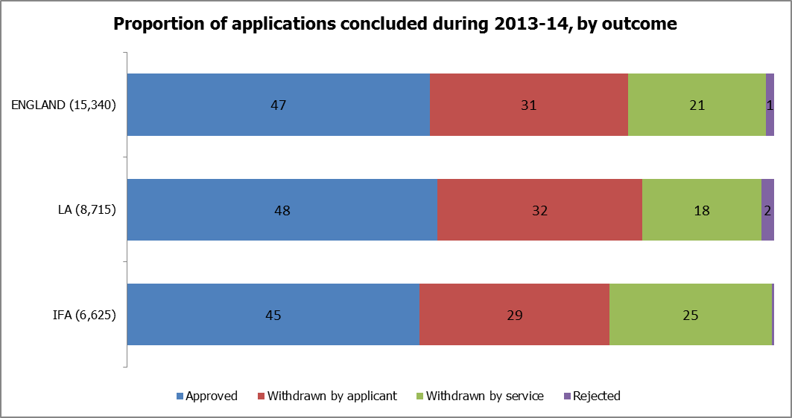
Source: C3.1-3.4
Percentages are rounded and may not sum to 100
- Local authorities and IFAs had slightly different profiles of application outcomes during 2013-14. There was a lower proportion of applications withdrawn by LA fostering services than by IFAs, by seven percentage points. This difference was accounted for by a slightly higher proportion approved and withdrawn by applicants among LAs than in IFAs. (C3.1-3.4)
- Application outcomes overall in England were slightly different in 2013-14 compared to the previous year 2012-13. A slightly lower proportion of applications were approved and a slightly higher proportion of applications were withdrawn. Approvals (7,175) accounted for 47% of completed applications which was four percentage points lower than in 2012-13. Withdrawals (7,975) were four percentage points higher at 52%. (C3.1-3.4)
- One hundred applications were made to the Independent Review Mechanism (IRM) during 2013-14, which was similar to the number made in the previous year (102). Around a third (34%) of applications to the IRM resulted in recommendations being made for services to review decisions. (C5.1-5.2)

De-registration of fostering households
- In the year ending 31 March 2014, there were 5,880 fostering households which de-registered. This was a 24% increase on the number in the previous year 2012-13. (C2.4)
Chart 12: Proportion of de-registrations during 2013-14, by reason
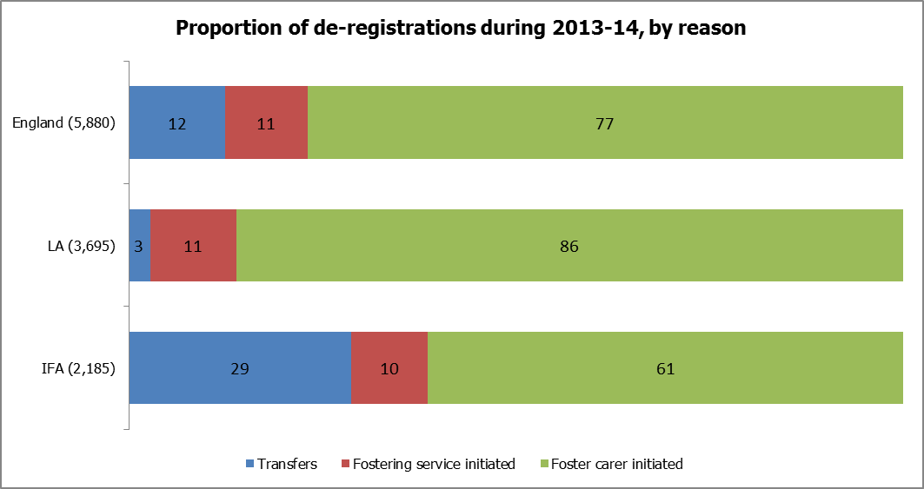
Source: C2.5-2.7
Percentages are rounded and may not sum to 100
- Additional data items were collected for the year 2013-14 regarding de-registrations. Of the de-registered households during the year, the large majority (4,525) were initiated by the foster carers. A few de-registrations were initiated by fostering services or were to facilitate transfers to another service: 630 and 730 respectively. (C2.5-2.7)
- Of all de-registrations, the proportion that was transfers was substantially higher among IFAs compared to LAs, by 26 percentage points. Transfers accounted for over a quarter (29%) of de-registrations among IFAs. (C2.5-2.7)

Complaints and allegations of misconduct

Complaints
- The number of complaints made to fostering services during 2013-14 was very similar to the previous year. There were 1,625 complaints, which was a 1% decrease on the number in 2012-13. Of all complaints in 2013-14, 60% were made to LAs and 40% were made to IFAs. (E1.1-1.6)
- The highest number of complaints (545) was received from foster carers, which equated to a third of all complaints received during 2013-14. Just over one in five complaints (21%) were instigated by children and young people with 335 complaints. There was an approximately even share of complaints from three groups: social workers, parents and ‘others’ at 12-13% each. The lowest number of complaints was from ‘other professionals’ with 145 (9%) complaints. (E1.1-1.6)
- Very little change was found in the proportion of complaints from the various sources in 2013-14 compared to the previous year 2012-13. There were marginally higher proportions of complaints from ‘others’ and children’s social workers, which increased in 2013-14 by one to two percentage points respectively. This small difference was accounted for by marginally lower proportions of complaints from children, foster carers and parents: a decrease of one percentage point each. (E1.1-1.6)
- Of the 1,625 complaints received during 2013-14, 765 complaints (47%) were not upheld. It can be inferred that 53% of complaints were upheld for at least one aspect of the complaints. The group with the highest proportion of complaints not upheld was children and young people (53%). Conversely, the group with the lowest proportion not upheld was social workers; 41% of their complaints not upheld. (E1.1-1.6)
- In 2013-14, almost three quarters (73%) of foster carers who complained did so to LAs and 27% complained to IFAs. Just under two thirds (64%) of the reported complaints from social workers and from ‘other professionals’ were made to IFAs with only one third (36%) being made to LA fostering services. (E1.1-1.6)

Allegations of misconduct
- In the year ending 31 March 2014, there were 2,315 allegations of misconduct made against foster carers. This was a 25% increase on the number of misconduct allegations from the previous year (1,856).
- This increase is mostly accounted for by the increase reported by IFAs. The number of allegations in IFAs increased by 42%; much larger than the 17% increase reported by LAs. (D1.1)
- The proportion of allegations of misconduct during 2013-14 within each provision type was 64% in LA fostering services and 36% in IFAs. (D1.1)

Methodology
- The data in this publication are taken from returns made to Ofsted by LA and IFAs. Most of the data relate to the period between 1 April 2013 and 31 March 2014.
- For data protection and disclosure purposes, figures have been rounded up to multiples of five (i.e. there are no figures which have been rounded down to the nearest five). This methodology has been applied following a recent assessment of these statistics and in light of the updated Government Statistical Service (GSS) standards. The purpose of the rounding is to ensure non-disclosure of sensitive data while maintaining its usefulness. In light of the supplementary data at provider level that will be released by February 2015, totals have been rounded up to five to allow maximum use of provider level data with the minimum risk of disclosure. This means that some total figures do not match exactly with data aggregated at provider type levels.
- For more information on how Ofsted regulates and inspects independent fostering services, please go to the Ofsted website: www.gov.uk/government/publications/introduction-to-independent-fostering-agencies

Response rates
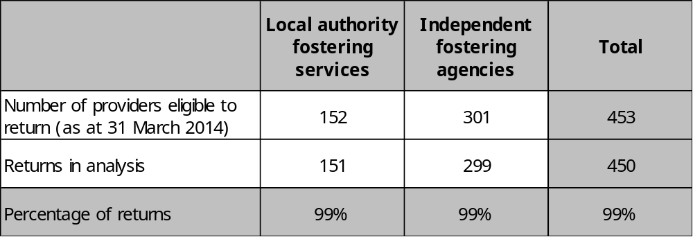
Ofsted received data returns from 99% of LA fostering services and IFAs eligible to return data. This represented a one percentage point increase on the response rate from the previous year. A small number of returns contained data inaccuracies which were not able to be reconciled. These data have been included in the national, LA and IFA data and in this report, with an acknowledgement where necessary.
Responses were received from 151 LAs in England. A total of six LAs operate under three joint arrangements, whereby fostering families were shared across member authorities and, as such, it was not possible to distinguish the families across individual authorities. To avoid double counting of returns, therefore, five LA returns have been excluded. Instead, an aggregated return was counted for the joint arrangements therefore data from 147 returns captures 99% of all LA fostering activity; from the 151 LAs who submitted data.
Of the 309 registered IFAs on 31 March 2014, eight were not eligible to submit data because they resigned after the start of the collection. The 299 returns in this dataset, therefore, represented a 99% response rate of eligible IFAs in England.

Coherence and comparability

- The DfE collects data about all children looked after through their annual SSDA903 return, which includes children who are fostered. The fostering data collected by Ofsted appears broadly in line with data published by the DfE. In some cases there would appear to be small discrepancies, which were established as arising from differences in definitions or collection methods. Where this is the case, there are explanatory footnotes in the text.
- Trend data from previous datasets has been included where applicable. The data collection has developed over time, however, resulting in some questions and definitions which have been amended. These changes occurred in response to new legislation or policies, and also in response to feedback from previous collections. Questions, definitions and guidance have also been refined to better enable respondents to complete the form. The revisions have improved the reliability of the data but also mean that longer term trends are not always available. Where data have been compared, these factors have been taken into consideration to ensure comparisons are valid.
- An analysis, of the impact of non-responses on the year on year comparisons, found that there was a negligible difference between the data in this report and data which included estimated responses. These national data are therefore deemed as comparable to data from 2012-13 and not affected by the minimal change to response rates.

Additional information
The aggregated data at England, total LA and total IFA levels, are available in Excel format on the Ofsted website in the same location as this document: www.gov.uk/government/statistics/fostering-in-england-1-april-2013-to-31-march-2014

Glossary

Alternative educational provision
This includes provisions outside of mainstream and special schools. This includes: provision directly managed by a local authority; pupil referral units; hospital schools; hospital and home teaching services; tuition centres; e-learning centres; and provision that is brokered or arranged by a local authority, school or group of schools, such as placements in FE colleges, extended work experience, projects provided by the voluntary or private sector or multi-agency initiatives.

Approved foster carers
These are individual foster carers who are currently approved by a fostering service as at 31 March 2014.

Complaints not upheld
This only includes those complaints where no action on any aspect was necessary.

Compulsory school age
Children are of ‘compulsory school age’ on the 1st January, 1st April or 1st September following their 5th birthday. Young people cease to be of ‘compulsory school age’ on the last Friday of June during the year that they become 16, provided that their birthday is before the beginning of the next school year.

Disabled
Section 6 of the Equality Act 2010 defines a disabled person as someone who has a physical or mental impairment which has a substantial and long term adverse effect on his or her ability to carry out normal day to day activities. Examples include cancer, diabetes, multiple sclerosis and heart conditions; hearing or sight impairments, or a significant mobility difficulty; and mental health conditions or learning difficulties.

Exemption
An exemption is required in the specific situation in which a foster carer is asked to look after more than three children who are not all part of a sibling group, under sections 63(12) and Schedule 7(2) of the Children Act 1989.

Fostering services
Local authority fostering services are defined by section 4 of the Care Standards Act 2000. Local authority fostering services and independent fostering services recruit, prepare, assess, train and support foster carers. Independent fostering services are private companies or charities, which are registered with Ofsted and provide placements to children with foster carers approved by them. Independent fostering services work closely with local authorities to deliver these placements.

Foster places
Foster places refers to the total number of places that foster carers are approved to provide, whether occupied or not; it relates to the capacity of foster care in England.

Foster placements
Foster placements refers to arrangements made for children to be looked after, in this context living with foster carers.

Misconduct
Where a formal investigation into the conduct of a member of staff or a prospective adopter is undertaken which follows a voluntary adoption agency's procedures for investigating such allegations. The use of the term allegation is used for employment as well as safeguarding.

Missing
In this context refer to children up to the age of 18 who have run away from their foster placement, have been abducted, or whose whereabouts is unknown. Missing does include child abduction where a child has been abducted or forcibly removed from their place of residence. Missing does not include unauthorised absence where a looked-after child's whereabouts is known or thought to be known but unconfirmed, they are not missing and may instead be considered as absent without authorisation from their placement. Missing is reported in terms of the numbers of children who went missing and also the total number of ‘instances’ on which children went missing.

Persistent absence from school
'Persistent absence' from school is defined by the Department for Education. Persistent absentees are defined as having an overall absence rate of around 15 per cent or more. As an example, this would equate to 46 or more sessions (23 days) of absence (authorised and unauthorised) during the first five half terms of the academic year. www.education.gov.uk/rsgateway/DB/SFR/s001117/index.shtml
The data needs to cover the financial year April-March (not the academic year) and is only applicable when the child/young person is in a foster placement.

Physical restraint
Means stopping a foster child/young person from doing something they appear to want to do by physical means. For example, the foster carer moving the child/young person or blocking their movement to stop them hurting themselves or others or from seriously damaging property.

Raising the participation age (RPA)
The government introduced legislation in summer 2013 which requires young people to continue in some form or education or training until their 18th birthday. www.gov.uk/government/policies/increasing-opportunities-for-young-people-and-helping-them-to-achieve-their-potential/supporting-pages/raising-the-participation-age

Section 47
Refers to section 47 of the Children Act 1989 and relates to the local authority's duty to investigate child protection concerns.

Withdrawn
The definition of withdrawn is ‘those applications that were stopped by the applicant’.

Acknowledgements

Thanks to the following, for their contribution to this statistical release: Kathryn Kaal, Marc McGreavy and Matthew Watts.

© Crown copyright

You may re-use this information (not including logos) free of charge in any format or medium, under the terms of the Open Government Licence. To view this licence, visit http://www.nationalarchives.gov.uk/doc/open-government-licence/ or write to the Information Policy Team, The National Archives, Kew, London, TW9 4DU or e-mail: psi@nationalarchives.gsi.gov.uk.

Places refers to the total number of places that foster carers are approved to provide, whether occupied or not; it relates to the capacity of foster care in England.
Placements refers to those arrangements made for children to be looked after, in this context living with foster carers; it relates to children.
These data are higher because they are likely to include some children who were placed with more than one fostering service during the year and, therefore, would have been reported by multiple services. The DfE published a figure of 76,570, for the same period, which was a count of all those individual children in fostering placements during the year ending 31 March 2014. (DfE statistics 2013-14, www.gov.uk/government/statistics/children-looked-after-in-england-including-adoption--2, National Table B1)
The DfE published 51,340 children looked after who were in fostering placements on 31 March 2014, a difference of approximately 25 children from the number collected by Ofsted. (DfE statistics 2013-14, www.gov.uk/government/statistics/children-looked-after-in-england-including-adoption--2, National Table A3)
For further details of this scheme visit: www.gov.uk/government/policies/increasing-opportunities-for-young-people-and-helping-them-to-achieve-their-potential/supporting-pages/raising-the-participation-age
This proportion is broadly in line with the 26% of children looked after during 2013-14 who were aged up to four years old on the 31 March 2014. (DfE statistics 2013-14, www.gov.uk/government/statistics/children-looked-after-in-england-including-adoption--2, National Table B1)
There is a negligible (<0.5%) error in the data submitted for numbers of children as at 31 March 2014. The discrepancy between filled places and ethnicity data equated to approximately 180 children and is attributed to just two local authority returns. (A1.2, B2)
According to the 2011 census, 4% of all children and young people (aged 0-19) in England were disabled. (Office for national statistics (ONS) 2011 census, www.nomisweb.co.uk/census/2011/LC3101EWLS/view/2092957699?rows=c_disability&cols=c_age) The exact proportion of children looked after who had disabilities is unknown, however, it must be a minimum of 3%: the figure published by the DfE for children looked after during 2013-14 with a category of need ‘Child's disability’. (DfE statistics 2013-14, www.gov.uk/government/statistics/children-looked-after-in-england-including-adoption--2, National Table B1)
During the academic year 2012/13, 5% of children looked after were persistent absentees compared to 4.6% of all children. These figures published by the DfE measures absence for those children who had been continuously looked after for 12 months as at 31 March 2013 and also where the DfE were able to match local authority data to school census data. All children reports on all enrolments from the school census. The (DfE statistics 2013-14, www.gov.uk/government/statistics/outcomes-for-children-looked-after-by-las-in-england, National Table 12)
The 6% of children is described as a ‘maximum proportion’. Due to a question revision, multiple placement endings during the year 2013-14 may be counted i.e. the question is a count of distinct placements, not individual children who may have had more than one unplanned ending of placements.
The displayed figure of 147 agencies relates to provision offered by 151 local authorities, with the difference accounted by joint arrangements, and is therefore described as 100% of the local authorities that submitted data.
For details about de-registrations of fostering households, see page 19
There is a negligible (<0.5%) error in the data submitted for numbers of foster carers as at 31 March 2014. The discrepancy between the number of individual carers and ethnicity data equated to approximately 290 foster carers and is attributed to just three returns; two LAs and one IFA. (B1.1-1.3, B2)
Office for national statistics (ONS) 2011 census, www.nomisweb.co.uk/census/2011/DC2101EW/view/2092957699?rows=c_age&cols=c_ethpuk11
Fostering services which were provided under joint arrangements involved the following LAs: City of London through the Pan London agreement; Isles of Scilly with Cornwall. London Tri-borough Hammersmith & Fulham, Kensington and Chelsea, and Westminster.

