Domestic Green Deal and Energy Company Obligation in Great Britain, Monthly report

Statistical release: Experimental statistics
18 December 2014
© Crown copyright 2014
You may re-use this information (not including logos) free of charge in any format or medium, under the terms of the Open Government Licence.
To view this licence, visit www.nationalarchives.gov.uk/doc/open-government-licence/
or write to the Information Policy Team, The National Archives, Kew, London TW9 4DU,
or email: psi@nationalarchives.gsi.gov.uk.
Any enquiries or comments in relation to this statistical release should be sent to DECC’s Household Energy Efficiency Statistics Team at the following email address: EnergyEfficiency.Stats@decc.gsi.gov.uk
Contact telephone: 0300 068 5106
This document is also available from our website at https://www.gov.uk/government/collections/green-deal-and-energy-company-obligation-eco-statistics

Contents
Charts 4
Executive summary 5
Introduction 5
Key points 5
Detailed Results 6
All measures installed up to end October 2014 (Table 1 and Table 1a) 6
Green Deal Assessments, by month (Table 2, Chart 1) 6
Green Deal Plans in unique properties, cumulative totals by month (Table 3, Table 3a, Table 3b, Chart 2) 7
Cashback vouchers where payments have been made, by month of installation (Table 4, Table 4a, Chart 3) 8
Green Deal Home Improvement Fund where payments have been made, by month of installation (Table 5, Table 5a, Chart 4) 10
ECO measures installed by obligation, up to the end of October 2014 (Table 6, Table 6a, Chart 5, Chart 6) 11
ECO brokerage, as at the end of November 2014 (Table 7, Chart 7) 13
Measures not captured by administrative data sources 13
Supply chain, as at the end of November 2014 (Table 8, Chart 8) 14
Annex A – Tables 16
Annex B – Background 30
Green Deal 30
Energy Company Obligation 31
Green Deal Cashback 32
Green Deal Home Improvement Fund 32
ECO Brokerage 32
The Supply Chain 33
Annex C – Sources and Methodology 34
National Statistics 34
Further Information and Feedback 35
Next Releases 35

Charts
Chart 1 - Number of Green Deal Assessments lodged, by month 7
Chart 2 - Number of Green Deal Plans in unique properties, cumulative totals at end of each month, and by stages 8
Chart 3 - Number of Cashback vouchers where payments have been made (excluding payments made through the exception process), by month of installation 9
Chart 4 – Cumulative number of Green Deal Home Improvement Fund vouchers where payments have been made, by month of installation and by month of payment, at end of each month 10
Chart 5 - Provisional cumulative number of ECO measures installed, by obligation, at end of each month 11
Chart 6 - Provisional number of measures installed under ECO, by measure type, by obligation, up to end October 2014 12
Chart 7 – Value of ECO brokerage contracts let, by auction 13
Chart 8 – Development of supply chain (cumulative numbers) at end of each month 14

Executive summary

Introduction
This release presents the latest statistics on the Green Deal (GD) up to the end of November 2014 and the Energy Company Obligation (ECO) up to the end of October 2014.
For more details about the GD/ECO schemes, please see Annex B. More detailed analysis of GD Assessments lodged, measures installed under Cashback and the Green Deal Home Improvement Fund and provisional measures installed under ECO up to the end of September 2014 are also available in the quarterly statistical release.

Key points
- A provisional 1,023,000 measures were installed in around 829,000 properties through ECO, Cashback, GD Plans and the Green Deal Home Improvement Fund to the end of October 2014 (the latest month that we have complete data for), up from 997,000 measures to the end of September. The large majority of installed measures (97 per cent) were delivered through ECO. In addition, around 194,000 measures eligible under the ECO amendment order have also been installed (see page 12).

- GD Assessments – 422,436 were lodged up to the end of November 2014 (Chart 1), up from 389,702 at end of October. The 32,734 GD Assessments in November was similar to the number in October (33,191).

- GD Plans – 8,133 households had GD Plans in progress at the end of November 2014, 13 per cent more than the 7,207 at the end of October. Of these, 2,285 were ‘new’ (quote accepted), another 1,887 were ‘pending’ (Plan signed) and 3,961 were ‘live’ (all measures installed), nearly half of all Plans (Chart 2).

- Cashback vouchers – by the end of the scheme, 14,743 vouchers had been paid (following installation of 15,696 measures) (Chart 3) through the standard route. Overall, including additional measures installed through the Cashback Exception process around £15.8 million has been paid and the majority have been for boiler replacements.

- Green Deal Home Improvement Fund release 1 – by the end of November 2014, there were 20,616 active applications and, of these, 8,957 vouchers had been paid (following installation of 11,310 measures), with a value of £42.5 million. Around £12.5 million payments were made in November alone from 2,270 vouchers. Over half (61 per cent) of these measures have been for solid wall insulation.

- ECO measures – provisional figures show there were 988,603 measures installed under ECO up to the end of October 2014, with 23,306 installed in October, similar to the 23,480 installed in September. Energy companies continue to deliver measures eligible under the ECO amendment order, with around 194,000 additional installations reported between April and October.

- Of all notified ECO measures installed to date, 35 per cent were for cavity wall insulation, 28 per cent were for boiler upgrades and 22 per cent were for loft insulation. All solid wall insulation types accounted for seven per cent (Chart 6).

Detailed Results
This section of the report provides the latest available information on different elements of the Green Deal (GD) and ECO. This includes the number of Assessments and GD Plans, Cashback and GDHIF vouchers spent, measures installed through Cashback, GDHIF, Green Deal Plans and ECO, a summary of ECO brokerage and an overview of the supply chain. Data on GD are presented to the end of November 2014 in this release, whilst ECO is presented to the end of October 2014. Aggregate data on all measures installed are also presented to the end of October.

The GD and ECO quarterly statistical release provides a range of analysis and further breakdowns on Assessments lodged, Cashback measures installed and provisional ECO measures installed to the end of September 2014.

All measures installed up to end October 2014 (Table 1 and Table 1a)

A provisional 1,023,000 measures were installed in around 829,000 properties through ECO, Cashback, GD Plans and the Green Deal Home Improvement Fund to the end of October 2014 (the latest month that we have complete data for), up from 997,000 measures to the end of September (Table 1 and Table 1a). The large majority of installed measures (97 per cent) were delivered through the Energy Company Obligation. The most prevalent measures were cavity wall insulation, boilers and loft insulation. Further detailed results of each of these delivery mechanisms are within the main commentary. This excludes measures installed but not captured by administrative data sources, i.e. using alternative finance (see page 14), and also the 194,000 installed ECO measures eligible under the ECO amendment order.

Green Deal Assessments, by month (Table 2, Chart 1)

The first step in the GD process involves a GD Assessor coming to the home, talking to the owner/occupier about their energy use and seeing if they can benefit from making energy efficiency improvements to their property. This leads to a Green Deal Advice Report (GDAR) being produced for the householder and lodged on a national register. The customer is then able to view the energy efficiency measures which have been recommended and understand the potential costs and savings. For more information on the GD Assessment process see here.

At the end of November 2014 there were 422,436 GD Assessments lodged in total (Chart 1). The 32,734 GD Assessments in November was one per cent lower than the number in October (33,191). The number of GD Assessments in November was the third highest number recorded in a month to date.

Chart 1 - Number of Green Deal Assessments lodged, by month
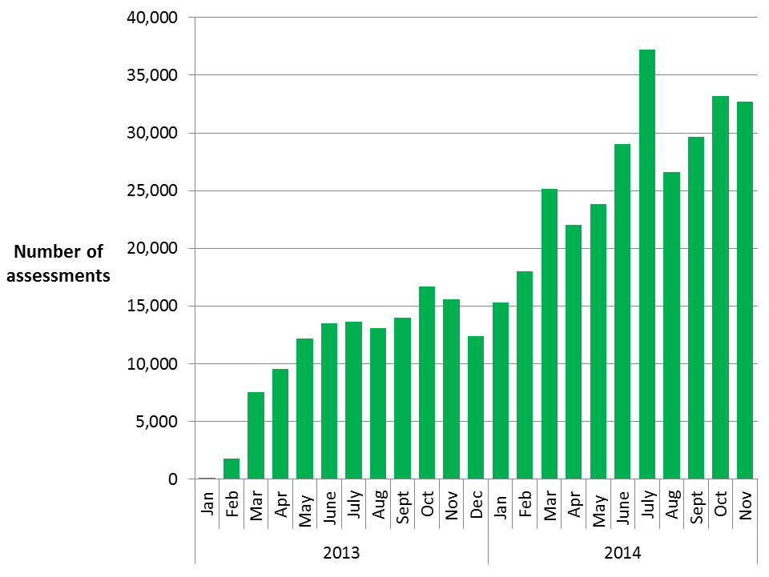

Green Deal Plans in unique properties, cumulative totals by month (Table 3, Table 3a, Table 3b, Chart 2)

Following an Assessment, for householders who choose to take on any of the recommended measures, there are a number of routes to pay for the improvements. Some customers may choose GD finance to pay for part or all of their planned improvements, whilst others may choose to pay for measures out of savings or other sources of finance, and some may be part funded through ECO support.

For those who choose GD finance, there are three stages in the life cycle of a GD Plan. The first stage (a ‘new’ Plan) is after a customer has obtained a quote and confirmed they wish to proceed, the second stage (a ‘pending’ Plan) is when a Plan has been signed by the customer and progress is being made to install measures, whilst the final stage (a ‘live’ Plan) is after the measures have been installed and the energy supplier has all the information required to bill GD charges. For more detail on these stages, please see Annex B.

In total, there were 8,133 GD Plans in the system at the end of November 2014, up from 7,207 at the end of October 2014. This represents continued growth in the number of GD Plans in the system after a period of relatively low activity. Of these 8,133 Plans, 2,285 were ‘new’ (quote accepted), another 1,887 were ‘pending’ (Plan signed) and 3,961 were ‘live’ (all measures installed), nearly half of all Plans. As ‘new’ and ‘pending’ GD Plans lead to installation of measures and charges starting to accrue, they will be replaced as ‘live’ GD Plans in future monthly releases. The three reporting stages are presented in Table 3 and Chart 2.
The total number of measures installed using GD finance was 7,939 up to the end of November 2014 (see Table 3a). Photovoltaics accounted for 29 per cent of measures installed, followed by boilers (24 per cent), and solid wall insulation (16 per cent) (see Table 3b).

Chart 2 - Number of Green Deal Plans in unique properties, cumulative totals at end of each month, and by stages

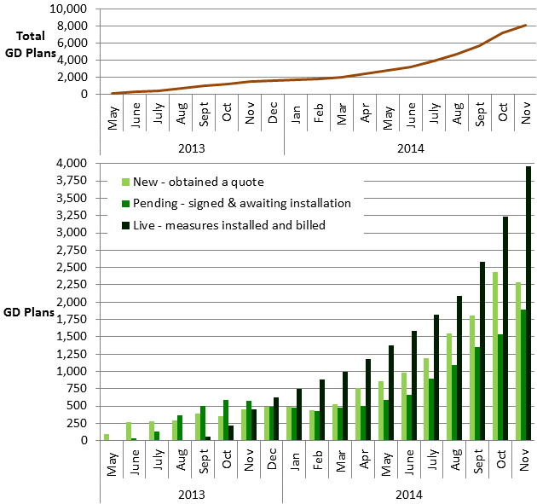
Cashback vouchers where payments have been made, by month of installation (Table 4, Table 4a, Chart 3)

The Cashback scheme was available from January 2013 to June 2014 in England and Wales. It was a financial incentive specifically aimed to encourage domestic customers to get measures installed through the GD process, although it was the customers’ choice whether to take out GD finance or other sources of finance to fund the installation of the measures. The Cashback scheme closed to new applications at the end of June 2014 and claims for payments under the standard Cashback payment process closed at the end of October 2014. Payments for vouchers issued under the Cashback Exception process are still being processed and will continue to be reflected in future statistical releases as payments continue to be made.

As the Cashback payment process closed at the end of October 2014 there will be no further redemptions under the standard Cashback process. Of the 16,116 vouchers issued at the end of November 2014, 14,743 (91 per cent) had been paid following the installation of 15,696 measures (mainly boilers, solid wall insulation and loft insulation) through the standard Cashback route (Table 4, Table 4a and Chart 3). Additionally, 2,508 applications and payments were made through the Cashback Exception process, which includes payments for solid wall insulation and warm air heating measures when these measures are not displayed on the EPC. These take the total number of vouchers issued at the end of the scheme to 18,624 and the total number of payments made to 17,251. Measures installed through the Cashback Exception process are not included in Table 4a as the appropriate data are not currently available. Overall, measures to the value of around £15.8 million have been paid through the Cashback Scheme, including uplift payments due to the new Cashback measure rates.

Customers only received payments once Providers confirmed to the Cashback Administrator that the measures were installed. A large batch of payments were processed in June 2013, hence the higher number that month. Subsequently, the number of Cashback vouchers paid each month decreased from this peak. However, the £2.8m of Cashback vouchers paid for installations in June 2014 was the highest recorded (see Table 4).

Chart 3 - Number of Cashback vouchers where payments have been made (excluding payments made through the exception process), by month of installation
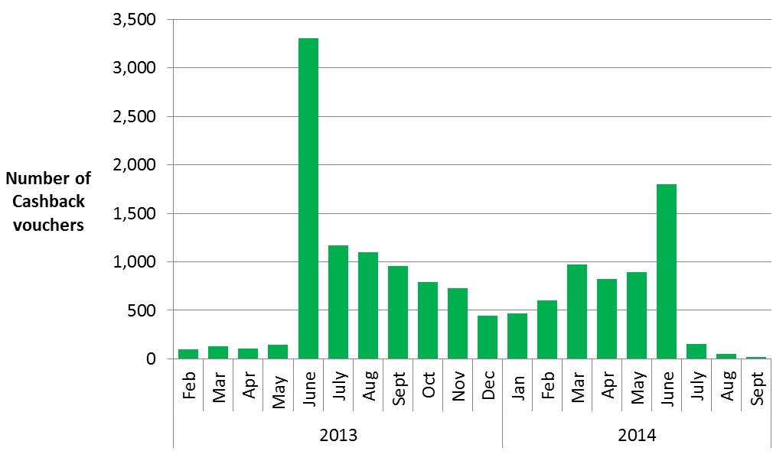
Cashback measures where payments have been made (Table 4a)

Table 4a shows that replacement boilers were the main measure where Cashback payments have been made (79 per cent of all Cashback measures installed), whilst a further 13 per cent were for solid wall insulation, five per cent were for loft insulation and two per cent were for cavity wall insulation. More than one measure can be installed in a property and covered by a single Cashback payment.

Green Deal Home Improvement Fund where payments have been made, by month of installation (Table 5, Table 5a, Chart 4)

The Green Deal Home Improvement Fund (GDHIF) is an incentive scheme open to all householders in England and Wales wanting to improve the energy efficiency of their homes. The scheme allows householders to choose one or both of two offers available and they are eligible to claim money back. GDHIF release 1 opened in June 2014 and closed to new applicants at 6:30pm on 24 July 2014. GDHIF release 2 commenced on 10 December 2014. Data on measures installed from GDHIF release 2 will be reported from the February Monthly statistics release, subject to data availability.

By the end of November 2014, there were 20,616 Green Deal Home Improvement Fund release 1 active applications, with a total budget committed of around £111m. Just over half of GDHIF applications were accompanied with a Green Deal Advice Report, with the remainder accompanied with just an Energy Performance Certificate. By the end of November 2014, of these active applications, 20,437 vouchers had been issued.

Of these, 8,957 vouchers had been paid (following installation of 11,310 measures) by the end of November, with a value of around £42.5 million. Around £12.5 million payments were made in November alone from 2,270 vouchers (see Table 5). Solid wall insulation was the main measure where GDHIF payments have been made (61 per cent of measures installed) followed by gas boiler installations (19 per cent) and flue gas heat recovery device installations (19 per cent). Of the 8,957 payments made, 5,081 included the Green Deal Advice Report (GDAR) refund (of up to £100 each), and 686 included the Home Buyer Bonus (of up to £500 each).

Chart 4 – Cumulative number of Green Deal Home Improvement Fund vouchers where payments have been made, by month of installation and by month of payment, at end of each month
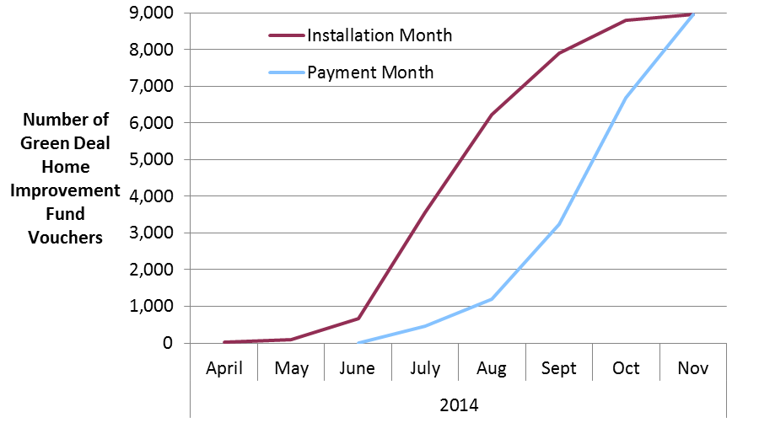

ECO measures installed by obligation, up to the end of October 2014 (Table 6, Table 6a, Chart 5, Chart 6)

The Energy Company Obligation (ECO) was introduced in January 2013 to reduce energy consumption and support people at greater risk of living in fuel poverty. Information on measures installed under ECO is at a lag of a month compared to other figures presented in this release due to the time taken for information to be reported and verified. Hence, data on measures installed under ECO is presented until the end of October 2014.

All measures installed under ECO are provisional until the end of the obligation period as checks are undertaken. Users should note that, in order to produce the timeliest data possible, estimates in this report include a month of data that has yet to be through initial Ofgem validation checks (i.e. they are as reported by energy suppliers to Ofgem). Revisions to data are routinely included in releases and will be explained if they are large.

Table 6 shows the provisional number of measures installed under ECO and Chart 5 shows the cumulative number of measures installed by ECO obligation and by installation month.

Chart 5 - Provisional cumulative number of ECO measures installed, by obligation, at end of each month
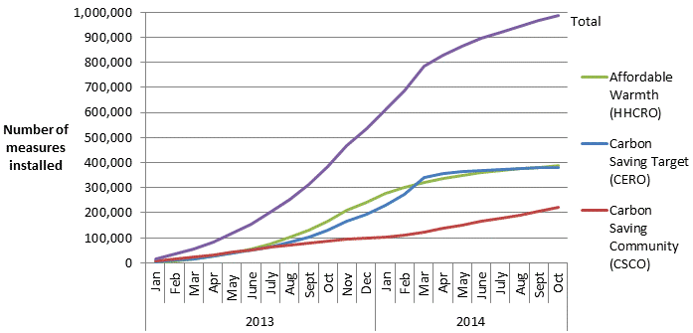

Overall, 988,603 measures had been installed to the end of October 2014, with 23,306 installed in October, which was one per cent lower than the 23,480 installed in September. The number of measures installed peaked in March (98,945), in part, due to the incentive for energy companies to deliver Carbon Saving Target (CERO) measures by the end of March 2014 in order to benefit from the proposed levelisation which would provide uplift to CERO carbon scoring. Consequently the number of measures installed since March 2014 were much lower. However, companies have started delivering measures eligible under the ECO amendment order with around 194,000 installations reported between April and October 2014, of which around 43,100 were reported in October. Under the ECO amendment order, 114,900 of these measures were reported under CERO, and 79,200 were reported under CSCO of which 29,900 were reported under CSCO rural sub-obligation. Over half of these (53 per cent) were cavity wall insulation measures and under half (44 per cent) were loft insulation measures. The revised regulations were passed by Parliament on 5 December 2014, so these measures can be captured through the formal Ofgem reporting process from the end of December 2014. Therefore these are not yet included in the headline statistics nor in the breakdowns below, but will be reported in future if they are formally notified as ECO measures.

The split by obligation shows 38 per cent of measures installed under ECO were delivered through the Carbon Saving Target (CERO), 22 per cent were through Carbon Saving Communities (CSCO) and 39 per cent were through Affordable Warmth (HHCRO).

Table 6a and Chart 6 show the provisional number of measures installed under ECO, by measure type and ECO obligation. This shows that the majority of the 988,603 measures installed under ECO were for cavity wall insulation (35 per cent), boiler upgrades (28 per cent) and loft insulation (22 per cent). Overall, 801,756 properties benefitted from one or more ECO measures being installed up to the end of October 2014 (Table 6a).

Chart 6 - Provisional number of measures installed under ECO, by measure type, by obligation, up to end October 2014
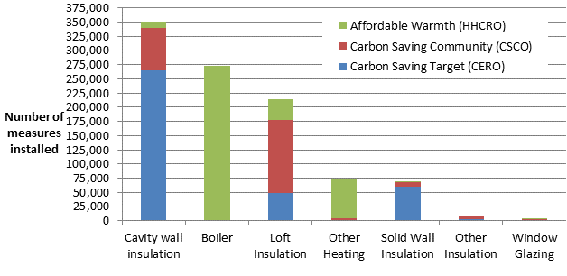
The majority (77 per cent) of the 350,873 cavity wall insulation measures installed were delivered to Hard to Treat cavity wall properties.
Around two thirds (61 per cent) of the 214,953 loft insulation measures installed under ECO up to the end of October 2014 were top ups.

Of the 67,467 solid wall insulation measures installed, the large majority (93 per cent) were External Wall Insulation.

ECO brokerage, as at the end of November 2014 (Table 7, Chart 7)

The ECO Brokerage system operates as a fortnightly anonymous auction where providers can sell ‘lots’ of future measures of ECO Carbon Saving Target, ECO Carbon Saving Communities and ECO Affordable Warmth, to energy companies in return for ECO subsidy. Chart 7 shows that up to the end of November 2014 there have been 48 auctions, with a total value of contracts let worth £425.4 million. Auctions 25, 32, 33, 34, 36, 40, 46 and 47 saw no contracts let; however auction 48 had nearly £4.5m of contracts traded. The levels of brokerage activity in recent months are likely to have been affected by uncertainty around the period, following the announced proposals for a set of changes to ECO.
Chart 7 – Value of ECO brokerage contracts let, by auction
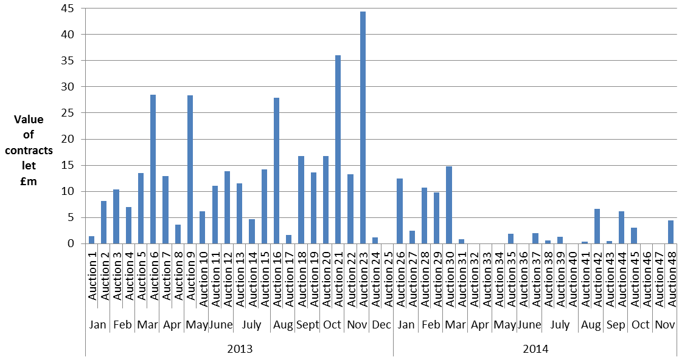

For more detail on the results of each auction, please see ECO Brokerage.

Measures not captured by administrative data sources

The figures in these tables do not include estimates of measures installed following a GD Assessment where the measure was not captured by administrative data sources (i.e. measures installed using alternative finance). Alternative sources of finance may include savings, payment from a landlord, housing association or Local Authority or other type of loan or credit, but would not have received funding from any of our reported routes. Additional work has been undertaken on this which is reported in the quarterly statistical release.

Supply chain, as at the end of November 2014 (Table 8, Chart 8)

The supply chain to support the GD has been developing since October 2012. This includes individual Advisors (who carry out and produce Green Deal Advice Reports) and Assessor organisations (who employ authorised GD Advisors), GD Providers (who quote for and arrange GD Plans with householders and arrange for the measures to be installed), and Installer organisations (who install energy efficiency improvements under the GD finance mechanism). Chart 8 shows the number of organisations and individuals who have been accredited as of the end of each month.

Chart 8 – Development of supply chain (cumulative numbers) at end of each month

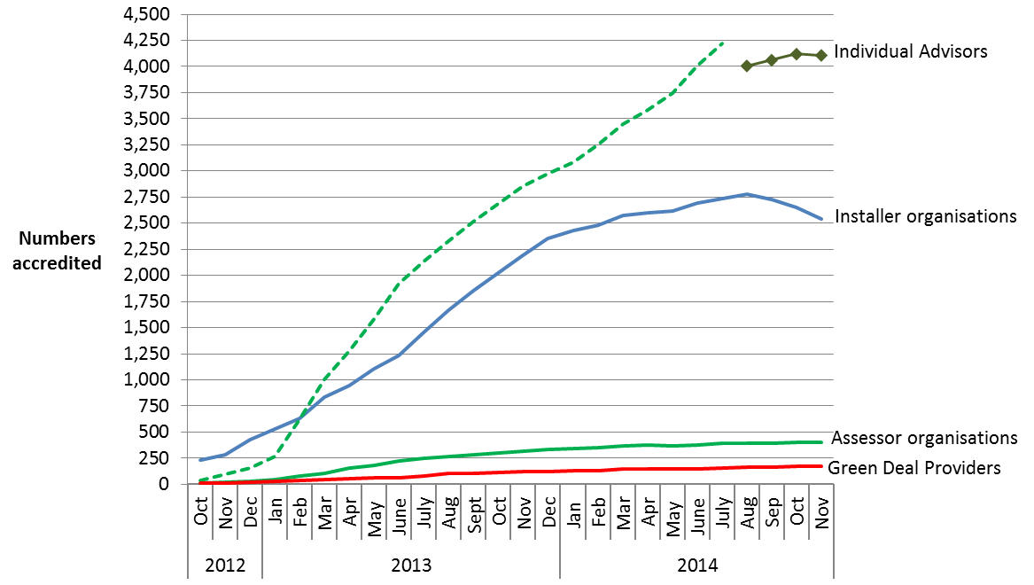

The numbers of accredited GD Assessor organisations and individual Advisors has been increasing steadily as individual Assessors complete their training and are accredited. At the end of November 2014 there were 398 Assessor organisations employing a total of 4,107 Advisors, compared to 314 and 2,855 respectively at the end of November 2013. The measurement of the number of individual Advisors changed in August 2014 following improved data quality checks by the GD ORB. An improved automated deduplication process, implemented in August 2014, is more effective at identifying potential duplicate Advisor entries and has therefore reduced the total number of unique individual Advisors. The new series of individual Advisors is illustrated in Chart 8 by the dark green line with “” markers and is not directly comparable with the original series (dotted line).

The number of GD Providers has increased to 176 from 123 at the end of November 2013. There were 2,539 accredited Installer organisations at the end of November 2014, a slight decrease since the peak of 2,774 seen at the end of August 2014. A reason for part of this decrease was the decision by some installer organisations to not yet renew their membership which was due for annual renewal.

These organisations will provide a wide range of different measures and in different geographical locations (see quarterly statistical release for more details).

The Green Deal Oversight and Regulation Body (ORB) produces publically available information on the supply chain, and the latest figures are available by using the search tool on the ORB website. There is also information available on contacts in local areas.

Annex A – Tables
Please note, percentages may not add up to totals due to rounding.
Table 1: Provisional number of measures installed through ECO, Cashback, using Green Deal finance or Green Deal Home Improvement Fund, by month of installation
 | Delivery mechanism
Installation Month¹ | ECO ² | Cashback ³ |  | Green Deal  Finance Plans |  |  | Green Deal Home Improvement Fund ⁴ | Total number of measures installed ⁵
January 2013 ⁶ | 14,692 | 0 |  | 0 |  |  | 0 | 14,692
February 2013 | 18,872 | 96 |  | 0 |  |  | 0 | 18,968
March 2013 | 21,689 | 136 |  | 0 |  |  | 0 | 21,825
April 2013 | 28,751 | 110 |  | 0 |  |  | 0 | 28,861
May 2013 | 34,122 | 145 |  | 0 |  |  | 0 | 34,267
June 2013 | 36,429 | 3,337 |  | 5 |  |  | 0 | 39,771
July 2013 | 45,902 | 1,266 |  | 7 |  |  | 0 | 47,175
August 2013 | 50,887 | 1,158 |  | 133 |  |  | 0 | 52,178
September 2013 | 59,795 | 1,012 |  | 170 |  |  | 0 | 60,977
October 2013 | 72,584 | 844 |  | 524 |  |  | 0 | 73,952
November 2013 | 82,442 | 787 |  | 467 |  |  | 0 | 83,696
December 2013 | 67,594 | 472 |  | 432 |  |  | 0 | 68,498
January 2014 | 75,100 | 498 |  | 275 |  |  | 0 | 75,873
February 2014 | 77,112 | 677 |  | 309 |  |  | 0 | 78,098
March 2014 | 98,945 | 1,069 |  | 260 |  |  | 0 | 100,274
April 2014 | 42,720 | 945 |  | 381 |  |  | 20 | 44,066
May 2014 | 37,492 | 973 |  | 476 |  |  | 63 | 39,004
June 2014 | 28,778 | 1,934 |  | 382 |  |  | 619 | 31,713
July 2014 | 25,768 | 157 |  | 552 |  |  | 4,010 | 30,487
August 2014 | 22,143 | 60 |  | 612 |  |  | 3,548 | 26,363
September 2014 | 23,480 | 20 |  | 1,028 |  |  | 1,882 | 26,410
October 2014 | 23,306 | 0 |  | 1,071 |  |  | 993 | 25,370
Total to date | 988,603 | 15,696 |  | 7,084 |  |  | 11,135 | 1,022,518
¹ Measures installed in earlier installation months can be notified at a later date under some circumstances.
² Energy companies have also reported the installation of an additional 194,000 measures eligible under the ECO amendment order between April and October 2014, of which around 43,100 were reported in October. These are not included in the table.
³ Cashback figures do not include any measures from the Cashback Exception process.
⁴ The Green Deal Home Improvement Fund was only available from June 2014. The April figure includes a small number of measures that were installed in February.
⁵ Some measures may have been installed through more than one delivery mechanism and there is therefore a small level of double counting.
⁶ Includes some measures installed between October and December 2012.

Table 1a: Provisional number of individual households that have had measures installed through ECO, Cashback, using Green Deal finance or Green Deal Home Improvement Fund, by month of installation
 | Delivery mechanism
Installation Month¹ | ECO ² | Cashback ³ | Green Deal Finance Plans | Green Deal Home Improvement Fund ⁴ | Total number of individual households ⁵
January 2013 ⁶ | 13,029 | 0 | 0 | 0 | 13,029
February 2013 | 16,777 | 95 | 0 | 0 | 16,872
March 2013 | 19,179 | 133 | 0 | 0 | 19,312
April 2013 | 25,266 | 109 | 0 | 0 | 25,375
May 2013 | 30,364 | 143 | 0 | 0 | 30,507
June 2013 | 32,398 | 3,302 | 0 | 0 | 35,700
July 2013 | 40,024 | 1,172 | 1 | 0 | 41,197
August 2013 | 41,907 | 1,099 | 11 | 0 | 43,017
September 2013 | 48,843 | 954 | 45 | 0 | 49,842
October 2013 | 58,277 | 789 | 162 | 0 | 59,228
November 2013 | 65,813 | 725 | 239 | 0 | 66,777
December 2013 | 53,013 | 444 | 168 | 0 | 53,625
January 2014 | 59,646 | 465 | 120 | 0 | 60,231
February 2014 | 61,253 | 604 | 137 | 0 | 61,994
March 2014 | 80,175 | 973 | 112 | 0 | 81,260
April 2014 | 32,979 | 826 | 183 | 20 | 34,008
May 2014 | 29,239 | 894 | 194 | 63 | 30,390
June 2014 | 22,053 | 1,800 | 215 | 588 | 24,656
July 2014 | 19,928 | 150 | 228 | 2,881 | 23,187
August 2014 | 16,762 | 51 | 277 | 2,658 | 19,748
September 2014 | 17,969 | 15 | 489 | 1,678 | 20,151
October 2014 | 16,862 | 0 | 658 | 899 | 18,419
Total to date | 801,756 | 14,743 | 3,239 | 8,787 | 828,525
¹ Measures installed in earlier installation months can be notified at a later date under some circumstances.
² Where a household has measures installed in two or more months, the earliest installation month is recorded. Following improved de-duplication processes the number of unique properties in receipt of ECO has been revised in all months.
³ Cashback figures do not include any households that have had measures installed solely through the Cashback Exception process.
⁴ Where a household has measures installed in two or more months, the earliest installation month is recorded. This is lower than the number of vouchers issued as it is possible for there to be more than one GDHIF voucher paid per household.
⁵ Some households may have had installations through more than one delivery mechanism and there is therefore a small level of double counting.
⁶ Includes some measures installed between October and December 2012.

Table 2: Number of Green Deal Assessments¹ and cumulative total, by month

 |  | Total in Month |  | Cumulative Total
Month |  | Green Deal Assessments |  | Green Deal Assessments
January 2013 |  | 74 |  | 74
February 2013 |  | 1,729 |  | 1,803
March 2013 |  | 7,491 |  | 9,294
April 2013 |  | 9,522 |  | 18,816
May 2013 |  | 12,146 |  | 30,962
June 2013 |  | 13,517 |  | 44,479
July 2013 |  | 13,645 |  | 58,124
August 2013 |  | 13,087 |  | 71,211
September 2013 |  | 13,965 |  | 85,176
October 2013 |  | 16,672 |  | 101,848
November 2013 |  | 15,595 |  | 117,443
December 2013 |  | 12,385 |  | 129,828
January 2014 |  | 15,267 |  | 145,095
February 2014 |  | 17,998 |  | 163,093
March 2014 |  | 25,138 |  | 188,231
April 2014 |  | 22,004 |  | 210,235
May 2014 |  | 23,811 |  | 234,046
June 2014 |  | 29,018 |  | 263,064
July 2014 ² |  | 37,192 |  | 300,256
August 2014 |  | 26,625 |  | 326,881
September 2014 |  | 29,630 |  | 356,511
October 2014 |  | 33,191 |  | 389,702
November 2014 |  | 32,734 |  | 422,436
¹ As measured by the number of Green Deal Advice Reports lodged on the central register against unique property.
² The number of Assessments in July 2014 has been revised from 37,193 to 37,192.

Table 3: Number of Green Deal Plans^{1,2,3,4} in unique properties, cumulative total by month
Month |  | 'New'¹ Green Deal Plans |  | 'Pending'² Green Deal Plans |  | 'Live'³ Green Deal Plans |  |  |  | 'Total'⁵ Green Deal Plans
May 2013 |  | 98 |  | 2 |  | 0 |  |  |  | 100
June 2013 |  | 270 |  | 36 |  | 0 |  |  |  | 306
July 2013 |  | 286 |  | 132 |  | 1 |  |  |  | 419
August 2013 |  | 293 |  | 372 |  | 12 |  |  |  | 677
September 2013 |  | 392 |  | 505 |  | 57 |  |  |  | 954
October 2013 |  | 360 |  | 594 |  | 219 |  |  |  | 1,173
November 2013 |  | 448 |  | 572 |  | 458 |  |  |  | 1,478
December 2013 |  | 493 |  | 493 |  | 626 |  |  |  | 1,612
January 2014 |  | 494 |  | 481 |  | 746 |  |  |  | 1,721
February 2014 |  | 445 |  | 426 |  | 883 |  |  |  | 1,754
March 2014 |  | 532 |  | 473 |  | 995 |  |  |  | 2,000
April 2014 |  | 756 |  | 505 |  | 1,178 |  |  |  | 2,439
May 2014 |  | 863 |  | 593 |  | 1,372 |  |  |  | 2,828
June 2014 |  | 986 |  | 661 |  | 1,587 |  |  |  | 3,234
July 2014 |  | 1,192 |  | 891 |  | 1,815 |  |  |  | 3,898
August 2014 |  | 1,547 |  | 1,098 |  | 2,092 |  |  |  | 4,737
September 2014 |  | 1,808 |  | 1,347 |  | 2,581 |  |  |  | 5,736
October 2014 |  | 2,434 |  | 1,534 |  | 3,239 |  |  |  | 7,207
November 2014 |  | 2,285 |  | 1,887 |  | 3,961 |  |  |  | 8,133
¹ A 'new' Green Deal Plan is after a customer has obtained a quote from a Green Deal Provider and confirmed they wish to proceed. The Green Deal Provider has then successfully requested a Green Deal Plan record prior to signature by the customer.
² A 'pending' Green Deal is when a Green Deal Plan has been signed by the customer, progress is being made to install Green Deal Plan measures (measures are installed during the ‘pending’ stage) and the Plan is being finalised so that charging can start.
³ A 'live' Green Deal Plan is after all the measures have been installed in the property, the information required to disclose the Plan to future bill payers has been attached to the Plan and the energy supplier has all the information required to bill Green Deal charges.
⁴ There are an additional 96 'completed' Green Deal Plans at the end of November 2014. These are when Plans have been paid off in full after all the measures have been installed in the property, and therefore the Plan is no longer active on the system.
⁵ Total Green Deal Plans are the total number of Plan identifiers for unique properties on the Central Charge Database at the end of reporting month.
Table 3a: Number of measures installed using Green Deal finance^{1,2}, and cumulative total³,
by installation month⁴
 | Total in Month |  |  |  |  |  |  | Cumulative Total
Installation Month | Green Deal  Measures |  |  |  |  |  |  | Green Deal Measures
June 2013 | 5 |  |  |  |  |  |  | 5
July 2013 | 7 |  |  |  |  |  |  | 12
August 2013 | 133 |  |  |  |  |  |  | 145
September 2013 | 170 |  |  |  |  |  |  | 315
October 2013 | 524 |  |  |  |  |  |  | 839
November 2013 | 467 |  |  |  |  |  |  | 1,306
December 2013 | 432 |  |  |  |  |  |  | 1,738
January 2014 | 275 |  |  |  |  |  |  | 2,013
February 2014 | 309 |  |  |  |  |  |  | 2,322
March 2014 | 260 |  |  |  |  |  |  | 2,582
April 2014 | 381 |  |  |  |  |  |  | 2,963
May 2014 | 476 |  |  |  |  |  |  | 3,439
June 2014 | 382 |  |  |  |  |  |  | 3,821
July 2014 | 552 |  |  |  |  |  |  | 4,373
August 2014 | 612 |  |  |  |  |  |  | 4,985
September 2014 | 1,028 |  |  |  |  |  |  | 6,013
October 2014 | 1,071 |  |  |  |  |  |  | 7,084
November 2014 | 855 |  |  |  |  |  |  | 7,939
¹ As measured by the number of measures installed using Green Deal finance where a Green Deal Plan has gone ‘live’ or ‘completed’ following being ‘live’.
² There may be a number of measures which have also been reported under ECO or Cashback.
³ The number of measures installed using Green Deal finance in earlier installation months are subject to revision as Green Deal Plans may become 'live' after the month of installation.
⁴ The number of measures installed using Green Deal finance in any month other than the latest month are not directly comparable with the number of ‘live’ Green Deal Plans for each of those respective months. This is because some measures may have been installed in a month previous to when the corresponding Green Deal Plan went ‘live’.

Table 3b: Number of measures installed using Green Deal finance^{1,2}, up to end of November 2014
Measure Types | Total number of Measures installed using Green Deal finance³ |  |  | Percentage of Measures
Boiler |  | 1,881 |  | 24
Condensing bottled LPG boiler |  | 1 |  | 0
Condensing bulk LPG (not community) boiler |  | 2 |  | 0
Condensing gas boiler |  | 852 |  | 11
Condensing gas boiler with flue gas heat recovery |  | 27 |  | 0
Condensing LPG boiler |  | 1 |  | 0
Condensing mains gas (not community) boiler |  | 944 |  | 12
Condensing mains gas (not community) boiler with flue gas heat recovery |  |  | 42 | 1
Condensing oil (not community) boiler |  | 11 |  | 0
Condensing oil boiler |  | 1 |  | 0
Cavity Wall Insulation |  | 298 |  | 4
Loft Insulation |  | 771 |  | 10
Loft insulation |  | 759 |  | 10
Room in roof insulation |  | 12 |  | 0
Micro-generation |  | 2,290 |  | 29
Air source heat pump and radiators |  | 3 |  | 0
Ground source heat pump and radiators |  | 1 |  | 0
Photovoltaics |  | 2,279 |  | 29
Solar water heating |  | 4 |  | 0
Wood logs boiler |  | 3 |  | 0
Other Heating |  | 639 |  | 8
Fan assisted storage heaters |  | 2 |  | 0
Heating controls |  | 587 |  | 7
Hot water cylinder thermostat |  | 50 |  | 1
Other Insulation |  | 741 |  | 9
Draught proofing |  | 185 |  | 2
Flat Roof Insulation |  | 37 |  | 0
High performance external doors |  | 7 |  | 0
Hot water cylinder insulation |  | 142 |  | 2
Under floor insulation |  | 370 |  | 5
Solid Wall Insulation |  | 1,307 |  | 16
Cavity fill and external wall insulation |  | 7 |  | 0
External wall insulation |  | 1,254 |  | 16
Internal wall insulation |  | 46 |  | 1
Window Glazing |  | 12 |  | 0
Total |  | 7,939 |  | 100
¹ As measured by the number of measures installed using Green Deal finance where a Green Deal Plan has gone 'live', or ‘completed’ following being ‘live’.
² There may be a small number of measures which have also been reported under ECO or Cashback.
³ The number of measures installed using Green Deal finance are subject to revision as Green Deal Plans may become 'live' after the month of installation.

Table 4: Number and value of Cashback vouchers paid, and cumulative total, by installation month, England and Wales only

Vouchers issued ¹ |  | Payments made ²
Installation Month | Number | Number | Value (£)
February 2013 |  | 95 | 25,750
March 2013 |  | 133 | 35,990
April 2013 |  | 109 | 29,510
May 2013 |  | 143 | 40,192
June 2013 |  | 3,302 | 896,305
July 2013 |  | 1,172 | 330,430
August 2013 |  | 1,099 | 309,646
September 2013 |  | 954 | 265,769
October 2013 |  | 789 | 228,878
November 2013 |  | 725 | 233,746
December 2013 |  | 444 | 141,696
January 2014 |  | 465 | 150,763
February 2014 |  | 604 | 255,133
March 2014 |  | 973 | 477,332
April 2014 |  | 826 | 503,921
May 2014 |  | 894 | 920,321
June 2014 |  | 1,800 | 2,810,844
July 2014 |  | 150 | 65,370
August 2014 |  | 51 | 61,700
September 2014 |  | 15 | 15,100
Sub-total | 16,116 | 14,743 | 7,798,394
Cashback Exception process ³ | 2,508 | 2,508 | 6,248,437
Cashback uplift payments ⁴ |  |  | 1,716,639
Total to date | 18,624 | 17,251 | 15,763,469

¹ Cashback vouchers issued data cannot be broken down to the same level of detail. The 16,116 Cashback vouchers issued up to the end of November 2014 equates to a total budget committed of around £10.1m. This has reduced slightly from the amount reported last month as some of these vouchers have since expired.
² The Cashback scheme closed for applications at the end of June 2014 and all redemptions required measures to be installed before the end of September 2014. The standard payment system stopped making payments at the end of October 2014. Therefore the breakdown of payments made by month is the final summary.
³ The Cashback Exception process has additionally paid 2,508 vouchers (following 2,508 exception applications), totalling £6.2m for solid wall insulation and warm air heating measures where those recommended measures are not displayed on the EPC. Of the total number of 2,508 exceptions, 216 were additional vouchers issued that were paid in November 2014 with a total value of £701,694.
⁴ Vouchers redeemed on or after 13 December 2013 are eligible for higher rates for Cashback. The values reported in the table for Cashback vouchers paid between 13 December and 25 March are for the original Cashback amount.

Table 4a: Number of measures installed with Cashback^{1,2}, at the end of the Cashback Scheme³, England and Wales only

Measure Types | Total number of Cashback measures delivered |  |  |  | Percentage of Measures
Boiler |  | 12,379 |  | 79
Gas Boiler |  | 12,308 |  | 78
Oil Boiler |  | 71 |  | 0
Cavity wall insulation |  | 300 |  | 2
Loft Insulation |  | 773 |  | 5
Loft Insulation |  | 762 |  | 5
Room in Roof Insulation |  | 11 |  | 0
Other Heating |  | 12 |  | 0
Electric Storage Heaters |  | 1 |  | 0
Flue Gas Heat Recovery Devices |  | 0 |  | 0
Heating Controls |  | 11 |  | 0
Warm Air Units |  | 0 |  | 0
Waste Water Heat Recovery Systems |  | 0 |  | 0
Other Insulation |  | 60 |  | 0
Draught Proofing |  | 12 |  | 0
Flat Roof Insulation |  | 23 |  | 0
Hot Water Cylinder Insulation |  | 6 |  | 0
Passageway Walk-through Doors |  | 9 |  | 0
Under Floor Insulation |  | 10 |  | 0
Solid Wall Insulation |  | 2,108 |  | 13
Window Glazing |  | 64 |  | 0
Double Glazing |  | 62 |  | 0
Secondary Glazing |  | 2 |  | 0
Total number of measures |  | 15,696 |  | 100
¹ More than one measure can be installed with Cashback per unique property.
² This table does not include any measures from the Cashback Exception process.
³ The standard payment system stopped making payments at the end of October 2014 and all measures were installed before the end of September 2014. Therefore the number of Cashback measures delivered is the final summary as at the end of October 2014.

Table 5: Number and value of Green Deal Home Improvement Fund vouchers paid, and cumulative total, by installation month, and by payment month, England and Wales only
 | Active applications ¹ |  |  |  | Vouchers issued ² |  | Payments made ^{3,4} by installation month ⁵ |  |  | Payments made ^{3,4} by payment month
 |  | Number ⁶ |  |  |  |  | Number | Value (£) |  | Number | Value (£)
Month ⁵
April 2014 ⁷ |  |  |  |  |  |  | 20 | 52,708 |  | 0 | 0
May 2014 |  |  |  |  |  |  | 63 | 177,014 |  | 0 | 0
June 2014 |  |  |  |  |  |  | 589 | 3,169,772 |  | 0 | 0
July 2014 |  |  |  |  |  |  | 2,884 | 11,903,251 |  | 449 | 2,275,382
August 2014 |  |  |  |  |  |  | 2,662 | 11,884,574 |  | 756 | 3,172,666
September 2014 |  |  |  |  |  |  | 1,679 | 9,195,201 |  | 2,030 | 8,113,913
October 2014 |  |  |  |  |  |  | 901 | 5,144,989 |  | 3,452 | 16,385,712
November 2014 |  |  |  |  |  |  | 159 | 925,590 |  | 2,270 | 12,505,424
Total to date |  |  | 20,616 |  | 20,437 |  | 8,957 | 42,453,098 |  | 8,957 | 42,453,098
¹ GDHIF active applications include any vouchers issued, pending, or vouchers which have been paid, under GDHIF release 1 funding. It excludes any vouchers which have been cancelled, rejected, superseded or claim failed, or any applications or vouchers under GDHIF release 2. The 20,616 applications up to the end of November 2014 equates to a total budget committed of around £111m.
² There may have been several vouchers issued for a single application where a customer has modified key elements of their application, but not all active applications have had a voucher issued. It is also possible to have more than one voucher issued and payment made per household.
³ Of the 8,957 payments made, 686 of these received the Home Buyer Bonus (of up to £500 each).
⁴ Of the 8,957 payments made, 5,081 of these received the Green Deal Advice Report refund (of up to £100 each).
⁵ The numbers of GDHIF payments made in early months have been revised. This is due to GDHIF redemptions being paid in later months. Where a household has measures installed in two or more months, the earliest installation month is recorded.
⁶ Comparable applications and voucher data are not available by installation month.
⁷ The April figure includes a small number of payments where measures were installed in February. These refer to applications that ‘transferred’ from the Cashback scheme.

Table 5a: Number of measures installed through Green Deal Home Improvement Fund¹ up to end of November 2014, England and Wales only
Measure Types | Total number of GDHIF measures delivered |  |  | Percentage of Measures
Boiler | 2,199 |  |  | 19
Gas Boiler | 2,199 |  |  | 19
Cavity wall insulation | 47 |  |  | 0
Loft Insulation | 5 |  |  | 0
Room in Roof Insulation | 5 |  |  | 0
Other Heating | 2,126 |  |  | 19
Electric Storage Heaters | 0 |  |  | 0
Flue Gas Heat Recovery Devices |  | 2,126 |  | 19
Warm Air Units | 0 |  |  | 0
Waste Water Heat Recovery Systems |  |  | 0 | 0
Other Insulation | 46 |  |  | 0
Flat Roof Insulation | 7 |  |  | 0
Passageway Walk-through Doors |  | 28 |  | 0
Under Floor Insulation | 11 |  |  | 0
Solid Wall Insulation | 6,856 |  |  | 61
Window Glazing | 31 |  |  | 0
Double/Triple Glazing | 28 |  |  | 0
Secondary Glazing | 3 |  |  | 0
Total number of measures | 11,310 |  |  | 100
¹ More than one measure can be installed with Green Deal Home Improvement Fund per unique property.

 | Table 6: Provisional number of ECO measures installed¹, by obligation, by installation month
 |  | Obligation
 | Installation Month ² | Carbon Saving Target (CERO) | Carbon Savings Community (CSCO) |  | Affordable Warmth (HHCRO) | Total number of ECO measures installed
of which 'Rural'
sub-obligation
 | January 2013¹ | 3,994 | 7,994 | 0 | 2,704 | 14,692
 | February 2013 | 5,310 | 7,467 | 0 | 6,095 | 18,872
 | March 2013 | 6,678 | 7,515 | 1 | 7,496 | 21,689
 | April 2013 | 10,167 | 8,289 | 2 | 10,295 | 28,751
 | May 2013 | 12,296 | 9,609 | 1 | 12,217 | 34,122
 | June 2013 | 10,466 | 9,876 | 8 | 16,087 | 36,429
 | July 2013 | 15,692 | 10,542 | 1 | 19,668 | 45,902
 | August 2013 | 17,209 | 7,682 | 0 | 25,996 | 50,887
 | September 2013 | 21,998 | 8,712 | 14 | 29,085 | 59,795
 | October 2013 | 26,965 | 7,617 | 27 | 38,002 | 72,584
 | November 2013 | 34,684 | 7,260 | 40 | 40,498 | 82,442
 | December 2013 | 29,332 | 4,872 | 57 | 33,390 | 67,594
 | January 2014 | 35,198 | 6,385 | 97 | 33,517 | 75,100
 | February 2014 | 44,684 | 7,474 | 369 | 24,954 | 77,112
 | March 2014 | 64,773 | 12,785 | 217 | 21,387 | 98,945
 | April 2014 | 14,767 | 12,330 | 52 | 15,623 | 42,720
 | May 2014 | 10,192 | 14,433 | 89 | 12,867 | 37,492
 | June 2014 | 5,019 | 13,587 | 109 | 10,172 | 28,778
 | July 2014 | 3,786 | 13,992 | 189 | 7,990 | 25,768
 | August 2014 | 2,551 | 12,685 | 170 | 6,907 | 22,143
 | September 2014 | 2,925 | 14,733 | 273 | 5,822 | 23,480
 | October 2014 | 1,119 | 13,538 | 393 | 8,649 | 23,306
 | Total to date ³ | 379,805 | 219,377 | 2,109 | 389,421 | 988,603
 | ¹ Includes some measures installed between October and December 2012.
² ECO measures installed in earlier installation months can be notified at a later date under some circumstances. Some notified measures can be reallocated to different ECO obligations and so are subject to change.
³ Energy companies have also reported the installation of an additional 194,000 measures eligible under the ECO amendment order between April and October 2014, of which around 43,100 were reported in October. 114,900 of these measures were reported under CERO, and 79,200 were reported under CSCO, of which 29,900 were reported under CSCO rural sub-obligation. Please note that energy companies can revise the number of interim measures reported in earlier months. The revised regulations were passed by Parliament on 5 December 2014, so these measures can be captured through the formal Ofgem reporting process from the end of December 2014. These measures will be reported in the table in future releases if they are formally notified as ECO measures.

Table 6a: Provisional number of ECO measures installed¹, by measure type*, by obligation, up to end October 2014

 | Obligation
Measure Types² | Carbon Saving Target (CERO) |  | Carbon Savings Community (CSCO) |  | Affordable Warmth (HHCRO)
 |  |  |  | of which 'Rural'  sub-obligation |  | Total number of ECO measures delivered |  | Percentage of ECO Measures
Boiler | N/A |  | N/A | N/A | 272,777 | 272,777 |  | 27.6
Cavity wall insulation | 265,658 |  | 74,494 | 678 | 10,721 | 350,873 |  | 35.5
Loft Insulation | 49,343 |  | 127,961 | 1,292 | 37,649 | 214,953 |  | 21.7
Micro-generation | N/A |  | N/A | N/A | 0 | 0 |  | 0.0
Other Heating | 1,695 |  | 3,147 | 0 | 68,164 | 73,006 |  | 7.4
Other Insulation | 2,214 |  | 5,069 | 73 | 99 | 7,382 |  | 0.7
Solid Wall Insulation | 59,895 |  | 7,562 | 66 | 10 | 67,467 |  | 6.8
Window Glazing | 1,000 |  | 1,144 | 0 | 1 | 2,145 |  | 0.2
Total number of measures ³ |  | 379,805 | 219,377 | 2,109 | 389,421 | 988,603 |  | 100
Total number of unique properties^{4,5,6} | 319,785 |  | 194,009 | 1,831 | 306,867 | 801,756
¹ As reported by energy suppliers to Ofgem in their monthly returns. Excludes any measures which have been rejected by Ofgem or withdrawn by obligated energy suppliers. Please see the accompanying Methodology Note for more details.
² Please see Ofgem’s guidance for suppliers for more details on eligible measures
³ Energy companies have also reported the installation of an additional 194,000 measures eligible under the ECO amendment order between April and October 2014, of which around 43,100 were reported in October. 114,900 of these measures were reported under CERO, and 79,200 were reported under CSCO, of which 29,900 were reported under CSCO rural sub-obligation. Please note that energy companies can revise the number of interim measures reported in earlier months. The revised regulations were passed by Parliament on 5 December 2014, so these measures can be captured through the formal Ofgem reporting process from the end of December 2014. These measures will be reported in the table in future releases if they are formally notified as ECO measures.
⁴ The addresses where 15 ECO measures were installed are unknown. As it is unknown whether these are unique properties they have been excluded from this total. Also, some ECO measures were installed in properties without recording the full address (e.g. blocks of flats), so there may be slightly more unique properties than recorded here. Following improved de-duplication processes the number of unique properties in receipt of ECO has been revised.
⁵ The total number of unique properties by obligation does not equal the total number of unique properties overall, as some properties have measures installed under more than one obligation.
⁶ The total number of unique properties with ECO measures installed under CSCO and/or HHCRO is 491,874.
*For the full list of measure types, please see Table 6a in Excel here.
Table 7: Number of ECO brokerage auctions¹ and total amount traded, by month
Month |  | Number of auctions |  | Total amount traded
January 2013 |  | 2 |  | £9.5m
February 2013 |  | 2 |  | £17.4m
March 2013 |  | 2 |  | £42.0m
April 2013 |  | 2 |  | £16.6m
May 2013 |  | 2 |  | £34.6m
June 2013 |  | 2 |  | £25.0m
July 2013 |  | 3 |  | £30.5m
August 2013 |  | 2 |  | £29.6m
September 2013 |  | 2 |  | £30.4m
October 2013 |  | 2 |  | £52.9m
November 2013 |  | 2 |  | £57.7m
December 2013 |  | 2 |  | £1.2m
January 2014 |  | 2 |  | £14.9m
February 2014 |  | 2 |  | £20.5m
March 2014 |  | 2 |  | £15.6m
April 2014 |  | 2 |  | £.0m
May 2014 |  | 2 |  | £1.9m
June 2014 |  | 2 |  | £2.0m
July 2014 |  | 3 |  | £1.9m
August 2014 |  | 2 |  | £7.0m
September 2014 |  | 2 |  | £6.8m
October 2014 |  | 2 |  | £3.0m
November 2014 |  | 2 |  | £4.5m
Total to date |  | 48 |  | £425.4m
¹ ECO brokerage auctions are scheduled to take place on a fortnightly basis.

Table 8: Number¹ of accredited Assessor organisations, individual Advisors, Green Deal Providers, and Installer organisations, cumulative totals by month

Month² | Assessor organisations | Individual Advisors | Green Deal Providers | Installer organisations
October 2012 | 13 | 40 | 8 | 231
November 2012 | 18 | 100 | 15 | 285
December 2012 | 29 | 159 | 20 | 429
January 2013 | 48 | 270 | 25 | 531
February 2013 | 77 | 618 | 40 | 629
March 2013 | 108 | 1,003 | 48 | 831
April 2013 | 152 | 1,274 | 55 | 942
May 2013 | 182 | 1,582 | 60 | 1,108
June 2013 | 226 | 1,919 | 66 | 1,234
July 2013 | 248 | 2,129 | 79 | 1,457
August 2013 | 269 | 2,332 | 101 | 1,662
September 2013 | 286 | 2,517 | 107 | 1,853
October 2013 | 302 | 2,687 | 112 | 2,020
November 2013 | 314 | 2,855 | 123 | 2,190
December 2013 ³ | 331 | 2,972 | 125 | 2,353
January 2014 | 344 | 3,087 | 130 | 2,432
February 2014 | 352 | 3,254 | 133 | 2,483
March 2014 | 364 | 3,445 | 143 | 2,575
April 2014 | 373 | 3,580 | 143 | 2,601
May 2014 | 369 | 3,747 | 151 | 2,619
June 2014 | 375 | 4,006 | 151 | 2,697
July 2014 | 392 | 4,219 | 156 | 2,735
August 2014 ⁴ | 393 | 4,006 | 161 | 2,774
September 2014 | 391 | 4,061 | 162 | 2,729
October 2014 | 404 | 4,119 | 174 | 2,649
November 2014 | 398 | 4,107 | 176 | 2,539
¹ Numbers include domestic, both domestic and non-domestic and a small number of non-domestic only participants.
² Months are approximate as they are based on numbers up to the end of the last full week in the month.
³ December reporting period is up to the 23rd December 2013.
⁴ The measurement of the number of individual Advisors changed in August 2014 and is not directly comparable with the number of Advisors up to the end of July 2014.

Annex B – Background

Green Deal
The Green Deal (GD) was launched on 28 January 2013 in England and Wales (and on 25 February 2013 in Scotland) with the aim of tackling a number of the key barriers to the take-up of energy efficiency measures.

Customers having GD Assessments undertaken have the choice of how they proceed. They might take the view that their home is sufficiently energy efficient, or that they want to finance work through a GD Plan or that they want to use alternative funding arrangements (e.g. use of savings).

The GD process for households is briefly described below:

Step 1 – Assessment – A GD Assessor will come to the home, talk to the owner/occupier about their energy use and see if they can benefit from making energy efficiency improvements to their property.

Step 2 – Recommendations – The GD Assessor will recommend improvements that are appropriate for the property and indicate whether they are expected to pay for themselves through reduced energy bills.

Step 3 – Quotes – GD Providers will discuss with the owner/occupier whether a GD Plan is right for them and quote for the recommended improvements, including the savings estimates, savings period, first year instalments and payment period for each improvement. A number of quotes can be obtained.

Step 4 – Signing a Plan – The customer chooses to proceed with a given provider and package of measures. The owner/occupier needs to obtain the necessary consent to make improvements to the property before they can agree terms with the GD Provider of a GD Plan, at which stage they enter a cooling-off period.

Step 5 – Installation – Once a GD Plan has been agreed, the Provider will arrange for the improvements to be made by a GD Installer. Once the installation has been completed a letter is sent to the Bill Payer and, at this stage, the GD Plan goes ‘live’.

Repayments will be no more than what a typical household should save in energy costs.

It has only been possible for GD Providers to request Plans once commercial agreements between the Green Deal Finance Company and GD Providers have been agreed. It took GD Providers some time to prepare their businesses to bring offers to the market with GD Plans being created from May onwards for the small number of GD Providers who have finalised their offer to date.

For those who choose GD finance, there are three stages in the life cycle of a GD Plan for which reports are generated.

- the first stage (a ‘new’ GD Plan) is after a customer has obtained a quote from a GD Provider and confirmed they wish to proceed. The GD Provider has then successfully requested a GD Plan record prior to signature by the customer. It is possible that more than one GD Plan may be requested for each household.
- the second stage (a ‘pending’ GD Plan) is when a GD Plan has been signed by the customer, progress is being made to install GD Plan measures and the Plan is being finalised so that charging can start.
- the final stage (a ‘live’ GD Plan) is after the measures have been installed in the property, the information required to disclose the Plan to future bill payers has been attached to the Plan and the energy supplier has all the information required to bill GD charges. At this stage the daily charge has been confirmed along with the date from when the charge will be accrued on their electricity bill.

Energy Company Obligation
The Energy Company Obligation (ECO) started on 1 January 2013 (although energy companies have been able to count against their targets measures delivered since 1 October 2012) and runs to 31 March 2015. It broadly takes over from two previous schemes (Carbon Emissions Reduction Target - CERT - and Community Energy Saving Programme - CESP) and focuses on providing energy efficiency measures to low income and vulnerable consumers and those living in 'hard-to-treat' properties.

There are three main ECO obligations – The Carbon Saving Target (CERO); Carbon Saving Communities (CSCO) and Affordable Warmth (HHCRO).

Carbon Saving Target – This covers the installation of measures like solid wall and hard-to-treat cavity wall insulation, which ordinarily can’t be financed solely through Green Deal Plans.

Carbon Saving Communities Obligation – This provides insulation measures to households in specified areas of low income. It also makes sure that 15 per cent of each supplier’s obligation is used to upgrade more hard-to-reach low-income households in rural areas.

Affordable Warmth Obligation – This provides heating and insulation measures to consumers living in private tenure properties who receive particular means-tested benefits. This obligation supports low-income consumers who are vulnerable to the impact of living in cold homes, including the elderly, disabled and families.

The Government announced proposals for a set of changes to ECO in December 2013. These include: extending through to 2017, with new targets; reducing the ambition of the Carbon Saving Target element; and allowing new measures (loft and standard cavity wall insulation, and district heating) to be eligible under that element. The Government published a consultation on these proposals in March 2014, and intends subject to consultation, that revised regulations will come into force later this year, but with many changes taking effect as from 1 April 2014.

How do the Green Deal and ECO interact?

Following a GD Assessment there will be a range of measures which could improve the energy efficiency of the property. Some of these could be paid for through GD finance, up to the point where the expected annual cost will not exceed what a typical household should save in energy costs. However, depending on the measure or the property, other sources of finance may also be required. ECO funding could be one of these sources, for example for measures such as Solid Wall Insulation and hard-to-treat Cavity Wall insulation.

Green Deal Cashback
The Cashback scheme closed at the end of June 2014. There will be no further applications for the Cashback scheme but vouchers will continue to be redeemed and paid until 30 September 2014.

The Cashback Scheme rewarded the first GD customers. It was a first-come, first served offer where householders can claim cash back from Government on energy saving improvements like insulation, front doors, windows and boilers with packages worth over £1,000. It was available for households in England and Wales.

For more information on the separate scheme that operates in Scotland please see the relevant website. Statistics on this scheme can be found here.

Green Deal Home Improvement Fund
The Green Deal Home Improvement Fund (GDHIF) is an incentive scheme open to all householders in England and Wales wanting to improve the energy efficiency of their homes. The scheme allows householders to choose one or both of two offers available and they are eligible to claim up to £7,600. Householders could also claim a refund of up to £100 for a Green Deal Advice Report (GDAR). GDHIF release 1 closed to new applicants at 6:30pm on 24 July 2014. GDHIF release 2 commenced on 10 December 2014. For more information please see the GDHIF website. For more information on the separate scheme that operates in Scotland please see the relevant website. Statistics on this scheme can be found here.

DECC published GDHIF application release 1 data on the gov.uk website on a weekly basis until the scheme closed, to assist businesses and households. This weekly series reported the number of applications, vouchers issued and maximum value of vouchers issued. Also included on a weekly basis from 17 December 2014 until January 2015 are GDHIF application statistics on GDHIF release 2. A one-off publication was made on 12 December to show that funding allocated to Solid Wall Insulation applications reached its maximum allocation amount. This data was provided from the GDHIF administrator and was therefore provisional.

ECO Brokerage
The ECO Brokerage system operates as a fortnightly anonymous auction where GD Providers can sell ‘lots’ of future measures of ECO Carbon Saving Target, ECO Carbon Saving Communities and ECO Affordable Warmth, to energy companies in return for ECO subsidy.

This market-based mechanism has been introduced to support an open and competitive market for the delivery of the ECO. Brokerage allows a range of GD providers to fairly compete on price to attract ECO support and enables energy suppliers to deliver their obligations at the lowest possible cost, thereby reducing the impact on customer energy bills.

Sellers (GD Providers) can make a competitive offer on brokerage by leveraging additional sources of finance, such as part funding measures through GD Finance, partnerships with local authorities, or driving down costs by economies of scale.

The Supply Chain
To understand more about the organisations and infrastructure underpinning the GD, this report also includes a section summarising the trends in the number of GD Advisors (and Assessor organisations), the number of GD Providers and the number of GD Installer organisations.

Annex C – Sources and Methodology
The estimates in this and future Statistical Release use administrative data generated as part of the GD and ECO processes.
There are seven main sources of information:
- Landmark – who manage the national lodgement of GD Assessments in England and Wales
- Energy Savings Trust (EST) – who manage the national lodgement of GD Assessments in Scotland
- Green Deal Central Charge Database – which manages the recording and administration of GD Plans
- Ofgem – who administer the Energy Company Obligation and collect information from energy companies on measures installed under ECO
- The Green Deal Oversight and Regulation Body (ORB) – who administer the certification of GD organisations (including Assessors, installers and providers)
- Data on ECO brokerage is publically available following each auction
- Capita – who administer the Cashback Scheme and the Green Deal Home Improvement Fund

This report uses data from Landmark and the Energy Savings Trust for numbers of lodged Assessments and on measures installed using GD finance, data from the Central Charge Database on GD Plans, data from the Cashback and Green Deal Home Improvement Fund Scheme Administrator on vouchers issued and measures installed, data from Ofgem on ECO measures, data from the ORB for the supply chain and the published data on ECO brokerage.

The statistics presented in this report are used by a wide range of organisations. Please see the accompanying methodology note here for more details.

National Statistics
These statistics have been assessed by the UK Statistics Authority against the Code of Practice for Official Statistics. The Statistics Authority published its report on 12 June 2014: http://www.statisticsauthority.gov.uk/assessment/assessment/assessment-reports/index.html. These statistics can be designated as National Statistics subject to DECC implementing a small number of requirements across the range of DECC statistics assessed, relating to further documentation on the needs of users, improving methodology on assumptions, assessing risks to use of admin data, improving clarity and linkages between the range of stats produced and review data release formats. These actions have been addressed and are detailed in the updated methodology note here. DECC is awaiting formal confirmation of National statistics status for this statistical series.

As with any new data collection, there are likely to be some data quality issues to resolve as the process beds in. Therefore data in these monthly releases should be treated as provisional and subject to revision.

Any revisions will be marked in the data tables and for any significant revisions we will provide an explanation of the main reasons.

Further Information and Feedback
Any enquiries or comments in relation to this statistical release should be sent to DECC’s Household Energy Efficiency Statistics Team at the following email address:
EnergyEfficiency.Stats@decc.gsi.gov.uk

Contact telephone: 0300 068 5106

The statistician responsible for this publication is Peter Antoniades.

Further information on energy statistics is available at
https://www.gov.uk/government/organisations/department-of-energy-climate-change/about/statistics

Next Releases
All future publications of this series will be released mid-month to cover the preceding month, with publication dates available on the gov.uk website.

The next monthly publication is planned for publication at 9.30am on 22 January 2015 and will contain the latest available information on the number of Assessments and GD Plans, Cashback and GDHIF vouchers paid, measures installed, a summary of ECO brokerage and an overview of the supply chain.

The next quarterly publication is planned for publication at 9.30am on 19 March 2015 and will contain more detailed information on activity up to the end of December 2014 including geographic breakdowns of GD Assessments, GD Plans, ECO measures and the Green Deal Home Improvement Fund.

© Crown copyright 2014
Department of Energy & Climate Change
3 Whitehall Place
London SW1A 2AW
www.gov.uk/decc

Data on measures installed from GDHIF release 2 will be reported from the February Monthly release, subject to data availability.
Information on the number of Green Deal Home Improvement Fund (GDHIF) release 1 applications, vouchers issued and maximum value of vouchers issued was published on a weekly basis from 17 June until the scheme closed on 24 July. Also included on a weekly basis from 17 December 2014 until January 2015 are GDHIF application statistics on GDHIF release 2. https://www.gov.uk/government/statistics/energy-savings-advice-service-esas-calls-and-green-deal-webpage-views
Available if householders bought a home in the 12 months prior to application.
ECO measures installed in earlier months can be notified at a later date under some circumstances. Some notified measures can be reallocated to different ECO obligations and so are subject to change.
Energy companies can revise the number of interim measures reported in earlier months.
Boilers are only eligible under HHCRO. A full list of measure type eligibility by obligation is published here: https://www.ofgem.gov.uk/ofgem-publications/83100/copyofecomeasurestable-mar2014url.pdf
Hard to Treat cavity wall properties are also sometimes known as ‘hard-to-fill’. This means that they cannot be insulated using the same methods and/or products as a standard cavity wall.
Where there was at least 60mm of existing loft insulation.
Unlike Advisors in Assessor organisations, individual Installers within an installer organisation do not need to register.
The number of Assessor organisations can decrease due to an organisation’s authorisation being suspended and / or withdrawn, or because they have voluntarily withdrawn (e.g. by not renewing their certification).
The number of Advisors is an approximation as there is no single point of entry to the Market for Assessors, Installers or Advisors to provide a unique participant ID.
The Plan is a contract between the owner/occupier and the Provider – it sets out the work that will be done and the repayments.
For example, in the case of a GD Plan that is regulated by the Consumer Credit Act 1974, the consumer will have 14 days to withdraw from the part of the GD Plan which provides credit.

