Outcomes for Children Looked After by Local Authorities in England, as at 31 March 2014
Methodology Document

Contents
- Summary 1

- Data sources 1

- Creation of input files 2

- Data matching 3

- Production of Statistical First Release 4

- Definitions 6

- Process map 7

- Summary
1.1. The Statistical First Release (SFR): ‘Outcomes for children looked after by local authorities in England’, provides information at national and local authority level on the outcomes for children who have been looked after continuously for at least 12 months in the year ending 31 March 2014.
1.2. The SFR includes information on:
- Educational attainment at key stage 1, key stage 2 and key stage 4
- Special Educational Needs (SEN)
- Outcome Indicators (OC2) such as health, offending, substance misuse and emotional and behavioural health
- Exclusions from school
- Absence from school (due for publication in spring 2015)
1.3. This publication follows on from the Statistical First Release: ‘Children looked after in England (including adoption and care leavers) year ending 31 March 2014’. This is the latest publication in the series giving information on looked after children in England.
1.4. The Outcomes SFR is the main source of information on the outcomes for looked after children in England. It is used to inform policy decisions to improve the life chances for this vulnerable group of children. It is also used extensively by other groups interested in this subject and by local authorities for benchmarking purposes.
1.5. This document aims to provide information on the methodology involved in the production of this SFR – from collection through to publication.

2. Data sources
2.1. The statistics in this SFR are based on two data sources.
- SSDA903 return: Contains information on children looked after by local authorities in England. It is a longitudinal database which is updated annually between April and June for the previous financial year. Local authorities have the opportunity during each collection period to update and amend previous years’ data. Information collected includes details about the child, for example gender, date of birth and unique pupil number (UPN) as well as details regarding the child’s episodes of care including legal status and type of placement. Information on the OC2 outcomes, such as health, offending and substance misuse are also returned in the collection.
More information is available on the Department for Education website: ‘Children looked after return 2013-14'.
- The National Pupil Database (NPD): Contains detailed information (including special educational needs, exclusions and absence) about pupils in schools and colleges in England. This information is matched to pupil level attainment data collected from schools and local authorities by the department and awarding bodies
The files used in the analysis for the SFR are produced by matching the information collected on the SSDA903 with information in the NPD.

3. Creation of input files
3.1. Following the collection of data from local authorities through the SSDA903, a ‘snapshot’ of the database is taken in early August each year. This contains data for the latest year as well as historic data for each child. From the ‘snapshot’, a series of tables are produced. This includes the ‘Episodes’ table, which presents a row for each separate episode of care during a child’s period of care for the year ending 31 March. This table is used to produce the ‘input’ files which are sent for matching with the NPD. An input file is created for each financial year showing all children who have been looked after during the year, e.g. the most recent input file covers the year from 1 April 2013 to 31 March 2014.
3.2. For a looked after child’s record to be eligible for matching, they must have a unique pupil number (UPN) and must not have been looked after in respite care only.
- UPN returns: This is the main field which is used to match data from the SSDA903 to the NPD. Only children with a valid UPN are sent for matching to the NPD. It is the responsibility of the local authority to submit valid UPNs for children on the SSDA903.

- Respite episodes: Some children are looked after in respite care, under a series of short term placements. This is to provide parents or full-time carers a break. This pattern of respite care is unlikely to impact on the outcomes for a child, and therefore children who are looked after in respite care only are excluded from the analysis.
3.3. On the child level files which are sent for matching a number of indicators are created:
- Child is looked after on 31 March
- Child is looked after continuously for at least six months
- Child is looked after continuously for at least 12 months
- Child is eligible for Pupil Premium
- Child is part of the OC3 cohort
Several other variables including child characteristics and placement information are also included.
3.4. Prior to finalising the input files, a number of quality assurance checks are completed. This includes the analysis being dual run by two members of the team, a check of summary figures against previous years for consistency and a check against summary figures from the CLA team ‘snapshot’ testing and SFR production. Additional checks include assessing the volumes of UPNs by local authority and age.
3.5. The format of the final files is set out in the input files specification document which is agreed between Children and Early Years Data Unit (CEYDU) and the National Pupil Database Data Unit (NPDDU) each year.
4. Data matching
4.1. The UPN is the key field in the collection which allows the looked after children data to be matched to the NPD. Other information such as date of birth, gender, ethnicity and the local authority responsible for the care of the child may also be used to aid matching. It is the responsibility of local authorities to ensure that the UPN and child information provided on the SSDA903 return is accurate, as incorrect data could lead to a mismatch of data with the NPD.
4.2. A valid UPN should be returned for all pupils aged 4 or over at 31 August 2013. This criterion changed in 2013. Previously UPNs were only required for children aged 6 to 15 years old, although UPNs could be returned for younger children if they had been assigned one.
There are several reasons why a child may not have a UPN. These are as follows:
- Child looked after is not of school age and has not yet been assigned a UPN
- Child looked after has never attended a maintained school in England (e.g. some unaccompanied asylum seeking children)
- Child looked after is educated outside England
- Child is newly looked after (from one week before the end of the collection period) and the UPN was not yet known at the time of the SSDA903 annual statistical return
- Sources collating UPNs reflect discrepancies for the child’s name and/or surname and/or date of birth therefore preventing reliable matching (e.g. duplicated UPNs)
4.3. The percentages of children who have a valid UPN submitted for the previous 5 years are given below.
Percentage of children looked after continuously for at least 12 months as at 31 March with a UPN submitted in the SSDA903

 | Children aged 4-15 at 31 August | Children eligible for Key Stage 1 teacher assessment | Children eligible for Key Stage 2 tests | Children eligible for Key Stage 4 tests
2014 | 99.0% | 99.2% | 99.8% | 99.0%
2013 | 99.4% | 99.6% | 100.0% | 99.2%
2012 | 99.4% | 99.3% | 99.8% | 99.3%
2011 | 99.2% | 99.7% | 99.8% | 99.0%
2010 | 99.0% | 99.7% | 99.8% | 98.1%
Based on snapshot of SSDA903 as at 31 March 2014
4.4. The CLA database is a longitudinal dataset and local authorities can amend UPNs for earlier years. The matching process is re-run for historical data each year to ensure that as many records as possible are updated and matched.
4.5. UPNS were first required to be submitted for 4 and 5 year olds in 2013, previously they could be submitted on a voluntary basis if the child had been assigned one. The percentage of 4 year olds that had a UPN submitted in 2014 was 90.7 per cent. This is up slightly from the 2013 snapshot when 87.7 per cent had a UPN submitted. The percentage of 5 year olds with a UPN submitted in 2014 was 97.5%, again up slightly from the 2013 snapshot when it was 95.6 per cent.
4.6. The UPN allows the data to be matched to attainment information held in the NPD, which is collected from awarding bodies. The percentage of successful matches with attainment information is summarised in the table below. Although this publication does not use an age filter when presenting attainment information (i.e. we publish data for children at the end of the key stage so they can be of varying age), the matching rates in the table below use the following age groups to ascertain the degree of matching: age 6 for KS1, age 10 for KS2 and age 15 for KS4. This is not a precise measure of data quality, as some of these children may have repeated a year and therefore wouldn’t be eligible for key stage exams. Conversely, there will be other children who are eligible for exams who are not aged 6, 10, or 15 years old but will not be included in the measure below.
Percentage of children looked after continuously for at least 12 months as at 31 March with a UPN which has successfully been matched to attainment data in the NPD
 | Percentage of children looked after aged 6 with UPNs who were successfully matched to key stage 1 attainment | Percentage of children looked after aged 10 with UPNs who were successfully matched to key stage 2 attainment | Percentage of children looked after aged 15 with UPNs who were successfully matched to key stage 4 attainment
2014 | 93.8% | 93.0% | 94.6%
2013 | 94.3% | 93.3% | 93.9%
2012 | 95.1% | 94.3% | 94.2%
2011 | 95.4% | 93.5% | 93.1%
2010 | 94.2% | 93.8% | 92.3%
Based on snapshot of SSDA903 as at 31 March 2014
4.7. The NPD also includes school census data returned in the spring census. This is a snapshot of pupil information in schools as at the third Thursday in January. Pupil level information has been returned via the census for nursery, primary, secondary and special schools for all years since 2006; it has also been used by pupil referral units since 2014 (the pupil referral unit census was introduced in 2010, but discontinued from 2014 onwards as these institutions now complete the school census). The looked after children data is also matched to the alternative provision (AP) census and to the pupil referral unit census (PRU). The AP census was introduced in January 2008, and matched data from the pupil referral unit census was also used from January 2010 to January 2013. These returns give a snapshot of the situation as at the third Thursday in January.

5. Production of Statistical First Release
Denominators
5.1. In this publication, denominators for educational attainment, Special Educational Needs (SEN) and exclusions only include those children for whom a UPN has been supplied and have been matched to the NPD. This methodology was introduced in 2012. Prior to this, percentages were given based on the total number of looked after children with and without UPNs. Since 2012, a new quality measure has been included for the local authority tables which use data matched to the NPD. This quality indicator shows the percentage of children in the SSDA903 who had a UPN returned.
Attainment data
5.3. In this publication, data for 2014 key stage 2 and key stage 4 is provisional. Once final data becomes available, the differences will be assessed and amended if there are significant changes.
5.4. In 2013 for key stage 2, a new test on English grammar, punctuation and spelling was introduced for all pupils following a pilot in 2012. It was also decided that there would no longer be an overall English level from the reading test and writing teacher assessment as in 2012, but should publish results on reading and writing separately. As a result of this, the measures of English and English and mathematics are no longer reported and instead the focus has switched to reading test, mathematics test and writing teacher assessment.
5.5. Two major reforms have been implemented which effect the calculation of key stage 4 (KS4) performance measures data and mean that 2013/14 results are not directly comparable to previous years. Full details of the reforms and their impact can be found at ‘Provisional GCSE and equivalent results in England: 2013 to 2014’.
5.6 Occasionally a child will be matched to more than one record of attainment if they have attended more than one school during the year. In these cases, we have removed duplicates by taking the best attainment result for that child.
5.7 Attainment data is given for looked after children in any educational setting who is at the end of the key stage and has key stage data available.
5.8 Further information on attainment data can be found in the following publications:
Phonics screening check and key stage 1 assessments: England 2014
‘National Curriculum Assessments at Key Stage 2 in England, 2014 (Provisional)’
‘Provisional GCSE and equivalent results in England: 2013 to 2014’
Special Educational Needs
5.8. The Special Educational Needs (SEN) information is sourced from the school census return. Arrangements for identifying and providing for children with SEN are set out in part IV of the 1996 Act. Also new rights and duties were introduced by the SEN and Disability Act 2001 (SENDA).
5.9. The national SEN table relates to looked after children who have been matched to the school census, the PRU census and the AP census. It is possible for a child to be matched to more than one of these census types if they attend more than one kind of setting. Such cases will be included in the figures for each type of setting, but will only count once in the total, therefore the sum of the numbers of children in each type of setting may not equal the number in the total for all settings. In the local authority tables, a looked after child with SEN has only been included once if they attend more than one setting. In these cases, the highest level of SEN has been counted.
Absence data
5.10. The school census started to collect absence information on a termly basis in 2006 from maintained secondary schools, city technology colleges and academies. From 2007, this was extended to cover maintained primary schools and special schools.
5.11. Absence information is collected in arrears and therefore the latest available data is for the for the 2012/13 school year. This was published in April 2014 and can be found in the following link: ‘Outcomes for children looked after by local authorities’. Absence data for 2013/14 will be available in spring 2015.
Exclusions data
5.12. Exclusions information is collected in the school census returns and is collected two terms in arrears. For example, information on exclusions which occurred during the Summer term 2013 were collected in the Spring term 2014. This release therefore provides information for children looked after continuously for at least 12 months in 2013, taken from the 2014 CLA database matched to exclusions information from 2013 which is held on the NPD.
Rounding conventions
5.13. All figures in this publication have been rounded to the nearest 10, apart from figures relating to local authorities which have been rounded to the nearest 5. For confidentiality purposes numbers from one to five inclusive have been replaced in published tables by a cross (x). In the local authority tables, where there are zero (0) children for a measure, these too have been replaced by a cross (x). In the national tables, where a number is displayed as zero (0), the original figure submitted was zero (0).
5.14. Percentages have been rounded to whole numbers for key stage 1 and key stage 2 and rounded to one decimal place for key stage 4. For exclusions they have been rounded to 2 decimal places. Percentage roundings are in line with the level of precision given in related publications. Where the numerator was five or less or the denominator was 10 or less, the percentage has been suppressed and replaced by a cross (x). Not all percentages will sum to 100 due to these rounding conventions.
6. Definitions
Term | Definition
Child | A ‘child’ is anyone aged under 18. In the vast majority of cases, children cease to be looked after on their 18th birthday.
Looked After | The term ‘looked after’ has a specific, legal meaning, based on the Children Act 1989 and the SSDA903 collection follows this as closely as possible. A child is looked after by a local authority if they are provided with accommodation for a continuous period of more than 24 hours; are subject to a care order or are subject to a placement order.
An ‘Episode’ on the SSDA903 | The period of time during which a child is looked after by the local authority is broken down into ‘episodes’ of care on the SSDA903. Each episode represents a period of being looked after under the same legal status and in the same placement. When either of these changes, a new episode begins.
Respite Care | Respite care is the term used to describe children who are subject to short-term break agreements. Special legal codes (V3 and V4) are used to identify this group of children.
Unique Pupil Number (UPN) | A UPN is a number that identifies each pupil in England uniquely. It is allocated to each pupil on first entry to school, following a national formula and is intended to remain with the child throughout their school career.
Statistical First Release (SFR) | A Statistical First Release is an annual publication of statistics which adhere to the UK Statistics Authority’s Code of Practice. The Outcomes for Looked After Children publication is honoured as National Statistics by UKSA.
Local Authority | A Local Authority is an administrative unit of Local Government in England. In the Outcomes for Looked After Children publication, outcomes are reported by the Local Authority who is responsible for the care of the looked after child.

7. Process map
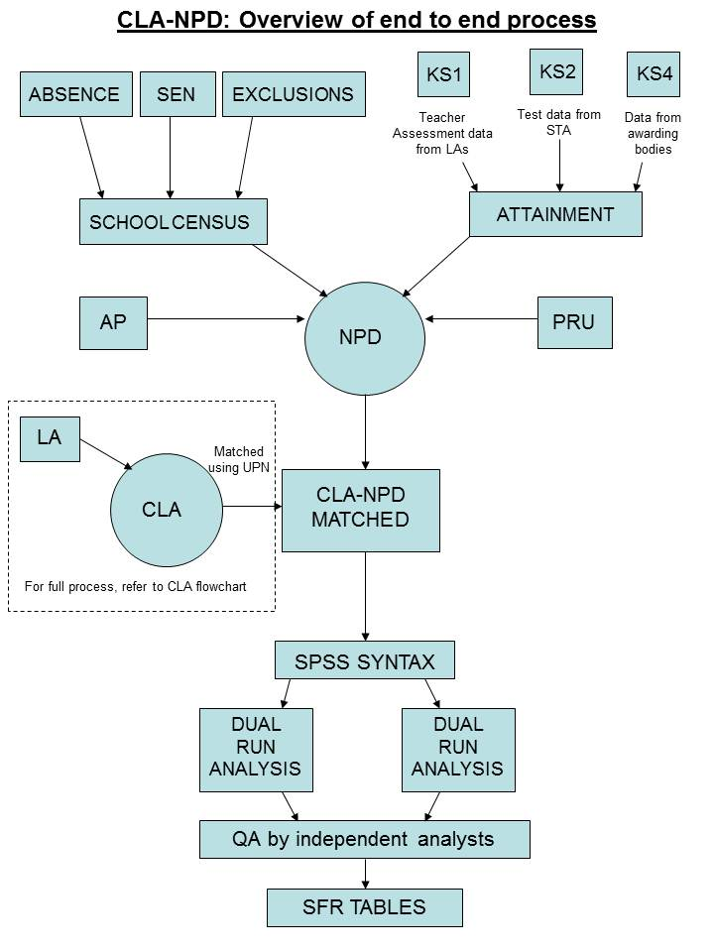
Key
SEN – Special Educational Needs
KS1 – Key Stage 1
KS2 – Key Stage 2
KS4 – Key Stage 4
AP – Alternative Provision
PRU – Pupil Referral Unit
LA – Local Authority
STA – Standards and Testing Agency
CLA – Children Looked After
UPN – Unique Pupil Number
NPD – National Pupil Database
SFR – Statistical First Release

