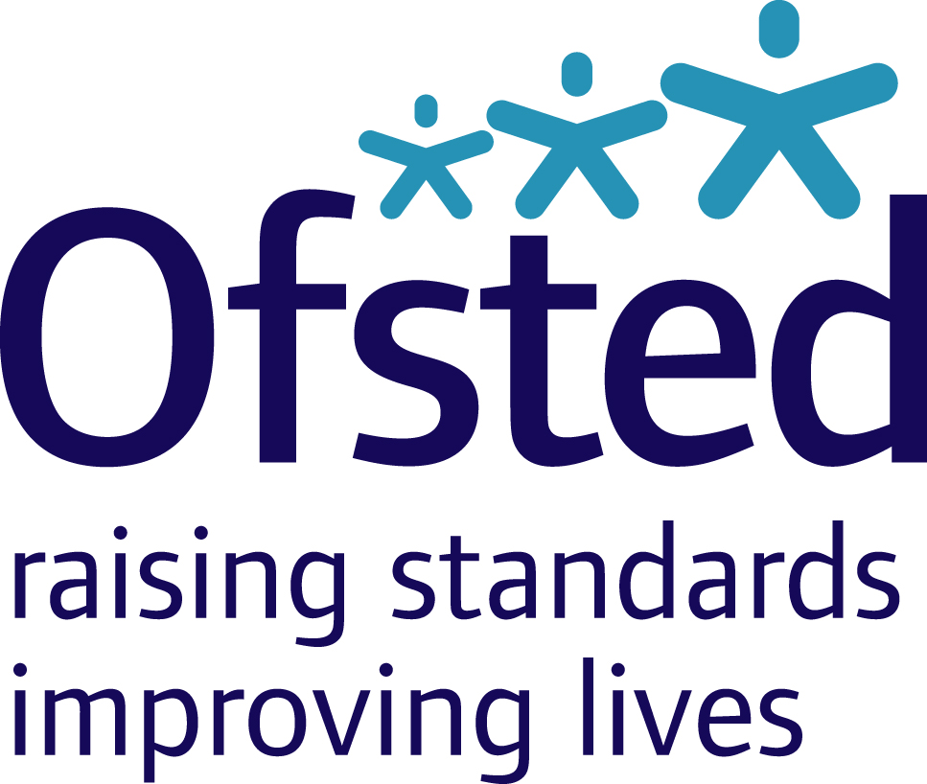


Memorandum of understanding between the Care Quality Commission and the Office for Standards in Education, Children’s Services and Skills

Introduction

- This Memorandum of understanding (MOU) is between the Care Quality Commission (CQC) and Her Majesty’s Chief Inspector of Education, Children’s Services and Skills (Ofsted).

- It sets out the areas in which Ofsted and CQC will work together and coordinate their roles and activity. Our shared aim is to protect and promote the interests and rights of children and adults who use services either regulated and/or inspected by each inspectorate.

- The MOU sets out how the two inspectorates' interests and responsibilities will complement each other and how they will work together to avoid duplication or confusion. This will help regulated bodies and those being inspected to be clear about their accountability. It will also clarify to our staff when and how to coordinate our work.

- This MOU does not override the statutory responsibilities and functions of the CQC and Ofsted and is not enforceable in law. However, the CQC and Ofsted are committed to working in ways that are consistent with the content of this MOU.

Principles of cooperation

- In working together, our approach will be built on five core principles.

  - Good regulation and inspection. We are committed to the principles of good regulation and inspection, set out by the Better Regulation Task Force. These are that regulation and inspection should be proportionate, accountable, consistent, transparent and targeted. Working together and coordinating our activities enables us to put these into practice more successfully than if we acted alone and helps us to be more cost-effective overall.
.
  - Understanding each organisation and its independence. Joint work and coordination must be in the context of our two organisations' different remits, statutory powers and duties, and systems of accountability to parliament, the public and ministers (as appropriate). The ways in which we deliver our statutory functions should however be aligned wherever this will avoid confusion or duplication and wherever this will lead to the efficient and effective exercise of our different functions.

  - Focus on results. In working together and co-operating in the exercise of our respective regulatory functions, our aim is to stimulate improvement in the care and welfare of children and young people across health, education and social care services. We will target any joint action on aspects of regulation that are likely to make a positive difference, and will therefore consider:

- areas of work which may not be a priority when considered from just one organisation's perspective, but where co-operation and joint action is likely to bring broader benefits to the people using, or running, the service
- seeking out areas where, by acting together, we may have greater impact in promoting quality of care than if we acted alone.

  - Pragmatism. We will take a practical approach to collaboration and design our methods so that they accommodate and make maximum use of each organisation's knowledge, expertise and existing processes, wherever appropriate. We will both seek to re-use each other's findings and information wherever this is 'good enough', relevant to our respective functions, and where it is lawful for us to do so. We will take a common-sense approach that, between our efforts, finds the quickest, simplest, most efficient and effective ways of assuring quality of care.

  - Being as clear as possible. We will set out in this MOU which areas we will prioritise for working together, and review them regularly. We will set out in detail what working together means in practice in each case, for example through joint working agreements and information sharing agreements linked to this MOU.

Areas for joint work and coordination

- The range of Ofsted’s and CQC’s functions are summarised in Annex 1. Areas for joint working and coordination include:

  - inspections of children’s services
  - inspections of secure training centres
  - regulation of certain children’s residential settings which are registered with Ofsted and also require registration with CQC to provide health services under the Health and Social Care Act 2008 (Regulated Activities) Regulations 2010
  - sharing information on any developments in relation to the inspection of children’s centres
  - dual registration of Independent Specialist Colleges
  - review and study projects where collaboration or information sharing is beneficial to the outcomes.

- We will share information and intelligence, and pool knowledge and expertise, as appropriate and as necessary where it is fair and lawful to do so to achieve the objectives of this MOU. We will also coordinate activity and, in particular, inspections and enforcement activity or other steps to follow up concerns. In practice, we will do this by developing joint working protocols and/or information sharing agreements, agreed separately as required.

Our approach to joint working

- Ofsted is the expert body in relation to children’s social care, education, childcare and learning and skills, and is the lead inspectorate for the inspection of children’s services. CQC is the expert body on the health and adult social care system and the lead regulator for all healthcare services. Further information on the functions of each organisation is available in Annex 1.

- Each organisation will seek to access the other's expertise when needed and involve the other in any direct intervention where the other body has relevant statutory powers.

- In relation to issues that affect both organisations where relevant we will engage in these jointly as far as possible, and act in close coordination.

- We will involve each other in meetings with stakeholders or other key partners where discussions relate to development of joint programmes of work, and will facilitate understanding amongst external partners of each other’s functions and approaches.

- We will involve each other in our planning for future work including any project or thematic review work where there may be significant benefit in a joined-up approach.

- We will keep our employees informed of the working arrangements between us and enable joint operational working at within the principles of this MOU. All decisions that may have national implications,, require more than short-term resource, may have media impact or contradict the principles of this MOU will be referred to the officers named in this MOU who will facilitate discussions and resolution at an appropriate level.

- We will collaborate on staff training where joint work is being carried out or where such training is considered beneficial to joint working arrangements.

- Unless we agree specific exceptions, our work together will not affect each organisation's standing policies and procedures, including human resources policies and terms and conditions of employment for staff.

- We will promote equality and wider diversity issues throughout our work together.

Exchange of information

- Joint working may in certain circumstances require the CQC and Ofsted to exchange information. The CQC and Ofsted acknowledge and agree that ultimately any decision to share information will be judged on a case-by-case basis and subject to compliance with any applicable data protection principles, code of practices, guidance and information sharing agreements.

Media and publications

- We aim always to give each other advance notice of external communications relating to relevant areas of activity. We will coordinate in presenting our findings externally where appropriate.

- Any documents shared in advance of publication are shared in confidence, and we will take appropriate steps to maintain that confidentiality to the fullest extent possible.

- We will consult with the other party when considering any disclosure of information received from that party – for example, in response to requests under the Freedom of Information Act 2000.

Resolution of disagreement

- We will nominate leads for day to day management of our joint work. Any disagreement will normally be resolved swiftly at operational level or through these leads. If this is not possible, it may be referred upwards by them, up to and including Her Majesty’s Chief Inspector and the chief executive of CQC, who will jointly be responsible for ensuring a mutually satisfactory resolution.

Implementation

- This MOU commences on 1 September 2011. It will continue to remain in force until such time as it is revoked by the parties.

- The MOU may be reviewed at any time at the request of either party.

- The officers named in the appendix to this MOU, together with any other relevant staff, will meet quarterly.

- This MOU has been agreed by Miriam Rosen, Her Majesty’s Chief Inspector of Education, Children’s Services and Skills and Cynthia Bower, Chief Executive, CQC.

Annex 1

Functions of CQC and Ofsted

Ofsted

- The Office for Standards in Education, Children’s Services and Skills (Ofsted) was established under the Education and Inspections Act 2006. It came into existence on 1 April 2007 by bringing together in a single organisation four previously separate inspectorates. It regulates and inspects to achieve excellence in the care of children and young people, and in education and skills for learners of all ages.

Ofsted’s strategic priorities:
- Better outcomes
- Better inspection and regulation
- Better public involvement
- Better ways of working.

- Ofsted regulates and inspects childcare and children’s social care. It inspects schools, colleges, initial teacher education, work-based learning and skills training, adult and community learning, education and training in prisons and other secure establishments, and the Children and Family Court Advisory Support Service (Cafcass). It assesses children’s services in local areas, and inspects services for looked after children, safeguarding and child protection.

- Ofsted seeks to promote improvement in the services it inspects and regulates, and to ensure that they focus on the interests of the children and young people, parents and carers, adult learners and employers who use them. Ofsted also encourages services to be efficient and effective.

CQC

- The Care Quality Commission was established under the Health and Social Care Act 2008 as the independent regulator of health and adult social care in England.

CQC’s strategic priorities (from January 2011):
- Focus on quality, and acting swiftly to eliminate poor quality care
- Ensuring care is centred on people’s needs and protects their human rights.

- CQC’s main activities are:
- registration of health and adult social care providers to ensure they are meeting essential common quality standards, with monitoring and inspection of this on an ongoing basis, and enforcement powers, such as fines and public warnings or closures, if standards are not being met
- reporting the outcomes of its work so that people who use services have information about the quality of their local health and adult social care services.

Lead officers for contact between Ofsted and CQC

CQC  Amanda Hutchinson  Head of Better Regulation  Care Quality Commission  Finsbury Tower  103-105 Bunhill Row  London EC1Y 8TG  Tel: 020 7448 9089  Email: amanda.hutchinson@cqc.org.uk  Andrea Gordon  Regional Director – East and West Midlands  Care Quality Commission  Finsbury Tower  103-105 Bunhill Row  London EC1Y 8TG  Tel: 0121 600 5390  Email : andrea.gordon@cqc.org.uk | Ofsted  John Goldup  National Director, Development and Strategy  Ofsted  Aviation House  125 Kingsway, Holborn  London WC2B 6SE  Tel: 0207 421 6897  Email: john.goldup@ofsted.gov.uk

Further information on this is available in our publication CQC and Ofsted guidance: registration of healthcare at children’s homes available at: www.ofsted.gov.uk/Ofsted-home/Forms-and-guidance/Browse-all-by/Other/General/CQC-and-Ofsted-guidance-registration-of-healthcare-at-children-s-homes/(language)/eng-GB.

