Supporting young people to participate in education and training
An AoC/Ofsted project reviewing factors that help or hinder young people aged 16 to 18 living in London to participate in education, employment or training
This project forms part of Ofsted’s improvement activity in conjunction with the Association of Colleges’ (AoC) professional engagement with the further education (FE) sector.
Age group: 16 to 18
Published: February 2014
Reference no: 140039

Contents
Introduction 4
Main findings 5
Context 6
What the data on the London NEET cohort show 7
Ofsted and other publications relevant to this project 11
Vulnerable groups and young people not in education, employment or training 12
The curriculum 13
Types of programmes 13
Access to learning 14
Teaching and learning 15
Enrichment and work experience 16
Parental support and involvement 17
Measuring success 17
Support for students 19
Wrap-around support 19
Financial support 20
Resources 22
How leaders support young people to participate 22
Information sharing 22
Information, advice and guidance 23
Recommendations for further developments 25
For government departments, funding agencies, colleges and other partners 25
For local authorities, schools and colleges 25
For colleges 25
Further information 26
Publications by Ofsted 26
Supporting young people to participate in education and training (140057), Ofsted, 2014; www.ofsted.gov.uk/resources/140057. 26
Other publications 26
Annex: Providers visited 28

Introduction
This project forms part of Ofsted’s improvement activity carried out in conjunction with the Association of Colleges’ (AoC) professional engagement with the further education (FE) sector. Together, Ofsted and the AoC are committed to identifying and understanding better how to disseminate effective practice.
Work in London has centred on the challenges, context and practice of colleges in urban settings. The previous joint project, the outcomes of which were published in 2013, identified the barriers to students’ good attendance and punctuality. This led to valuable learning for the leadership teams and staff in colleges and for inspectors. The current project again aimed to promote learning and improve performance through jointly agreeing a focus and pooling the experience of both Ofsted’s inspectors and college staff. This was not a formal inspection.
The project explored the good practice taking place in colleges in London that re-engages young people, including many who come from disadvantaged backgrounds and who are not in education, employment or training (NEET). It focused, in particular, on identifying successful curriculum delivery models. The objectives, developed jointly by the AoC London Region and Ofsted, also aimed to identify factors that enabled or hindered effective practice.
Seven of Her Majesty’s Inspectors (HMI) visited seven colleges, gathering evidence from over 50 students and 80 college staff and partner agencies. The colleges provided data and information on their performance. A consultative workshop enabled a wider group of London colleges to challenge and contribute to the initial findings of the visits. The Annex lists the colleges involved.
Inspectors explored the same themes at each college. These included:
- how well the curriculum meets young people’s needs and the outcomes they achieve
- the strategies and actions used to engage young people who are disadvantaged and/or NEET and how effectively this work is managed
- the nature and effectiveness of the relationship between colleges and partner agencies in supporting young people.
Outcomes of the action learning activity were:
- a short, unpublished summary of findings to inform discussion at the consultative workshop and to identify critical issues and good practice
- this published report on the project’s findings
- further work by the AoC and HMI to develop these findings and disseminate the good practice regionally and nationally.

Main findings
- All the colleges visited had a wide range of courses and discrete programmes that focused strongly on young people’s vocational aspirations.
- Good links with employers played an important role in enriching students’ vocational experience.
- A variety of enrichment courses enhanced students’ all-round college experience.
- College leaders were highly committed to engaging disadvantaged young people, creating a strong ethos of support for students at risk.
- Of paramount importance was the close attention paid to the welfare of individual students. Approaches that supported vulnerable students effectively were characterised by colleges creating a ‘team around the student’ of support services, based on good knowledge and understanding of individuals’ needs and aspirations. Direct support was provided through welfare arrangements and/or through outside agencies. Attendance and progress were monitored closely.
- Staff in colleges, schools, local authorities and the voluntary and community sector taking part in this project were implementing new policy initiatives and approaches to engage young people against a backdrop of reductions in funding, staffing and organisational change. They found this a challenging environment in which to maintain and improve the systems of support available to prevent young people falling through the net.
- The lack of effective information sharing between agencies, in particular between local authorities, schools and colleges, was commonly cited during the project as hindering the identification and successful engagement of young people. The consultative workshop confirmed this and identified further barriers in information-sharing with schools. The representation of senior college staff on local strategic groups had not overcome systemic barriers to young people’s engagement.
- Colleges had developed good operational partnerships that supported specific ‘groups’ of vulnerable young people to participate effectively in further education. Consistently good partnerships helped care-leavers, young offenders and those with learning difficulties and/or disabilities to participate in relevant courses. In six of the seven colleges visited, strong links with alternative education providers resulted in a high level of provision for vulnerable and ‘at risk’ 14–16-year-olds.
- Few of the colleges visited compared data on the performance of their different groups of disadvantaged students with data for their student population as a whole; there was little evidence that they compared outcomes of like-for-like groups on comparable courses across London colleges. Since no agreed benchmarks existed, it was difficult for them to compare and evaluate their performance against that of other colleges.
- In the vast majority of London boroughs, the number of young people in the NEET cohort increases at age 17 and rises further for 18-year-olds. The colleges visited pointed to ineffective information, advice and guidance for 16- and 17-year-olds at school as a key factor. This led to students’ dissatisfaction with academic study and their subsequent drop-out from courses, particularly from schools and academy sixth forms.
- The colleges visited noted that, for 18-year-olds planning to study on a full-time course beyond the age of 19, the benefits system could be a barrier to their participation.

Context
- The government has introduced a series of reforms to increase the number of young people taking part in education and training. These reforms include:
- the raising of the participation age so that, by 2015, everyone will be required to stay in education or training until they are 18. At present this applies to those aged up to 17
- six-month traineeships, delivered by good and outstanding providers, aimed at securing an apprenticeship or sustainable job for 16–24-year-olds
- the proposals outlined in the Richard review, aimed at improving apprenticeships so that they are of a consistently high quality
- the duty on schools, established in September 2012, to provide impartial careers guidance.
- In his Annual Report 2012/13, the Chief Inspector recognised the disproportionately high number of pupils from disadvantaged backgrounds who enter further education and the central role of colleges in improving the economic prospects of these students. The report highlights the need for a secure system to ensure that the most disadvantaged young people continue to engage in education and training. It also draws attention to the fact that too many young people from disadvantaged backgrounds fail to achieve well in their post-16 setting and do not complete their courses. The report recognises, too, the ‘huge difference’ that some colleges make to the lives of their students.
- Local authorities have a range of statutory duties to ensure the smooth transition of young people into post-16 education, including: tracking the participation of young people; the offer of a learning place to all 16- and 17-year-olds through the ‘September Guarantee’, and supporting young people’s participation in education and training. In November 2011, the government announced a £1 billion Youth Contract to help young unemployed people get a job. The Youth Contract is intended to increase support for disengaged 16–17-year-olds to move into education, training, or work with training; provide new work places for 18–24-year-olds through wage subsidies and incentives for employers; and offer a quarter of a million work experience placements.
- London Councils provide pan-London leadership for 14 to 19 education and training through the Young People’s Education and Skills Board; the Board aims to ensure that all young Londoners are engaged in learning leading to successful working lives.
- In October 2013 the Skills Minister, Matthew Hancock, affirmed the government’s commitment to reducing unemployment, saying: ‘We are determined to do everything we can to tackle the problem of youth unemployment and this starts by identifying our young people who are NEET.’
- This project is set against a background of public service cuts that affect colleges and partner agencies alike. In December 2013 the Department for Education announced a reduction in the funding for the academic year 2014/15 that colleges would receive for 18-year-olds. With a higher proportion of 18-year-olds in full-time education than any other region, London colleges will be disproportionately affected by this reduction.

What the data on the London NEET cohort show
- At 4.7%, London has the lowest proportion of young people in the NEET cohort of all English regions (Figure 1), although there has been a slight increase since 2011. However, despite this good news story, London is, in fact, the only region in England to have seen an increase since 2011 in the proportion of 16–18-year-olds who are NEET, although this may partially be accounted for by a fall in the proportion of young people whose activity is unknown. The NEET cohort amounts to 11,650 young people aged 16 to 18 (as at the end of 2012).
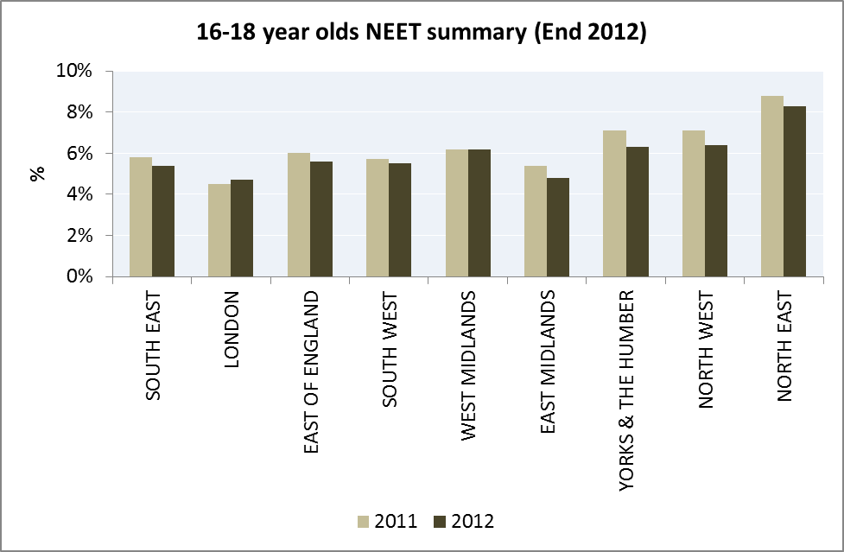

Figure 1: 16–18-year olds NEET summary (end 2012)

- At 10.2%, Camden currently has one of the highest proportions of young people who were NEET in 2012 – an increase from 7.2% in 2011. The London Boroughs of Lambeth (3.9% points), Southwark (3.3% points) and Hackney (3.1% points) saw the largest increases in NEET rates between 2011 and 2012.
- Of equal concern is the fact that there are around 29,000 young Londoners (as at December 2012) whose status is ‘not known’; that is, authorities do not have information about whether or not these young people are participating in education, employment or training. This number is almost two and a half times greater than the number of young people who are known to be NEET (11,650).
- The proportion of young people aged 16 to 18 of ‘unknown’ status varies widely across London boroughs, as shown in Figure 2. Three London boroughs, Croydon (43.6%), Haringey (25.7%) and Waltham Forest (24.7%), have very high proportions of ‘unknown’ 16–18-year-olds. This suggests that there is too much variation in the performance of London boroughs in terms of tracking and, more importantly, supporting young people.
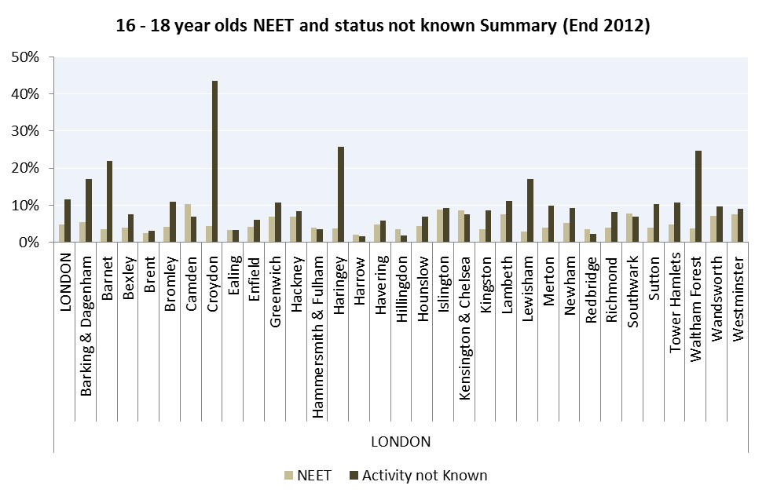

Note – City of London removed as 80.7% activity not known (0.3% NEET).

Figure 2: 16–18-year olds NEET and status not known summary (end 2012)

- Marked differences are found in how well 16-, 17- and 18-year-olds are engaged in education, both nationally and in London (Figure 3).
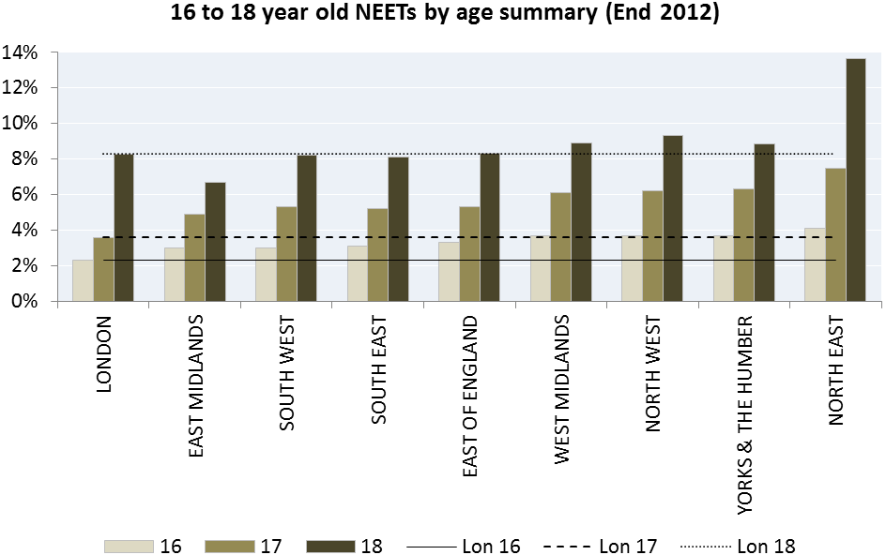

Figure 3: 16–18-year-old NEETs by age summary national (end 2012)

- The proportion of young people who are known to be NEET at 16 years of age contrasts starkly with the high numbers who are not engaged at the ages of 17 and 18 across the vast majority of London boroughs. Figure 4 illustrates this vividly. The fact that, across the capital, 18-year-olds form 59% of the 16 to 18 NEET cohort as a whole indicates this age group’s progressive disengagement with education, training or employment.
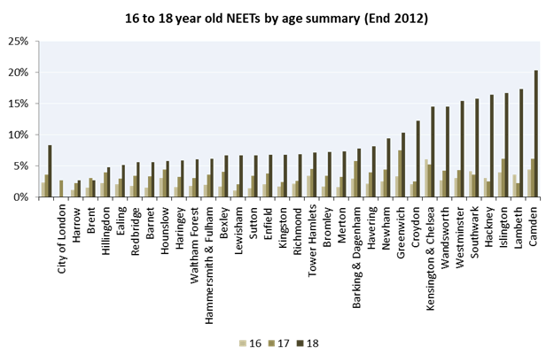
Figure 4: 16–18-year-old NEETs by age summary London (end 2012)

Ofsted and other publications relevant to this project
- Ofsted has reviewed issues concerning vulnerable young people and those who are NEET in recent reports, including the following:
- Reducing the numbers of young people not in education, employment or training: what works and why
- Going in the right direction? Careers guidance in schools from September 2012
- Pupils missing out on education
- Improving attendance and punctuality
- In September 2013, the Institute for Employment Studies (IES) and the Centre for Education and Industry (CEI), University of Warwick, published research into the Phase 4 Locally Led Delivery Projects for raising the participation age. This project considered the findings of the research study and the other publications listed and found common ground in key areas, including:
- the need for the early identification of and offer of support to vulnerable young people and those at risk of becoming NEET
- the importance of good information-sharing between agencies about vulnerable young people and a coordinated approach to supporting them.

Vulnerable groups and young people not in education, employment or training
- A common feature of the young people identified by college staff and other agencies as NEET, or at risk of becoming NEET, was that they held qualifications below level 2, including in English and mathematics. Other factors identified in this project affecting young people’s non-participation in education and training included:
- poor school attendance
- experience of bullying
- history of exclusion from school
- school phobia
- gang association
- families’ low income
- learning difficulties and/or disabilities
- offending behaviour
- status as looked-after children and care leavers
- first language not being English
- mental health problems.
- One profile provided for inspectors by a college for a group of 24 students on an employability programme gives a good insight into the circumstances of the group of young people with whom this project is concerned. The profile showed that, of these 24 students:
- forty per cent were looked after children or care leavers
- eighty-three per cent had levels of ability in English at level 1 or below, with almost half of them at entry level 3
- one third had a special educational need or disability
- two thirds had multiple needs, such as mental health and housing difficulties.

The curriculum

Types of programmes
- The strong commitment to vulnerable students evident in all the colleges visited helped to establish a whole-college ethos of high expectations. Managers and staff developed programmes and support services that met the needs of students. Staff at all levels had a high degree of ownership of this agenda and used their expertise well to adapt the curriculum in the light of experience. They formed relationships and exploited opportunities in the community to benefit students.
- The colleges took a variety of approaches to supporting disengaged young people. Curriculum models typically fell into two categories:
- preventing young people becoming NEET through work with alternative education providers, schools and special schools
- specific programmes aimed at those who had become NEET that had a strong focus on vocational and work-related learning, personal and social skills development, and a practical ‘hands on’ approach.
- Programmes targeting particular groups of students with barriers to engagement were less evident, but included courses tailored to the specific needs and circumstances of learners. For example, Hackney Community College works with the orthodox Jewish community and those with learning difficulties and/or disabilities. More details about Hackney’s programme are provided here. Bespoke programmes such as these increased the participation of these groups and led to more widespread support for young people.
- All the colleges visited had additional programmes complementing their existing provision to meet the needs of specific young people, such as work with under-16s. Most of this provision was below level 2. Three colleges identified gaps in the curriculum in their area for students aged 17 and over at level 3, thus inhibiting vocational progression routes for them.
- Colleges adapted their approach with schools and alternative education providers according to local circumstances. Commonly, they focused on young people who were ‘at risk’ in some way. Provision ranged from small-scale taster courses and one-off events to introduce pupils to further education and projects targeting specific groups of students, such as those speaking English as an additional language, to larger-scale programmes targeted at preventing young people from becoming NEET. Young people achieved well through attending these programmes and, on completing their course, many progressed to further learning. An example of an alternative curriculum model (New Horizons Federation Bexley) is provided here.

Barnet and Southgate College – Young College
Annually, the college supports approximately 120 pupils aged from 14 to 16 from 35 different agencies, including schools, pupil referral units and seven different local authorities. Students enrol throughout the year. This flexible approach promotes access to learning well, for example for young people who are not succeeding elsewhere or those who are newly arrived in the UK. Students have experienced a number of barriers that hinder their progress and chances of success, including being bullied, poor behaviour and school phobia.
During a six-week assessment period, the college identifies the level and type of course that best suits individuals. Courses include vocational options, English for Speakers of Other Languages (ESOL) and GCSEs. Mentors provide additional support, monitoring students closely and supporting their attendance. Progression rates are excellent, with 96% remaining in further education and 3% gaining employment on completing their course.

Access to learning
- Six out of seven of the colleges visited had some courses that enabled young people to join at different times of the year, thus increasing flexible access for them. However, this was not consistent across all of the courses offered. For example, in one college a key course specifically aimed at young people who were NEET started only twice during the academic year (in September and January).
- The January enrolment period aimed to provide an alternative route back into learning for students who had dropped out of other courses during the preceding autumn term. While this broadened the safety net for young people, opportunities for them to progress to other courses immediately after completion were limited. This increased the risk that students would become disengaged from learning. Over time, some of the colleges visited had reconfigured their programmes in order to reduce the waiting time for students. Reducing delay before they started a course increased the continuity of students’ learning.

Croydon College – Fresh Start
Fresh Start, a 12-week programme, provides an opportunity for young people to trial a range of vocational learning. This includes hair and beauty; health and social care; retail; construction; motor vehicle; and art and design, alongside functional skills in English and mathematics. The programme runs once a term and is targeted at those who are NEET.
Previously, the programme ran over 17 weeks, twice a year, but it was modified to reduce the amount of time young people might have to wait before beginning a new course.
- Two of the colleges visited improved access for students by delivering provision from smaller satellite bases, giving an alternative ‘front door’ in the local community. Westminster Kingsway College uses smaller centres with a strong community ethos for students who are not ready to attend a large and busy college campus. Bexley College works with Charlton Athletic Community Trust, delivering a BTEC award in sport, football coaching and work skills. Three quarters of these students progress to further learning, training, employment and volunteer roles. Further information on Bexley College’s programme is provided here.
- The colleges visited offered a curriculum with a consistently strong focus on vocational and work-related learning. One-off sessions and taster courses were effective in giving young people good opportunities to try different trades, explore different career paths and get a sense of what they might be interested in studying. These gave them an early indication of course demands and expectations. A good example of this was an employability programme developed by Croydon College with the London Fire Brigade. College staff set high expectations for students to develop their work-related behaviour and skills. They balance this with providing additional support such as one-to-one mentoring that develops students’ capacity to meet such expectations.
- Partnership arrangements to support young people in the NEET cohort were central to engaging them successfully and enhancing their access to further education. Good operational partnerships were evident at all the colleges, with the nature of the partnerships varying according to local circumstances. The most effective partnerships were with special schools, alternative education providers and local authority leaving care teams. These all supported access to further education well. The partnerships particularly benefited young people who were already known to agencies, such as youth offending and care leaving teams.

Teaching and learning
- Tutors in the colleges visited were aware that many students had had negative experiences at school. They were therefore keen to make sure that their course engaged young people’s attention from the start and they ensured that teaching was adapted to keep them interested. Staff used their imagination, creativity and subject knowledge well to tailor learning to engage young people quickly. Good knowledge of individual students informed their teaching strategies. Staff developed trusting relationships with students, gave them regular feedback on their progress, varied learning activities frequently, used students’ feedback to develop new activities, and engaged them with practical tasks.
- Tutors recognised that it was often difficult to engage young people in programmes to develop their English and mathematics, yet making these relevant to students’ individual needs and their vocational pathway is a key factor in improving their skills and knowledge.
- In three of the colleges visited, staff saw the introduction of study programmes, recommended by the Wolf review, as an opportunity to develop students’ practical English and mathematics skills over a short period of time without the need to focus on qualifications. However, the staff felt pressure to deliver qualification-based programmes; these, then, became a barrier to some students’ positive engagement with English and mathematics.

Enrichment and work experience
- Enrichment activities play a crucial part in enhancing the experience of vulnerable students and building their capacity as learners. These activities can give vulnerable learners a ‘taste of success’, increasing their confidence. Many of these students cited such activities, including additional learning in vocational areas through work experience placements, and opportunities for personal and social development, as highlights of their time at college. Bexley College, for example, offers students a supported internship for young people with learning difficulties and/or disabilities. This provides a structured study programme based with an employer and at the college, tailored to the individual needs of young people. Further information is provided here.
- In the colleges visited, enrichment activities were not related exclusively to the course that students were following. They added significant value to students’ all-round experience of college. One student told inspectors how he had developed his interest in boxing outside college as a result of trying it at college. Another attended a dance group at the college that had helped to accelerate her acquisition of spoken English.
- Many of the colleges visited ran specific sessions, aimed at supporting young people’s personal and social development, in parallel with their course of study. These sessions covered topics such as domestic violence, sexual health education and drugs awareness. They were often built around students’ specific needs and aspirations and benefited from good links with outside agencies. One college manager was considering withdrawing the universal provision of enrichment activities as a way of managing reductions in the funding allocation for 18-year-olds.
- Young people greatly valued high-quality work experience which enhanced their employment prospects. It enabled them to gain up-to-date, relevant experience, make contacts in business and industry, and develop a broader knowledge of career pathways. Even work experience placements in the college itself could be useful for vulnerable students, providing a safe first step for them into the world of work and forming an important part of a continuum of work-related learning. Other related activities that were beneficial included voluntary work, part-time paid employment in the college and visits to employers. College staff expressed concern, however, that new policy developments restricting work experience in students’ own colleges had the potential to hinder opportunities for such students to gain work experience in environments where the most vulnerable of them felt safe.
- Two of the colleges visited used restorative justice approaches with their students. These non-punitive approaches were successful in helping to resolve conflicts between individuals and groups of young people and enabled them to explore and resolve problems themselves. But, importantly, the approaches also built up young people’s personal capabilities and developed the skills they needed to manage themselves better when dealing with confrontation.

Parental support and involvement
- Colleges with provision for students aged under16 and for those with learning difficulties and/or disabilities had much stronger relationships with their parents than for other groups of students’ parents. The most common form of engagement was keeping parents informed of their children’s progress. Parents were seen as key to supporting attendance and helping to ensure that students met the high expectations of the college. One college visited achieved this through developing a learning contract for the parents, students and the college.
- Relationships with local authorities acting as the corporate parent for looked after children and care leavers were consistently good in the colleges taking part in this project.

Measuring success
- College staff, both in the colleges visited and in the consultative workshop, held a wide range of views as to how to measure success for vulnerable young people. The majority felt that success equated with high attendance and retention rates and the progression of students to relevant destinations on completing their courses, either within or outside the college. These factors comprise a reasonable balance of information on which to judge colleges’ effectiveness and reflect measures used to judge outcomes more generally. A reduction in overall exclusions from college was also seen as a useful indicator of success.
- While some of the colleges visited compared data on the performance of their different groups of disadvantaged students against data for their student population as a whole, there was little evidence that they compared the outcomes of like-for-like groups on comparable courses across London colleges. There were no agreed benchmarks to determine what a high level of success or progression might be and this made it difficult to judge the relative performance of providers.
- The complexity of young people’s lives, and their varying abilities when beginning courses, were important factors when judging the success of a specific programme. For disadvantaged students, each young person’s journey was important and staff spoke passionately to inspectors about how individuals had succeeded against the odds. Case studies and students’ first-hand accounts supported this.
- Colleges that had tracked the performance of different groups of NEET and vulnerable young people found that their outcome measures compared favourably with their overall college performance. However, evidence of this type of analysis was seen in just two of the colleges visited.
Croydon College – comparing success
Managers track the performance of students in receipt of bursaries and compare their success rates with the overall college average. The success rate on long courses in 2012/13 for supported 16–18-year-old students who were not ‘looked after’ was 87.6%; and it was 76.7% for 16–18-year-old looked after learners.

Critical issues
Too few opportunities exist for students to access appropriate learning programmes at convenient times throughout the year.
When young people whose circumstances make them hard to reach become re-engaged in education and training and join a short course, there are not always immediate and suitable progression opportunities.
It is difficult for colleges to measure the effectiveness of their work with young people who are vulnerable or NEET in the absence of any like-for-like indicators to compare their performance with that of other London colleges.

Support for students

Wrap-around support
- Securing the successful participation of vulnerable young people needs strong support services that complement their course of study. Individual welfare needs must also be given full attention. This often involves not only college support services and tutors but specialist external agencies. Students’ chances of success are improved when all these elements come together systematically to provide holistic oversight of their needs.
- In a few instances, the oversight of students’ welfare was enhanced by outside agency staff participating directly in reviewing students’ progress; for example through a fortnightly multi-agency forum. In Hackney, for example, staff from the youth service attended weekly meetings at the college and provided oversight of more vulnerable learners, helping to tailor support for them. Inspectors identified many examples of the tenacity of college staff in promoting students’ welfare and participation.

Barking and Dagenham College – ‘a ring of steel’
Barking and Dagenham College has adopted a ‘risk management’ approach to support vulnerable learners.
The college gains as much information as possible on students’ individual needs and circumstances as soon as they enrol, so that it can best understand how to provide the right kind of help. The approach includes comprehensive liaison and information-sharing with a range of agencies, including the youth offending team, police, Jobcentre Plus, disability employment advisers and the local authority children’s services department. Enrolment forms provide young people with the opportunity to declare, for example, any criminal convictions they have, or learning support needs. Structured one-to-one interviews focus effectively on well-recognised risk factors and identify, early on, students who are at the greatest risk of leaving programmes prematurely. Close daily and weekly monitoring for high-risk students means they feel valued and part of the college community.
- Specialist staff provide valuable expertise in supporting vulnerable young people. For example, Bromley College has employed staff with expert knowledge to support students joining the college who are on the autistic spectrum. At Westminster Kingsway College looked after children receive additional tutoring and mentoring in college from the virtual school. They have close working relationships with the education welfare service that promotes the attendance of 14–16-year-olds.
- Colleges are able to draw on their full range of support services to provide a ‘team around the student’ to include counselling, breakfast clubs and mentoring. In the best practice, these form a strong spine of support that contributes effectively to provision for more vulnerable students.

Financial support
- Some colleges were adopting imaginative approaches to supplement the funding that is available to support vulnerable young people.

Newham College of Further Education – charitable arm
Newham College has established a charitable arm to provide additional support for vulnerable students. It provides free meals to all students aged 16 to 18. This removes any stigma for students who might be entitled to a subsidy but might not claim it if they had to apply for it.
- Some colleges used funding effectively to provide emergency funds. These enabled students to access accommodation, food and transport when they needed it and safeguarded their welfare in times of crisis.
- College staff held very mixed views regarding how well bursary funding for vulnerable students was supporting their engagement with education. Most college staff felt that access to funding relied too heavily on students’ self-disclosure of personal information and that the exchange of information between agencies was inefficient. This led to delays in young people receiving funding and prevented some accessing the support they were entitled to. Colleges referenced a specific concern that the absence of information exchange could hinder the forthcoming extension of free school meals to 16–18-year-olds. Inspectors identified a couple of good examples where students themselves had helped to set the priorities for funding additional support.
Westminster Kingsway College – student involvement
Westminster Kingsway College has established a student focus group that works with the college’s finance team to improve how bursary funds can be used best to support them.
In response to student feedback on a lack of funds, the college set up a breakfast club that is regularly attended by around 20 students. Students also felt they had insufficient access to laptops and computers outside college. The college therefore provided a netbook on loan to students receiving a bursary so they could access information outside college and complete their coursework.
- College staff identified disincentives in the benefits system when young people became 19 as a key factor in students failing to progress or being ‘forced’ to drop out of college, because some of those relying on benefits were prohibited from continuing full-time study. Jobcentre Plus advisers who had a strong relationship with a college, for example through regular attendance at the college, knew young people well and were able to exercise discretion, case-by-case, about young people’s entitlement to benefits. These arrangements were seen in two colleges and served young people well.

Resources
- The colleges visited deployed considerable resources to support vulnerable students. They placed much importance on ensuring they had high-quality staff. They ensured that these staff were well-trained. One college had taken action to improve the terms and conditions of those working specifically with these vulnerable groups so as to recruit and retain the best staff. Managers acknowledged that the personal qualities of staff working with vulnerable young people were as important as tutors’ good subject knowledge. Students told inspectors that the quality they valued most highly was the ability of staff to build trusting relationships, exhibiting patience and empathy. However, tracking and supporting vulnerable students are highly labour-intensive activities and some staff said that they did not have sufficient time to ensure they met the needs of all such students.
Critical issues
Colleges should investigate whether there are vulnerable groups in their community who do not access existing provision.
Ways of administering the bursary fund for vulnerable students should be improved so that it supports young people better.

How leaders support young people to participate
- In all the colleges visited, inspectors found active, visible leadership, both strategically and operationally, that supported and encouraged young people to participate in education and training. Senior staff and managers were often closely involved in local strategic groups. This enhanced their knowledge of local needs which they used to extend and refine their provision for vulnerable groups.
Croydon College
The local authority youth service helps to identify the needs of young people and then commissions Croydon College to deliver taster courses through the Journey Project. In the last academic year, half of the young people who attended events progressed to courses at the college.

Information sharing
- The effective sharing of information between local authorities and colleges was inconsistent in the colleges visited. The strong strategic links that the colleges had with local authority staff had not helped to ensure that information was shared consistently well. Five of the seven colleges did not have information-sharing protocols that were effective enough to identify young people who were NEET, or whose status was not known, and engage them in learning.
- The colleges identified key factors that were prohibiting effective information-sharing. Local authorities interpreted data protection legislation in different ways. This, together with instability in some authorities as a result of budget reductions and reorganisations, weakened arrangements to identify, track and support young people effectively. For example, some youth services had only limited capacity to engage hard-to-reach young people.
- Staff described factors that made effective information-sharing particularly difficult in London, including the complex travel-to-study patterns in the capital. For colleges, this often meant liaison with many different agencies that were not immediately local to them, putting pressure on their capacity to do this liaison well. However, when information was shared effectively between colleges and local authorities, inspectors found examples of increased participation in college courses of young people who were NEET.
Hackney Community College – information sharing
The Hackney Learning Trust, which delivers education services for Hackney Council, and the college have a well-established protocol for sharing information. The college deploys its own staff to contact young people by telephone, text and flyers to their home. As a result, recruiting identified NEET young people to the college has increased fourfold since 2010.

Westminster Kingsway College – engaging hard-to-reach learners
The college works closely with Camden council’s welfare and inclusion team and Troubled Family initiative. This has helped the college to engage young people from 60% of the borough’s most difficult-to-reach families. A fortnightly multi-agency professional forum enhances oversight of young people’s progress and circumstances. The strong link with Centrepoint, a charity supporting individuals who are homeless, has increased the participation of students who speak English as a second language.

Information, advice and guidance
- Inspectors commonly came across the view from college staff that information, advice and guidance in schools was failing to help young people explore the full range of options for education and training when they reached the age of 16. As a result, too many young people chose to follow academic routes in Year 12, when they might have been better suited to a vocational course or apprenticeship. They then dropped out of school during or at the end of the year, thus joining the NEET cohort. Many college staff attributed the high proportion of 17-year-olds in the NEET group to inadequate information, advice and guidance at school.
- College staff often received insufficient information from schools on students’ previous attendance, behaviour and personal circumstances when they joined the college. This hindered a smooth transition from school to college and made it difficult for college staff to plan timely and holistic support. Inspectors, however, identified examples of sound collaboration between schools and colleges.
Barnet and Southgate College – collaboration for Year 12 students
The college and local schools are undertaking a pilot project to support the raising of the participation age. The project focuses on a ‘soft’ introduction to college for young people. Courses are offered in the creative and media diploma and multi-skills construction at level 2. To promote these courses, young people are offered taster sessions of their choice. Young people stay at school during Year 12, completing the vocational elements of their course at the college to acclimatise themselves to the college environment. The curriculum includes weekly work experience. Young people passing the course are guaranteed a college place at level 3.

Critical issues
Across all London boroughs, information-sharing between local authorities and colleges on the education, employment and training status of young people aged 16 to 18 is not effective.
Across all London boroughs, information-sharing between local authorities and colleges on the education, employment and training status of young people aged 16 to 18 is not effective
Too many young people aged 17 and 18 are not in education, employment or training.
The quality of information, advice and guidance in schools does not always equip young people to make informed choices on their next steps in learning.

Recommendations for further developments

For government departments, funding agencies, colleges and other partners
- To urgently agree strategies to improve the engagement of 17- and 18-year-olds who are not in education, employment or training, many of whom have become ‘unknown’ within local authority data.
- To agree protocols among staff of the Education Funding Agency, local authorities, colleges and schools to improve information-sharing so that young people receive the resources to which they are entitled, including:
- the bursary fund for vulnerable young people
- free school meals (in readiness for arrangements to extend this entitlement to disadvantaged students in further education and sixth-form colleges from September 2014).

For local authorities, schools and colleges
- To implement effective information-sharing across local authorities, schools and colleges so they are better able to monitor, engage and support young people aged 16 to 18 who are not in education, employment or training. In particular, these should include:
- systems to better identify, track and exchange information and data on the whereabouts of 16–18-year-olds whose education, employment and training status is ‘not known’ and for those young people who leave courses during or at the end of year 12.
- To ensure that, in choosing their next steps in learning all young people have access to independent, impartial advice and guidance and are made aware of the full range of vocational opportunities available to them, including apprenticeships.
- To investigate whether there are vulnerable groups who do not currently engage in provision and to develop strategies to help them to participate in education.

For colleges
- To ensure young people can join courses throughout the year, at times convenient to them, and that suitable progression routes are available once they complete the courses
- To develop a set of indicators and success measures that enable comparisons to be drawn across London of performance across similar courses and for key vulnerable groups.

Further information

Publications by Ofsted
Reducing the numbers of young people not in education, employment or training: what works and why (090236), Ofsted, 2010; www.ofsted.gov.uk/resources/090236.
Going in the right direction? Careers guidance in schools from September 2012 (130114), Ofsted, 2013; www.ofsted.gov.uk/resources/130114.
Pupils missing out on education (130048), Ofsted, 2013; www.ofsted.gov.uk/resources/130048.
Improving attendance and punctuality (130212), Ofsted, 2013; www.ofsted.gov.uk/resources/130212.
Supporting young people to participate in education and training (140057), Ofsted, 2014; www.ofsted.gov.uk/resources/140057.

Other publications
Review of vocational education: the Wolf report, DfE/BIS, 2011; www.gov.uk/government/publications/review-of-vocational-education-the-wolf-report.
The Richard review of apprenticeships, DfE, 2012; www.education.gov.uk/childrenandyoungpeople/youngpeople/qandlearning/apprenticeships/a00211634/richard-review.
Research into the phase 4 locally led delivery projects for raising the participation age: research report: September 2013 (DFE-RR308), Institute for Employment Studies, 2013; www.gov.uk/government/publications/research-into-the-phase-4-locally-led-delivery-projects-for-raising-the-participation-age.
http://www.employment-studies.co.uk/pubs/report.php?id=dferr308.

Annex: Providers visited
Barking and Dagenham College
Barnet and Southgate College
Bexley College
Bromley College
Croydon College
Hackney Community College
Westminster Kingsway College

The workshop was attended by the following colleges:
Barking and Dagenham College
Barnet and Southgate College
Bexley College
Bromley College
Capel Manor College
Hackney Community College
Newham College
Westminster Kingsway College

Improving attendance and punctuality (130212), Ofsted, 2013; www.ofsted.gov.uk/resources/130212.
The Richard review of apprenticeships, 2012. For further information, see: www.education.gov.uk/childrenandyoungpeople/youngpeople/qandlearning/apprenticeships/a00211634/richard-review
The Annual Report of Her Majesty’s Chief Inspector of Schools 2012/13 (120348), Ofsted, 2013; www.ofsted.gov.uk/resources/120348
On 10 October 2013 Matthew Hancock wrote to 12 local authorities who were failing to properly track 16–18-year-olds’ education or training involvement. For more details see: www.gov.uk/government/news/skills-minister-writes-to-councils-over-teen-participation-concerns.
The annual Statistical First Release (SFR) produced by the DfE is the authoritative national estimate of NEET and NET rates. Currently published data relate to the period covering November 2012 to January 2013.
Full details of these reports are in the Further information section.
Research into the Phase 4 locally led delivery projects for raising the participation age: Research report: September 2013 (DFE-RR308), DfE, 2013; www.education.gov.uk/researchandstatistics/research.
Study programmes for 16–19-year-olds, recommended by the Wolf review, are tailored to the individual needs, education and employment goals of all 16–19-year-old students. For further information, see: www.education.gov.uk/childrenandyoungpeople/youngpeople/qandlearning/programmes.
Local authorities have a statutory responsibility to make sure that they promote the educational achievement of the children they look after. For further information, see: http://webarchive.nationalarchives.gov.uk/20131027134109/http://www.education.gov.uk/childrenandyoungpeople/families/childrenincare/education/a00208592/virtual-school-head.
Travel-to-study was also discussed in the previous Ofsted/AoC report: Improving attendance and punctuality (130212), Ofsted, 2013; www.ofsted.gov.uk/resources/130212.

